國立交通大學電子工程研究所九十六級王盛弘9611842
DSP Spring 2009
HW #3 (110%) Due: 04/14
[MATLAB EXERCISE]
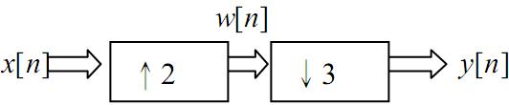
1. (25%) x[n] is sampled from a continuous time signal x(t)=sin(2πt), 0≦t≦3 with sampling period T=0.01s. x[n] is happened to be a sampled sequence from another continuous time signal with sampling period T=0.02s.

ts1=0.01;
fs1=1/ts1;
ts2=0.02;
fs2=1/ts2;
input1=0:ts1:3;
input2=0:ts2:3;
x1=sin(2*pi*input1);
x2=sin(2*pi*input2);
w1=upsample(x1,2);
w2=upsample(x2,2);
y1=downsample(w1,3);
y2=downsample(w2,3);
%(1)
y1_fft_512=fft(y1,512);
y2_fft_512=fft(y2,512);
n1=0:length(y1_fft_512)-1;
n2=0:length(y2_fft_512)-1;
f1=fs1*n1/length(y1_fft_512);
f2=fs2*n2/length(y2_fft_512);
figure();
subplot(1,2,1); stem(f1, abs(y1_fft_512)); title('y1 of 512 points of fft, T=0.01s');
subplot(1,2,2); stem(f2, abs(y2_fft_512)); title('y2 of 512 points of fft, T=0.02s');
%(2-1)
figure();
subplot(3,2,1); stem(x1); title('x1, T=0.01s');
subplot(3,2,3); stem(w1); title('w1, x upsample 2, T=0.01s');
subplot(3,2,5); stem(y1); title('y1, w downsample 3, T=0.01s');
subplot(3,2,2); stem(x2); title('x2, T=0.02s');
subplot(3,2,4); stem(w2); title('w2, x upsample 2, T=0.02s');
subplot(3,2,6); stem(y2); title('y2, w downsample 3, T=0.02s');
%(2-2)
figure();
subplot(3,2,1); stem(abs(fft(x1))); title('x1 of fft, T=0.01s');
subplot(3,2,3); stem(abs(fft(w1))); title('w1 of fft, x upsample 2, T=0.01s');
subplot(3,2,5); stem(abs(fft(y1))); title('y1 of fft, w downsample 3, T=0.01s');
subplot(3,2,2); stem(abs(fft(x2))); title('x2 of fft, T=0.02s');
subplot(3,2,4); stem(abs(fft(w2))); title('w2 of fft, x upsample 2, T=0.02s');
subplot(3,2,6); stem(abs(fft(y2))); title('y2 of fft, w downsample 3, T=0.02s');

%(3)
y1_r=resample(x1,2,3);
y2_r=resample(x2,2,3);
figure();
subplot(2,2,1); stem(y1_r); title('y1 of resample, T=0.01s');
subplot(2,2,2); stem(abs(fft(y1_r))); title('y1 of resample of fft, T=0.01s');
subplot(2,2,3); stem(y2_r); title('y2 of resample, T=0.02s');
subplot(2,2,4); stem(abs(fft(y2_r))); title('y2 of resample of fft, T=0.02s');
(1) (5%) Show its two corresponding 512-point spectra for T=0.01 and T=0.02 in the same figure. The abscissa should be in Hz.
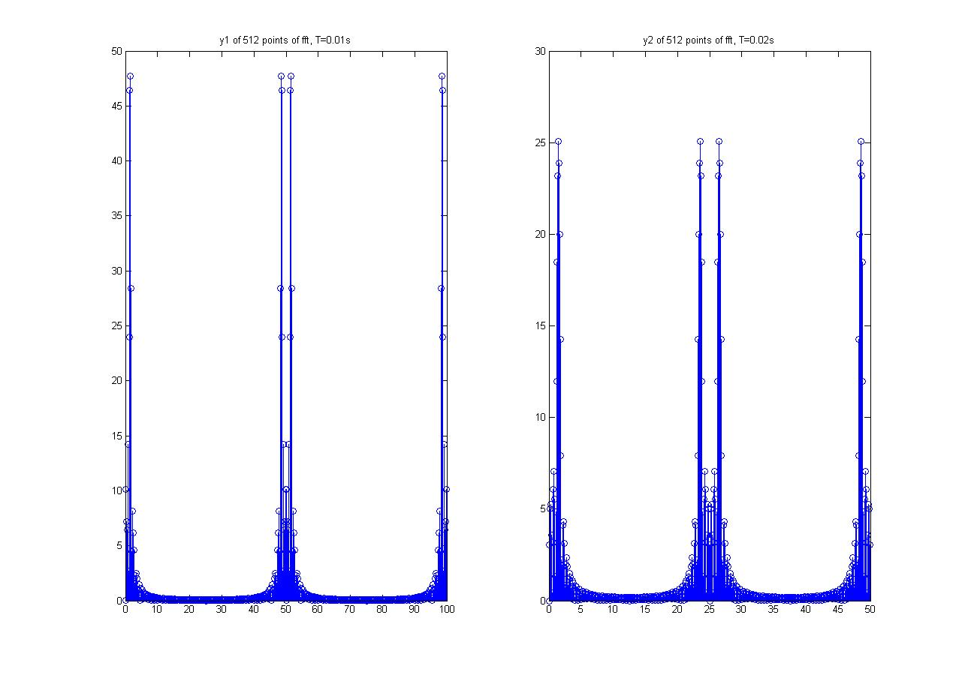
(2) (10%) Please use MATLAB commands: “downsample” and “upsample” to find w[n] and y[n]. Plot x[n], w[n] and y[n] in the same figure (use the subplot command). Plot the magnitude spectra of x[n], w[n] and y[n] in another figure.
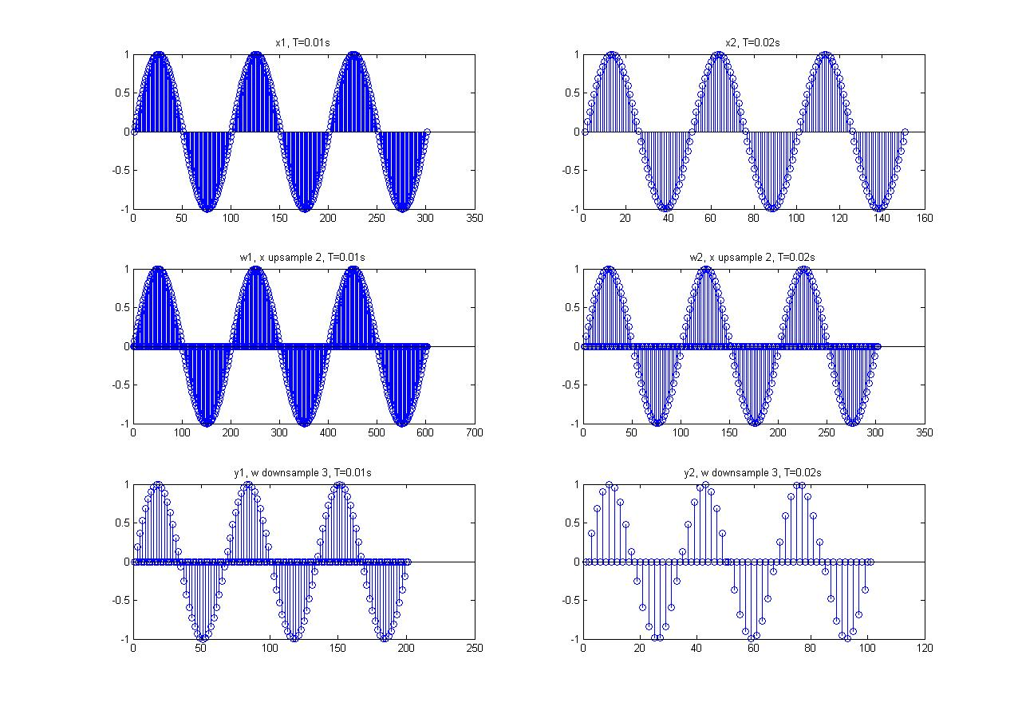
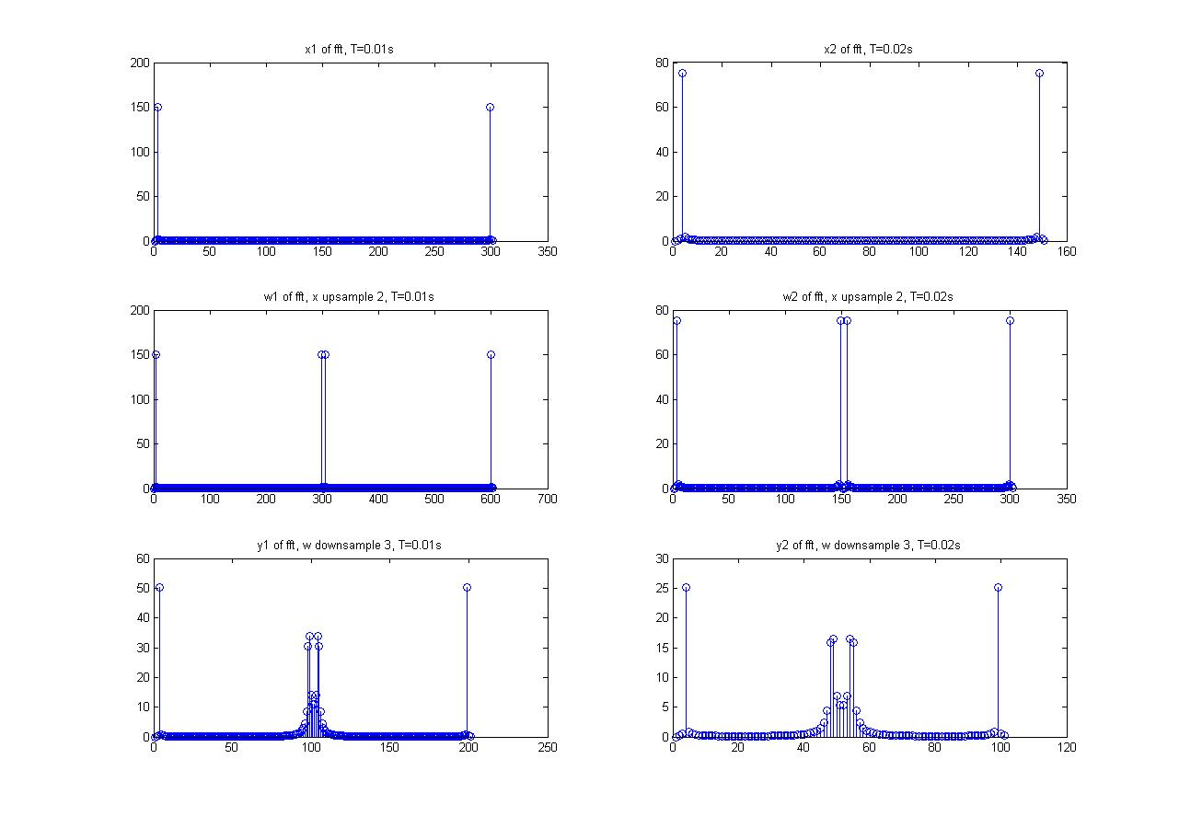
(3) (5%) Use another command “resample” to get y[n] directly by changing the sampling rate of x[n]. Plot the resampled time sequence and its magnitude spectrum.
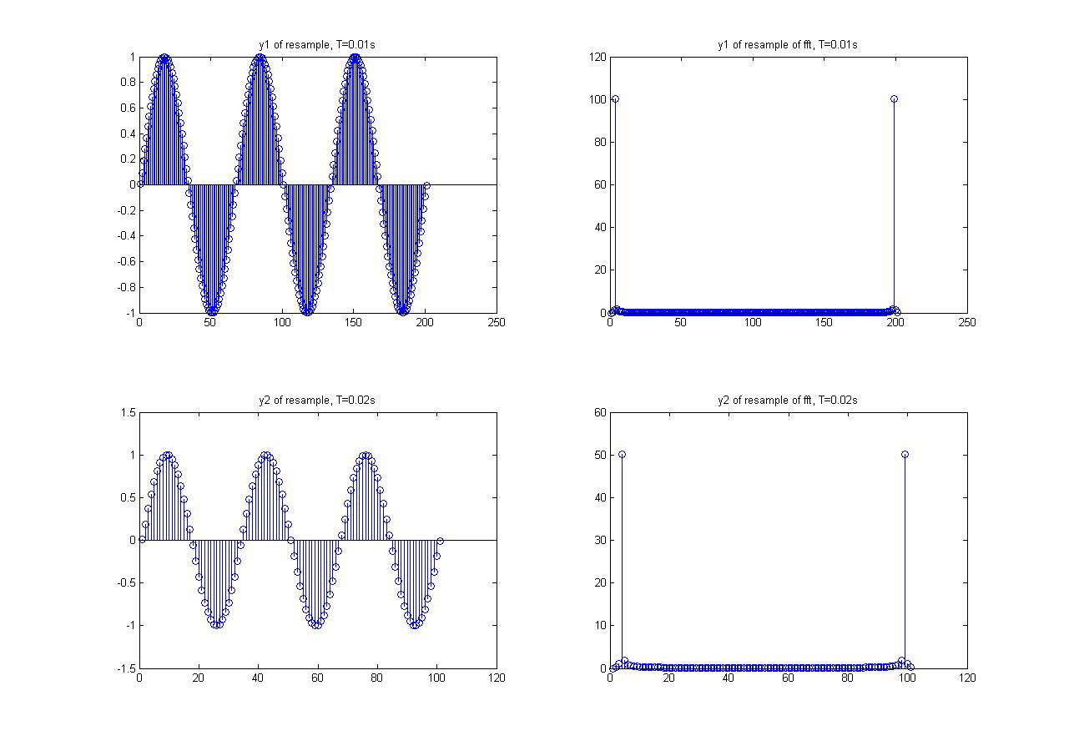
(4) (5%) Compare the results in (2) and (3). Are they the same or not? State your reasons.(Hint: the plot(abs(fft(.))) only shows the magnitude spectrum within [0, 2π])
不一樣，在(2)中的y先做upsample再做downsample，取樣的點以upsample插入點的0或是原本序列取樣點的值，而在(3)中的y則是以原取樣速率的2/3倍取樣，因此取樣點的值是以內插估計產生，所以兩種產生的序列不相同，觀念上來說，resample的function內含了LPF，所以有sample後較平滑的效應，可參考課本P177 Figure 4.28。
2. (15%) We can read music files into MATLAB by using command wavread or auread such as “[y, fs] = wavread('**.wav');”. It returns the sampled data y and the sample rate fs (in Hertz). Please get the music data from the wave file “Peter.wav” and upsample the data to 3 times of the sampling rate; downsample the data to 1/2 of the sampling rate.
(1) (10%) Plot and compare the magnitude spectra of the original (y), the upsampled data (y_up) and the downsampled date (y_down). The abscissa should be in Hz.
[y,fs]=wavread('peter.wav'); %按照wavread的指令將聲波檔中的y以及取樣率取出
y_up=upsample(y,3); %將y upsample 3 times
y_down=downsample(y,2); %將y downsample 2 times

%畫出原始y圖
subplot(3,1,1);plot(abs(fft(y)));title('originaly');xlabel('frequency(HZ)');ylabel('Magnitude');

%畫出 經過upsample 的y圖
subplot(3,1,2);plot(abs(fft(y_up)));title('upsample(y)');xlabel('frequency(HZ)');ylabel('Magnitude');

%畫出 經過 downsample 的 y圖
subplot(3,1,3);plot(abs(fft(y_down)));title('downsample(y)');xlabel('frequency(HZ)');ylabel('Magnitude');
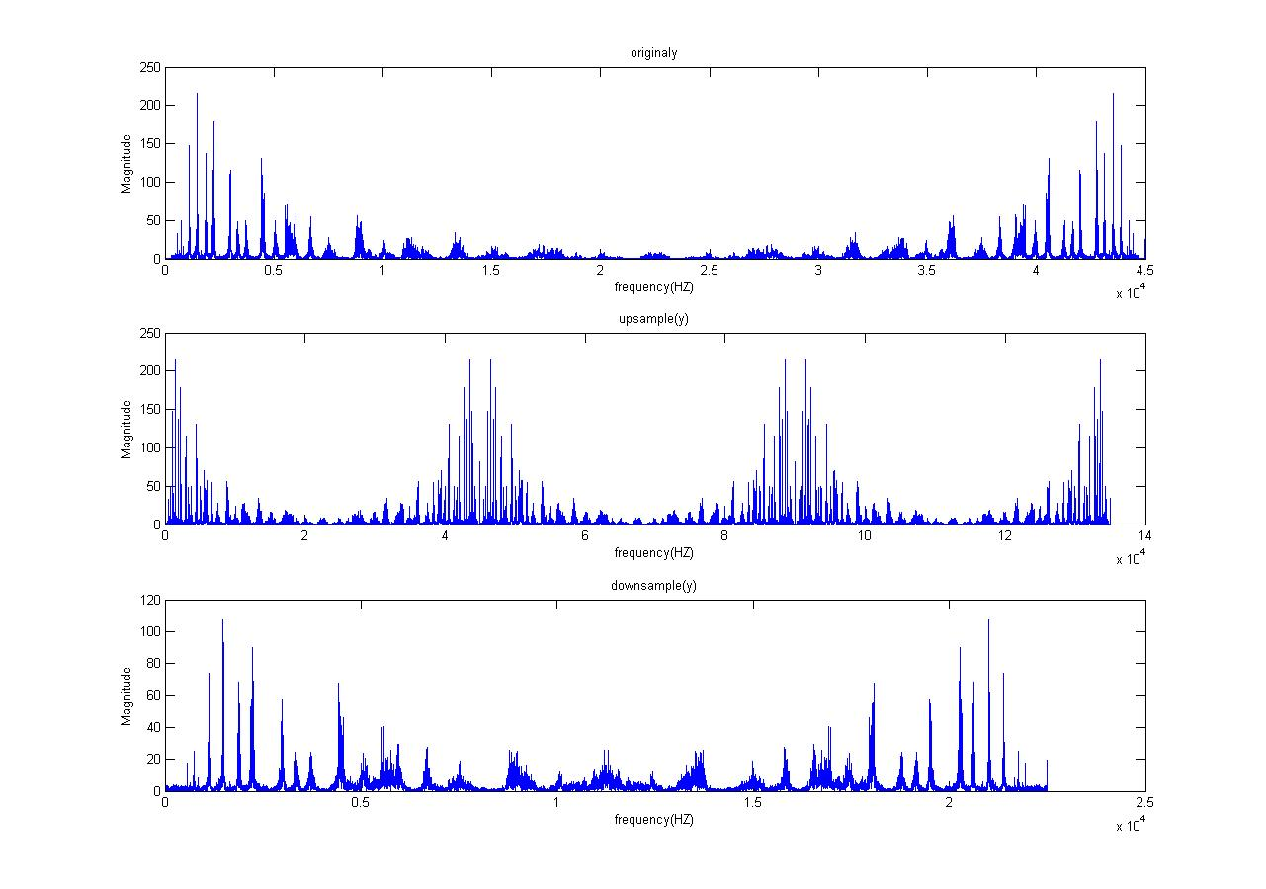
(2) (5%) Try the following commands to hear the modified music clips: soundsc(y, fs); soundsc(y_up, fs); soundsc(y_up, fs*3); soundsc(y_down, fs); soundsc(y_down, fs/2); soundsc(resample(y, 3, 1), fs*3). State what you’ve heard.
[The same reason as in Exercise 1-(4) makes the sound generated by soundsc(resample(y,3,1),fs*3) much nicer than the sound generated by soundsc(y_up, fs*3).]
%%%%%%%%%%%%%%%%%%%%%%%以下為soundsc指令
%%%%%%%%%%%%%%%%%%%%%%%必須附上你的comparison
soundsc(y,fs)
%原始音樂
soundsc(y_up,fs)
%upsample 3後，原time sequence 插入多餘的0點（time sequence 變為原來的三倍長）
%而fs（播放速度）一樣，所以撥放時間較長，且因為插入0點，所以聲音沒有原聲音精細
%（因插入多餘點，有雜音)，聽起來聲音較原來低的感覺

soundsc(y_up,fs*3)
%upsample 3後，原time sequence 插入多餘的0點（time sequence 變為原來的三倍長）
%而fs*3（播放速度）變為三倍，所以撥放時間長短與原聲音相同，
%但因為upsample插入多餘的0點（給予非必要的點），所以比起原音，聽起來有雜音的感覺

soundsc(y_down,fs)
%downsample 2後，原time sequence變短（資訊量被減少（compress）），
%而fs（播放速度）一樣，所以撥放時間較短，且因為刪除部份的點，
%聲音沒有原聲音精細（細節部分被刪去）聽起來聲音較原來高的感覺

soundsc(y_down,fs/2)
%downsample 2後，原time sequence 變短（資訊量被減少（compress））
%而fs/2（播放速度）放慢兩倍，所以撥放時間長短與原聲音相同，但因為downsample刪除部份的點
%所以聲音沒有原聲音精細，聽起來無法聽到原聲音的細節，聽起來有糊糊（聲音細節度不高）的感覺

soundsc(resample(y,3,1),fs*3)
%利用resample 做upsample 3後，time sequence變為原來的三倍長，
%且因為resample有內建filter，所以使加入點後的time sequence有做smoothing
%（新加入的點不是0點，而是內插所求得的點）而fs*3（播放速度）變為原來的三倍，
%因此撥放時間長短與原聲音相同，音樂細節部分被內插法所模擬，整體聽起來會接近原聲音，
%如果仔細聽小提琴部分，會發現小提琴的聲音更細緻。
[TEXTBOOK PROBLEMS]
3. (10%) 4.25 (a)(b)
Figure P4.25-1 shows the overall system for filtering a continuous-time signal using a discrete-time filter. The frequency response of the reconstruction filter H_{r}(jΩ) and the discrete-time filter H(e^{jω}) are shown in Figure P4.25-2.
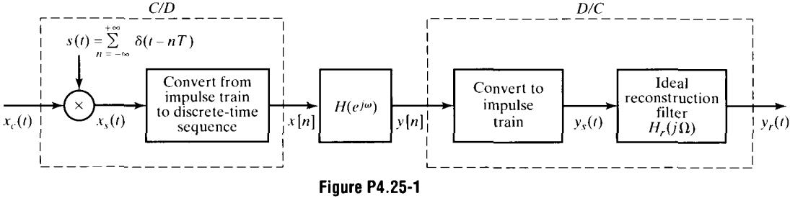
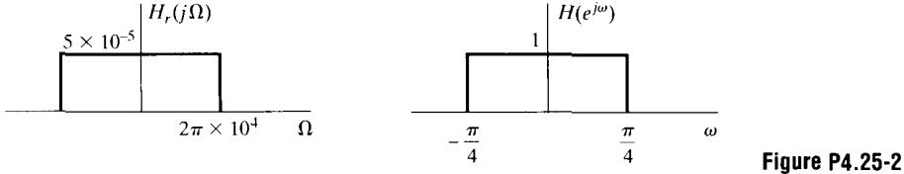
(a) For X_{c}(jΩ) as shown in Figure P4.25-3 and 1/T=20kHz, sketch X_{s}(jΩ) and X(e^{jω}).
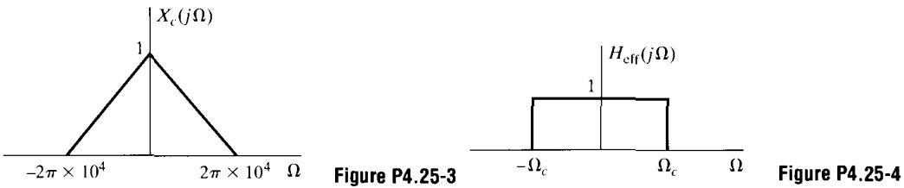
For a certain range of values of T, the overall system, with input x_{c}(t) and output y_{c}(t), is equivalent to a continuous-time lowpass filter with frequency response H_{eff}(jΩ) sketched in Figure P4.25-4.
，請參看P142-144

代入下式中
（由於sifting property）
Ω
2π/T
-2π/T
X_{s}(jΩ)
1/T
(b) Determine the range of values of T for which the information presented in (a) is true when X_{c}(jΩ) is bandlimited to as shown in Fig. 4.25-3.
ω
2π
-2π
X(e^{jω})
1/T
由於H_{d}(e^{jω})為一理想的低通濾波器其，我們不在乎在所發生的信號失真現象，我們需要：

同樣地，一旦所有的信號座落於，其濾波器便失效，也就是說，，故
4. (10%) 4.26 (a)
Consider the sequence x[n] whose Fourier transform X(e^{jω}) is shown in Figure P4.26-1. Define

and

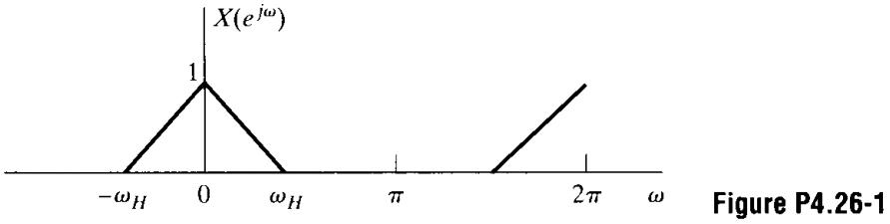
X_{s}(e^{jω})為X(e^{jω})移項後的總合

此外，X_{d}(e^{jω})為X_{s}(e^{jω})於頻率軸上M的延伸

(a) Sketch X_{s}(e^{jω}) and X_{d}(e^{jω}) for each of the following cases:
(i) M=3, ω_{H}=π/2
ω
2π/3
-π/2
X_{s}(e^{jω})
1/3
π/2
-2π/3
ω
2π
-π
X_{d}(e^{jω})
1/3
π
-2π
(ii) M=3, ω_{H}=π/4
5. (10%) 4.30
ω
2π/3
-2π/3
X_{s}(e^{jω})
1/3
π/4
-π/4
ω
2π
-2π
X_{d}(e^{jω})
1/3
π
-π
In the system of Figure 4.11, assume that the discrete-time system is linear and time invariant and that X_{c}(jΩ)=0 for . Determine the largest possible value for T and the corresponding frequency response H(e^{jω}) for the discrete-time system such that

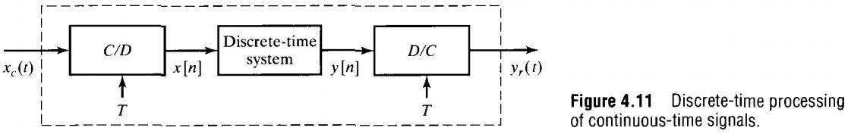
由於只有X_{c}(jΩ)的一半頻率帶是需要的，便可讓past Ω=2000π的部份失真，所以T=1/3000 s
現在T確定了，故

6. (10%) 4.38
Consider the system shown in Figure P4.38-1, where

Sketch Y_{c}(jΩ) if X_{c}(jΩ) is as shown in Figure P4.38-2.
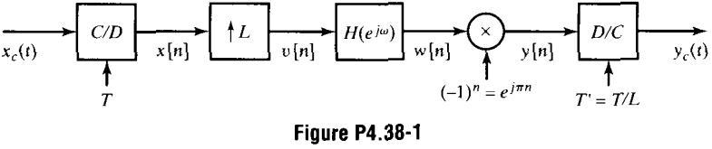

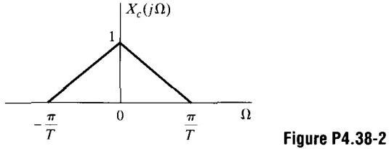
X_{c}(jΩ)如下圖
x_{c}(t)是經由取樣率為1/T所得，所以在x[n]下是沒有失真的
X_{c}(jΩ)
1/T
插入L-1個零點在取樣點間
ω
-π
X(e^{jω})
1/T
π
ω
-π/L
V(e^{jω})
1/LT
π/L
濾波器H(e^{jω})移除在π/L與π間的頻率成份
乘上(-1)^{n}將頻率帶的中心從0移位到π
ω
W(e^{jω})
1/LT
π/L
-π/L
ω
Y(e^{jω})
1/LT
π
-π
D/C轉換的map從-π到π轉移到-π/T到π/T

7. (10%) 4.40
Ω
Y_{c}(jΩ)
1/LT
πL/T
-πL/T
In the system of Figure P4.40-1,

and

How is y[n] related to the input is signal x_{c}(t)?
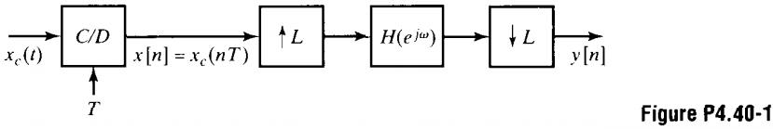
分解H(e^{jω})成為低通濾波器與一個延遲元件

C/D
↑L
↓L
H_{LP}(e^{jω})
e^{-jω}
x_{c}(t)
x[n]
w[n]
v[n]
y_{c}(t)
Ideal Upsampler with gain of 1 instead of L
於是，該系統的各個部份為
假設沒有失真
rate change
delay at higher rate

8. (10%) 4.46 (a)(b)
Consider the system in Figure P4.46-1 with H₀(z), H₁(z), and H₂(z) as the system functions of LTI systems. Assume that x[n] is an arbitrary stable complex signal without any symmetry properties.
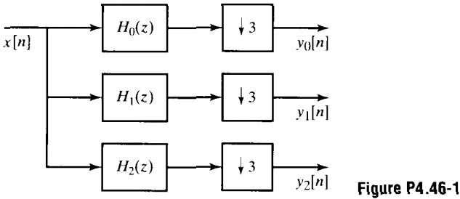
(a) Let H₀(z)=1, H₁(z)=z⁻¹, and H₂(z)=z⁻². Can you reconstruct x[n] from y₀[n], y₁[n], and y₂[n]? If so, how ? If not, justify your answer.

所以，

(b) Assume that H₀(e^{jω}), H₁(e^{jω}), and H₂(e^{jω}) are as follows:

Can you reconstruct x[n] from y₀[n], y₁[n], and y₂[n]? If so, how? If not, justify your answer.
是可以的，由於濾波器的頻寬為2π/3，所以在downsample時不會發生失真的現象，因此，在重建x[n]時，我們需要下圖的系統：
9. (10%) 4.53 (a)(b)
↑3
3H₀(z)
y₀[n]
↑3
3H₁(z)
y₁[n]
↑3
3H₂(z)
y₂[n]
+
x[n]
Consider the analysis-synthesis system shown in Figure P4.53-1. The lowpass filter h₀[n] is identical in the analyzer and synthesizer, and the highpass filter h₁[n] is identical in the analyzer and synthesizer. The Fourier transforms of h₀[n] and h₁[n] are related by
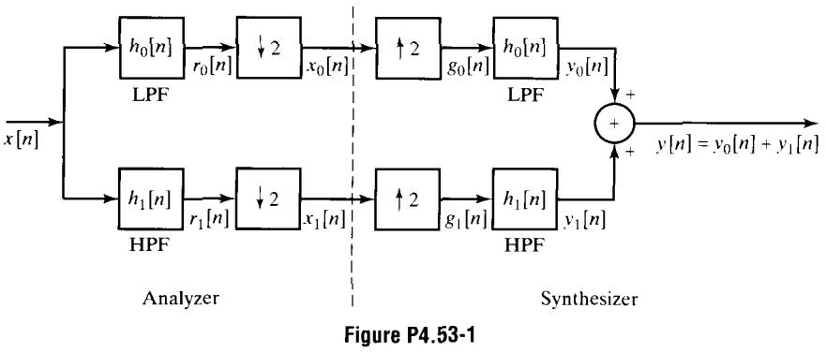
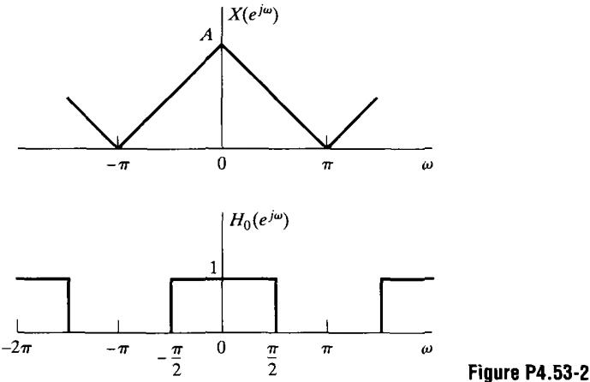
(a) If X(e^{jω}) and H₀(e^{jω}) are as shown in Figure P4.53-2, sketch (to within a scale factor) X₀(e^{jω}), G₀(e^{jω}), and Y₀(e^{jω}).
X(e^{jω})為
低通濾波器的截止頻率在π/2處
ω
-π
X(e^{jω})
π
downsample延伸拉長頻率軸，由於R₀(e^{jω})被限制在π/M，所以不會有失真發生
ω
-π/2
R₀(e^{jω})
π/2
upsample壓縮頻率軸其factor為2
ω
-π
X₀(e^{jω})
π
低通濾波器的截止頻率為π/2，其Y₀(e^{jω})=R₀(e^{jω})描繪如上
ω
-π
G₀(e^{jω})
π
(b) Write a general expression for G₀(e^{jω}) in terms of X(e^{jω}) and H₀(e^{jω}). Do not assume that X(e^{jω}) and H₀(e^{jω}) are as shown in Figure 4.53-2.

