MATLAB Exercise
1.
(1)
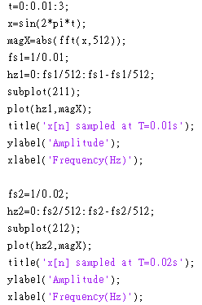
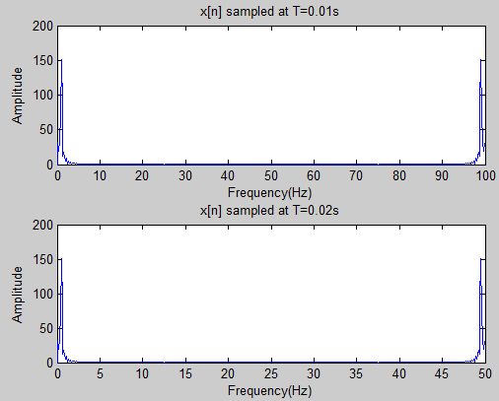

(2)
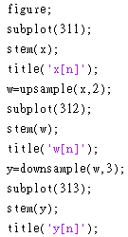
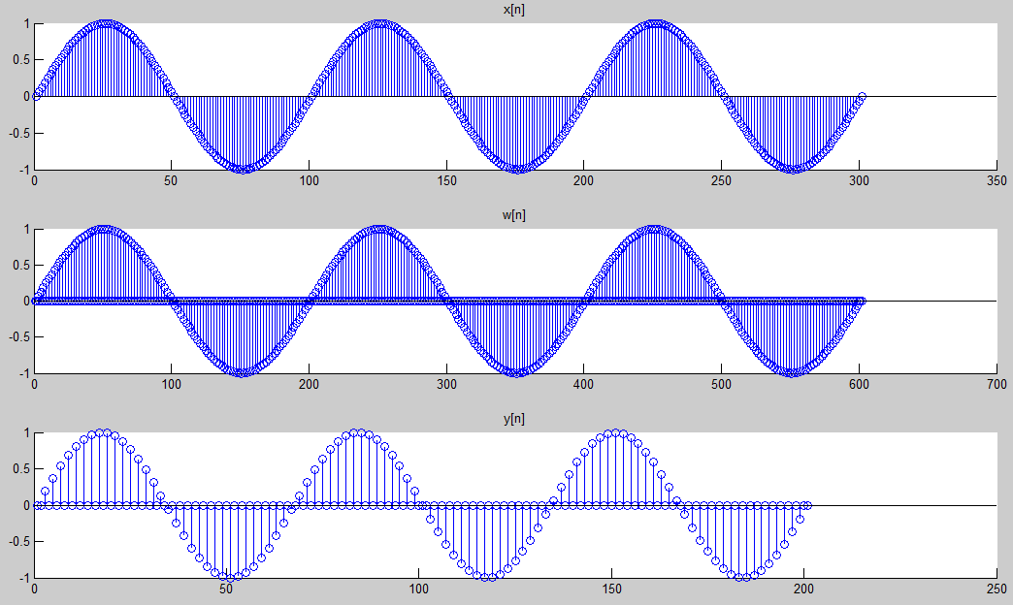
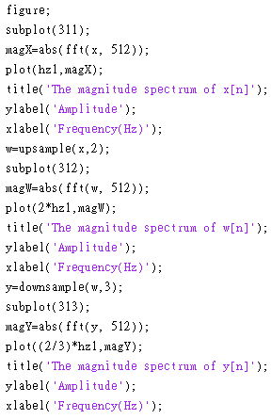
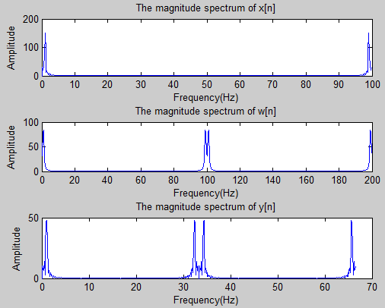
(3)
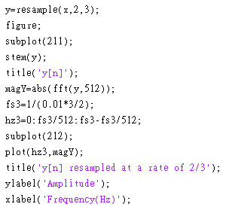
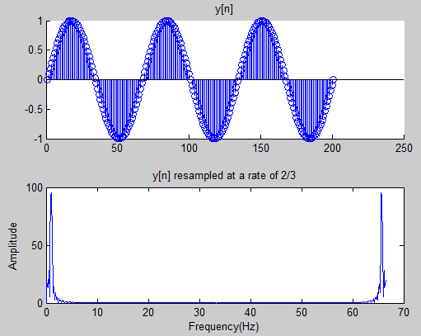

(4)
They are not the same. Because the command “resample” directly resamples the original sequence at a rate 2/3, however sequentially using the commands, “upsample” and “downsample” would introduce some unwanted “zeros”.
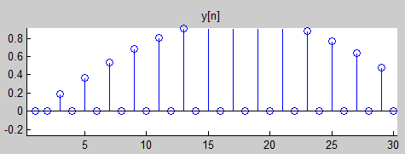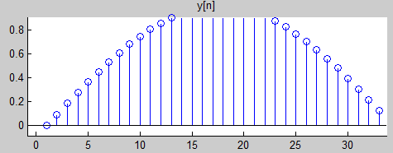
2.
(1)
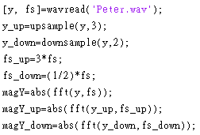
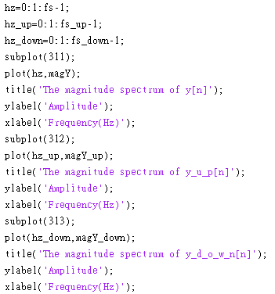
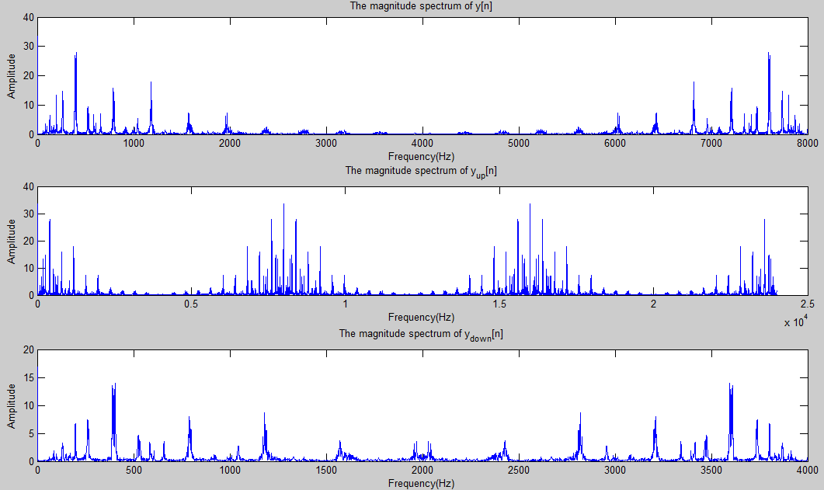
The upsampled version, y_up[n], contains much more high frequency components, which seem to be 8KHz-periodic. The downsampled version, y_down[n], looks like a compact version of y[n] in frequency domain.
(2)
soundsc(y_up, fs)➔sounds like a slow version of soundsc(y, fs)
soundsc(y_down, fs)➔sounds like a quick version of soundsc(y, fs)
soundsc(y_up, fs*3)➔the playing seed is right, but sounds a little bit bright=>low-frequency distortion.
soundsc(y_down, fs*(1/2))➔ the playing seed is right, but sounds a little bit dark=>high-frequency distortion.
soundsc(resample(y, 3, 1), fs*3)➔ sounds exactly the same of soundsc(y, fs), since the command “resample(y, 3, 1) “ prevents aliasing in frequency.


