國立交通大學電子工程研究所九十六級王盛弘9611842
DSP Spring 2009
HW #4 (100%) Due: 05/08
[MATLAB EXERCISE]
1. (25%) Consider the system function H(z) of a FIR system in textbook Problem 5.38 (pp. 325). Let H(z)=H_{min}(z)H_{ap}(z).

(1) (5%) The zero-pole plots of H(z), H_{min}(z) and H_{ap}(z). 參看P280與P335的5.64

首先，假設

把提到H_{min}(z)處，
得到
以及

H(z)的極點與零點分佈圖
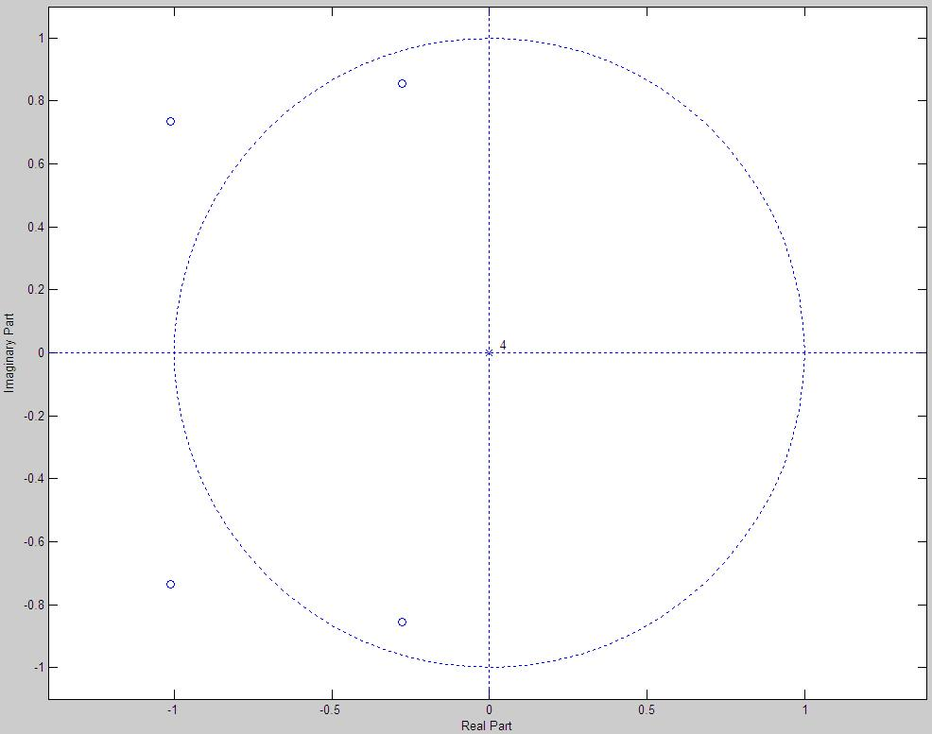
H_{min}(z)的極點與零點分佈圖
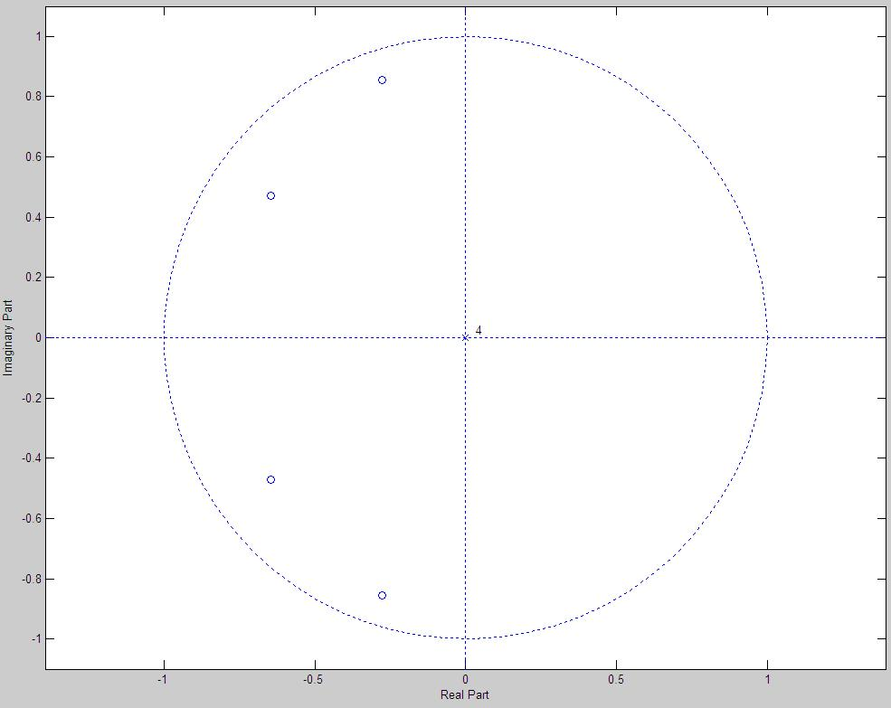
H_{ap}(z)的極點與零點分佈圖
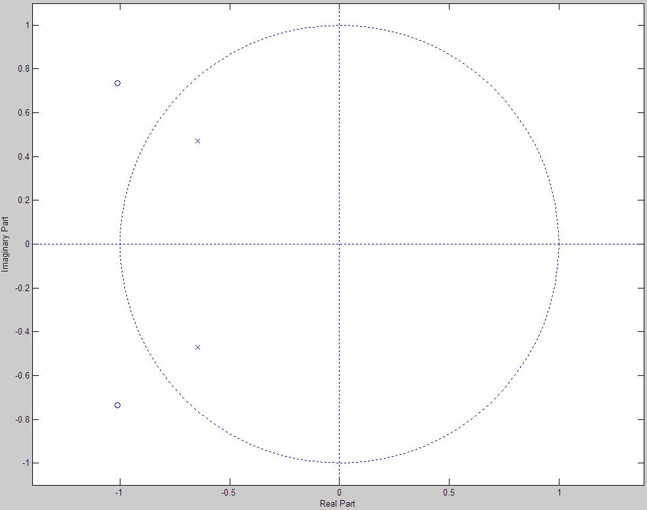
(2) (10%) Plot the magnitude response (in dB), phase response and group delay of the minimum phase system (0≦ω≦2π).
minimum phase system的magnitude response及phase response
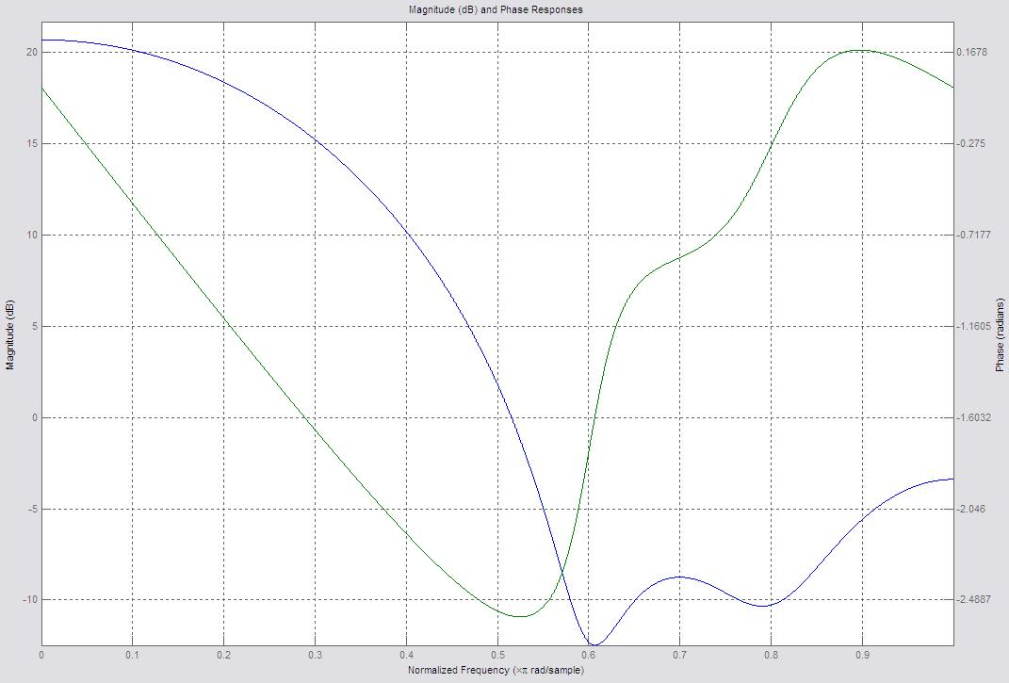

minimum phase system的group delay
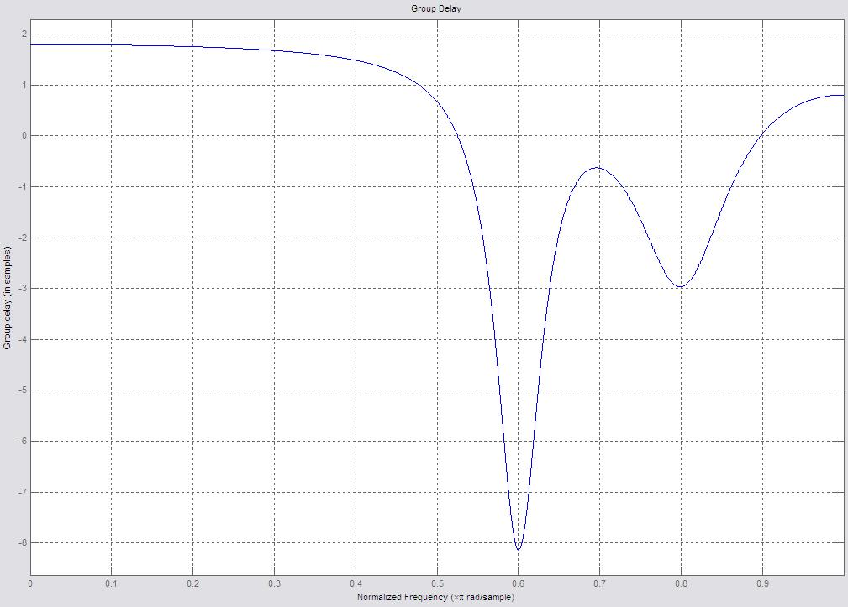
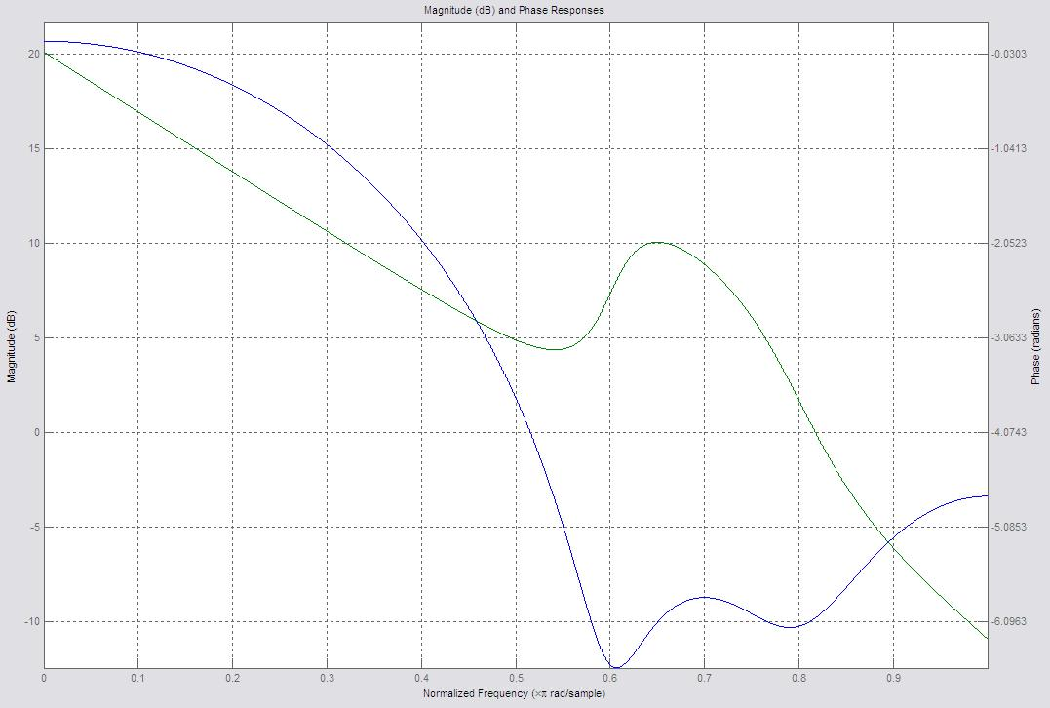
(3) (5%) Verify that H(z) and H_{min}(z) have the same magnitude response.
H(z)的magnitude response及phase response，其中藍線的部份和(2)的藍線一樣

(4) (5%) Plot the impulse responses of H(z) and H_{min}(z) and verify the minimum energy delay property.
H(z)的impulse response
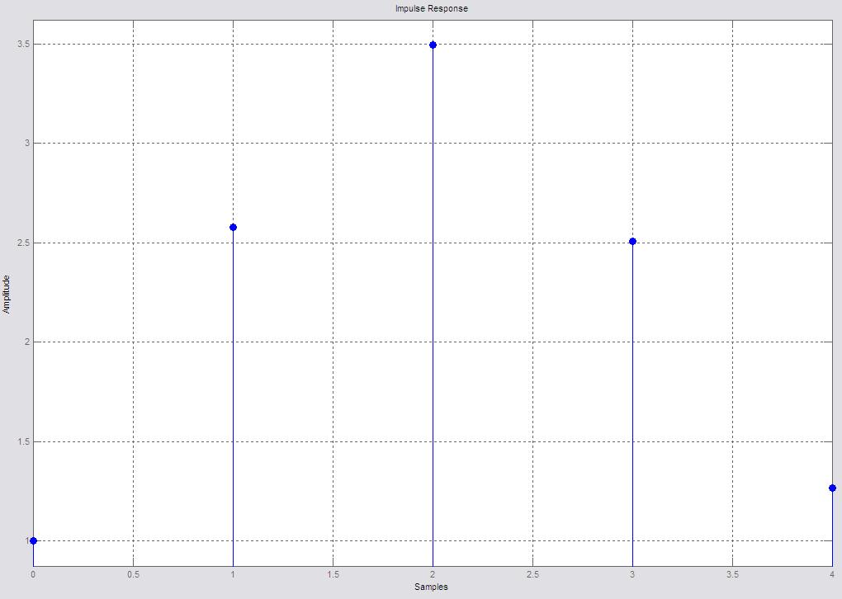
H_{min}(z)的impulse response
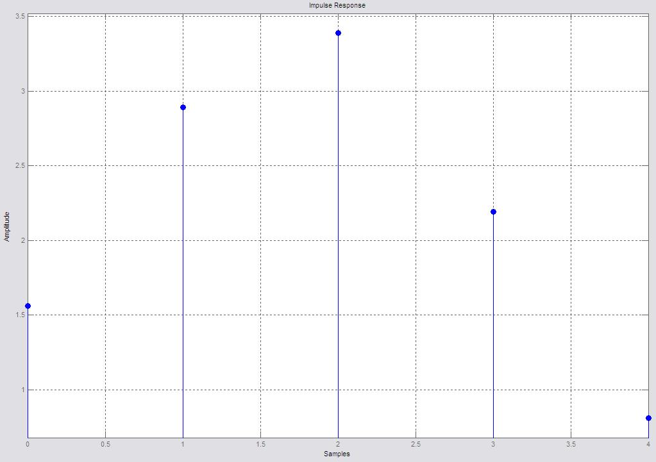

程式碼
h=[1, 2.57873, 3.4975, 2.5071, 1.266];
h_min=[1.5625 2.8916 3.3906 2.1945 0.8100];
h_ap_x=[0.64 1.2944 1];
h_ap_y=[1 1.2944 0.64];

%1-1
figure();
zplane(h);
%1-2
figure();
zplane(h_min);
%1-3
figure();
zplane(h_ap_x, h_ap_y);

%2
h_min_result=dfilt.df1(h_min);
freqz(h_min_result);
grpdelay(h_min_result);

%3
h_result=dfilt.df1(h);
freqz(h_result);

%4
impz(h_result);
impz(h_min_result);
[TEXTBOOK PROBLEMS]
2. (12%) 5.35
Consider a causal linear time-invariant system with system function H(z) and real impulse response. H(z) evaluated for z=e^{jω} is shown in Figure P5.35-1.
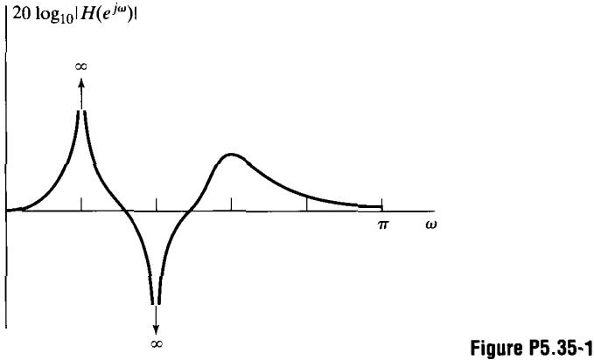
(a) Carefully sketch a pole-zero plot for H(z) showing all information about the pole and zero locations that can be inferred from the figure.
在圖5.35-1中，表示極點在e^{j(π/5)}，表示零點在e^{j(2π/5)}，共振發生在ω=3π/5處，表示極點在單位圓內。
由於impulse response是實數部，其極點和零點必須要成共軛對偶，使保持了2個零點在零的位置上（極點的總數要和零點的總數相同）。
(b) What can be said about the length of the impulse response?
Re
Im
由於H(z)有極點，所以，其h[n]為IIR。
(c) Specify whether ≮H(e^{jω}) is linear.
由於h[n]為causal及IIR，它不是對稱的，並且沒有linear phase。
(d) Specify whether the system is stable.
由於有一個極點在|z|=1處，表示其ROC不包含單位圓，故該系統是不穩定的
3. ( 8%) 5.37
Consider a causal sequence x[n] with the z-transform

For what values of α is α^{n}x[n] a real, minimum-phase sequence?

而
該minimum phase sequence在單位圓內有其所有的極點及零點，
，，，
因此，α^{n}x[n]是real and minimum phase iff α is real and
4. (10%) 5.45
A causal linear time-invariant discrete-time system has system function

(a) Find expressions for a minimum-phase system H₁(z) and an all-pass system H_{ap}(z) such that

(b) Find expressions for a different minimum-phase system H₂(z) and a generalized linear-phase FIR system H_{lin}(z) such that

所謂generalized linear phase system為其零點及極點在z=1, -1, 0 or ∞或是在共軛倒數處

5. (15%) 5.53
In this problem, you will consider three different LTI systems. All three are causal and have real impulse responses. You will be given additional information about each system. Using this information, state as much as possible about the poles and zeros of each system function and about the length of the impulse response of the system.
(a) H₁(z) has a pole at z=0.9e^{jπ/3}, and when x[n]=u[n],
1．若h₁[n]為實數部，並且有複數共軛極點在
2．若是x[n]=u[n]

上式為Y(z)的部份分式，而其極點為z=1，由於y[n]最終將decay至零的該項必定被零點所消掉，故，該filter必定有一個零點在z=1處
3．The length of the impulse response is infinite
(b) H₂(z) has a zero at z=0.8e^{jπ/4}, and H₂(e^{jω}) has linear phase with ≮H₂(e^{jω})=-2.5ω,
1．linear phase與real impulse response表示的是該系統的零點發生在共軛倒數位置，其零點在z=z₁, 1/z₁, z₁*, 1/z₁*, 而z₁=0.8e^{jπ/4}。
2．由於h₂[n]同時是causal及linear phase，故其必為Type I，II， III，或是IV FIR filter，所以該filter的極點只會發生在z=0處。
3．由於{H₂(e^{jω})}=-2.5ω，所以該filter的可能性便只會是Type II或是Type IV filter，同時這也可以得知該impulse response的長度為6，並且有5個零點。由於極點的數目會和零點的數目相同，所以同樣也有5個極點在z=0處。
4．由於，所以必定有一個零點在z=1的位置，所以，此時可確定該filter為Type IV filter。

(c) H₃(z) has a pole at z=0.8e^{jπ/4}, and for all ω.
由於H₃(z)是all pass，所以知道其極點與零點發生在共軛倒數的位置，該impulse response的長度是無限的，其通式為：

6. (15%) 5.58
The signal y[n] is the output of a linear time-invariant system with input x[n], which is zero-mean white noise. The system is described bye the difference equation.

(a) What is the z-transform of the autocorrelation function ?
Sometimes it is of interest to process y[n] with a linear filter such that the power spectrum of the linear filter's output will be flat when the input to the linear filter is y[n]. This procedure is known as “whitening filter” for the signal y[n]. Suppose that we know the autocorrelation function and its z-transform , but not the a_{k}'s and the b_{k}'s.

所以
或者

(b) Discuss a procedure for finding a system function H_{w}(z) of the whitening filter.
為了要whiten y[n]，我們需要：

其h_{w}(z)的極點為H(z)的零點，其H_{w}(z)的零點為H(z)的極點，we must now decide which N of the 2N zeros of H_{w}(z)H_{w}(z⁻¹) to associate with H_{w}(z)。剩餘的N個零點和M個極點為倒數並且associated with H_{w}(z⁻¹)。為了讓H_{w}(z)穩定，必須選擇讓所有的極點在單位圓中，因此，，必須選擇在單位圓中
(c) Is the whitening filter unique?
由於H_{w}(z)的零點沒有real constraint，所以可以擇擇或，故並非unique。
7. (15%) 5.64
It is not possible to obtain a causal and stable inverse system (a perfect compensator) for a non minimum-phase system. In this problem, we study an approach to compensating for only the magnitude of the frequency response of a non minimum-phase system.
Suppose that a stable non minimum-phase linear time-invariant discrete-time system with a rationial system function H(z) is cascaded with a compensating system H_{c}(z) as shown in Figure P5.64-1.
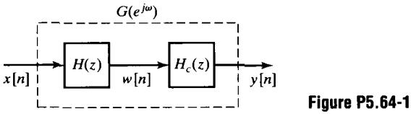
(a) How should H_{c}(z) be chosen so that it is stable and causal and so that the magnitude of the overall effective frequency response is unity? (Recall that H(z) can always be represented as H(z)=H_{ap}(z)H_{min}(z))
我們希望，H_{c}(z)為穩定且因果，而H(z)非minimum phase，所以

由於，我們希望

這意味著其式

當所有H_{min}(z)的零點變成H_{c}(z)的極點都在單位圓內時便會穩定且因果。
(b) What are the corresponding system functions H_{c}(z) and G(z)?
由於，所以
(c) Assume that

Find H_{min}(z), H_{ap}(z), H_{c}(z), and G(z) for this case, and construct the pole-zero plots for each system function.

