國立交通大學電子工程研究所九十六級王盛弘9611842
DSP Spring 2009
HW #5 (140%) Due: 05/26
[TEXTBOOK PROBLEMS]
1. (30%) 6.23
Consider a causal linear time-invariant system whose system function is

(a) Draw the signal flow graphs for implementations of the system in each of the following forms:
(i) Direct form I

(ii) Direct form II
x[n]
z⁻¹
-1/5
1/4
-5/24
-1/12
z⁻¹
z⁻¹
z⁻¹
y[n]
1
1

x[n]
-1/5
1/4
-5/24
-1/12
z⁻¹
z⁻¹
z⁻¹
y[n]
1
1

(iii) Cascade form using first- and second-order direct form II sections

(iv) Parallel form using first-and second-order direct form II sections
x[n]
z⁻¹
-1/4
1/2
-1/3
z⁻¹
z⁻¹
y[n]
-1/5

x[n]
z⁻¹
-1/4
1/2
z⁻¹
y[n]
27/125
z⁻¹
-1/3
-36/125
98/125
(v) Transposed direct form II
把(ii)中的direct form II做reverse其箭頭，並且互換其輸入與輸出位置，並且重劃該流程圖
Direct form II Reverse direct form II
Transposed direct form II
x[n]
-1/5
1/4
-5/24
-1/12
z⁻¹
z⁻¹
z⁻¹
y[n]
1
1
x[n]
-1/5
1/4
-5/24
-1/12
z⁻¹
z⁻¹
z⁻¹
y[n]
1
1
(b) Write the difference equations for the flow graph of (v) in Part (a), and show that this system has the correct system function.
x[n]
-1/5
1/4
-5/24
-1/12
z⁻¹
z⁻¹
z⁻¹
y[n]
1
1
w₁[n]
w₂[n]
w₃[n]
其變數w₁[n]、w₂[n]、w₃[n]及w₄[n]標示如(a)中的(v)圖

把上式整理後得到

取其逆轉換，並得到其轉移函數，其和題目的原式是相等的。

2. (10%) 6.28
The flow graph shown in Figure P6.28-1 is non computable; i.e., it is not possible to compute the output using the difference equations represented by the flow graph because it contains a closed loop having no delay elements.
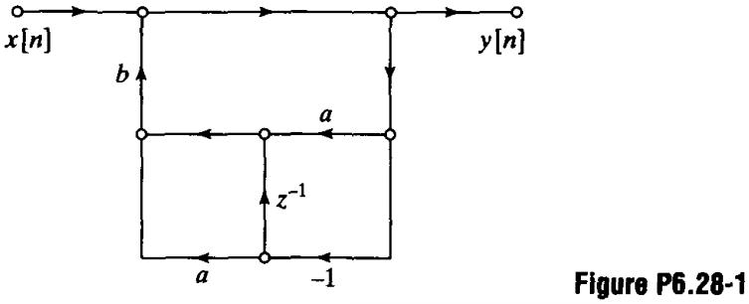
(a) Write the difference equations for the system of Figure P6.28-1, and from them, find the system function of the network.
w[n]
令w[n]為圖上的位置，

所以，得到

(b) From the system function, obtain a flow graph that is computable.
3. (30%) 6.33
x[n]
-b
y[n]
z⁻¹
Consider an all-pass system with system function

A flow graph for an implementation of this system is shown in Figure P6.33-1.
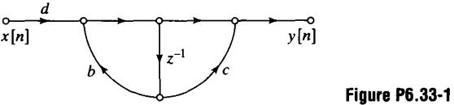
(a) Determine the coefficients b, c, and d such that the flow graph in Figure P6.33-1 is a realization of H(z).
x[n]
z⁻¹
b
y[n]
c
d
x[n]
z⁻¹
b
z⁻¹
y[n]
c
d
得到b=0.54，d=-0.54，c=-1.852
(b) In a practical implementation of the network in Figure P6.33-1, the coefficients b, c, and d might be quantized by rounding the exact value to the nearest tenth (e.g., 0.54 will be rounded to 0.5 and 1.8518... will be rounded to 1.9). Would the resulting system still be an all-pass system?
The difference equation relating the input and output of the all-pass system with system function H(z) can be expressed as

其量化的係數中，，故該系統不會是all-pass system
(c) Draw the flow graph of a network that implements this difference equation using two delay elements, but that requires only one multiplication by a constant other than ±1.
(d) With quantized coefficients, would the network of part (c) be an all-pass system?
x[n]
z⁻¹
-1
y[n]
0.54
z⁻¹
The primary disadvantage of the implementation in part (c) compared with the implementation in part (a) is that it requires two delay elements. However, for higher order systems, it is necessary to implement a cascade of all-pass systems. For N all-pass sections in cascade, it is possible to use all-pass sections in the form determined in Part (c) while requiring only (N+1) delay elements. This is accomplished by sharing a delay element between sections.
是的，只要有一個0.54是做量化。
(e) Consider the all-pass system with system function

Draw the flow graph of a “cascade” realization composed of two sections of the form obtained in Part (c) with one delay element shared between the sections. The resulting network should have only three delay elements.

cascade兩個部份即產生下圖
w[n]
z⁻¹
-1
a
z⁻¹
z⁻¹
-1
b
z⁻¹
w[n-1]
x[n]
y[n]
在second section的第一個delay有一個輸出w[n-1]，所以我們可以結合在first section的第二個delay
(f) With quantized coefficients a and b, would the network in Part (e) be an all-pass system?
z⁻¹
-1
a
z⁻¹
-1
b
z⁻¹
x[n]
y[n]
對，只要有一個0.54是做量化。
4. (15%) 6.35
Consider an all-pass system whose system function is

(a) Draw the direct form I signal flow graph for the system. How many delays and multipliers do you need? (Do not count multiplying by )
Direct form I:
由上圖可知，需要兩個延遲及兩個乘法器。
-1/3
z⁻¹
1/3
z⁻¹
x[n]
y[n]
(b) Draw a signal flow graph for the system that uses one multiplier. Minimize the number of delays.

取逆轉換

其可改用下圖實現
(c) Now consider another all-pass system whose system function is
z⁻¹
1/3
z⁻¹
x[n]
y[n]
-1

Find and draw a signal flow graph for the system with two multipliers and three delays.

This can be implemented as the cascade of the flow graph in part (b) with the following flow graph:
該流程圖可以改畫為：
z⁻¹
2
z⁻¹
x[n]
y[n]
-1
-1
2
z⁻¹
x[n]
y[n]
z⁻¹
Now cascading the above flow graph with the one from part (b) and grouping the delay element. 我們可以得到由兩個乘法器以及三個延遲器的下圖
5. (10%) 6.42 (a), (c)
z⁻¹
-1
1/3
z⁻¹
-1
2
z⁻¹
x[n]
y[n]
The networks in Figure P6.42-1 all have the same system function. Assume that the systems in the figure are implemented using (B+1)-bit fixed-point arithmetic in all the computations. Assume also that all products are rounded to (B+1) bits before additions are performed.
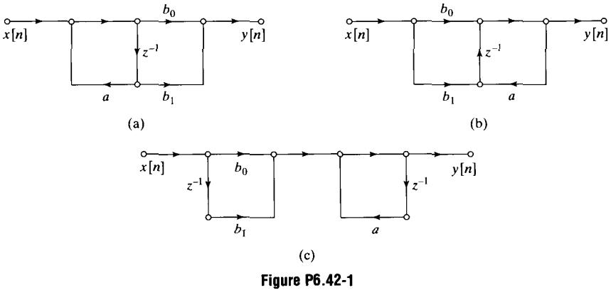
(a) Draw linear-noise models for each of the systems in Figure P6.42-1.
(c) Determine the output noise power for each of the networks in Figure P6.42-1. Express your answer in terms of , the power of a single source of round-off noise.
a
z⁻¹
x[n]
y[n]
b₀
b₁
σ²
2σ²
a
z⁻¹
x[n]
y[n]
b₀
b₁
σ²
2σ²
b₀
z⁻¹
a
z⁻¹
x[n]
y[n]
b₁
(3σ²)
(a)
(b)
(c)
For network (c),

or using the frequency domain formula,

For network (a),

For network (b), 則和network (c)相同。
Time domain calculation:

Frequency domain calculation:

residue (z=0)=
residue (z=a)=

6. (25%) 6.45
When implemented with infinite-precision arithmetic, the flow graphs in Figure P6.45-1 have the same system function.
w₁[n]
w₂[n]
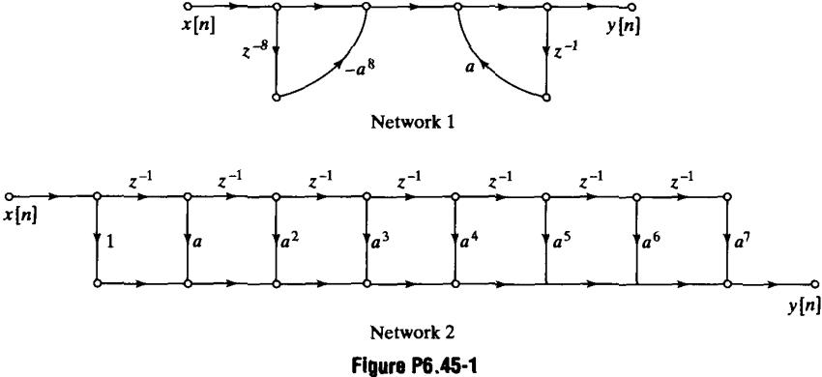
(a) Show that the two systems have the same overall system function from input x[n] to output y[n].
如同Network 1所標示的w₁[n]以及w₂[n]

將上式合併，並取其z轉換

而Network 2，則是

取其z轉換

(b) Assume that the preceding systems are implemented with two's complement fixed-point arithmetic and that products are rounded before additions are performed. Draw signal flow graphs that insert round-off noise sources at appropriate locations in the signal flow graphs of Figure P6.45-1.
round-off error source發生在乘法運算處，overflow發生在加法運算處。
Network 1:
Network 2:
w₁[n]
z⁻⁸
a
z⁻¹
x[n]
y[n]
-a⁸
w₂[n]
e₁
e₂
(c) Circle the nodes in your figure from Part (b) where over flow can occur.
a¹
x[n]
y[n]
1
z⁻¹
e₁
a²
z⁻¹
e₂
a³
z⁻¹
e₃
a⁵
z⁻¹
e₅
a⁴
z⁻¹
e₄
a⁶
z⁻¹
e₆
a⁷
z⁻¹
e₇
其node標示在(b)的紅圈圈
(d) Determine the maximum size of the input samples such that overflow cannot occur in either of the two systems.
在系統為了避免溢位的現象發生，在network中的每一個node其magnitude必須小於1，也就是說，如果w_{k}[n]代表了第k個node的變數，而h_{k}[n]代表著impulse response從輸入x[n]到node變數w_{k}[n]，針對|w_{k}[n]|<1滿足的條件為

在該問題中，必須要保證在每一個node上不會發生溢位的情形，也就是說，在x_{max}的邊界值，我們需要較嚴謹的限制，針對network 1，從w₂到y[n]的impulse response是a^{n}u[n]，因此要避免溢位的條件為

假設其|a|<1，從x[n]到w₁[n]的transfer function為，因此在此node要避免溢位的條件則為：

因此，要在network 1避免溢位，我們則需要

目前，對network 2來說，從輸入到輸出的transfer function為，因此，為了要避免溢位，需要滿足下式

(e) Assume that |a|<1. Find the total noise power at the output of each system, and determine the maximum value of |a| such that Network 1 has lower output noise power than Network 2.
對network 1來說，total noise power為，對network 2來說，total noise power為，要讓network 1的noise power小於network 2，則需要滿足

整理一下式子，

所以，要讓network 1的noise power小於network 2的|a|之最大值為。
7. (10%) 7.23
A continuous-time filter with impulse response h_{c}(t) and frequency-response magnitude

is to be used as the prototype for the design of a discrete-time filter. The resulting discrete-time system is to be used in the configuration of Figure P7.23-1 to filter the continuous-time signal x_{c}(t).
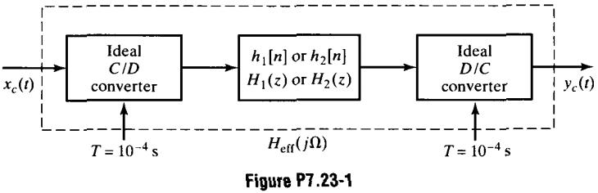
(a) A discrete-time system with impulse response h₁[n] and system function H₁(z) is obtained from the prototype continuous-time system by impulse invariance with T_{d}=0.01; i.e., h₁[n]=0.01h_{c}(0.01n). Plot the magnitude of the overall effective frequency response H_{eff}(jΩ)=Y_{c}(jΩ)/X_{c}(jΩ) when this discrete-time system is used in Figure P7.26-1.
從的圖形開始
By impulse invariance we scale the frequency axis by T_{d} to get
10π
10π
-10π
0
|H_{c}(jΩ)|
Ω

10π
0.1π
-0.1π
0
|H₁(e^{jω})|
ω
π
-π
接著，為了得到整體系統的響應，由T來scale frequency axis並且根據方程式來band limit the result。

(b) Alternatively, suppose that a discrete-time system with impulse response h₂[n] and system function H₂(z) is obtained from the prototype continuous-time system by the bilinear transformation with T_{d}=2; i.e.,
10π
1000π
-1000π
0
|H_{eff1}(jΩ)|
Ω

Plot the magnitude of the overall effective frequency response H_{eff}(jΩ) when this discrete-time system is used in Figure P7.23-1.
使用bilinear transform的frequency mapping relationships

我們可以得到

接著，為了得到整體系統的響應，由T來scale frequency axis並且根據方程式來band limit the result。
10π
π
-π
0
|H₂(e^{jω})|
ω
0.98π

10π
9800π
-9800π
0
|H_{eff2}(jΩ)|
Ω

8. (20%) 7.25
Impulse invariance and the bilinear transformation are two methods for designing discrete-time filters. Both methods transform a continuous-time system function H_{c}(s) into a discrete-time system function H(z). Answer the following questions by indicating which methods(s) will yield the desired result:
(a) A minimum-phase continuous-time system has all its poles and zeros in the left-half s plane. If a minimum-phase continuous-time system is transformed into a discrete-time system, which methods(s) will result in a minimum-phase discrete-time system?
答案：只有bilinear transform設計才能保證從minimum phase continuous-time filter能轉換成minimum phase discrete-time filter，記住discrete-time minimum phase system其極點與其零點都在單位圓內
Impulse Invariance：而impulse Invariance則對應s左半平面到z單位圓內，然而，在s左平面的零點則不需要對應到z單位圓內。

如果定義，則poly_{k}(z)的所有roots都在單位圓內，而H(z)的分子為A_{k}Poly_{k}(z)的總合，然而，這並不保證多項式中分子項的root會在單位圓之內，也就是說，minimum phase filter的總合不需要是minimum phase，若考慮以下的例子。

令T=1，其minimum phase filter被轉換成non-minimum phase discrete time filter。
Bilinear Transform：The bilinear transform maps to a pole or zero at s=s₀ to a pole or zero,，所以

由於H_{c}(s)是minimum phase，則H_{c}(s)的所有極點會在s左半平面內，所以，極點必須滿足利用s₀的關係式，得到

所以，所有的極點和零點都會在z單位圓內，而discrete-time filter便會是minimum phase
(b) If the continuous-time system is an all-pass system, its poles will be at locations s_{k} in the left-half s-plane, Which design methods(s) will result in an all-pass discrete-time system?
答案：Only the bilinear transform design will result in an all pass filter.
Impulse Invariance：若是impulse invariance design，則是

其aliasing的項會毀掉continuous-time filter的all pass特性
Bilinear Transform：其bilinear transform只能warp其頻率軸，所以magnitude response不被影響，故all pass filer將可map成all pass filter。
(c) Which design method(s) will guarantee that
?
只有bilinear transform能夠保證
Impulse Invariance：由於Impulse Invariance可能會產生失真現象，會發生下式的狀況

若且唯若

或是

which is generally note the case.
Bilinear Transform：在Bilinear transform時，Ω=0時對應著ω=0

for all H_{c}(s)
(d) If the continuous-time system is a bandstop filter, which method(s) will result in a discrete-time bandstop filter?
只有bilinear transform設計能夠保證從bandstop filter到bandstop filter
如果H_{c}(s)為bandstop filter，bilinear transform會保留其bandstop的特性，因為bilinear transform只會warp其頻率軸，而impulse invariance則會使失真發生在stop band
(e) Suppose the H₁(z), H₂(z) and H(z) are transformed versions of H_{c1}(s), H_{c2}(s), and H_{c}(s), respectively. Which design method(s) will guarantee that H(z)=H₁(z)H₂(z) whenever H_{c}(s)=H_{c1}(s)H_{c2}(s)?
該特性在bilinear transform下會保留住，但在impulse invariance下則無法保留
Impulse Invariance：Impulse Invariance可能會發生失真，Since the order aliasing and multiplication沒有互換性，故想要的特性便無法保留，如的例子
Bilinear Transform：藉由bilinear transform

(f) Suppose the H₁(z), H₂(z) and H(z) are transformed versions of H_{c1}(s), H_{c2}(s), and H_{c}(s), respectively. Which design method(s) will guarantee that H(z)=H₁(z)+H₂(z) whenever H_{c}(s)=H_{c1}(s)+H_{c2}(s)?
bilinear transform和impulse invariance都可以保留該特性
Impulse Invariance：

Bilinear Transform：

(g) Assume that two continuous-time system functions satisfy the condition

If H₁(z) and H₂(z) are transformed versions of H_{c1}(s) and H_{c2}(s), respectively, which design method(s) will result in discrete-time systems such that

(Such system are called “90-degree phase splitters.”)
只有Bilinear Transform會符合
Impulse Invariance：

可以觀察到其aliasing的現象，其phase relationship無法被保證
Bilinear Transform：

因此，

