國立交通大學電子工程研究所九十六級王盛弘9611842
DSP Spring 2009
HW #6 (120%) Due: 06/12
[MATLAB EXERCISE]
1. (15%) [Textbook] 8.29
(1) (10%) Use the IDFT/IFFT of the multiplication of the DFT/FFT of the two sequences to calculate the circular convolution.
Figure P8.29-1 shows two finite-length sequences. Sketch their N-point circular convolution for N=6 and for N=10.
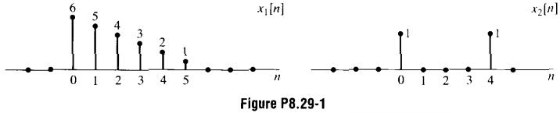
circular convolution with N=6
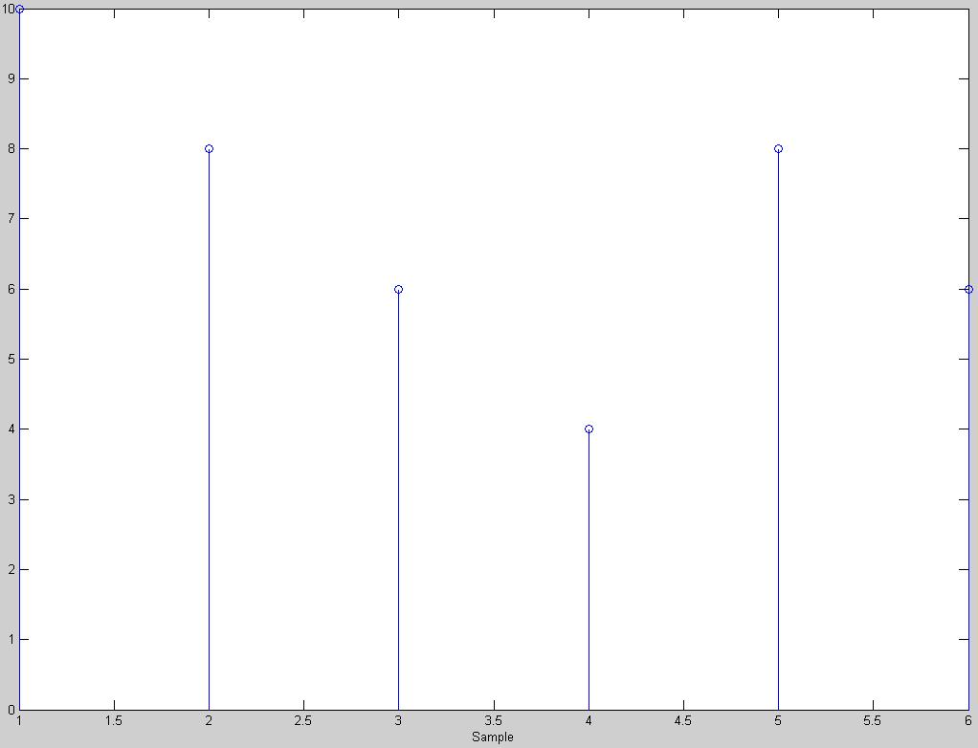
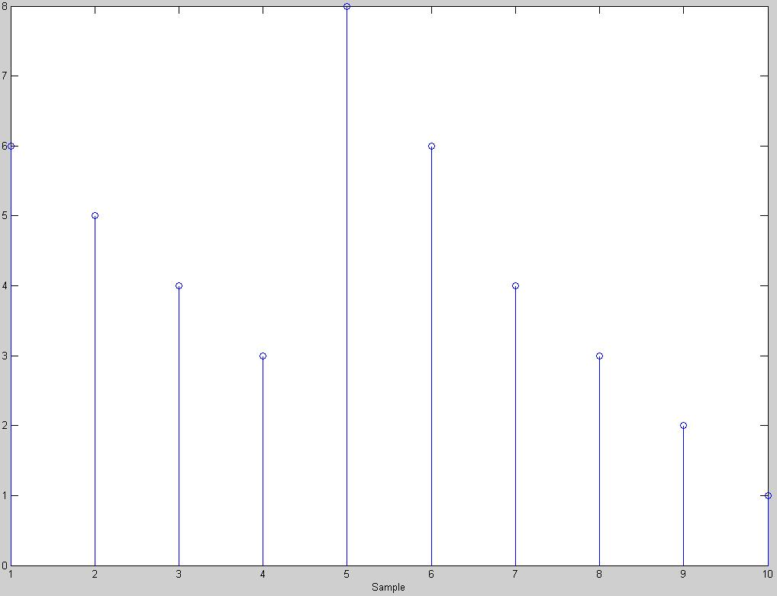
circular convolution with N=10

(2) (5%) Compare the result of the circular convolution to the result of the linear convolution of these two sequences.
linear convolution
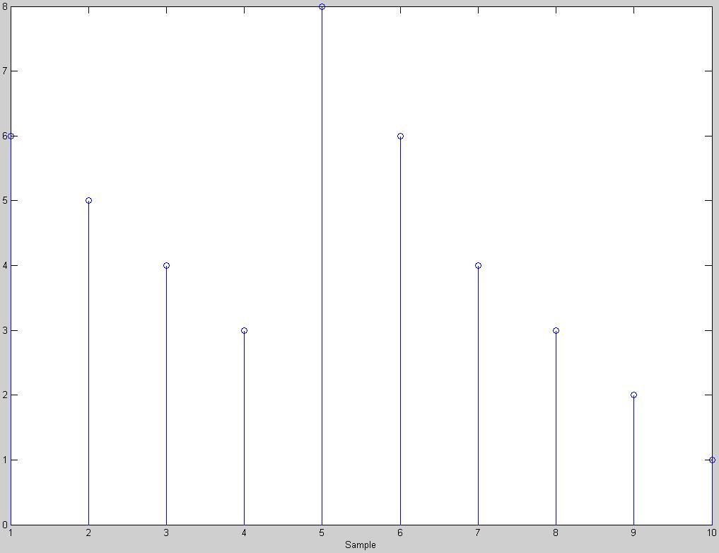
x1的長度為6，x2的長度為5，所以若是希望經由circular convolution的計算而不發生失真的情形，則其條件為，故N=10時，其結果和linear convolution相同。
程式碼
x1=[6 5 4 3 2 1];
x2=[1 0 0 0 1];
y_circular_6=cconv(x1,x2,6);
y_circular_10=cconv(x1,x2,10);
y_linear=conv(x1,x2);

figure();
stem(y_circular_6);
xlabel('Sample');

figure();
stem(y_circular_10);
xlabel('Sample');

figure();
stem(y_linear);
xlabel('Sample');
2. (10%) [Textbook] 8.42 (Note: You can define the amplitude of h[n] or any parameters in your Matlab implementation.)
Two finite-duration sequences h₁[n] and h₂[n] of length 8 are sketched in Figure P8.42-1. The two sequences are related by a circular shift, i.e., h₁[n]=h₂[((n-m))₈].
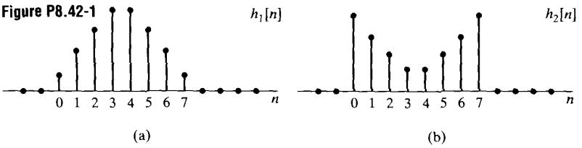
(a) Specify whether the magnitudes of the eight-point DFTs are equal.
此兩個序列有此關係：
所以，
並且，
故，8點DFT的magnitude是相同的。
h₁的magnitude
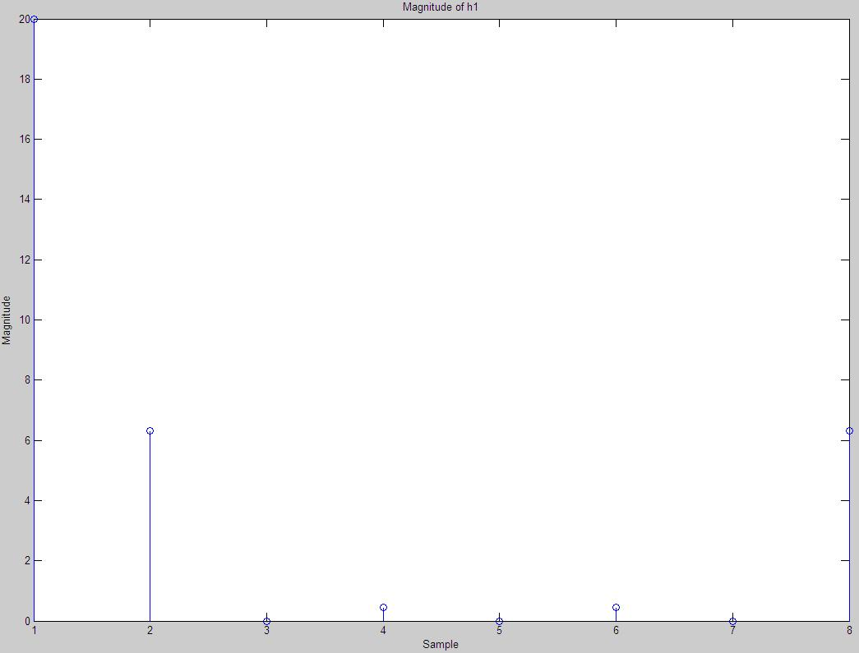
h₂的magnitude
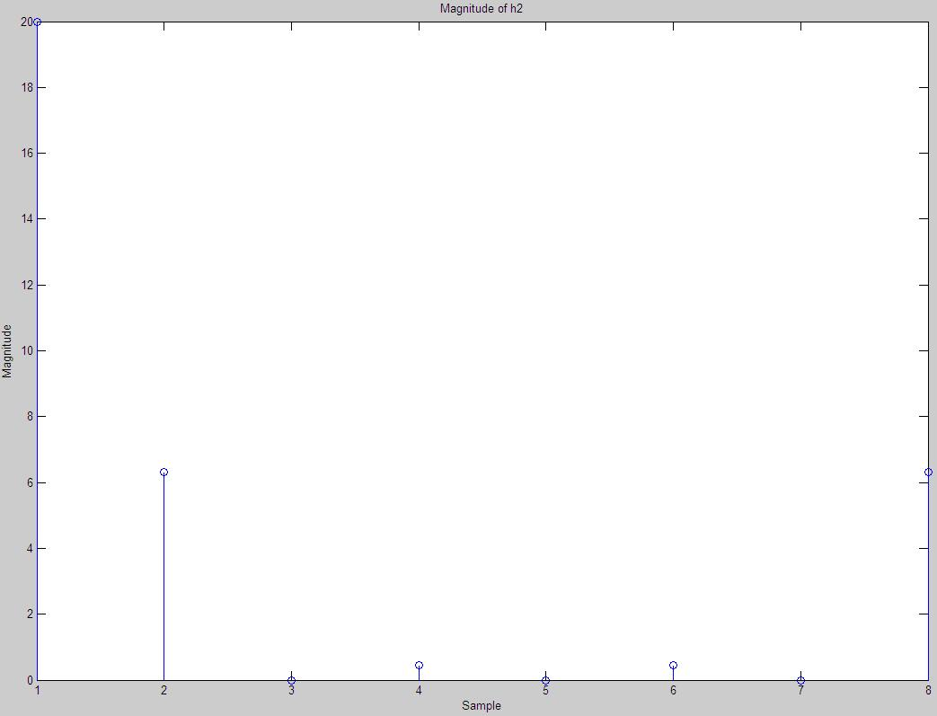
由兩圖的結果顯示，其magnitude是相同的
程式碼
h1=[1 2 3 4 4 3 2 1];
h2=[4 3 2 1 1 2 3 4];

h1_fft=fft(h1,8);
h2_fft=fft(h2,8);

figure();
stem(abs(h1_fft));
title('Magnitude of h1');
xlabel('Sample');
ylabel('Magnitude');

figure();
stem(abs(h2_fft));
title('Magnitude of h2');
xlabel('Sample');
ylabel('Magnitude');
(b) We wish to implement a lowpass FIR filter and must use either h₁[n] or h₂[n] as the impulse response. Which one of the following statements is correct?
i. h₁[n] is a better lowpass filter that h₂[n].
ii. h₂[n] is a better lowpass filter than h₂[n].
iii. The two sequences are both about equally good (or bad) as lowpass filters.
h₁[n]較接近(sin x)/x
由於H₂[k]=e^{jπk}H₁[k]，所以h₁[n]是較好的lowpass filter
[TEXTBOOK PROBLEMS]
3. (20%) 7.51
In this problem we develop a technique for designing discrete-time filters with minimum phase. Such filters have all their poles and zeros inside (or on) the unit circle. (we will allow zeros on the unit circle.) Let us first consider the problem of converting a type I linear phase FIR equiripple low pass filter to a minimum-phase system. If H(e^{jω}) is the frequency response of a type I linear phase filter, then
(1) The corresponding impulse response

is real and M is an even integer.
(2) It follows from Part (1) that , where is real and n₀=M/2 is an integer.
(3) The passband ripple is δ₁; i.e., in the passband, oscillates between (1+δ₁) and (1-δ₁). (See Figure P7.51-1)
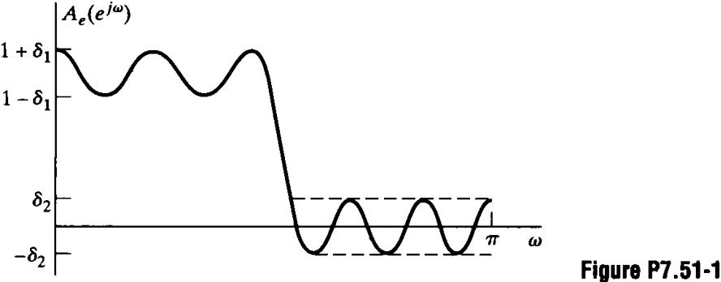
(4) The stop band ripple is δ₂; i.e., in the stop band, , and oscillates between -δ₂ and +δ₂.(See Figure P7.51-1)
The following techniques was proposed by Hermann and Schussler (1970a) for converting this linear phase system into a minimum phase system that has a system function H_{min}(z) and unit sample response h_{min}[n] (in this problem, we assume that minimum phase systems can have zeros on the unit circle):
Step 1. Create a new sequence

Step 2. Recognize that H₁(z) can be expressed in the form

for some H₂(z), where H₂(z) has all its poles and zeros inside or on the unit circle and h₂[n] is real.
Step 3. Define

The denominator constant where normalizes the passband so that the resulting frequency response H_{min}(e^{jω}) will oscillate about a value of unity.
(a) Show that if h₁[n] is chosen as in Step 1, then H₁(e^{jω}) can be written as

where H₃(e^{jω}) is real and nonnegative for all values of ω

當A_{e}(e^{jω})及δ₂為real時，H₃(e^{jω})也會是real，而當時為nonnegative，注意到H₃(e^{jω})是ω的even function，並且是zero phase的filter。
(b) If , as was shown in Part (a), show that there exists an H₂(z) such that
H₃(z)=H₂(z)H₂(1/z),
where H₂(z) is a minimum phase system function and h₂[n] is real (i.e., justify Step 2).
H₃(e^{jω})為具有實係數的zero phase filter。因此，在z_{k}的零點意味著也有其在的零點。除此之外，在單位圓上的零點必定是兩個，因為其該值都是零點，而該性質只對於H₃(e^{jω})是適用的，而不適用於A_{e}(e^{jω})，將H₃(z)寫成

H₂(z)包含所有在單位圓內所有的共軛複數零點對偶，而H₂(1/z)包含所有在單位圓外所有的共軛複數零點對偶，將單位圓上的兩個零點以及其共軛複數零點分解成H₂(z)，而其他在單位圓上的對偶則分解為H₂(1/z)。
而H₂(z)有其零點在單位圓上或其內，其為minimum phase（我們在這個題目中允許零點在單位圓上），而零點為共軛複數對偶，h₂[n]為實數。
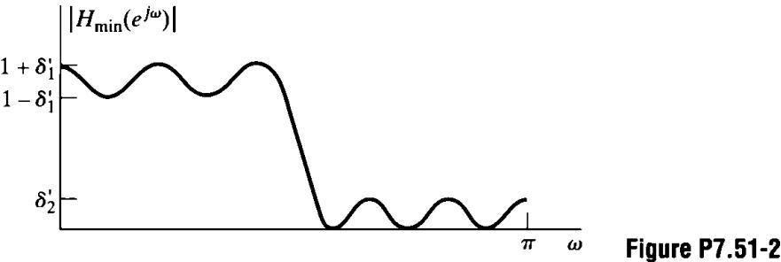
(c) Demonstrate that the new filter H_{min}(e^{jω}) is an equiripple lowpass filter (i.e., that its magnitude characteristic is of the form shown in Figure P7.51-2) by evaluating and . What is the length of the new impulse response h_{min}[n]?

在此，，然而由於在passband中，而在stopband中，所以

因此，

其原來的filter h[n]的order為M，因此，h₁[n]的order也會是M，但是 h₂[n]的order是M/2，因為spectral factorization，所以 h_{min}[n]和h₂[n]的order會一樣，h_{min}[n]的長度為M/2+1。
(d) In Parts (a), (b), and (c), we assumed that we started with a type I FIR linear phase filter. Will this technique work if we remove the linear phase constraint? Will it work if we use a type II FIR linear phase system?
不，如果解除linear phase的限制，H₃(z)的零點便不會分佈在conjugate reciprocal quads，便無法表示下式

H₂(z)為minimum phase filter
不，用Type II linear phase filter將無法work，因為n₀=M/2不是整數。
4. (15%) 8.37
Consider a finite-duration sequence x[n] that is zero for n<0 and n>=N, where N is even. The z transform of x[n] is denoted by X(z). Table P8.37-1 lists seven sequences obtained from x[n]. Table P8.37-2 lists nine sequence obtained from X(z). For each sequence in Table 8.37-1, find its DFT in Table P8.37-2. The size of the transform considered must be greater than or equal to the length of the sequence g_{k}[n]. For purpose of illustration only, assume that x[n] can be represented by the envelope shown in Figure P8.37-1.
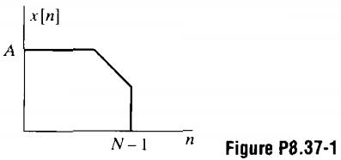
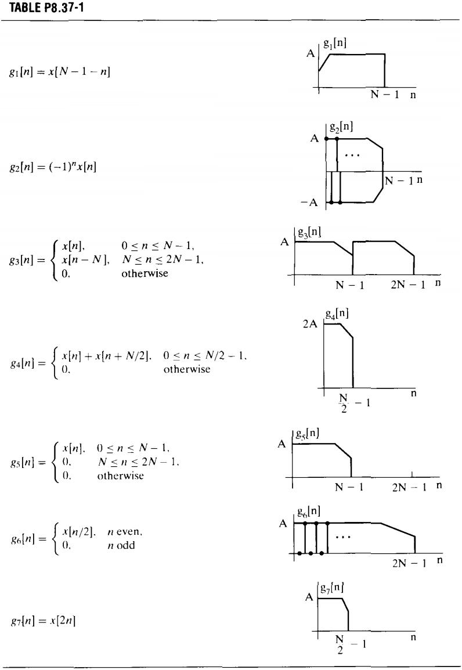
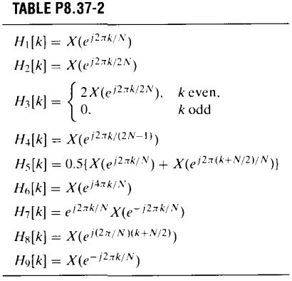
(a)

令m=N-1-n

而

(b)

(c)

(d)

(e)

(f)

(g)

5. (20%) 8.47
Let

be a real eight-point sequence, and let X[k] be its eight-point DFT.
(a) Evaluate

in terms of x[n].

(b) Let

be an eight-point sequence, and let V[k] be its eight-point DFT.
If V[k]=X(z) at z=2exp(j(2πk+π)/8) for k=0...7, where X(z) is the z-transform of x[n], express v[n] in terms of x[n].
故
(c) Let

be a four-point sequence, and let W[k] be its four-point DFT.
If W[k]=X[k]+X[k+4], express w[n] in terms of x[n].

所以，
(d) Let

be an eight-point sequence, and let Y[k] be its eight-point DFT.
If

express y[n] in terms of x[n].
其Y[k]能寫成

使用DFT特性，我們可得到下面的結論

6. (15%) 8.50
Read each part of this problem carefully to note the differences among parts.
(a) Consider the signal

which can be represented by the IDFT equation as

where X₈[k] is the eight-point DFT of x[n], Plot X₈[k] for
令n=0,...,7，而x[n]寫成

所以，其X₈[k]的極點為

k
X₈[k]
8
4
0
1
2
-2
-2
3
4
5
4
7
6
(b)Determine V₁₆[k], the sixteen-point DFT of the sixteen-point sequence

Plot V₁₆[k] for
首先，令n=0,...,15，而v[n]可寫成

所以，其V₁₆[k]的極點為
(c) Finally, consider , the magnitude of the sixteen-point DFT of the eight-point sequence
k
V₁₆[k]
16
8
0
1
2
-4
-4
3
4
5
7
6
8
9
10
11
12
13
14
15
8

Sketch for without explicitly evaluating the DFT expression. You will not be able to find all values of by inspection as in Parts (a) and (b), but you should be able to find some of the values exactly. Plot all the values you know exactly with a solid circle, and plot estimates of the other values with an open circle.

其X(e^{jω})為x[n]的Fourier transform，而x[n]可表示為
而y[n]為
並且w[n]為一eight-point rectangular window。 will therefore have as its even points the sequence ，the odd points will correspond to the bandlimited interpolation between the even-point samples，經由觀察法我們可以得到該值。

7. (25%) 8.64
k
|X₁₆[k]|
8
4
0
1
2
2
2
3
4
5
7
6
8
9
10
11
12
13
14
15
4
A problem that often arises in practice is one in which a distorted signal y[n] is the output that results when a desired signal x[n] has been filtered by an LTI system. We wish to recover the original signal x[n] by processing y[n]. In theory, x[n] can be covered from y[n] by passing y[n] through an inverse filter having a system function equal to the reciprocal of the system function of the distorting filter.
Suppose that the distortion is caused by an FIR filter with impulse response

where n₀ is a positive integer, i.e., the distortion of x[n] takes the form of an echo at delay n₀.
(a) Determine the z-transform H(z) and the N-point DFT H[k] of the impulse response h[n]. Assume that N=4n₀.
h[n]的z轉換為
h[n]的N點DFT為下式，而N=4n₀

(b) Let H_{i}(z) denote the system function of the inverse filter, and let h_{i}[n] be the corresponding impulse response. Determine h_{i}[n]. Is this an FIR or an IIR filter? What is the duration of h_{i}[n]?
for causality
，所以該filter為IIR，為Infinite duration。
(c) Suppose that we use an FIR filter of length N in an attempt to implement the inverse filter, and let the N-point DFT of the FIR filter be

What is the impulse response g[n] of the FIR filter?

The impulse response, g[n], is just h_{i}[n] time-aliased by 4n₀ points:

(d) It might appear that the FIR filter with DFT G[k]=1/H[k] implements the inverse filter perfectly. After all, one might argue that the FIR distorting filter has an N-point DFT H[k] and the FIR filter in cascade has an N-point DFT G[k]=1/H[k], and since G[k]H[k]=1 for all k, we have implemented an all-pass, non distorting filter. Briefly explain the fallacy in this argument.

然而，上式的關係只有在4n₀的頻率時才會成立，而這並不表示適用於所有的ω

(e) Perform the convolution of g[n] with h[n], and thus determine how well the FIR filter with N-point DFT G[k]=1/H[k] implements the inverse filter.

