國立交通大學電子工程研究所九十六級王盛弘9611842
DSP Spring 2009
HW #7 Chapter 9~10.5
[TEXTBOOK PROBLEMS]
1. 9.20
Suppose that you time-reverse and delay a real-valued 32-point sequence x[n] to obtain x₁=x[32-n]. If x₁[n] is used as the input for the system in Figure P9.7-1, find an expression y[32] in terms of X(e^{jω}), the discrete-time Fourier transform of the original sequence x[n].
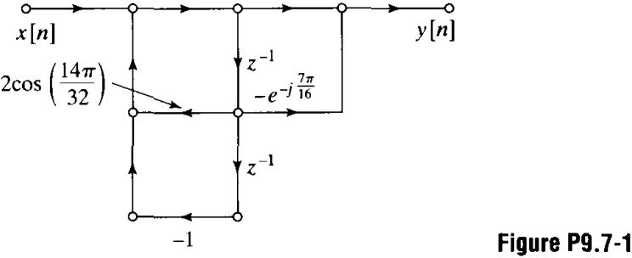
首先，應用DTFT的shift以及time reversal特性，推導出X₁(e^{jω})與X(e^{jω})之間的關係

由圖上可知，計算y[32]的部份是利用Goertzel的演算法，其k=7且N=32，其式為

注意到若是將x[n]直接放在系統中，便可以評估在單位圓上共軛位置的X(z)，如ω=7π/16
2. 9.26
The N-point DFT of the N-point sequence , for N even, is

Determine the 2N-point DFT of the 2N-point sequence , assuming that N is even.

因此，
3. 9.29
Suppose that a finite-length sequence x[n] has the N-point DFT X[k], and suppose that the sequence satisfies the symmetry condition.

where N is even and x[n] is complex.
(a) Show that X[k]=0 for k=0,2,...N-2.
方法一
找尋其序列的DFT，得到

方法二
利用DFT的circular shift property，從可得到

若k為偶數時，只有當X[k]=0，X[k]=-X[k]便會成立。
(b) Show how to compute the odd-indexed DFT values X[k], k=1,3,...N-1 using only one N/2-point DFT plus a small amount of extra computation.
評估在odd-indexed samples的DFT可導出

其k=0,...,N/2-1，所以可以利用一個N/2點的DFT來計算odd-indexed DFT value。
4. 9.48
The input and output of a linear time-invariant system satisfy a difference equation of the form

Assume that an FFT program is available for computing the DFT of any finite-length sequence of length N=2^{v}. Describe a procedure that utilizes the available FFT program to compute
for k=0, 1, …, 511,
where H(z) is the system function of the system.
先計算H(z)的取樣表示式
，然後
Now assume ，令b[n]=b_{n}，並且
令B[k]及A[k]分別為b[n]及a[n]的512點DFT。所以
5. 10.10
Let x[n] be a discrete-time signal obtained by sampling a continuous-time signal x_{c}(t) with some sampling period T so that x[n]=x_{c}(nT). Assume x_{c}(t) is bandlimited to 100 Hz. i.e, for . We wish to estimate the continuous-time spectrum X_{c}(jΩ) by computing a 1024-point DFT of x[n], X[k]. What is the smallest value of T such that the equivalent frequency spacing between consecutive DFT samples X[k] corresponds to 1 Hz or less in continuous-time frequency?
其等同的continuous-time frequency spacing為
因此，為了滿足使連續的DFT samples小於或等於1 Hz的frequency spacing的限制為下式

無論如何，必須滿足取樣定理來避免失真發生，必須有一些附加的限制條件

將該兩個限制合併則變為
6. 10.17 Method 1 ~ Method 4 and verify your answer by Matlab (specgram command).
A signal x[n] is analyzed using the time-dependent Fourier transform X_{r}[k], as defined in Eq. (10.36). Initially, the analysis is performed with an N=128 DFT using an L=128-point Hamming window w[n]. The time-domain sampling of adjacent blocks is R=128; i.e., the windowed segments are offset by 128 samples in time. The frequency resolution obtained with this analysis is not sufficient, and it is desired to improve the resolution. Several methods of modifying the analysis are suggested to accomplish this goal. Which of the following methods will improve the frequency resolution of the time-dependent Fourier transform X_{r}[k]?
METHOD 1: Increase N to 256 while maintaining L and R at the same values.
METHOD 2: Increase both N and L to 256, while maintaining R the same.
METHOD 3: Decrease R to 64 while maintaining the same N and L.
METHOD 4: Decrease L to 64 while maintaining the same N and R.
METHOD 5: Maintain N, R and L the same, but change w[n] to be a rectangular window.

METHOD 2為最佳的方法
METHOD 1：此法會將frequency variable的取樣數量double，但是並不會因此改變其frequency resolution，window中其main lobe的size則保持不變。
METHOD 2：此法可將window的main lobe的size變小，故可改善frequency resolution。
METHOD 3：此法增加了time resolution（在time domain分辨events的能力），但無法影響其frequency resolution。
METHOD 4：由於在window的main lobe會增加，故此法會減少frequency resolution。該方法的使用不是挺恰當，因為一些x[n]的取樣點在transform中其實不再需要使用到。
B = specgram(a, nfft, fs, window, numoverlap)
a: vector, nfft: FFT length, fs: frequency samping
window: windowing function and the number of samples
numoverlap: the number of samples by which the sections overlap
specgram(a, 128, fs, hamming(128), numoverlap);

7. 10.25
Suppose that y[n] is the output of a linear time-invariant FIR system with input x[n]; i.e.,

(a) Obtain a relationship between the time-dependent Fourier transform Y[n, λ) of the output of the linear system and the time-dependent Fourier transform X[n, λ) of the input.
從time-dependent Fourier transform的定義開始

we plug in

所以得到

其convolution為針對變數n
(b) Show that if the window is long compared to M, then

where H(e^{jω}) is the frequency response of the linear system.
由下式開始

進而可得到

如果window的長度為M，那麼在的small time shift便無法快速地改變spectrum

因此，

