國立交通大學電子工程研究所九十六級王盛弘9611842
DSP Spring 2009
Make-up Project Venue: ED725/ED711 Due: 06/29 1:30~3:30 PM
[The Story]
You are requested to build a music equalizer to simulate the effect of a particular sound field/music style, such as in a concert hall, theater or Rock&Roll, etc.
[Tasks]
1. Prepare one of your favorite songs (longer than 10 seconds) for MATLAB.
我挑選一首以色列的國歌（Hatikvah）中文意思：希望。曲調悲壯但是歌詞充滿正面能量，全長為一分十四秒，我用音樂編輯軟體擷取其前面的26秒，檔案名稱：HatikvahClip.wav。
2. Define your 5-band equalizer (to fit a particular sound field/music style).
3. Implement your equalizer using linear-phase FIR filters (Note: check your overall magnitude response in frequency domain). Choose your own design methods and parameters for your filter bank.
4. Implement your equalizer using IIR filters.

function [b, a, G1] = peq(G0, G, w0, Dw, NdB)

%Convert from Decibels to real values
GB = G * NdB;
G = (10^(G/20));
GB = (10^(GB/20));
G0 = (10^(G0/20));
F = abs(G^2 - GB^2);
G00 = abs(G^2 - G0^2);
F00 = abs(GB^2 - G0^2);
num = G0^2 * (w0^2 - pi^2)^2 + G^2 * F00 * pi^2 * Dw^2 / F;
den = (w0^2 - pi^2)^2 + F00 * pi^2 * Dw^2 / F;
G1 = sqrt(num/den);
G01 = abs(G^2 - G0*G1);
G11 = abs(G^2 - G1^2);
F01 = abs(GB^2 - G0*G1);
F11 = abs(GB^2 - G1^2);
W2 = sqrt(G11 / G00) * tan(w0/2)^2;
DW = (1 + sqrt(F00 / F11) * W2) * tan(Dw/2);
C = F11 * DW^2 - 2 * W2 * (F01 - sqrt(F00 * F11));
D = 2 * W2 * (G01 - sqrt(G00 * G11));
A = sqrt((C + D) / F);
B = sqrt((G^2 * C + GB^2 * D) / F);

b = [(G1 + G0*W2 + B), -2*(G1 - G0*W2), (G1 - B + G0*W2)] / (1 + W2 + A);
a = [1, [-2*(1 - W2), (1 + W2 - A)] / (1 + W2 + A)];
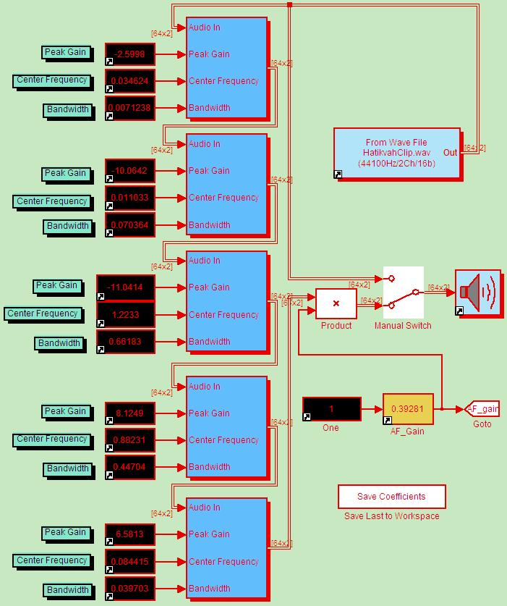

5. Consider the overlap-add method to filter your favorite song (since it has long duration).
6. Use DFT/IDFT to implement the overlap-add method for FIR filter banks.
7. Demonstrate your results
(a) plotting the overall magnitude response;
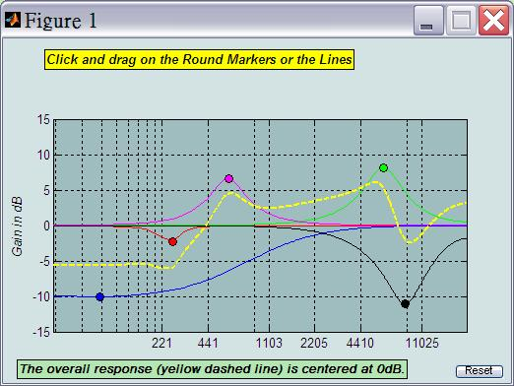
(b) plotting spectrograms of the song before/after passing through the filter bank;
[y, fs]=wavread('HatikvahClip.wav');
specgram(y, 512, fs)
(c) playing the filtered song.
8. Discussions
作者Sophocles提到由於在執行digital equalizer與analog equalizer間的bilinear transformation時，會由於prewarping effect而導致轉換後的digital equalizer在Nyquist frequency時的frequency response會比原先預期的analog equalizer規格較為快速下降，此一現象在peak frequency與width時會更加地顯著。在Fig. 1的右圖便可看出digital equalizer與analog equalizer間的差異。
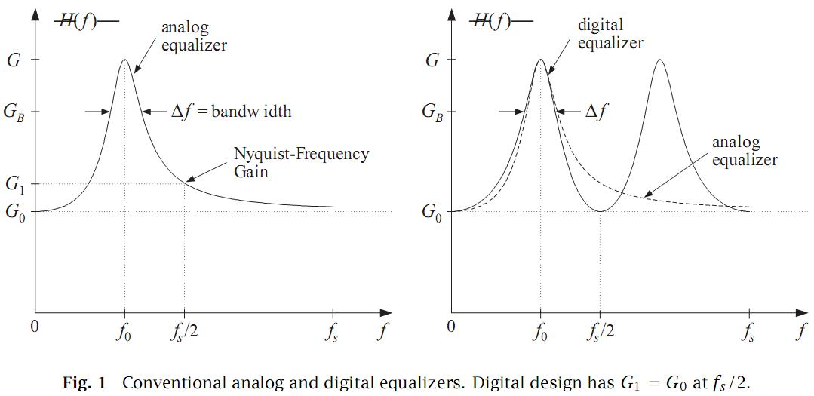
在Fig. 2的右圖便可看出digital equalizer與analog equalizer的波形差異變小。然而，若是當center frequency及width很小時，其傳統方法和新方法便沒有太大改進，因為此時的G₁和G₀便幾乎是相等的情況，所以，該論文提出的新方法只適用於high frequency及width的情況之下。

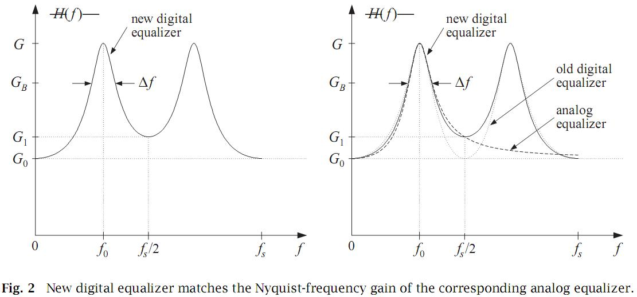
9. Reference
[1] Sophocles J. Orfanidis, “Introduction to signal processing”,. Prentice Hall International Editions, 1996.
[2] http://www.mathworks.com/matlabcentral/fileexchange/1963
[3] http://www.ece.rutgers.edu/~orfanidi/intro2sp/
[4] http://en.wikipedia.org/wiki/Hatikvah

