|  |  |  |  |  |
| --- | --- | --- | --- | --- |
| **場次** | **時間** | **比賽隊伍** | **裁判** | **紀錄台** |
| **3/28(四)** | | | | |
| **A** | 17:30~18:10 | 103vs105 | 陳峻逸 | 104 |
| **B** | 18:10~18:50 | 102vs104 | 謝蔚儒 | 103 |
| **C** | 18:50~19:30 | 104vs105 | 梁家豪 | 102 |
| **D** | 19:30~20:10 | 102vs105 | 謝蔚儒 | 103 |
| **E** | 20:10~20:50 | 103vs104 | 唐易聖 | 102 |
| **F** | 20:50~21:30 | 102vs103 | 謝蔚儒 | 104 |

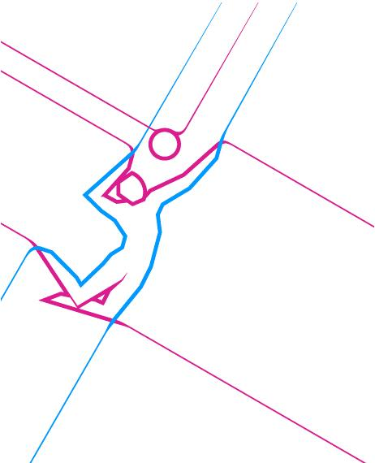排球 賽程時間表