Clinical System Test Cases

By Mohammad Hamo : 1230394 / Yanal Omar :1230156

Test Case 1 : adding to the clinical System

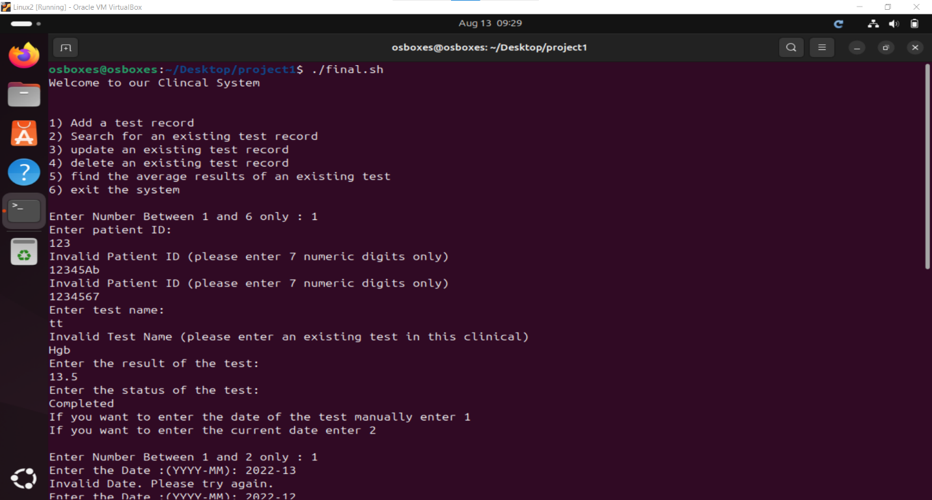

This is the Main menu it shows what you can do with this system

For example we wanted to add a new medical record so we entered 1

1)We tried to enter wrong format for the patient id and the system refused i

So when we entered the correct form , It was accepted and asked the user to enter the remaining details (and the same will be for the testName)

(if we added the same information (ID,testName,testDate) the system will tell you that there is already a person with these information )

2) when it comes to date the system gives the user two choices either to enter the date manually ( and it will check if its in the correct form and a valid date ) or the system will enter the date automatically due to the current date

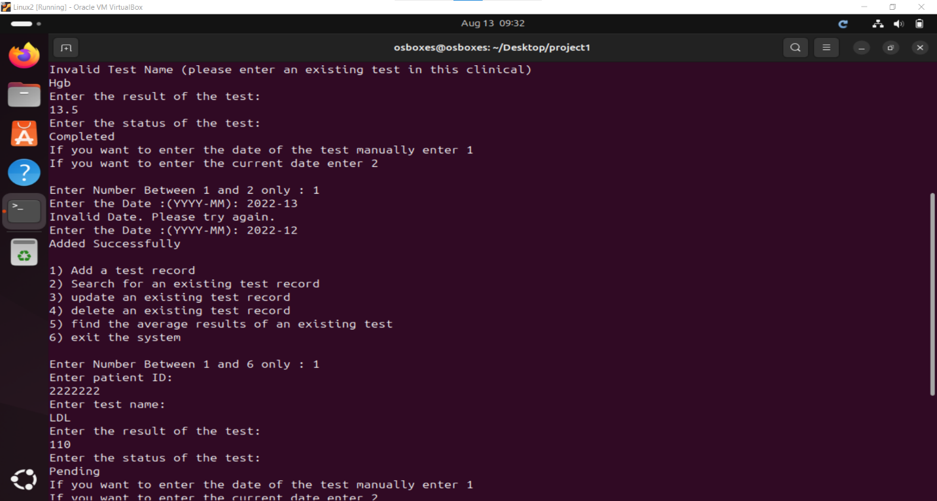look how when the user entered 2022-13 it refused it

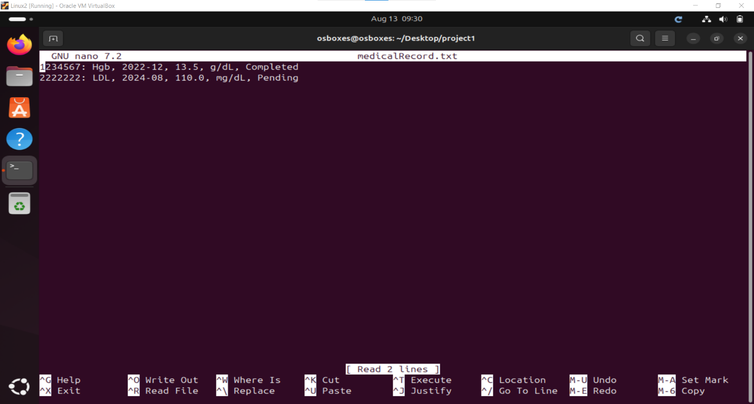this is the medical record After we added the two users

Test Case 2: Searching for an existing Record.

Again, we are back to the main menu, this time we entered “2” (Search for an existing test Record). As we clicked 2, it went to a Submenu that allows the user to search by a certain criteria.

1. When we clicked 3 (exit), it went back to the main menu, as it should.
2. After that we reopened the search menu to try different inputs. As it shows in the picture, when entering a number that is not shown on the menu, it gets refused and the user is asked to enter a different input.
3. Then, we entered 1 to search by patient ID, it asks the user to enter the ID of the patient, if entered in the right format, it will ask the user to choose what tests for that ID he wants to retrieve.
4. In this testcase we chose to search by date. The system asked us to enter the period that the tests were made on (First and End date). You can find the output in the last attached picture.
5. At the end we enter 6 to exit the system.