TD01
PART 5:
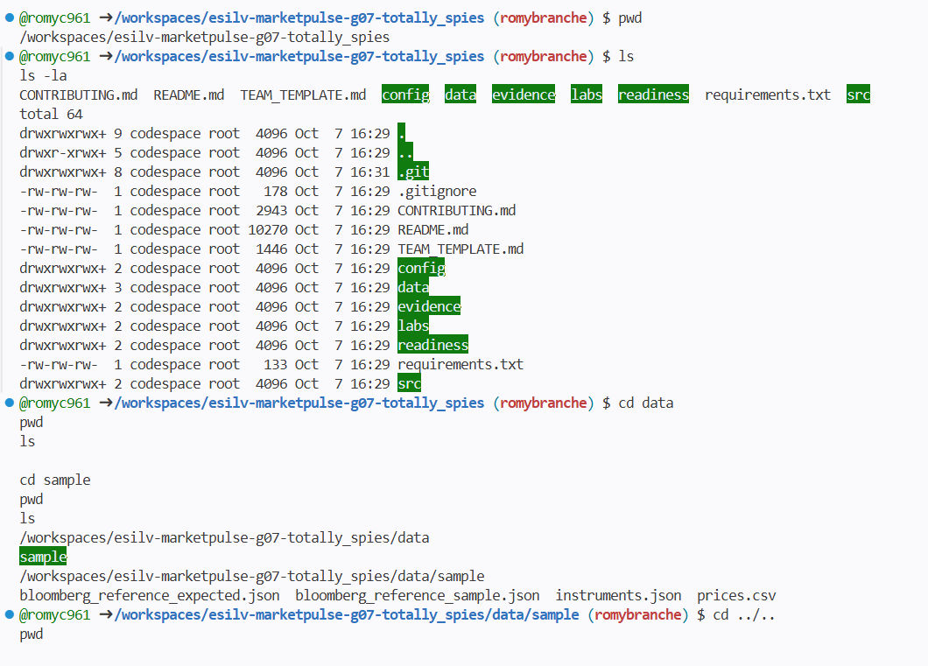
PART6
The instrument is Apple Inc. (AAPL)
The benchmark is the S&P 500 (SP500).
Their names and tickers are stored in:
data/sample/instruments.json
Inside the JSON file, they are organized under the two objects:
instrument → ticker, name, currency, market
benchmark → ticker, name, currency, market
The file:data/sample/prices.csv
contains the price observations for both AAPL and SP500.
Each row contains:
date
ticker
open
high
low
close
volume
For example:
2026-09-01,AAPL,249.20,251.50,248.00,250.00,38000000
2026-09-01,SP500,6592.00,6615.00,6580.00,6600.00,0
instruments.json tells us WHAT the instrument and benchmark are, while prices.csv contains their price observations over time.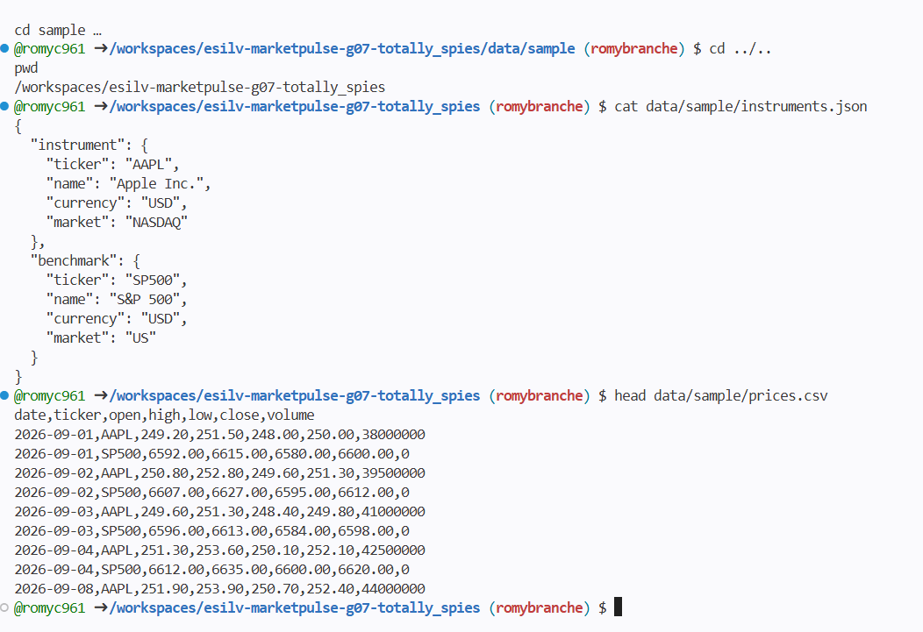
PART7:
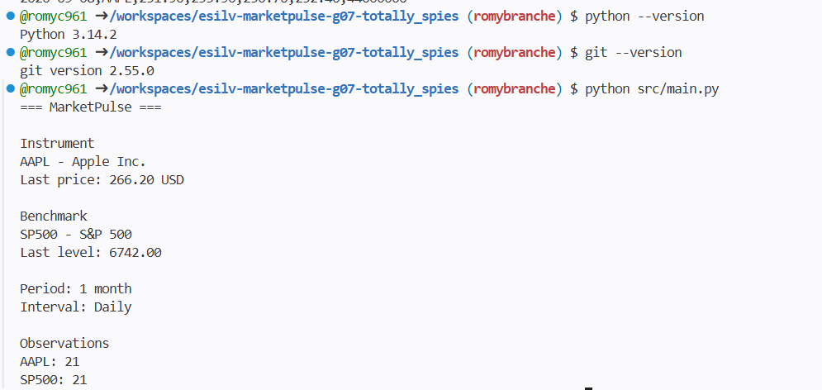

TD02
PART1:
Which function reads JSON?
load_instruments()
Which function reads CSV?
load_prices()
Which function selects one ticker?
filter_prices()
Which function coordinates execution?
main ()
Where are the input files stored?
In the data/sample/ directory, referenced through DATA_DIR.
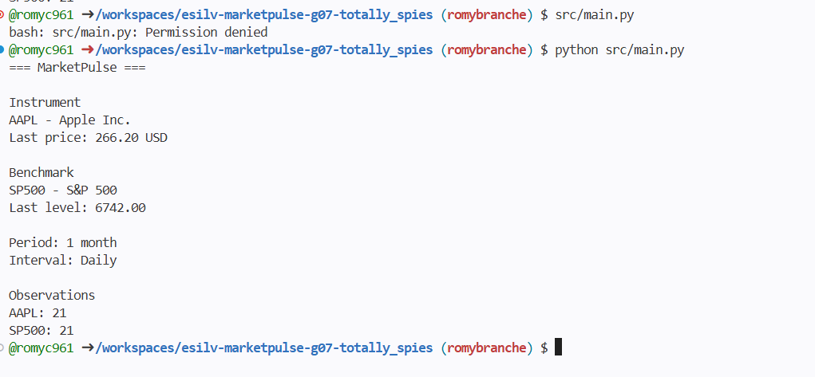
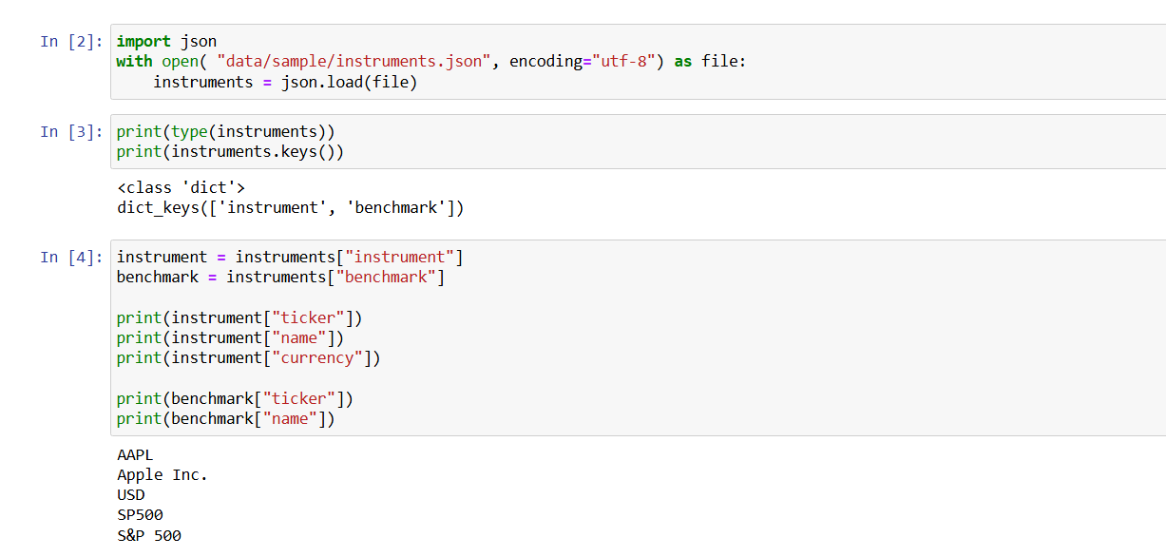
PART3: 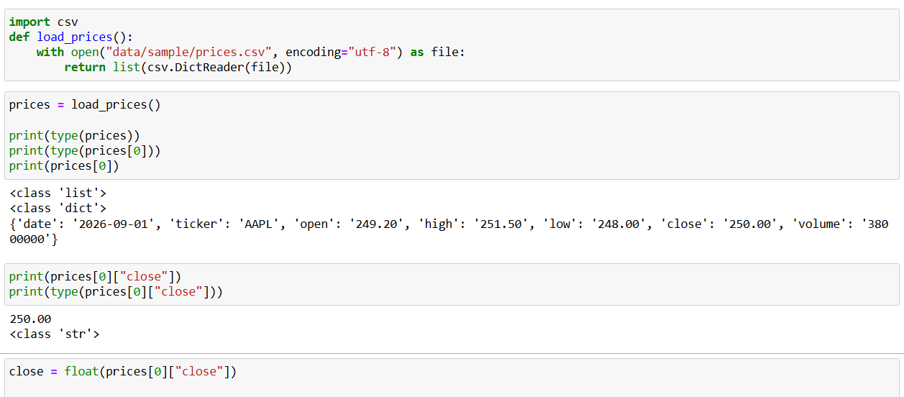
PART4:
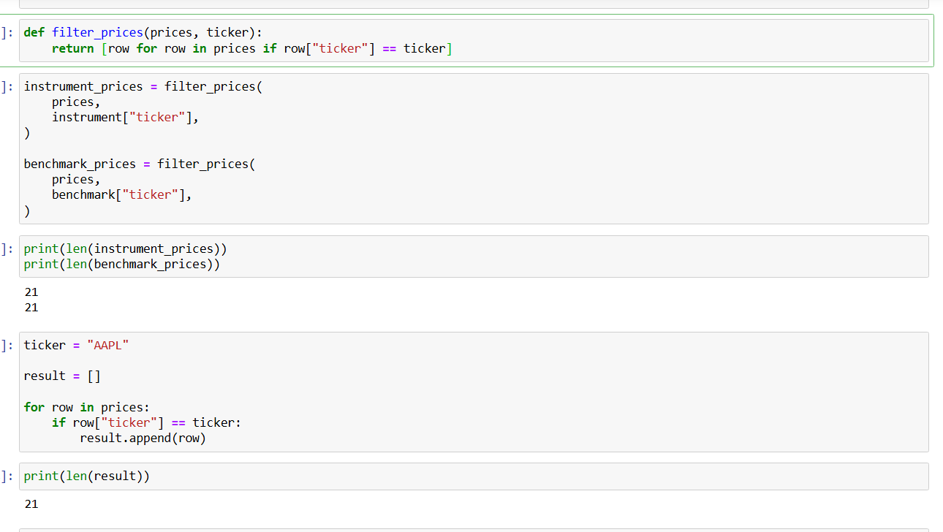
PART5:
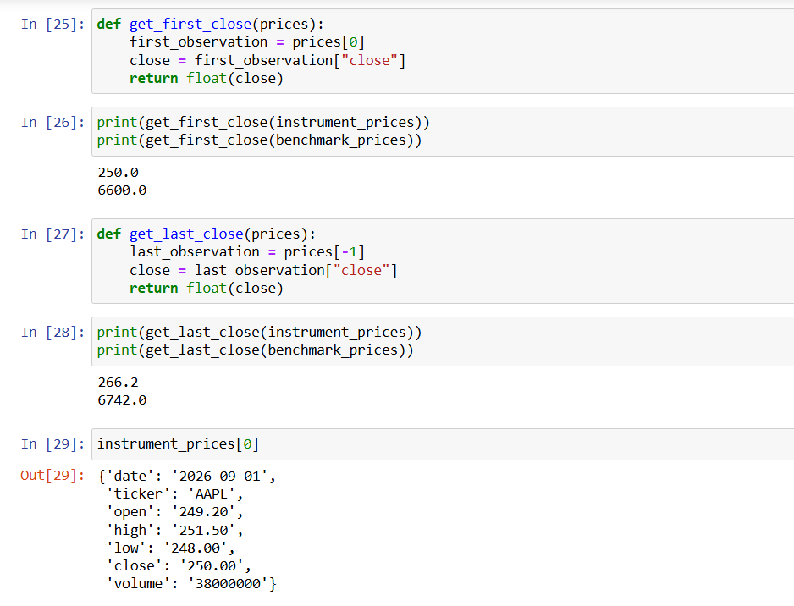
PART6:
