TD3
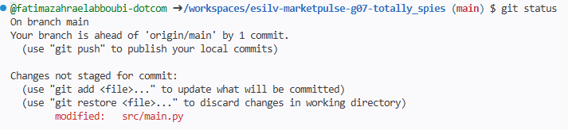

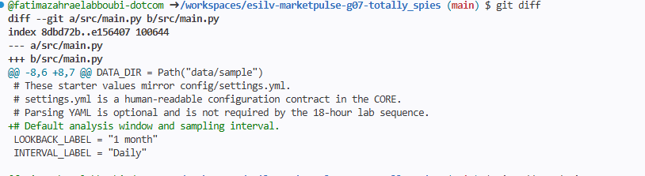

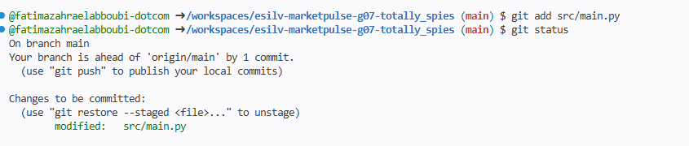

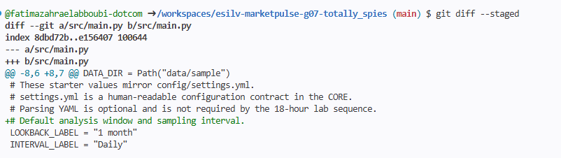

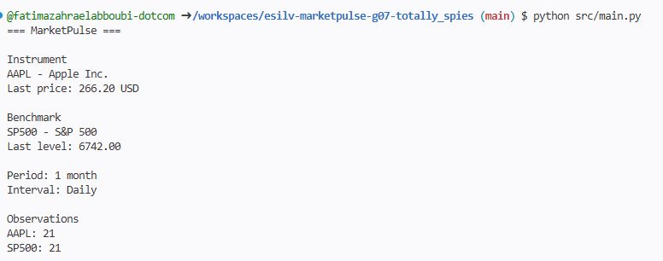

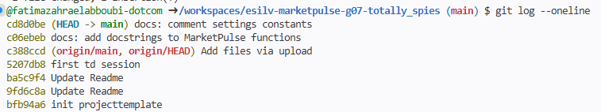

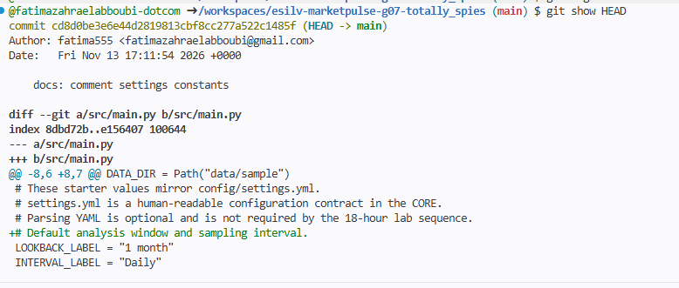

TD4
TERMINAL
@fatimazahraelabboubi-dotcom ➜ /workspaces/esilv-marketpulse-g07-totally_spies (main) $ git config --global core.pager cat
git status
git log --oneline -5
python src/main.py
On branch main
Your branch is ahead of 'origin/main' by 2 commits.
(use "git push" to publish your local commits)

nothing to commit, working tree clean
cd8d0be (HEAD -> main) docs: comment settings constants
c06ebeb docs: add docstrings to MarketPulse functions
c388ccd (origin/main, origin/HEAD) Add files via upload
5207db8 first td session
ba5c9f4 Update Readme
=== MarketPulse ===

Instrument
AAPL - Apple Inc.
Last price: 266.20 USD

Benchmark
SP500 - S&P 500
Last level: 6742.00

Period: 1 month
Interval: Daily

Observations
AAPL: 21
SP500: 21
@fatimazahraelabboubi-dotcom ➜ /workspaces/esilv-marketpulse-g07-totally_spies (main) $ git add src/main.py
git commit -m "docs: comment settings constants"
On branch main
Your branch is ahead of 'origin/main' by 2 commits.
(use "git push" to publish your local commits)

nothing to commit, working tree clean
@fatimazahraelabboubi-dotcom ➜ /workspaces/esilv-marketpulse-g07-totally_spies (main) $ git switch -c feature/display-observation-dates
git branch
Switched to a new branch 'feature/display-observation-dates'
* feature/display-observation-dates
main
@fatimazahraelabboubi-dotcom ➜ /workspaces/esilv-marketpulse-g07-totally_spies (feature/display-observation-dates) $ python src/main.py
=== MarketPulse ===

Instrument
AAPL - Apple Inc.
Last price: 266.20 USD

Benchmark
SP500 - S&P 500
Last level: 6742.00

Period: 1 month
Interval: Daily

Observations
AAPL: 21
SP500: 21

Observation dates
AAPL: 2026-09-01 -> 2026-09-30
SP500: 2026-09-01 -> 2026-09-30
@fatimazahraelabboubi-dotcom ➜ /workspaces/esilv-marketpulse-g07-totally_spies (feature/display-observation-dates) $ git status
On branch feature/display-observation-dates
Changes not staged for commit:
(use "git add <file>..." to update what will be committed)
(use "git restore <file>..." to discard changes in working directory)
modified: src/main.py

no changes added to commit (use "git add" and/or "git commit -a")
@fatimazahraelabboubi-dotcom ➜ /workspaces/esilv-marketpulse-g07-totally_spies (feature/display-observation-dates) $ git diff
diff --git a/src/main.py b/src/main.py
index e156407..2f8a8ae 100644
--- a/src/main.py
+++ b/src/main.py
@@ -29,6 +29,14 @@ def filter_prices(prices, ticker):
"""Return only the price rows that match the given ticker."""
return [row for row in prices if row["ticker"] == ticker]

+def get_first_date(prices):
+ """Return the date of the first observation."""
+ return prices[0]["date"]
+
+
+def get_last_date(prices):
+ """Return the date of the last observation."""
+ return prices[-1]["date"]

def main():
"""Display a short MarketPulse summary for the instrument and its benchmark."""
@@ -60,6 +68,10 @@ def main():
print("Observations")
print(f"{instrument['ticker']}: {len(instrument_prices)}")
print(f"{benchmark['ticker']}: {len(benchmark_prices)}")
+ print()
+ print("Observation dates")
+ print(f"{instrument['ticker']}: {get_first_date(instrument_prices)} -> {get_last_date(instrument_prices)}")
+ print(f"{benchmark['ticker']}: {get_first_date(benchmark_prices)} -> {get_last_date(benchmark_prices)}")

if __name__ == "__main__":
@fatimazahraelabboubi-dotcom ➜ /workspaces/esilv-marketpulse-g07-totally_spies (feature/display-observation-dates) $ git add src/main.py
@fatimazahraelabboubi-dotcom ➜ /workspaces/esilv-marketpulse-g07-totally_spies (feature/display-observation-dates) $ git diff --staged
diff --git a/src/main.py b/src/main.py
index e156407..2f8a8ae 100644
--- a/src/main.py
+++ b/src/main.py
@@ -29,6 +29,14 @@ def filter_prices(prices, ticker):
"""Return only the price rows that match the given ticker."""
return [row for row in prices if row["ticker"] == ticker]

+def get_first_date(prices):
+ """Return the date of the first observation."""
+ return prices[0]["date"]
+
+
+def get_last_date(prices):
+ """Return the date of the last observation."""
+ return prices[-1]["date"]

def main():
"""Display a short MarketPulse summary for the instrument and its benchmark."""
@@ -60,6 +68,10 @@ def main():
print("Observations")
print(f"{instrument['ticker']}: {len(instrument_prices)}")
print(f"{benchmark['ticker']}: {len(benchmark_prices)}")
+ print()
+ print("Observation dates")
+ print(f"{instrument['ticker']}: {get_first_date(instrument_prices)} -> {get_last_date(instrument_prices)}")
+ print(f"{benchmark['ticker']}: {get_first_date(benchmark_prices)} -> {get_last_date(benchmark_prices)}")

if __name__ == "__main__":
@fatimazahraelabboubi-dotcom ➜ /workspaces/esilv-marketpulse-g07-totally_spies (feature/display-observation-dates) $ git commit -m "feat: display first and last observation dates"
[feature/display-observation-dates b265687] feat: display first and last observation dates
1 file changed, 12 insertions(+)
@fatimazahraelabboubi-dotcom ➜ /workspaces/esilv-marketpulse-g07-totally_spies (feature/display-observation-dates) $ git status
On branch feature/display-observation-dates
nothing to commit, working tree clean
@fatimazahraelabboubi-dotcom ➜ /workspaces/esilv-marketpulse-g07-totally_spies (feature/display-observation-dates) $ git log --oneline -5
b265687 (HEAD -> feature/display-observation-dates) feat: display first and last observation dates
cd8d0be (main) docs: comment settings constants
c06ebeb docs: add docstrings to MarketPulse functions
c388ccd (origin/main, origin/HEAD) Add files via upload
5207db8 first td session
@fatimazahraelabboubi-dotcom ➜ /workspaces/esilv-marketpulse-g07-totally_spies (feature/display-observation-dates) $ git log --oneline --graph --decorate --all
git diff main..feature/display-observation-dates
* b265687 (HEAD -> feature/display-observation-dates) feat: display first and last observation dates
* cd8d0be (main) docs: comment settings constants
* c06ebeb docs: add docstrings to MarketPulse functions
| * 30729f9 (origin/yanis_branche) Merge branch 'plensy:main' into yanis_branche
| |\
| |/
|/|
| * 4bf5366 TD01
| | * 63d1303 (origin/BrancheSakti) Merge branch 'plensy:main' into BrancheSakti
| | |\
| |_|/
|/| |
| | * 1aacee8 TD1&2
| |/
| | * e5c2437 (origin/romybranche) Merge branch 'plensy:main' into romybranche
| | |\
| |_|/
|/| |
* | | c388ccd (origin/main, origin/HEAD) Add files via upload
|/ /
| * 53e1e6b TD1-2
|/
| * 9f95abb (origin/BrancheFatima) td1&2
|/
| * 93ae071 (origin/emmabranche) TD1 ET 2
|/
* 5207db8 first td session
* ba5c9f4 Update Readme
* 9fd6c8a Update Readme
* bfb94a6 init projecttemplate
diff --git a/src/main.py b/src/main.py
index e156407..2f8a8ae 100644
--- a/src/main.py
+++ b/src/main.py
@@ -29,6 +29,14 @@ def filter_prices(prices, ticker):
"""Return only the price rows that match the given ticker."""
return [row for row in prices if row["ticker"] == ticker]

+def get_first_date(prices):
+ """Return the date of the first observation."""
+ return prices[0]["date"]
+
+
+def get_last_date(prices):
+ """Return the date of the last observation."""
+ return prices[-1]["date"]

def main():
"""Display a short MarketPulse summary for the instrument and its benchmark."""
@@ -60,6 +68,10 @@ def main():
print("Observations")
print(f"{instrument['ticker']}: {len(instrument_prices)}")
print(f"{benchmark['ticker']}: {len(benchmark_prices)}")
+ print()
+ print("Observation dates")
+ print(f"{instrument['ticker']}: {get_first_date(instrument_prices)} -> {get_last_date(instrument_prices)}")
+ print(f"{benchmark['ticker']}: {get_first_date(benchmark_prices)} -> {get_last_date(benchmark_prices)}")

if __name__ == "__main__":
@fatimazahraelabboubi-dotcom ➜ /workspaces/esilv-marketpulse-g07-totally_spies (feature/display-observation-dates) $ git log --oneline --graph --decorate --all
* b265687 (HEAD -> feature/display-observation-dates) feat: display first and last observation dates
* cd8d0be (main) docs: comment settings constants
* c06ebeb docs: add docstrings to MarketPulse functions
| * 30729f9 (origin/yanis_branche) Merge branch 'plensy:main' into yanis_branche
| |\
| |/
|/|
| * 4bf5366 TD01
| | * 63d1303 (origin/BrancheSakti) Merge branch 'plensy:main' into BrancheSakti
| | |\
| |_|/
|/| |
| | * 1aacee8 TD1&2
| |/
| | * e5c2437 (origin/romybranche) Merge branch 'plensy:main' into romybranche
| | |\
| |_|/
|/| |
* | | c388ccd (origin/main, origin/HEAD) Add files via upload
|/ /
| * 53e1e6b TD1-2
|/
| * 9f95abb (origin/BrancheFatima) td1&2
|/
| * 93ae071 (origin/emmabranche) TD1 ET 2
|/
* 5207db8 first td session
* ba5c9f4 Update Readme
* 9fd6c8a Update Readme
* bfb94a6 init projecttemplate
@fatimazahraelabboubi-dotcom ➜ /workspaces/esilv-marketpulse-g07-totally_spies (feature/display-observation-dates) $ git diff main..feature/display-observation-dates
diff --git a/src/main.py b/src/main.py
index e156407..2f8a8ae 100644
--- a/src/main.py
+++ b/src/main.py
@@ -29,6 +29,14 @@ def filter_prices(prices, ticker):
"""Return only the price rows that match the given ticker."""
return [row for row in prices if row["ticker"] == ticker]

+def get_first_date(prices):
+ """Return the date of the first observation."""
+ return prices[0]["date"]
+
+
+def get_last_date(prices):
+ """Return the date of the last observation."""
+ return prices[-1]["date"]

def main():
"""Display a short MarketPulse summary for the instrument and its benchmark."""
@@ -60,6 +68,10 @@ def main():
print("Observations")
print(f"{instrument['ticker']}: {len(instrument_prices)}")
print(f"{benchmark['ticker']}: {len(benchmark_prices)}")
+ print()
+ print("Observation dates")
+ print(f"{instrument['ticker']}: {get_first_date(instrument_prices)} -> {get_last_date(instrument_prices)}")
+ print(f"{benchmark['ticker']}: {get_first_date(benchmark_prices)} -> {get_last_date(benchmark_prices)}")

if __name__ == "__main__":
@fatimazahraelabboubi-dotcom ➜ /workspaces/esilv-marketpulse-g07-totally_spies (feature/display-observation-dates) $ git switch main
Switched to branch 'main'
Your branch is ahead of 'origin/main' by 2 commits.
(use "git push" to publish your local commits)
@fatimazahraelabboubi-dotcom ➜ /workspaces/esilv-marketpulse-g07-totally_spies (main) $ git branch
feature/display-observation-dates
* main
@fatimazahraelabboubi-dotcom ➜ /workspaces/esilv-marketpulse-g07-totally_spies (main) $ git merge feature/display-observation-dates
Updating cd8d0be..b265687
Fast-forward
src/main.py | 12 ++++++++++++
1 file changed, 12 insertions(+)
@fatimazahraelabboubi-dotcom ➜ /workspaces/esilv-marketpulse-g07-totally_spies (main) $ git log --oneline --graph --decorate --all
* b265687 (HEAD -> main, feature/display-observation-dates) feat: display first and last observation dates
* cd8d0be docs: comment settings constants
* c06ebeb docs: add docstrings to MarketPulse functions
| * 30729f9 (origin/yanis_branche) Merge branch 'plensy:main' into yanis_branche
| |\
| |/
|/|
| * 4bf5366 TD01
| | * 63d1303 (origin/BrancheSakti) Merge branch 'plensy:main' into BrancheSakti
| | |\
| |_|/
|/| |
| | * 1aacee8 TD1&2
| |/
| | * e5c2437 (origin/romybranche) Merge branch 'plensy:main' into romybranche
| | |\
| |_|/
|/| |
* | | c388ccd (origin/main, origin/HEAD) Add files via upload
|/ /
| * 53e1e6b TD1-2
|/
| * 9f95abb (origin/BrancheFatima) td1&2
|/
| * 93ae071 (origin/emmabranche) TD1 ET 2
|/
* 5207db8 first td session
* ba5c9f4 Update Readme
* 9fd6c8a Update Readme
* bfb94a6 init projecttemplate
@fatimazahraelabboubi-dotcom ➜ /workspaces/esilv-marketpulse-g07-totally_spies (main) $ python src/main.py
=== MarketPulse ===

Instrument
AAPL - Apple Inc.
Last price: 266.20 USD

Benchmark
SP500 - S&P 500
Last level: 6742.00

Period: 1 month
Interval: Daily

Observations
AAPL: 21
SP500: 21

Observation dates
AAPL: 2026-09-01 -> 2026-09-30
SP500: 2026-09-01 -> 2026-09-30
@fatimazahraelabboubi-dotcom ➜ /workspaces/esilv-marketpulse-g07-totally_spies (main) $ git branch
feature/display-observation-dates
* main
@fatimazahraelabboubi-dotcom ➜ /workspaces/esilv-marketpulse-g07-totally_spies (main) $ git branch --merged
feature/display-observation-dates
* main
@fatimazahraelabboubi-dotcom ➜ /workspaces/esilv-marketpulse-g07-totally_spies (main) $ git log --oneline --graph --decorate --all
* b265687 (HEAD -> main, feature/display-observation-dates) feat: display first and last observation dates
* cd8d0be docs: comment settings constants
* c06ebeb docs: add docstrings to MarketPulse functions
| * 30729f9 (origin/yanis_branche) Merge branch 'plensy:main' into yanis_branche
| |\
| |/
|/|
| * 4bf5366 TD01
| | * 63d1303 (origin/BrancheSakti) Merge branch 'plensy:main' into BrancheSakti
| | |\
| |_|/
|/| |
| | * 1aacee8 TD1&2
| |/
| | * e5c2437 (origin/romybranche) Merge branch 'plensy:main' into romybranche
| | |\
| |_|/
|/| |
* | | c388ccd (origin/main, origin/HEAD) Add files via upload
|/ /
| * 53e1e6b TD1-2
|/
| * 9f95abb (origin/BrancheFatima) td1&2
|/
| * 93ae071 (origin/emmabranche) TD1 ET 2
|/
* 5207db8 first td session
* ba5c9f4 Update Readme
* 9fd6c8a Update Readme
* bfb94a6 init projecttemplate
@fatimazahraelabboubi-dotcom ➜ /workspaces/esilv-marketpulse-g07-totally_spies (main) $
REPONSES AUX QUESTIONS :
Comparaison (partie 6)
- Le commit b265687 ajoute get_first_date, get_last_date et l’affichage des dates d’observation dans main(). Il n’existe que sur la branche.
- Il n’est pas dans main parce que le commit a été créé sur la branche : main pointait encore sur cd8d0be et ne bouge que lors d’un merge.
- Si la branche était abandonnée avant le merge, main resterait inchangé : la fonctionnalité ne serait jamais intégrée et main n’aurait aucune modification non terminée.
Après le merge (partie 7)
- Oui, la fonctionnalité est visible depuis main : python src/main.py affiche maintenant la section « Observation dates ».
- Oui, le commit b265687 est toujours visible dans git log.
- Git a fait un fast-forward, sans commit de merge. Comme main n’avait pas avancé depuis la création de la branche, il a simplement déplacé son pointeur.
- Le graphe est linéaire : main et feature/display-observation-dates pointent sur le même commit, au sommet de l’historique.
Conflit de merge (partie 9)
Un conflit apparaît quand main et la branche modifient la même zone d’un fichier et que Git ne peut pas choisir automatiquement. Ce n’est pas une erreur : un humain doit comparer les deux versions, choisir le contenu final, supprimer les marqueurs (<<<<<<<, =======, >>>>>>>), faire git add puis terminer le merge

TD5

On branch main
Your branch is up to date with 'origin/main'.

nothing to commit, working tree clean
@fatimazahraelabboubi-dotcom ➜ /workspaces/esilv-marketpulse-g07-totally_spies (main) $ git rev-parse HEAD
d986008d525fc42506d7caf37e0b308a9d5bfe80
@fatimazahraelabboubi-dotcom ➜ /workspaces/esilv-marketpulse-g07-totally_spies (main) $ git rev-parse origin/main
d986008d525fc42506d7caf37e0b308a9d5bfe80
@fatimazahraelabboubi-dotcom ➜ /workspaces/esilv-marketpulse-g07-totally_spies (main) $ git switch -c docs/add-run-instructions
Switched to a new branch 'docs/add-run-instructions'
@fatimazahraelabboubi-dotcom ➜ /workspaces/esilv-marketpulse-g07-totally_spies (docs/add-run-instructions) $ git branch
archive/td04-local
* docs/add-run-instructions
feature/display-observation-dates
main
@fatimazahraelabboubi-dotcom ➜ /workspaces/esilv-marketpulse-g07-totally_spies (docs/add-run-instructions) $ python src/main.py
=== MarketPulse ===

Instrument
AAPL - Apple Inc.
First date: 2026-09-01
Last date: 2026-09-30
Last price: 266.20 USD

Benchmark
SP500 - S&P 500
First date: 2026-09-01
Last date: 2026-09-30
Last level: 6742.00

Period: 1 month
Interval: Daily

Observations
AAPL: 21
SP500: 21
@fatimazahraelabboubi-dotcom ➜ /workspaces/esilv-marketpulse-g07-totally_spies (docs/add-run-instructions) $ git status
On branch docs/add-run-instructions
Changes not staged for commit:
(use "git add <file>..." to update what will be committed)
(use "git restore <file>..." to discard changes in working directory)
modified: README.md

no changes added to commit (use "git add" and/or "git commit -a")
@fatimazahraelabboubi-dotcom ➜ /workspaces/esilv-marketpulse-g07-totally_spies (docs/add-run-instructions) $ git diff
diff --git a/README.md b/README.md
index c6a17b9..4680fab 100644
--- a/README.md
+++ b/README.md
@@ -475,3 +475,12 @@ This README intentionally does not display CI, security, release or license badg
**Course:** MESIFI472326 - Python, Git, Linux
**School:** ESILV - A4
**Use case:** MarketPulse - Multi-Source Financial Market Data Dashboard
+## How to run
+
+From the repository root, run:
+
+```bash
+python src/main.py
+```
+
+The program prints a short MarketPulse summary for the instrument (AAPL) and its benchmark (SP500): first and last dates, last price or level, the period, the interval and the number of observations.
\ No newline at end of file
@fatimazahraelabboubi-dotcom ➜ /workspaces/esilv-marketpulse-g07-totally_spies (docs/add-run-instructions) $ git add README.md
@fatimazahraelabboubi-dotcom ➜ /workspaces/esilv-marketpulse-g07-totally_spies (docs/add-run-instructions) $ git diff --staged
diff --git a/README.md b/README.md
index c6a17b9..4680fab 100644
--- a/README.md
+++ b/README.md
@@ -475,3 +475,12 @@ This README intentionally does not display CI, security, release or license badg
**Course:** MESIFI472326 - Python, Git, Linux
**School:** ESILV - A4
**Use case:** MarketPulse - Multi-Source Financial Market Data Dashboard
+## How to run
+
+From the repository root, run:
+
+```bash
+python src/main.py
+```
+
+The program prints a short MarketPulse summary for the instrument (AAPL) and its benchmark (SP500): first and last dates, last price or level, the period, the interval and the number of observations.
\ No newline at end of file
@fatimazahraelabboubi-dotcom ➜ /workspaces/esilv-marketpulse-g07-totally_spies (docs/add-run-instructions) $ git commit -m "docs: add how to run section to README"
[docs/add-run-instructions 4e5b1d8] docs: add how to run section to README
1 file changed, 9 insertions(+)
@fatimazahraelabboubi-dotcom ➜ /workspaces/esilv-marketpulse-g07-totally_spies (docs/add-run-instructions) $ git status
On branch docs/add-run-instructions
nothing to commit, working tree clean
@fatimazahraelabboubi-dotcom ➜ /workspaces/esilv-marketpulse-g07-totally_spies (docs/add-run-instructions) $ git log --oneline -5
4e5b1d8 (HEAD -> docs/add-run-instructions) docs: add how to run section to README
d986008 (origin/main, origin/HEAD, main) docs: add Checkpoint A evidence for emma659
207dea9 feat: display first and last observation dates
c388ccd Add files via upload
5207db8 first td session
@fatimazahraelabboubi-dotcom ➜ /workspaces/esilv-marketpulse-g07-totally_spies (docs/add-run-instructions) $ git remote get-url origin
https://github.com/yanis-00/esilv-marketpulse-g07-totally_spies
@fatimazahraelabboubi-dotcom ➜ /workspaces/esilv-marketpulse-g07-totally_spies (docs/add-run-instructions) $ git push -u origin docs/add-run-instructions
Enumerating objects: 21, done.
Counting objects: 100% (21/21), done.
Delta compression using up to 2 threads
Compressing objects: 100% (14/14), done.
Writing objects: 100% (16/16), 1.18 MiB | 3.80 MiB/s, done.
Total 16 (delta 5), reused 0 (delta 0), pack-reused 0 (from 0)
remote: Resolving deltas: 100% (5/5), completed with 3 local objects.
remote:
remote: Create a pull request for 'docs/add-run-instructions' on GitHub by visiting:
remote: https://github.com/yanis-00/esilv-marketpulse-g07-totally_spies/pull/new/docs/add-run-instructions
remote:
To https://github.com/yanis-00/esilv-marketpulse-g07-totally_spies
* [new branch] docs/add-run-instructions -> docs/add-run-instructions
branch 'docs/add-run-instructions' set up to track 'origin/docs/add-run-instructions'.
@fatimazahraelabboubi-dotcom ➜ /workspaces/esilv-marketpulse-g07-totally_spies (docs/add-run-instructions) $

Td6
Ma PR #5 a été mergée par erreur avant la revue du TD06.

