Medichal

Team name/project : Medichal
Groupe name : Parasite
Team members : Fellah Yanis yanis.fellah@u-psud.fr, Kolczynski Samuel samuel.kolczynski@u-psud.fr, Djebarra Kahina kahina.djebarra@u-psud.fr, Bouamara Nabila nabila.bouamar@u-psud.fr, Rabiai Samir samir.rabiai@u-psud.fr, Trinh Duc-Bao, duc-bao.trinh@u-psud.fr .
Challenge URL :
Github repo of the project :
Background and motivation :
We decided to work on medichal project because it's something very interesting. It attracted us because it will allow us to learn about medical data . Indeed we can learn about many things like image recognition, speech synthesis, credit risk analysis and much more. All these stuffs are in medical data and we really want to know more about medical data.

Data and problem description :
The problem is a classification problem. The goal of the project is therefore to create two data challenges on medical problems with newly generated data. More details are found on the README.ipynb file on our Github repository.
Classes :
Binôme 1 will work on data vizualisation, following the class outline Vizualisation.py on our github repo.
Binôme 2 will work on data model, following the class outline Model.py on our github repo.
Binôme 3 will work on data preprocessing, following the class outline Preprocessing.py on our github repo.
Preliminary results :
Mettre des photos
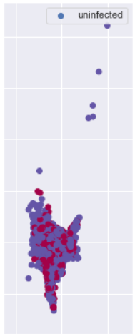
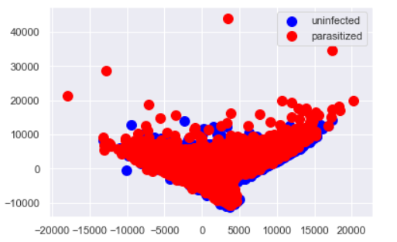

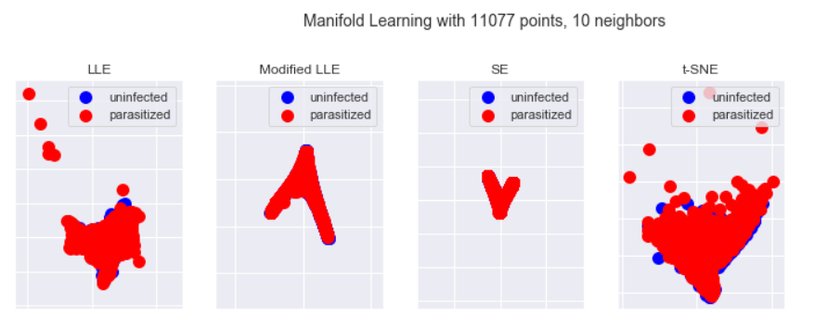
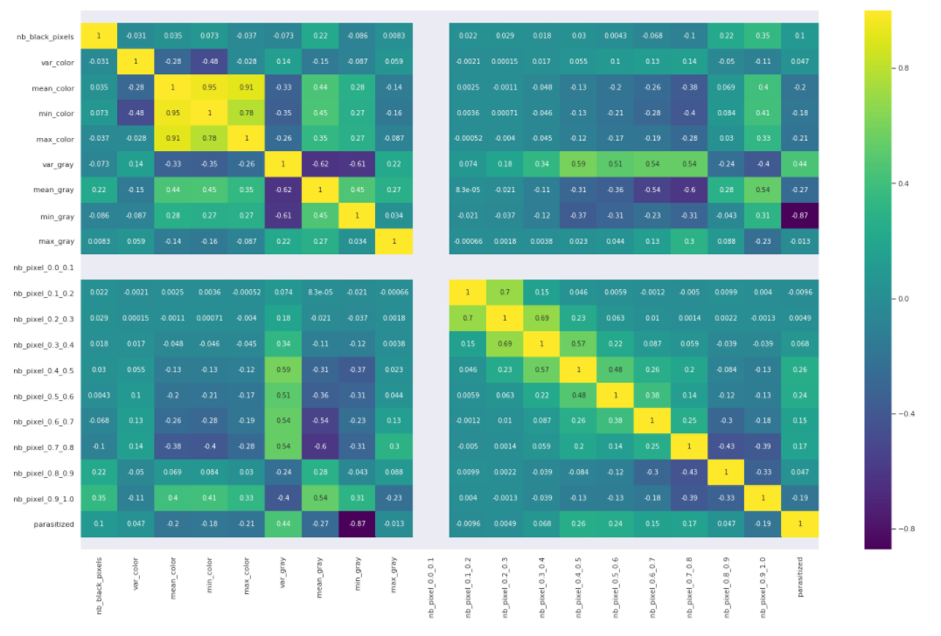

References :
Mettre les ref que tas utilisés
https://scikit-learn.org

