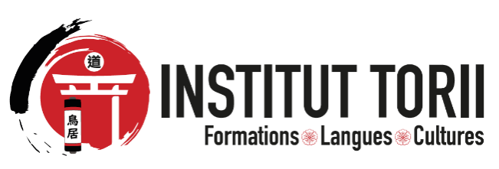

Torii Institute - El-Achour- Alger
Phone : 0540 90 02 54
Email:contact@institut-torii.com

CERTIFICATE OF PARTICIPATION

I, the undersigned, Mr. BAADJ Mohamed Amine, Director of Torii Institute, located in Algiers, El-Achour, hereby certify that:
Mr Mehdi Slimane Dehimi has successfully completed a training program in Chinese Language (Level 1) at Torii Institute. The course took place from January 31, 2026 to January 31, 2026.
We wish to commend the significant progress achieved, as well as the diligence and commitment demonstrated throughout the entire duration of the training.
This certificate is issued to the concerned party to serve and avail for all legal and necessary purposes.

Done in Algiers, on March 10, 2026

Mr. BAADJ Mohamed Amine

Director of the Institution

