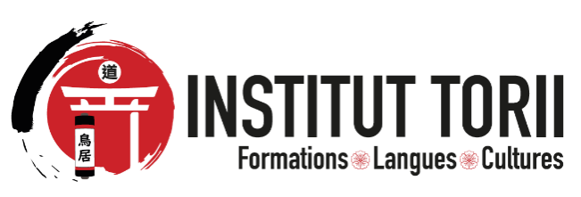

Torii Institute - El-Achour- Alger
Phone : 0540 90 02 54
Email:contact@institut-torii.com

CERTIFICATE OF PARTICIPATION

I, the undersigned, Mr. BAADJ Mohamed Amine, Director of Torii Institute, located in Algiers, El-Achour, hereby certify that:
Ms Rania Bouras has successfully completed a training program in Japanese Language (Level 1) at Torii Institute. The course took place from November 29, 2025 to February 14, 2026.
We wish to commend the significant progress achieved, as well as the diligence and commitment demonstrated throughout the entire duration of the training.
This certificate is issued to the concerned party to serve and avail for all legal and necessary purposes.

Done in Algiers, on February 12, 2026

Mr. BAADJ Mohamed Amine

Director of the Institution

