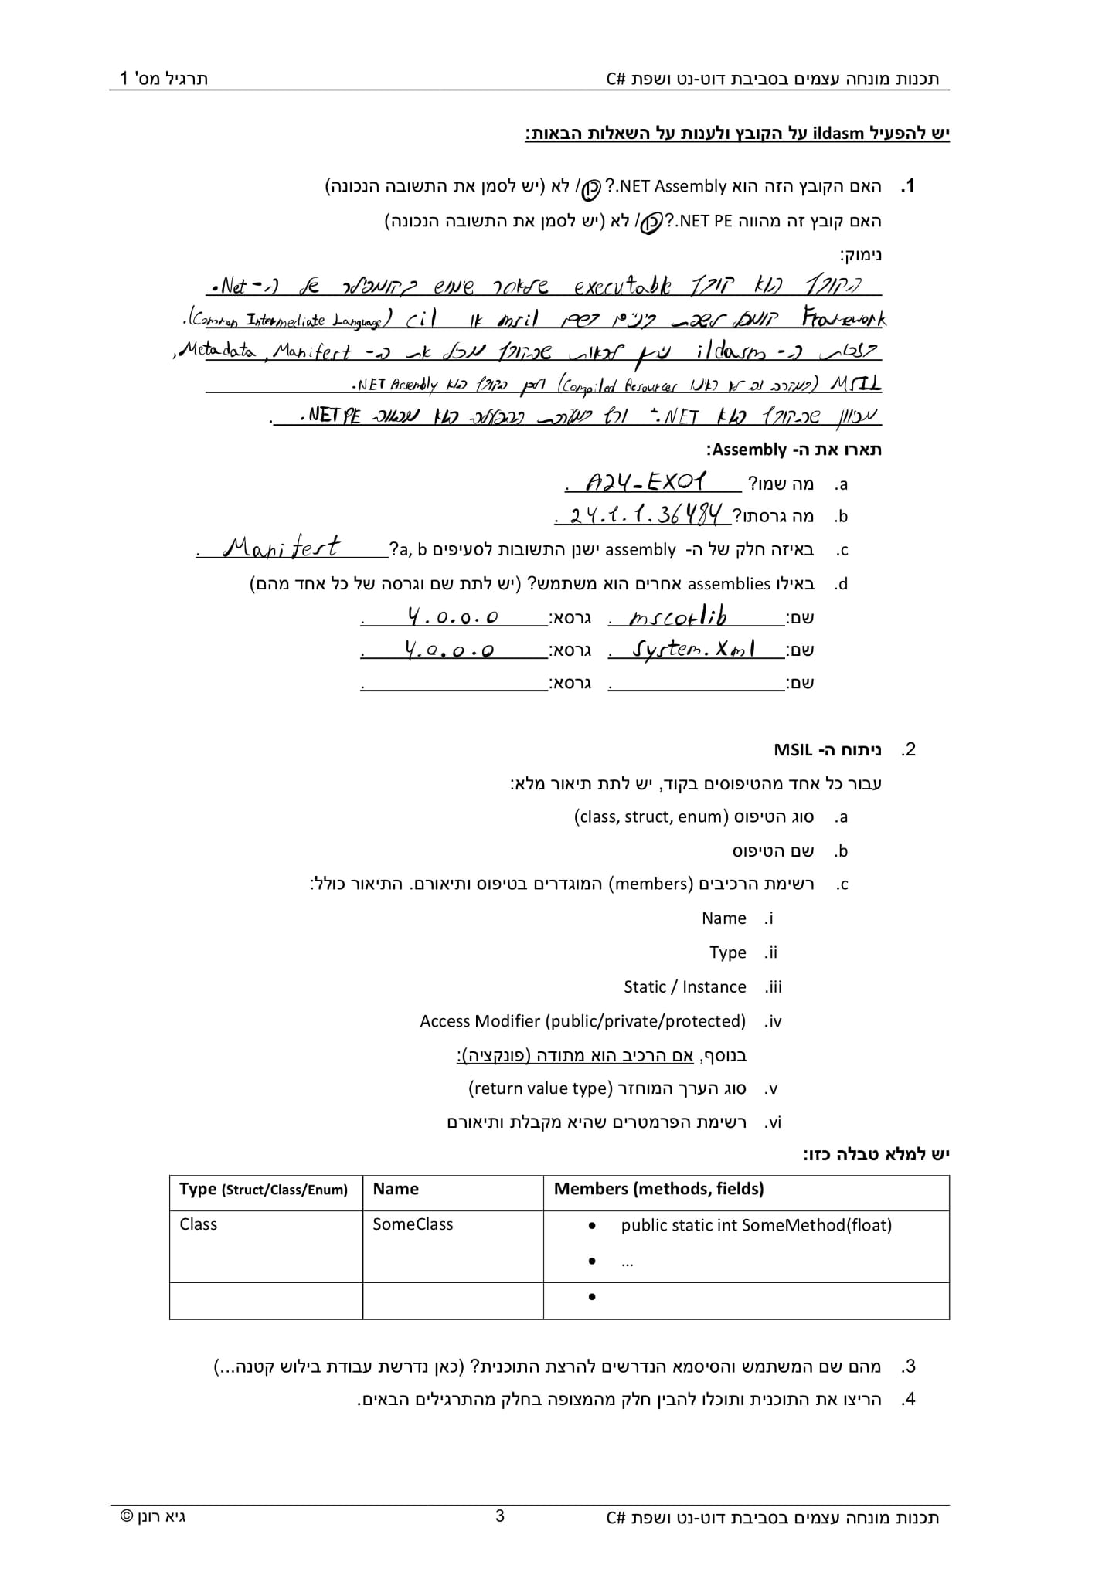

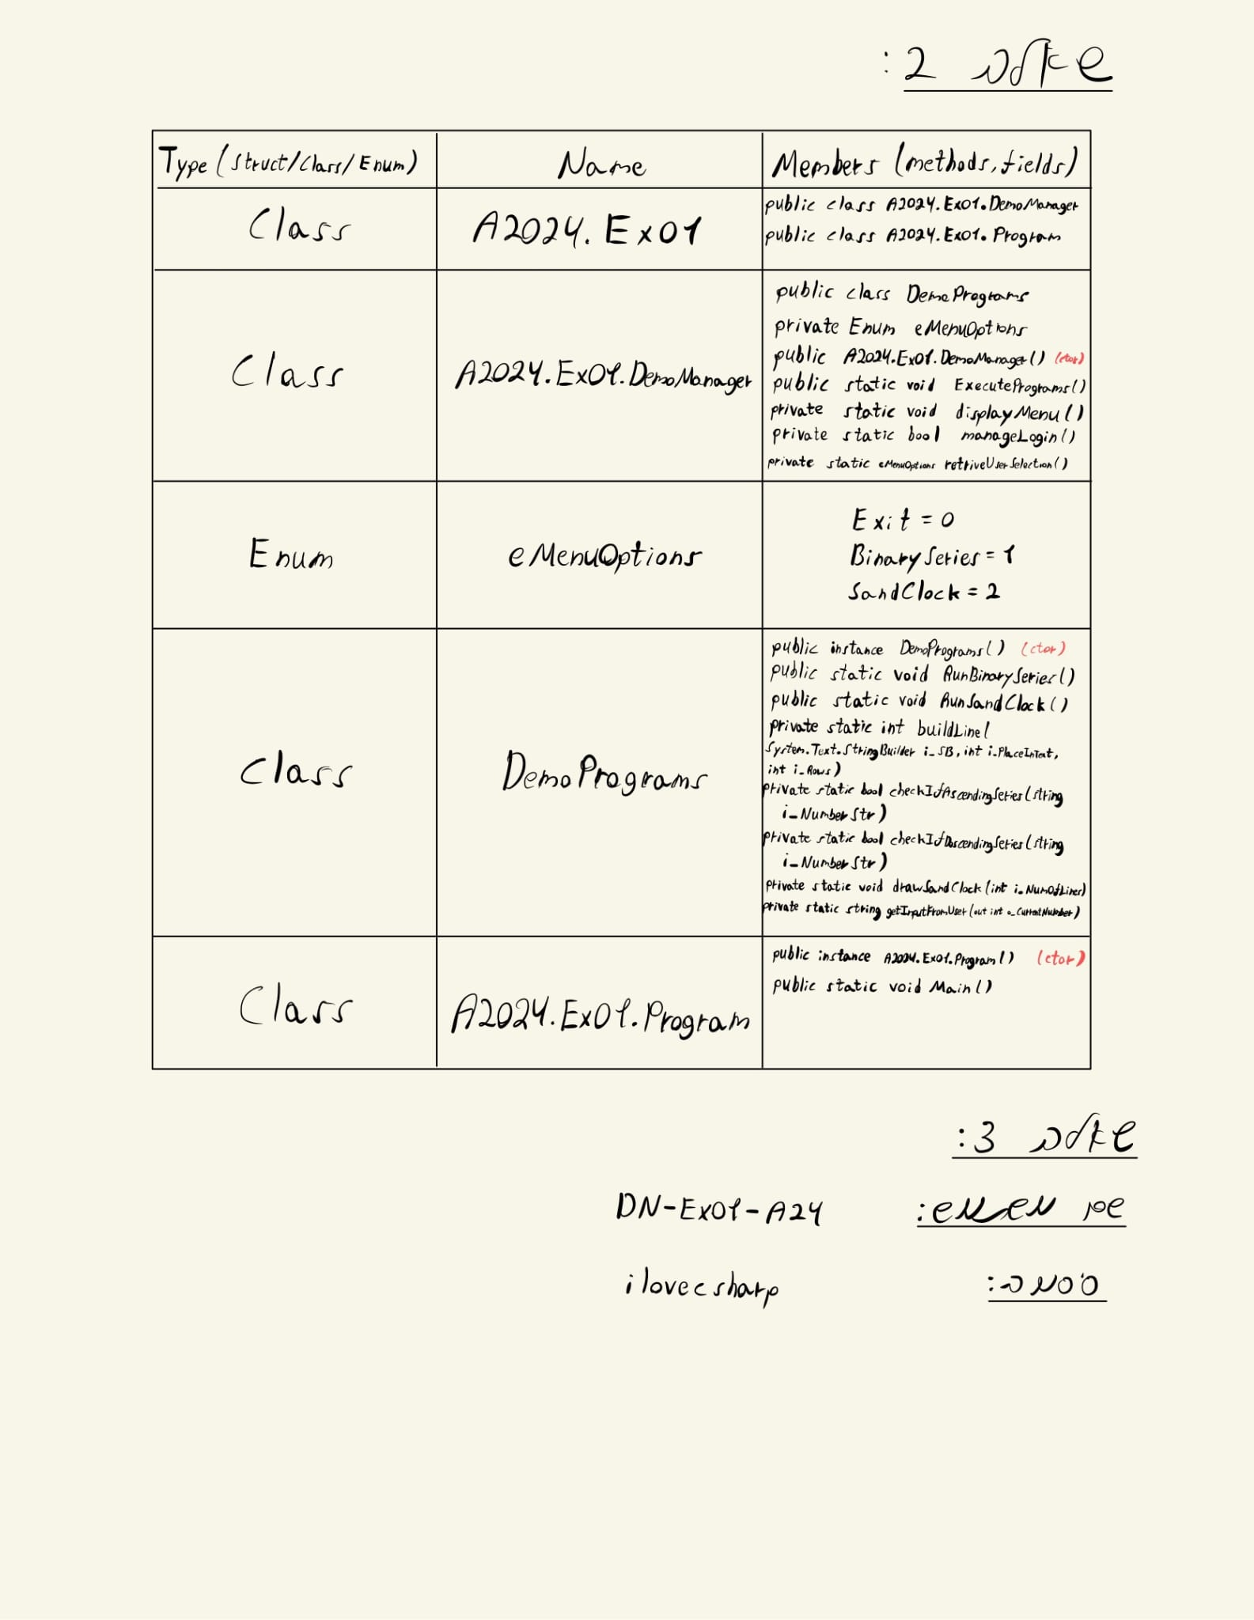

**Ex01_01**

1.

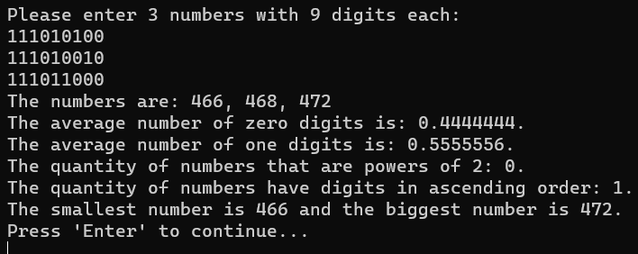

2.

3.

**Ex01_02**

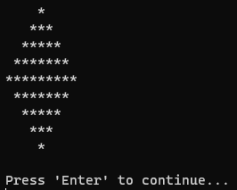

**Ex01_03**

1.

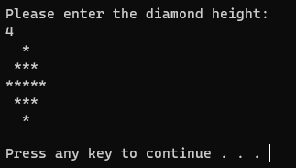

2.

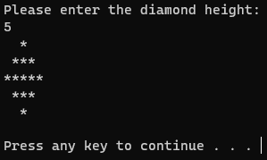

3.

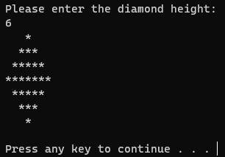

4.

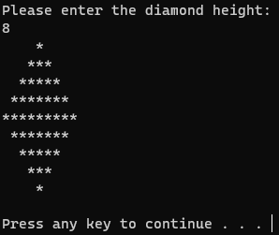

**Ex01_04**

1.

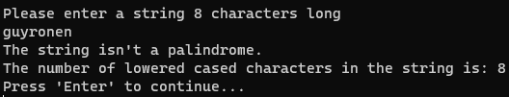

2.

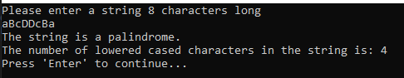

3.

4.

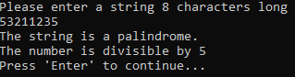

**Ex01_05**

