introduction

The number of external stimuli constantly surrounding us is countless. If we were aware all of the time to the feel of clothes on our bodies, to the annoying ticking sound of the clock, or to each and every little object located in our field of view, we could have never been able to focus on anything productive. Luckily for us, we humans become aware to just a small portion of the stimuli surrounding us, and mostly to those that are relevant and important at the time. Presumably, conscious awareness to only some preferred stimuli contributes to the individual’s functioning. That being the case, there are criteria in our mind that help distinguish which stimuli need to access our consciousness quickly, and which stimuli can stay unconscious. As our mind starts unconscious processing of the perceived stimulus, there are factors that will determine whether the processing of the stimulus should go on and become conscious or not. Those factors determining our conscious awareness are off great interest for anyone wanting to understand why we perceive the world us we do, and how it shapes our behavior.

Research into the factors determining conscious awareness is often conducted by examining the speed in which we become aware to different visual stimuli. The more quickly people become aware to a certain visual stimulus, we will consider it as being ‘prioritized’ more to consciousness. Certain methods allow us to measure the time it takes for a stimulus to access one’s consciousness, or to ‘break’ into consciousness. Chief among this is the continuous flash suppression (CFS) method, which is a presentation technique in which awareness can be dissociated from other cognitive processes. In this experiment, we used a recently developed method- repeated masked suppression (RMS)- that preserves the CFS’s ability in measuring breaking times, while allowing to conduct the experiment on the subjects’ computers through the internet, and not constraining us to experimenting only with special equipment in the lab.

In RMS, a target stimulus is rendered invisible by a rapidly alternating presentation between the stimulus itself and a high-contrast suppressor. Presentation parameters can be tuned for the stimulus to become visible after several hundred milliseconds (or even longer). Participants in such experiment are asked to respond as soon as they become aware of the stimulus by indicating the side of the screen in which they notice it appear- a paradigm called breaking RMS or bRMS. As mentioned, response times- or breaking times (BTs)- are a measure of how long it takes for participants to become aware of a stimulus, thus they are a measure of prioritization to consciousness.

Given the social importance of faces among humans, it is of little surprise that they have become widely used to examine prioritization for consciousness. Faces enjoy favored processing in the cognitive system, conscious or unconscious, and this processing is supported by exclusive neural circuitry. Previous studies have shown that faces are prioritized for consciousness compared to other objects. Moreover, different face qualities have been shown to effect prioritization for consciousness, among them face expression, gaze direction, personal familiarity and perceived social traits.

In this experiment, we used an approach rarely applied in the research field of prioritization for consciousness. We used a computational, data-driven approach, distinguished from hypothesis-driven approach, that enabled us to reveal the complete nature of the factors contributing to face prioritization, as we were unbound to any hypothesis presuming those factors. Usually, in a breaking suppression experiment, stimuli are selected by the researcher according to his hypothesis. Stimuli in those experiments differentiate along a hypothesized dimension(s) that the researcher believe as having a key role in contributing to BTs. While this method does enable a tight experimental control, it also limits any findings to the dimension(s) examined. Data-driven approach uses randomly generated stimuli, differentiating in a vast variety of dimensions. After attaining BTs for each of the stimuli, a priority dimension that contributes the most to BT can be revealed. This priority dimension will be richer and more comprehensive than the one that can be achieved using a hypothesis-driven method.

To be used as stimuli, 300 female and 300 male faces were selected from a broad pool of computer-generated human faces. This pool was derived from a large sample of real human faces, and the faces in it differ from one another in 50 orthogonal dimensions representing shape and 50 orthogonal dimensions representing reflectance, resembling the way real human faces differ from each other. Crucially, our stimuli were randomly drawn from a normal distribution on each of these parameters.

Previous study using this data-driven method, while using similar computer-generated faces, revealed a rich priority dimension that determines the speed in which different faces come into conscious awareness. This dimension was found to strongly correlate with the perceived degree of power/dominance of a face. That is, the more a face is perceived as powerful and dominant, the more prioritized to consciousness it tends to be. While it did show a reliable priority dimension for the participant group it examined, it is not unlikely that some details were lost due to the gender of the participants taking part in these experiments as well as the gender of the stimuli faces. A large majority of participants were female, and all stimuli were of male faces. As differences between genders in their priority dimensions are probable, in dependence or not to the stimuli gender, the priority dimension and conclusions found are limited to this combination only. In this experiment, we try to decipher the priority dimension differences between the different genders, while referring separately to stimuli of each gender.

Results

BTs of each of the 600 faces were measured in a sample of 114 participants using RMS. Each participant was allocated only female or only male stimuli, was informed about the gender of the faces he was going to see, and was instructed to indicate with a key press, as quickly as possible, whether the face appeared right or left of fixation point. On average, participants became aware of the faces after 2,138 ms (s.d.=823.6 ms). Age have been found to significantly correlate with BTs, r=0.26, P<0.01, as the older a participant the longer his average BT tends to be (Fig. 1). Neither participant gender (Fig. 2a) nor stimuli face gender (Fig. 2b) had any significant effect on BTs.

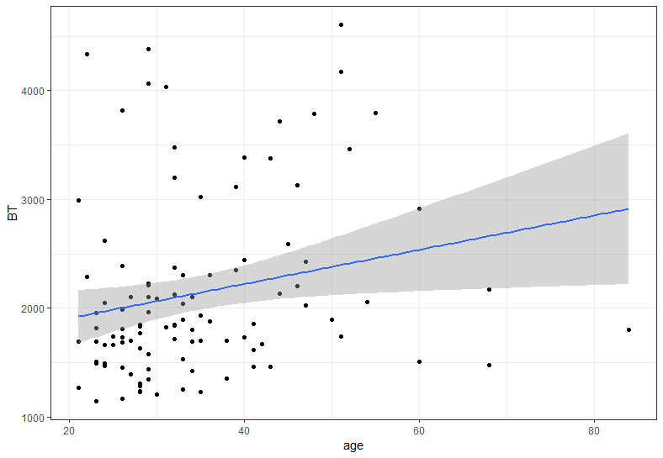

In order to find gender differences in face prioritization for consciousness, we used reverse correlation to model the facial properties predictive of BT. The vector of parameters defining the shape of each of the stimulus faces was multiplied by the average within-participant z score representing the BT of each stimulus face. These vectors were then averaged, producing a dimension we call the priority dimension, predictive of the time it will take for a face to become conscious. A priority dimension was produced for each one of the four groups examined: female stimuli perceived by female participants (referred to as “fXf”), female stimuli perceived by male participants (“fXm”), male stimuli perceived by male participants (“mXm”) and male stimuli perceived by female participants (“mXf”). These derived priority dimensions correlated significantly each with its own group’s BTs (r=0.39, p<0.001; r=0.41, p<0.001; r=0.36, p<0.001 and r=0.39, p<0.001, respectively), implying that the derived priority dimensions do in fact capture a large part of the variables contributing to prioritization for consciousness, explaining 15.21%, 16.81%, 12.96% and 15.21% of the variance in BTs, respectively. Thus, we identified four different dimensions in face-space that correlate with prioritization for conscious awareness, each for its appropriate gender perceiving male or female faces. remarkably, these dimensions are each exclusive to its own group, as no significant correlation was found between none of the four priority dimensions (all r’s<0.16, all p’s>0.29).

In order to examine the social meaningfulness of the priority dimension, in dependence of a person’s gender and the gender of the face perceived, we correlated each one of the priority dimensions with the two central social traits inferred from faces: trustworthiness and dominance.

*

*

Methods

**Participants**

We pre-specified a sample size of at least 100 participants for this experiment on the basis of previous studies applying reverse correlation to ratings of faces, and previous studies using the bRMS method.

#### Materials

#### Procedure

#### Statistics