# Setting up connection pool and datasource in GlassFish server

Start the server and login to admin console at http://localhost:4848

1. Select JDBC Connection Pools

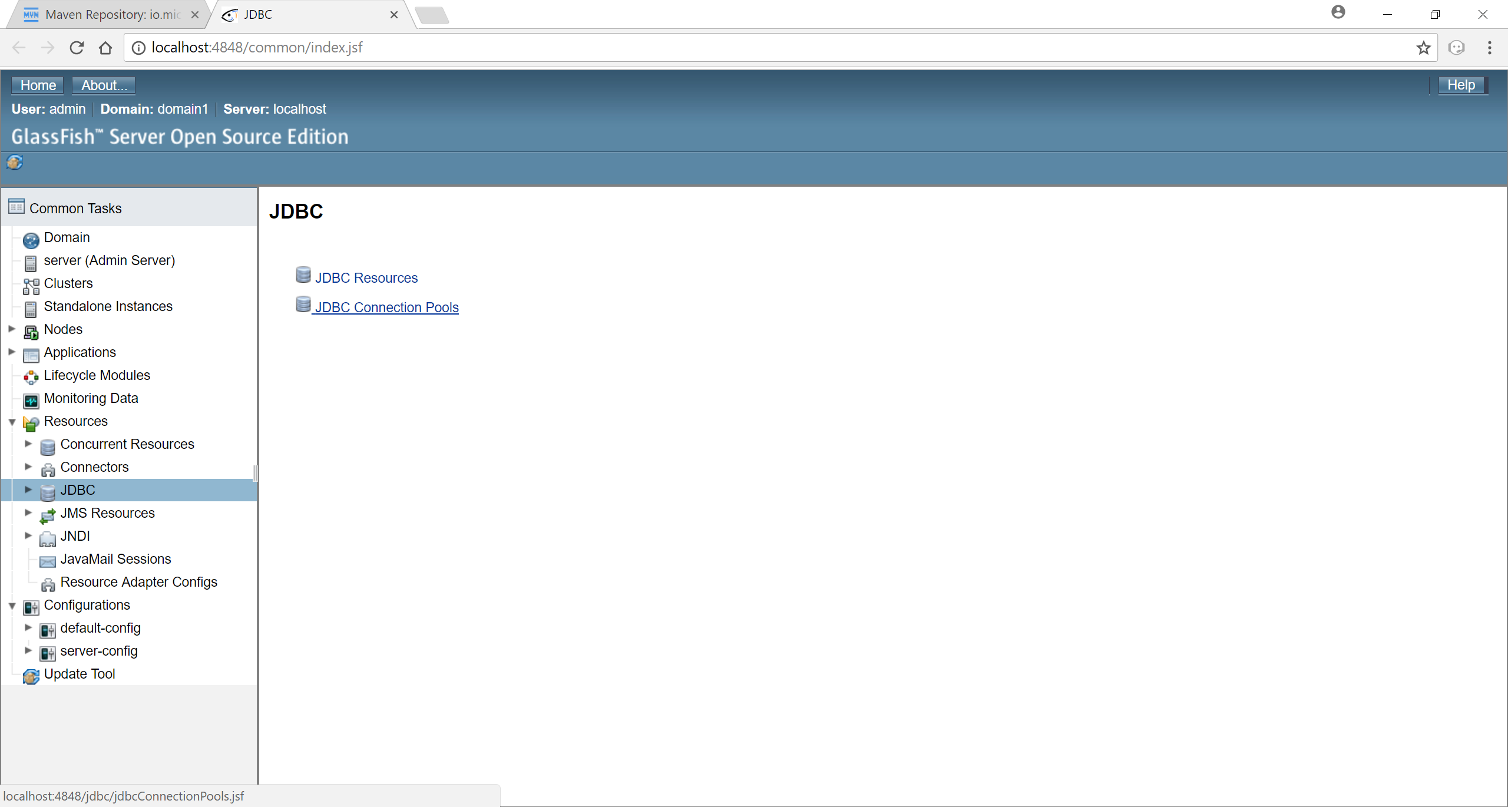

1. Click on New

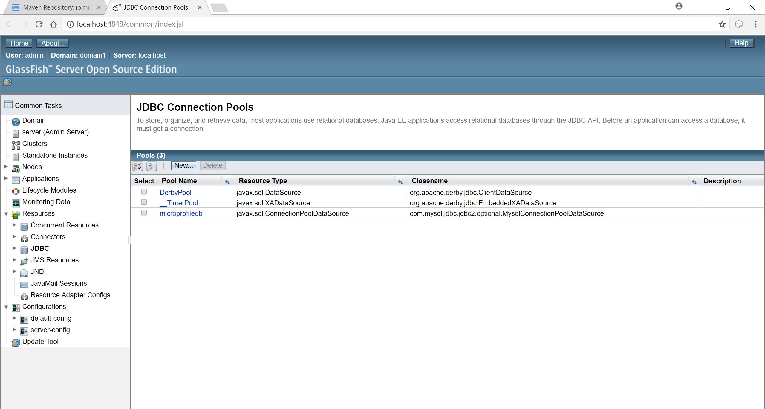

1. Fill in the details as suggested. Choose the Database vendor as per your setup and click Next.

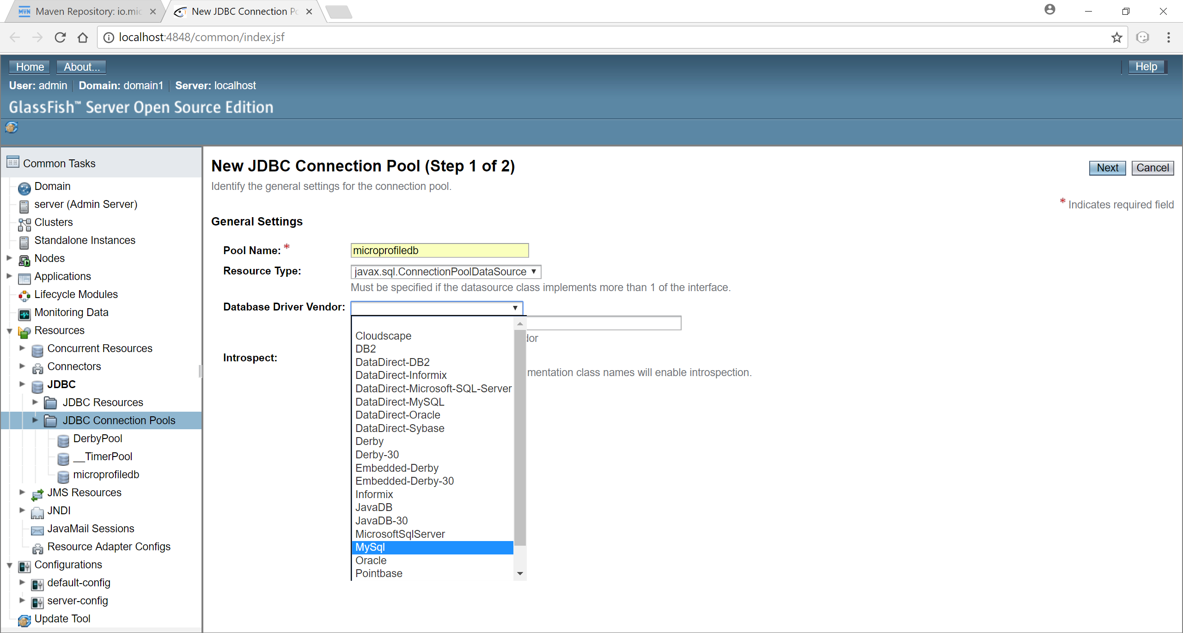

1. Scroll to the bottom of the page. Select all the properties and remove them as we need only 3 properties to make the connection possible.

url - jdbc:<DB vendor>://localhost:<port>/<DB name>

username and password.

Once these detials are filled. Click Finish.

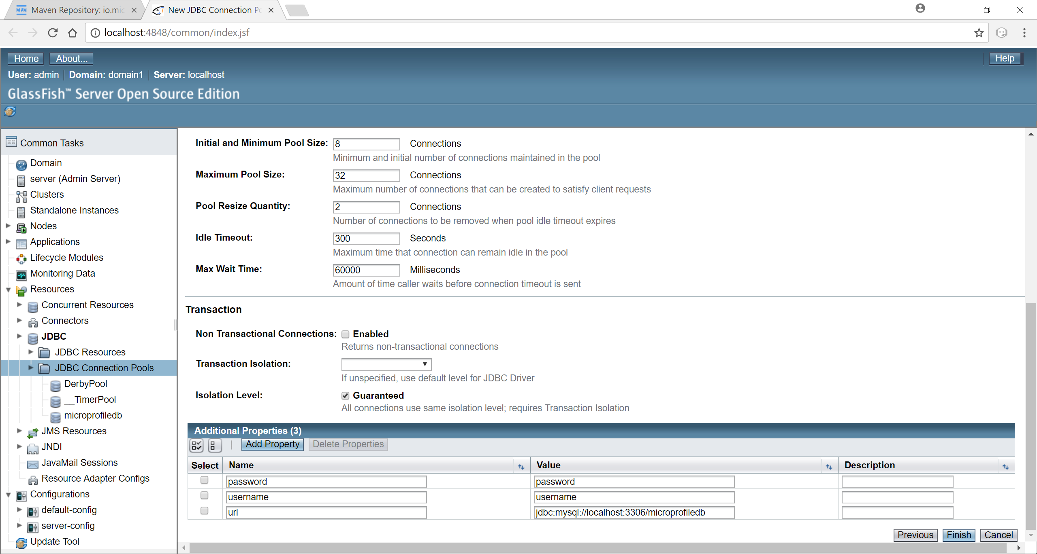

1. Test the newly create Connection pool by selecting and clicking on Ping. If you have placed the JDBC driver for the DB in the **domains\domain1\lib\ext** folder as mentioned, You wont be encountered with any error. If in case, the jar is in place but still getting the error. Please restart the server and try pinging again. The error which you encounter will be as below.

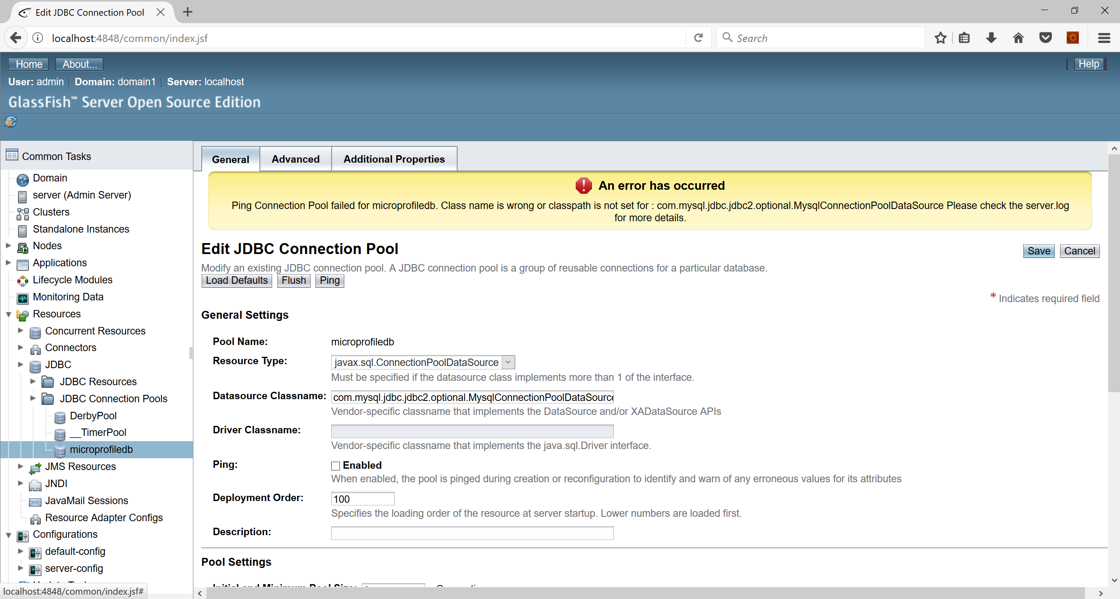

If you have placed the jar and provided the DB Connection details correctly then the ping should succeed confirming the connection to DB via server.

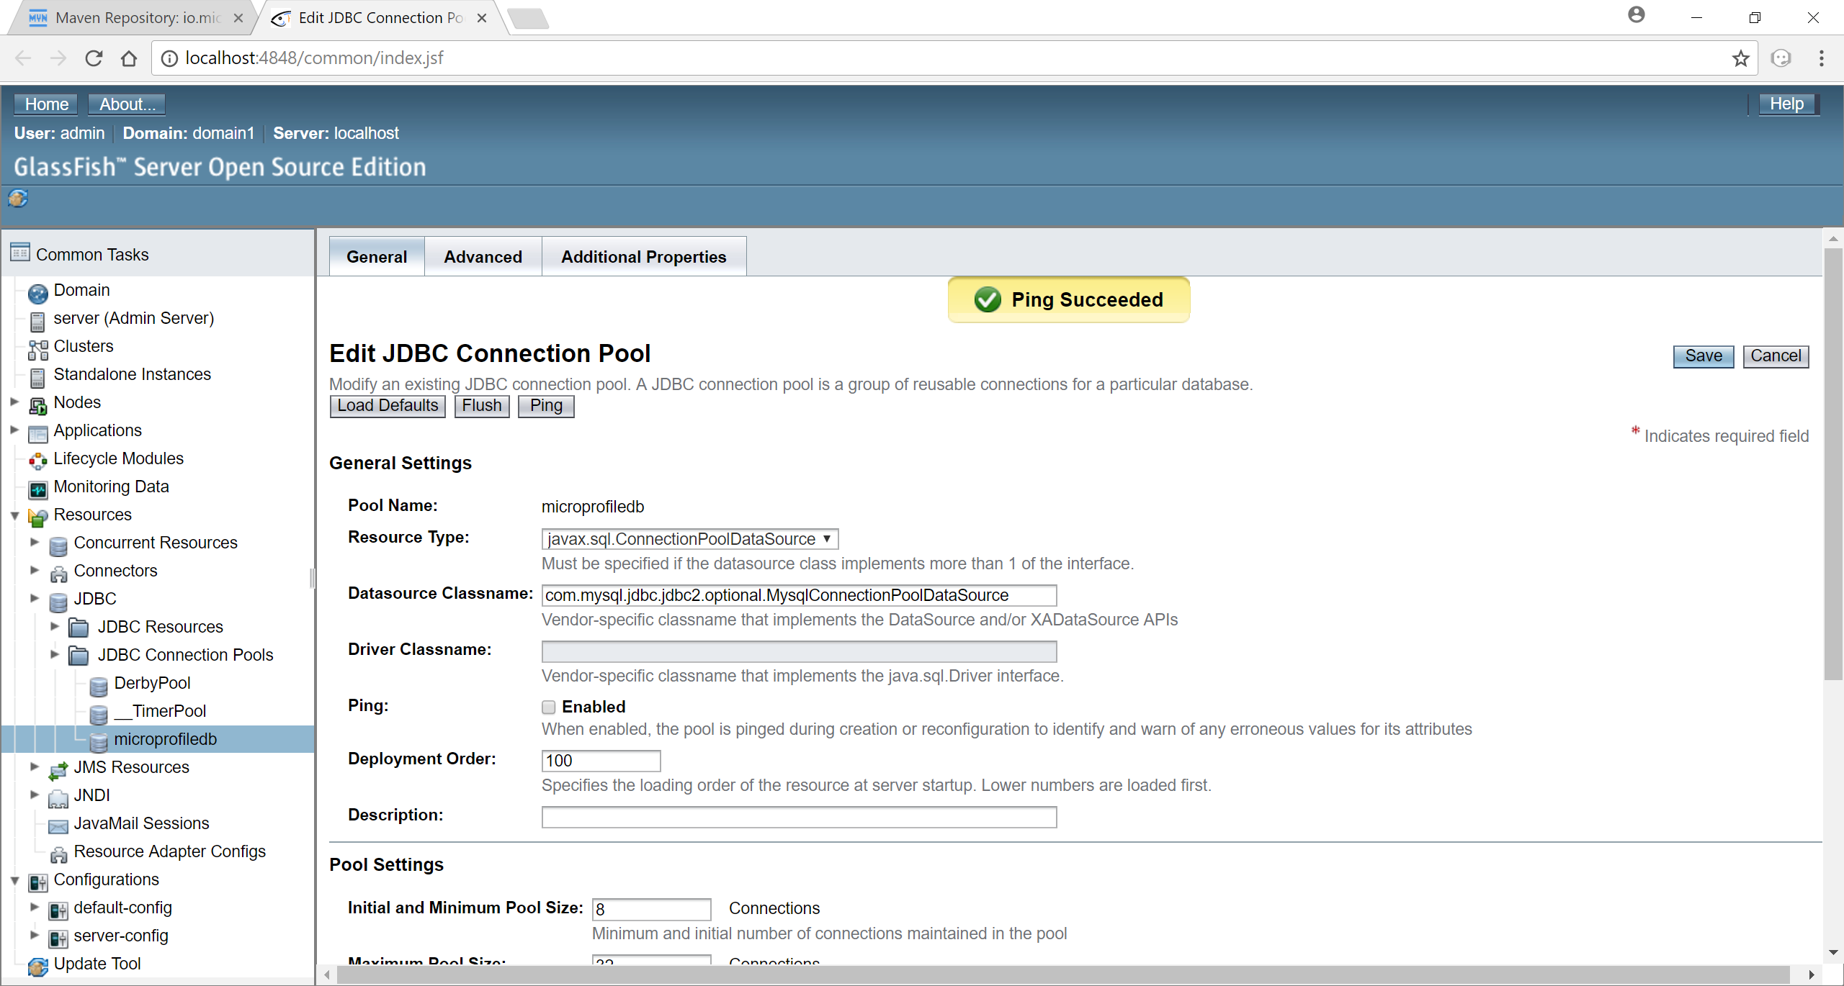

1. Set up a new JDBC resource by selecting the newly setup connection pool.

