**12/11/2014**

**SQLSchemaCompare**

**General**

SQLSchemaCompare is a tool designed to compare SQL Server databases schema between a source server and multiple target servers and find the schema differences if exist.

*SQLSchemaCompare* is a .NET 4.5 console application that can be scheduled to run automatically.

The application supports comparing schema between a single source server and an unlimited number of target servers while each task is carried out in a dedicated thread for optimal performance.

**Features**

* Detect schema differences and log to database table
  + Optionally create an xml report file in addition
* Generate a deployment script
  + (optionally in a future release)
* Deploy schema changes at target server(s)
  + (optionally in a future release)
* Deploy data changes at target server(s)
  + (optionally in a future release)

**Monitoring**

Having the differences between source and target servers logged to a table allows us to query the table and send a notification email if a change was logged since the last verification done.

Such a query can be executed from a monitoring tool or from an SQL Server Agent job

**Configuration**

There are 2 configuration files:

1. SQLSchemaCompare.exe.config
   1. Here is where you define the configuration of the server where the database table is located.
   2. Global settings related to the files generated by the application
2. Servers.config
   1. Here is where you define all the servers related information
   2. There are 4 main configurations:
      1. SourceServerSettings
         1. Defines the settings for the source server
      2. PackageOptions
         1. Defines the source package properties
         2. For the complete list of available properties see this link:
         3. <http://msdn.microsoft.com/en-us/library/microsoft.sqlserver.dac.dacextractoptions.aspx>
      3. DeployOptions
         1. Defines properties related to the 3 Actions that the program supports: DeployReport, Deploy, Script
         2. For the complete list of available properties see this link:
         3. <http://msdn.microsoft.com/en-us/library/microsoft.sqlserver.dac.dacdeployoptions.aspx>
      4. ServerSettings
         1. Defines the settings for the target servers.
         2. Each xml node represents a target server

**SQLSchemaCompare.exe.config:**

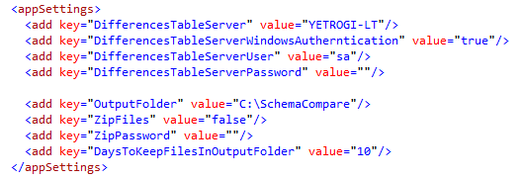

**Servers.config**

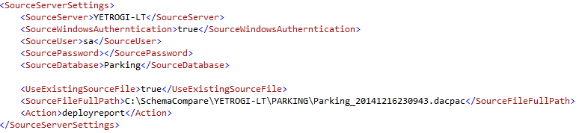

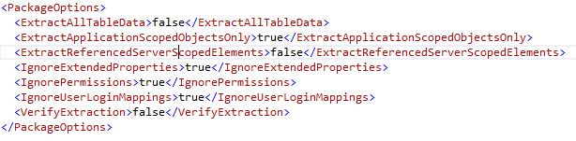

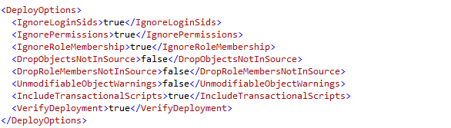

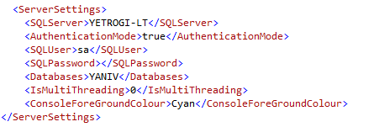

**Sample query**

/* Get all differences */

USE master; SET NOCOUNT ON;

SELECT

[id]

,[insert_time]

,[source_server]

,[source_database]

,[target_server]

,[target_database]

,[schema]

,[object]

,[operation]

,[type]

FROM [dbo].[SQLSchemaCompareDifferences] WHERE 1=1

AND type NOT IN ('SqlUser', 'SqlRole')

ORDER BY id;

/* Get all differences grouped by type */

SELECT

COUNT(*) cnt

,[type]

FROM [dbo].[SQLSchemaCompareDifferences] WHERE 1=1

AND type NOT IN ('SqlUser', 'SqlRole')

GROUP BY [type]

ORDER BY cnt;

**A query over *SQLSchemaCompareDifferences* differences table**

