Media SDK Windows DEMO Manuel

In P2P demo of following picture, duplex video connection and duplex audio connection are supported.

For A and B on two PC’s, there is one camera on one PC.

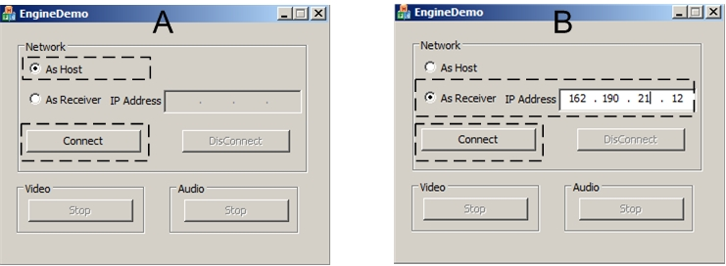

1. Connection
1) Click “As Host” on A. Click Connect button. You can see preview window.
2) Click “As receiver” on B. Enter into IP address of A. Click Connect button.

If connection is built, then you can see preview and remote two windows on one PC. At the same time, voice of remote PC can be sound.

Others:
The stop button can stop sending of video or audio. After you click it, you can click Start to resend data.
For video window, you can close window to close real video local Track or remote Track.
You can click disconnect to disconnect network link and destroy preview and remote windows.

