Media SDK iOS DEMO Manuel

This APP just supports the iOS6.0 and later device. And use experiences depend on the network status. There are two pages in the media SDK iOS demo APP.

The APP supports two modes.
Mode 1: As host mode: for setting the current device as host.
Mode 2: As receiver mode: for setting the current device as host.

The APP uses step.
For A and B on two iOS devices.
A
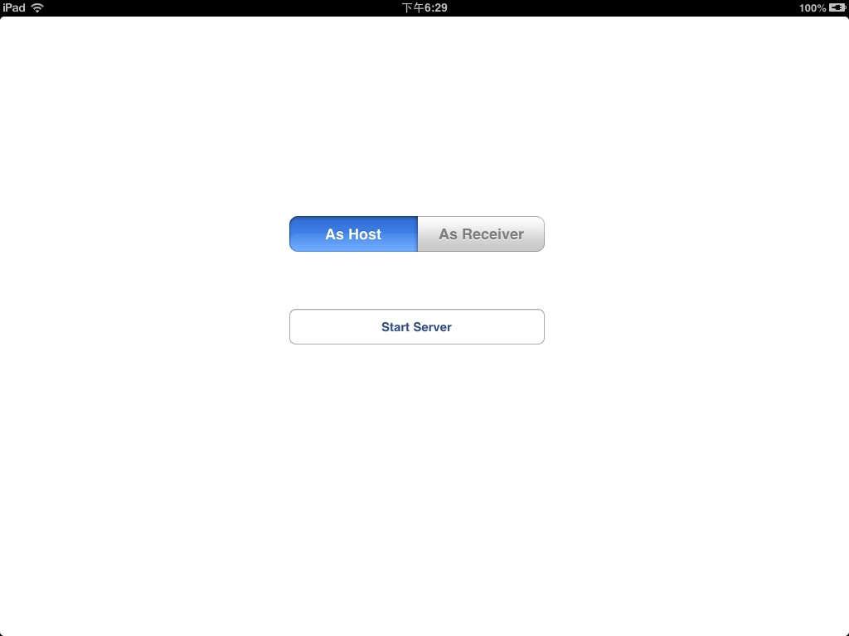
B
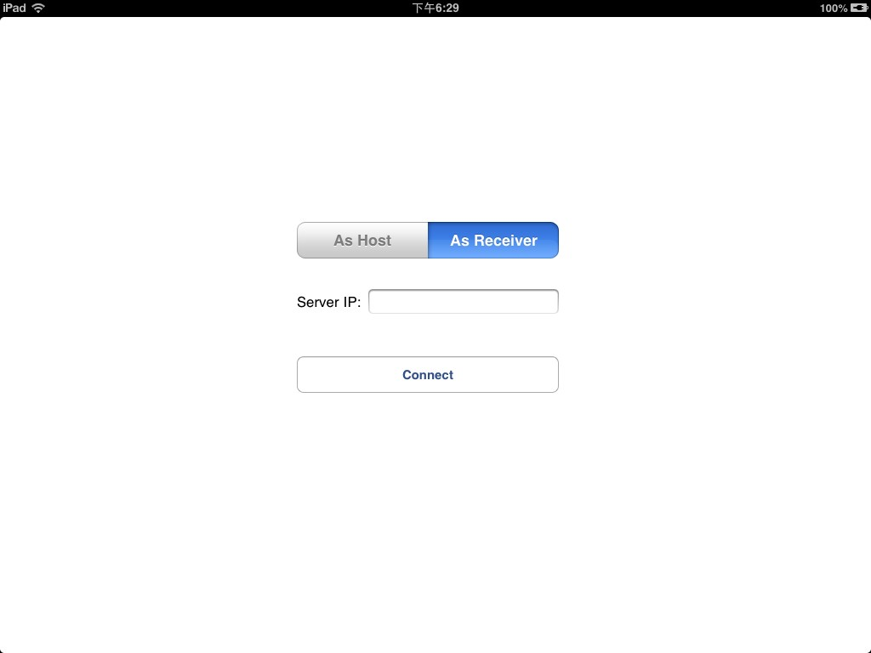
C
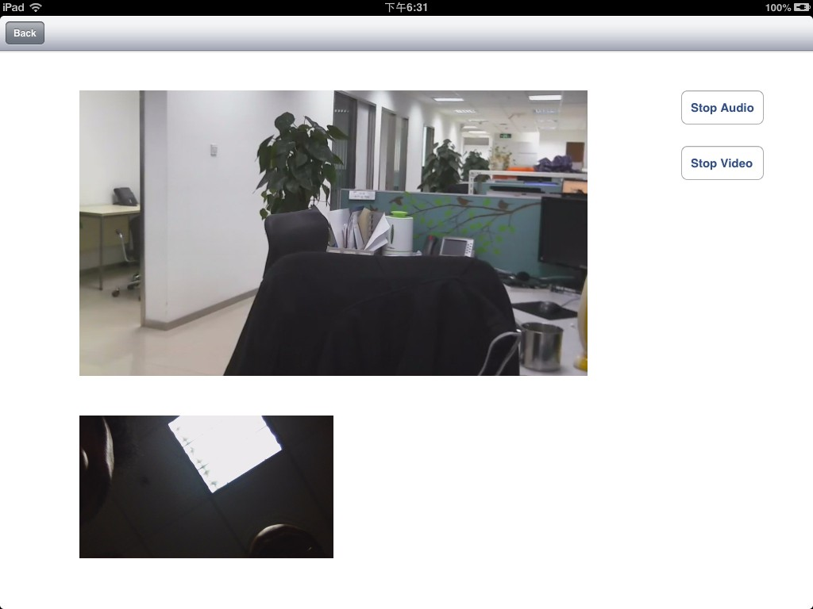
- Connection
  - Click “As Host” on A. Click “Start server” button. You can see an alert window.
  - Click “As receiver” on B. Enter into IP address of A. Click Connect button.
  - If connection is installed between host and receiver, the focus window switch to page C
- control video sending
  - Click the “Stop Video” button to stop the video sending, then the label of the button switch to “Start Video”.
  - Click the “Start Video” button to start the video sending, then the label of the button switch to “Start Video”.
- control audio sending
  - Click the “Stop Audio” button to stop the audio sending, then the label of the button switch to “Start Audio”.
  - Click the “Start Audio” button to start the audio sending, then the label of the button switch to “Stop Audio”.

