

FACULTY OF ENGINEERING

Second Semester of 2025/2026

ASSIGNMENT 2

COURSE NAME : DIGITAL SYSTEM

CODE : EEE3822

PROGRAMME : BACHELOR OF ELECTRICAL AND ELECTRONIC
ENGINEERING WITH HONOURS

LECTURER : DR ROSLINA BINTI MOHD SIDEK

DATE : 30rd June 2026

No. | Name | Matric No.
1. | PEH YAN JIUN | 229196
2. | LI XINYUAN | 226838

1. Project Title
FPGA-Based Custom Digital Door Lock System Using Verilog HDL, Reset-Mode Password Protection, 5-Second Lockout Timer, LED Status Indication, and 7-Segment Message Display.

2. Project Background

2.1 Description
This project designs and documents a protected password-based digital door lock using Verilog HDL on an Intel/Altera Cyclone IV FPGA development platform. The revised design uses the DE2-115 50 MHz clock, slide switches SW[9:0] as a 10-bit password input, SW16 as the password verification trigger, SW11 and SW12 as the reset-mode combination, and SW17 as the password reset/set switch only while reset mode is active.
The protection mechanism has been strengthened. Every incorrect password attempt starts a 5-second locked delay, and after five incorrect attempts the design enters lockdown. During reset mode, the seven-segment displays show RESET; during normal operation they show UNLOCKED, LOCKED, or blank according to the present state.
The implementation demonstrates synchronous sequential logic, register-based password storage, rising-edge detection, reset-mode gating, input comparison, failed-attempt counting, timer-based lockout, lockdown state control, seven-segment character decoding, simulation-based verification, synthesis review, and board-level implementation planning.

2.2 Market Research
The smart-lock market is expanding due to increased interest in smart homes, keyless entry, and connected security systems. Grand View Research reports that the global smart lock market was valued at USD 2,770.1 million in 2024 and is projected to reach USD 8,136.9 million by 2030, with a 19.7% compound annual growth rate from 2025 to 2030. Fortune Business Insights reports that the smart door lock market stood at USD 2.91 billion in 2024 and is projected to rise from USD 3.50 billion in 2025 to USD 13.44 billion by 2032.
Although the present FPGA design is an academic prototype rather than a commercial smart-lock product, it represents the fundamental password-verification logic used in electronic access-control systems.

2.3 Performance Highlight : Differentiation from Commercial Digital Lock Systems
The implementation of the access control logic as a finite state machine (FSM) directly synthesized onto FPGA fabric, rather than as firmware executing on a general-purpose microcontroller, introduces several architectural distinctions from commercially available digital door locks. This section discusses these distinctions with reference to the developed Verilog module.

Tiered Lockout Policy. A primary design feature is the explicit separation of failure-response behaviour into two distinct states, LOCKED and LOCKDOWN, rather than a single undifferentiated lockout condition. Upon an incorrect password entry, the system transitions to the LOCKED state and initiates a timed countdown governed by the lock_timer register, after which normal operation automatically resumes. However, should the cumulative count of failed attempts reach the parameterized threshold MAX_FAILED_ATTEMPTS, the system instead transitions to the LOCKDOWN state, a condition that does not self-clear on timer expiry and instead persists until an authorized password reset is performed. This two-tier escalation contrasts with many commercial keypad deadbolts, which typically implement either no lockout mechanism or a single fixed-duration delay irrespective of attempt history, offering comparatively limited resistance to sustained brute-force entry attempts.

Synthesis-Time Parameterization of Security Policy. The lockout duration and failure threshold are exposed as module parameters, LOCK_DELAY_SEC and MAX_FAILED_ATTEMPTS, computed against the system clock frequency via LOCK_DELAY_CYCLES = CLK_FREQ_HZ × LOCK_DELAY_SEC. This permits the security policy to be defined and verified at design time rather than being fixed within an opaque, vendor-supplied firmware image. In commercial products, equivalent timing behaviour is typically governed by software timers within proprietary firmware, which is not generally inspectable, auditable, or formally verifiable by the end user or a third party.

Deterministic Verification via Simulation. Because the lockout interval is derived directly from a known clock frequency and expressed in clock cycles, the timing behaviour of the system is exact and can be formally verified through cycle-accurate simulation, for instance using ModelSim, prior to physical deployment. This stands in contrast to firmware-based timing in commercial locks, which relies on real-time clock or software-timer behaviour that is generally not amenable to independent verification by the user.

Deliberate-Action Reset Interlock. Reprogramming of the stored password is gated behind a compound condition, reset_mode = SW[11] & SW[12], requiring two switches to be held concurrently before a rising edge on SW17 is recognized as a valid reset trigger. This interlock structure reduces the likelihood of accidental or incidental password reconfiguration. Several budget commercial digital locks, by comparison, permit reprogramming via a single button held for a fixed duration, a mechanism more susceptible to unintended triggering.
Hardware-Enforced Execution Model. Perhaps the most fundamental distinction lies in the execution substrate itself. The presented design is synthesized as fixed combinational and sequential logic directly on the FPGA, with no underlying operating system, interpreter, or updatable firmware layer. Consequently, the system's behaviour is not subject to runtime corruption from software faults, is not exposed to firmware-update attack vectors, and cannot enter an undefined state as a result of an interrupted instruction sequence, conditions that are architecturally possible in microcontroller-based commercial locks executing software on a general-purpose processor core.
It should be noted that the present implementation accepts the password as a static 10-bit configuration on switches SW[9:0] rather than as a sequentially entered, debounced numeric code via a keypad interface. This represents a usability divergence from typical commercial products, where passwords are conventionally entered as a temporal sequence of keypresses. Extension of the present design to incorporate sequential keypad entry with debounce logic is identified as a direction for future work, and would bring the input modality into closer alignment with commercial deployment while preserving the hardware-level security guarantees discussed above.

3. Technical Specifications

3.1 Target Hardware
Item | Specification
FPGA Family | Intel / Altera Cyclone IV E
FPGA Device | EP4CE115F29C7
Board Type | DE2-115 / Cyclone IV development platform
Design Language | Verilog HDL
Top Module | custom_FPGA_door_lock
Clock Period | 20 ns
Operating Frequency | 50 MHz
Input Interface | CLOCK_50, SW[9:0] password input, SW11 + SW12 reset-mode combination, SW16 verify trigger, and SW17 reset/set trigger
Output Interface | 9 green LEDs, 18 red LEDs, and 8 seven-segment displays showing UNLOCKED, LOCKED, RESET, or blank

4. Design Methodology and System Architecture

4.1 Top-Level System Architecture
The updated architecture uses slide switches as synchronous command and password inputs. SW11 and SW12 must both be ON to enter password reset mode. Only in this mode can SW17 store SW[9:0] as the new password and clear the failed-attempt counter. In normal mode, SW16 verifies the entered password when the 5-second penalty timer is inactive and the device is not in lockdown.
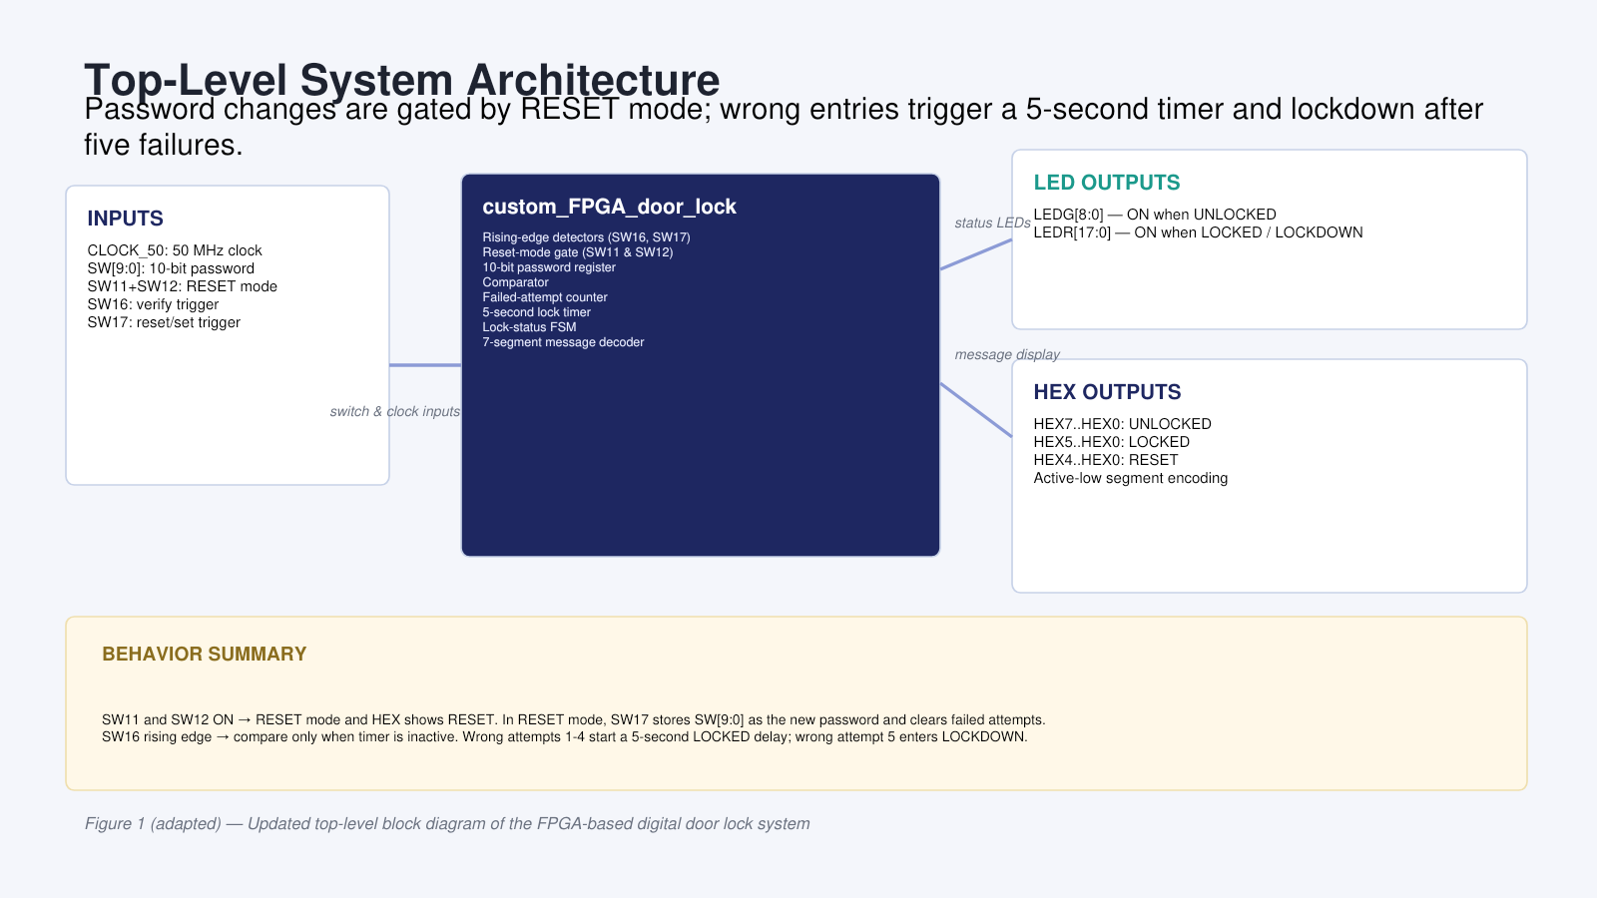
Figure 1. Updated top-level block diagram of the FPGA-based digital door lock system with reset-mode gating, timer lockout, failed-attempt counting, and lockdown control.

4.2 Flowchart of Verilog Code Operation
The flowchart summarizes initialization, reset-mode entry using SW11 and SW12, reset/set operation using SW17, password verification using SW16, 5-second penalty timing, failed-attempt counting, lockdown after five incorrect attempts, and state-based LED/HEX display operation.
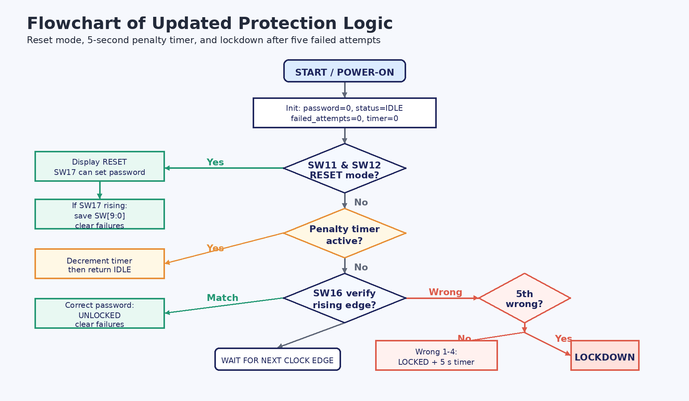
Figure 3. Flowchart of the updated Verilog code operation, including RESET mode, timer penalty, and lockdown behavior.

4.3 RTL Design
The following RTL source code is the updated design-under-test. It extends the previous custom_FPGA_door_lock top module with reset-mode password control, a 5-second lockout timer, a failed-attempt counter, and a lockdown state after five incorrect password entries.
module custom_FPGA_door_lock #(
parameter integer CLK_FREQ_HZ = 50000000,
parameter integer LOCK_DELAY_SEC = 5,
parameter integer MAX_FAILED_ATTEMPTS = 5
) (
input CLOCK_50, // DE2-115 50 MHz clock
input [17:0] SW, // SW[9:0] password, SW11+SW12 reset mode, SW16 verify, SW17 reset/set
output reg [8:0] LEDG, // Green LEDs
output reg [17:0] LEDR, // Red LEDs
output reg [6:0] HEX0,
output reg [6:0] HEX1,
output reg [6:0] HEX2,
output reg [6:0] HEX3,
output reg [6:0] HEX4,
output reg [6:0] HEX5,
output reg [6:0] HEX6,
output reg [6:0] HEX7
);
localparam [2:0] IDLE = 3'b000;
localparam [2:0] UNLOCKED = 3'b001;
localparam [2:0] LOCKED = 3'b010;
localparam [2:0] LOCKDOWN = 3'b011;
localparam integer LOCK_DELAY_CYCLES = CLK_FREQ_HZ * LOCK_DELAY_SEC;
reg [9:0] saved_password = 10'b0000000000;
reg [2:0] lock_status = IDLE;
reg [2:0] failed_attempts = 3'd0;
reg [31:0] lock_timer = 32'd0;
reg timer_active = 1'b0;
reg sw16_prev = 1'b0;
reg sw17_prev = 1'b0;
wire sw16_rising;
wire sw17_rising;
wire reset_mode;
assign sw16_rising = SW[16] & ~sw16_prev;
assign sw17_rising = SW[17] & ~sw17_prev;
assign reset_mode = SW[11] & SW[12];
always @(posedge CLOCK_50) begin
sw16_prev <= SW[16];
sw17_prev <= SW[17];
if (reset_mode == 1'b1) begin
timer_active <= 1'b0;
lock_timer <= 32'd0;
if (sw17_rising == 1'b1) begin
saved_password <= SW[9:0];
failed_attempts <= 3'd0;
lock_status <= IDLE;
end
end
else if (timer_active == 1'b1) begin
if (lock_timer > 32'd1) begin
lock_timer <= lock_timer - 32'd1;
end
else begin
lock_timer <= 32'd0;
timer_active <= 1'b0;
if (lock_status != LOCKDOWN) begin
lock_status <= IDLE;
end
end
end
else if (lock_status != LOCKDOWN && sw16_rising == 1'b1) begin
if (SW[9:0] == saved_password) begin
lock_status <= UNLOCKED;
failed_attempts <= 3'd0;
end
else begin
if (failed_attempts == MAX_FAILED_ATTEMPTS - 1) begin
failed_attempts <= failed_attempts + 3'd1;
lock_status <= LOCKDOWN;
timer_active <= 1'b0;
lock_timer <= 32'd0;
end
else begin
failed_attempts <= failed_attempts + 3'd1;
lock_status <= LOCKED;
timer_active <= 1'b1;
lock_timer <= LOCK_DELAY_CYCLES;
end
end
end
end
always @(*) begin
LEDG = 9'b000000000;
LEDR = 18'b000000000000000000;
if (reset_mode == 1'b1) begin
LEDG = 9'b000000000;
LEDR = 18'b000000000000000000;
end
else begin
case (lock_status)
UNLOCKED: begin
LEDG = 9'b111111111;
LEDR = 18'b000000000000000000;
end
LOCKED, LOCKDOWN: begin
LEDG = 9'b000000000;
LEDR = 18'b111111111111111111;
end
default: begin
LEDG = 9'b000000000;
LEDR = 18'b000000000000000000;
end
endcase
end
end
always @(*) begin
if (reset_mode == 1'b1) begin
HEX7 = seg7_char(" ");
HEX6 = seg7_char(" ");
HEX5 = seg7_char(" ");
HEX4 = seg7_char("R");
HEX3 = seg7_char("E");
HEX2 = seg7_char("S");
HEX1 = seg7_char("E");
HEX0 = seg7_char("T");
end
else begin
case (lock_status)
UNLOCKED: begin
HEX7 = seg7_char("U");
HEX6 = seg7_char("N");
HEX5 = seg7_char("L");
HEX4 = seg7_char("O");
HEX3 = seg7_char("C");
HEX2 = seg7_char("K");
HEX1 = seg7_char("E");
HEX0 = seg7_char("D");
end
LOCKED, LOCKDOWN: begin
HEX7 = seg7_char(" ");
HEX6 = seg7_char(" ");
HEX5 = seg7_char("L");
HEX4 = seg7_char("O");
HEX3 = seg7_char("C");
HEX2 = seg7_char("K");
HEX1 = seg7_char("E");
HEX0 = seg7_char("D");
end
default: begin
HEX7 = seg7_char(" ");
HEX6 = seg7_char(" ");
HEX5 = seg7_char(" ");
HEX4 = seg7_char(" ");
HEX3 = seg7_char(" ");
HEX2 = seg7_char(" ");
HEX1 = seg7_char(" ");
HEX0 = seg7_char(" ");
end
endcase
end
end
function [6:0] seg7_char;
input [7:0] ch;
begin
case (ch)
"U": seg7_char = 7'b1000001;
"N": seg7_char = 7'b1101010;
"L": seg7_char = 7'b1000111;
"O": seg7_char = 7'b1000000;
"C": seg7_char = 7'b1000110;
"K": seg7_char = 7'b1001000;
"E": seg7_char = 7'b0000110;
"D": seg7_char = 7'b0100001;
"R": seg7_char = 7'b0101111;
"S": seg7_char = 7'b0010010;
"T": seg7_char = 7'b0000111;
" ": seg7_char = 7'b1111111;
default: seg7_char = 7'b1111111;
endcase
end
endfunction
endmodule

4.4 Testbench for Functional Verification
`timescale 1ns/1ps
module tb_custom_FPGA_door_lock_final;
reg CLOCK_50;
reg [17:0] SW;
wire [8:0] LEDG;
wire [17:0] LEDR;
wire [6:0] HEX0;
wire [6:0] HEX1;
wire [6:0] HEX2;
wire [6:0] HEX3;
wire [6:0] HEX4;
wire [6:0] HEX5;
wire [6:0] HEX6;
wire [6:0] HEX7;
integer pass_count;
integer fail_count;
custom_FPGA_door_lock #(
.CLK_FREQ_HZ(10),
.LOCK_DELAY_SEC(5),
.MAX_FAILED_ATTEMPTS(5)
) dut (
.CLOCK_50(CLOCK_50),
.SW(SW),
.LEDG(LEDG),
.LEDR(LEDR),
.HEX0(HEX0),
.HEX1(HEX1),
.HEX2(HEX2),
.HEX3(HEX3),
.HEX4(HEX4),
.HEX5(HEX5),
.HEX6(HEX6),
.HEX7(HEX7)
);
always #10 CLOCK_50 = ~CLOCK_50;
function [6:0] seg7_char;
input [7:0] ch;
begin
case (ch)
"U": seg7_char = 7'b1000001;
"N": seg7_char = 7'b1101010;
"L": seg7_char = 7'b1000111;
"O": seg7_char = 7'b1000000;
"C": seg7_char = 7'b1000110;
"K": seg7_char = 7'b1001000;
"E": seg7_char = 7'b0000110;
"D": seg7_char = 7'b0100001;
"R": seg7_char = 7'b0101111;
"S": seg7_char = 7'b0010010;
"T": seg7_char = 7'b0000111;
" ": seg7_char = 7'b1111111;
default: seg7_char = 7'b1111111;
endcase
end
endfunction
task pulse_verify;
input [9:0] entered_password;
begin
@(negedge CLOCK_50);
SW[9:0] = entered_password;
SW[16] = 1'b1;
@(negedge CLOCK_50);
SW[16] = 1'b0;
@(posedge CLOCK_50);
#1;
end
endtask
task pulse_reset_set;
input [9:0] new_password;
begin
@(negedge CLOCK_50);
SW[9:0] = new_password;
SW[17] = 1'b1;
@(negedge CLOCK_50);
SW[17] = 1'b0;
@(posedge CLOCK_50);
#1;
end
endtask
task enter_reset_mode;
begin
@(negedge CLOCK_50);
SW[11] = 1'b1;
SW[12] = 1'b1;
@(posedge CLOCK_50);
#1;
end
endtask
task exit_reset_mode;
begin
@(negedge CLOCK_50);
SW[11] = 1'b0;
SW[12] = 1'b0;
@(posedge CLOCK_50);
#1;
end
endtask
task wait_lock_delay;
integer i;
begin
for (i = 0; i < 55; i = i + 1) begin
@(posedge CLOCK_50);
end
#1;
end
endtask
task check_outputs;
input [8:0] expected_ledg;
input [17:0] expected_ledr;
input [6:0] e7;
input [6:0] e6;
input [6:0] e5;
input [6:0] e4;
input [6:0] e3;
input [6:0] e2;
input [6:0] e1;
input [6:0] e0;
input [160*8-1:0] test_name;
begin
if (LEDG === expected_ledg &&
LEDR === expected_ledr &&
HEX7 === e7 && HEX6 === e6 && HEX5 === e5 && HEX4 === e4 &&
HEX3 === e3 && HEX2 === e2 && HEX1 === e1 && HEX0 === e0) begin
pass_count = pass_count + 1;
$display("PASS: %0s at time %0t", test_name, $time);
end
else begin
fail_count = fail_count + 1;
$display("FAIL: %0s at time %0t", test_name, $time);
$display("LEDG=%b LEDR=%b", LEDG, LEDR);
$display("HEX7..HEX0=%b %b %b %b %b %b %b %b",
HEX7, HEX6, HEX5, HEX4, HEX3, HEX2, HEX1, HEX0);
end
end
endtask
task expect_blank;
input [160*8-1:0] test_name;
begin
check_outputs(9'b0, 18'b0,
seg7_char(" "), seg7_char(" "), seg7_char(" "), seg7_char(" "),
seg7_char(" "), seg7_char(" "), seg7_char(" "), seg7_char(" "),
test_name);
end
endtask
task expect_reset;
input [160*8-1:0] test_name;
begin
check_outputs(9'b0, 18'b0,
seg7_char(" "), seg7_char(" "), seg7_char(" "), seg7_char("R"),
seg7_char("E"), seg7_char("S"), seg7_char("E"), seg7_char("T"),
test_name);
end
endtask
task expect_locked;
input [160*8-1:0] test_name;
begin
check_outputs(9'b0, 18'b111111111111111111,
seg7_char(" "), seg7_char(" "), seg7_char("L"), seg7_char("O"),
seg7_char("C"), seg7_char("K"), seg7_char("E"), seg7_char("D"),
test_name);
end
endtask
task expect_unlocked;
input [160*8-1:0] test_name;
begin
check_outputs(9'b111111111, 18'b0,
seg7_char("U"), seg7_char("N"), seg7_char("L"), seg7_char("O"),
seg7_char("C"), seg7_char("K"), seg7_char("E"), seg7_char("D"),
test_name);
end
endtask
initial begin
CLOCK_50 = 1'b0;
SW = 18'b0;
pass_count = 0;
fail_count = 0;
repeat (2) @(posedge CLOCK_50);
#1;
expect_blank("Initial IDLE state");
pulse_reset_set(10'b1010101010);
expect_blank("SW17 ignored outside reset mode");
enter_reset_mode();
expect_reset("SW11 and SW12 enter RESET mode");
pulse_reset_set(10'b1010101010);
expect_reset("Password set while RESET mode is active");
exit_reset_mode();
expect_blank("Exit RESET mode returns to IDLE");
pulse_verify(10'b1010101010);
expect_unlocked("Correct password unlocks device");
pulse_verify(10'b1110001110);
expect_locked("Incorrect password starts 5-second penalty");
pulse_verify(10'b1010101010);
expect_locked("Verify trigger ignored during penalty timer");
wait_lock_delay();
expect_blank("Penalty timer expires and returns to IDLE");
pulse_verify(10'b0000000001);
expect_locked("Wrong attempt 2");
wait_lock_delay();
pulse_verify(10'b0000000010);
expect_locked("Wrong attempt 3");
wait_lock_delay();
pulse_verify(10'b0000000011);
expect_locked("Wrong attempt 4");
wait_lock_delay();
pulse_verify(10'b0000000100);
expect_locked("Wrong attempt 5 triggers lockdown");
wait_lock_delay();
pulse_verify(10'b1010101010);
expect_locked("Correct password ignored during lockdown");
enter_reset_mode();
pulse_reset_set(10'b0011110011);
expect_reset("RESET mode clears lockdown and failed counter");
exit_reset_mode();
pulse_verify(10'b0011110011);
expect_unlocked("New reset password unlocks device");
$display("Simulation complete: pass_count=%0d fail_count=%0d", pass_count, fail_count);
if (fail_count == 0) begin
$display("ALL TESTS PASSED");
end
else begin
$display("TESTS FAILED");
end
$stop;
end
endmodule

4.5 Simulation Results
The directed simulation sequence should produce PASS messages for reset-mode entry, SW17 rejection outside reset mode, password reset inside reset mode, correct-password acceptance, incorrect-password rejection with a 5-second penalty timer, ignored verification during the timer, lockdown after five wrong attempts, and recovery by entering reset mode and storing a new password.
Test | Stimulus / operation | Expected LEDG | Expected LEDR | Expected HEX display | Verification result
1 | Pulse SW17 outside reset mode | all OFF | all OFF | Blank | Password reset is ignored unless SW11 and SW12 are ON.
2 | Turn SW11 and SW12 ON | all OFF | all OFF | RESET | Reset mode is entered and RESET is displayed.
3 | Set password in reset mode, then verify correct password | all ON | all OFF | UNLOCKED | Password is stored and accepted.
4 | Enter one incorrect password | all OFF | all ON | LOCKED | 5-second penalty timer starts.
5 | Enter five incorrect passwords total | all OFF | all ON | LOCKED | Device enters lockdown after the fifth wrong attempt.
6 | Enter reset mode, set a new password, then verify it | all ON | all OFF | UNLOCKED | Lockdown and failed-attempt counter are cleared.

No. | Verification point | Expected result
1 | SW17 is pulsed while SW11 and SW12 are OFF | Password reset is ignored and the display remains blank.
2 | SW11 and SW12 are both ON | RESET mode is entered and the seven-segment display shows RESET.
3 | Correct password is entered through SW16 | LEDG turns ON, LEDR turns OFF, and HEX displays UNLOCKED.
4 | Incorrect password is entered | LEDR turns ON, HEX displays LOCKED, and the 5-second timer starts.
5 | SW16 is pulsed while the timer is active | Verification is ignored until the penalty timer finishes.
6 | Five incorrect passwords are entered | The device enters lockdown and remains locked.
7 | RESET mode is used after lockdown | The failed counter is cleared and a new password can unlock the device.
8 | Final simulation counter check | Expected final result is pass_count > 0 and fail_count = 0.

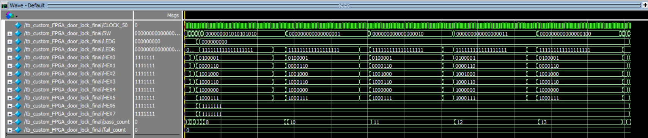

5. Conclusion
The FPGA-based digital door lock was updated using the protected custom_FPGA_door_lock Verilog module. The design stores a 10-bit password, requires SW11 and SW12 to enter reset mode before SW17 can reset the password, uses SW16 for verification, applies a 5-second timer after every incorrect attempt, enters lockdown after five incorrect attempts, lights green LEDs for an unlocked state, lights red LEDs for locked or lockdown states, and displays UNLOCKED, LOCKED, or RESET across the seven-segment displays.

6. References
1. Grand View Research. (2025). Smart lock market size and outlook, 2025-2030. https://www.grandviewresearch.com/horizon/outlook/smart-lock-market-size/global
2. Fortune Business Insights. (2025). Smart door lock market size, share and industry analysis. https://www.fortunebusinessinsights.com/industry-reports/smart-door-lock-market-100215
3. Intel Corporation. (n.d.). Cyclone IV device handbook and device documentation. https://www.intel.com
4. Ahmed, M. S., Mukherjee, R., Ghosh, P., Nayemuzzaman, S., & Sundaravadivel, P. (2022). FPGA-based assistive framework for smart home automation. In 2022 IEEE 15th Dallas Circuit and System Conference (DCAS) (pp. 1-2). IEEE. https://doi.org/10.1109/DCAS53974.2022.9845625
5. Singh, S. N., Kumar, J., Singh, R. P., & Kumar, S. (2009). FPGA based autonomous vehicle locking system-A smart door lock. International Journal of Recent Trends in Engineering, 2(4), 65-67.

7. Appendix
APPENDIX FOR FPGA DIGITAL DOOR LOCK

