**Contents**

Preface

Software version

1. Copy the SSH keys from gitlab to bitBucket

1.1 copy all your SSH Keys in gitlab

1.2 paste copied SSH key from last step to bitBucket one by one

2. set pull & push URL

3. Migrate from old repo to current repo

4. Clone new GIT repositories

4.1 use TortoiseGit

4.2 use Git Bash

5. How to submit CI

# Preface

This document mainly used to instruct you how to migrate from Gitlab server to Bitbucket server.

# Software version

In earlier practice, many unpredicted issue is due to git firmware out of date. By this chance, we strongly recommend you to upgrade your Git to below version, if your git version is already latest, pls ignore:

Git: Git-2.6.2-64-bit

TortoiseGit: TortoiseGit-2.1.0.0-64bit

You can get the software from the share folder:[\\zch49app06\mailattach\huangrurong\git](http://////zch49app06//mailattach//huangrurong//git)

If you don’t use this kind of version pls update them.

# 1. Copy the SSH keys from gitlab to bitBucket

## 1.1 copy all your SSH Keys in gitlab

1. Access <http://booster:8051/>

2. Login with your one IT user/password.

3. Click “Profile Settings”->”SSH Keys”, copy all your SSH keys from there.

## 1.2 paste copied SSH key from last step to bitBucket one by one

1. Access <https://bitbucket.mot-solutions.com/projects/MOTOTRBO_INFRA_FW>
2. Login with your one IT user/password. 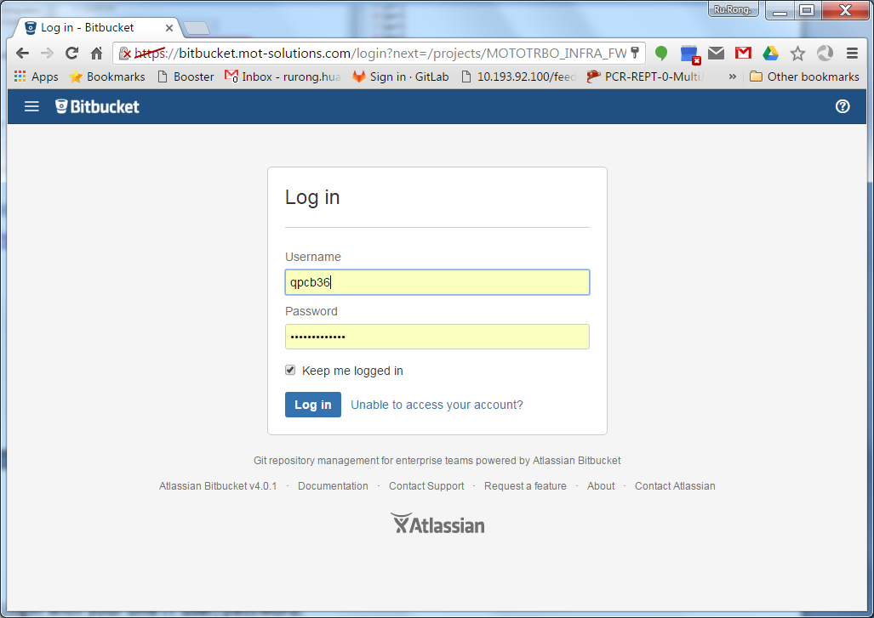
3. Click “head portrait”→“Manage account”→” SSH keys” ->”Add key” to paste your public keys(the keys copy from gitlab).

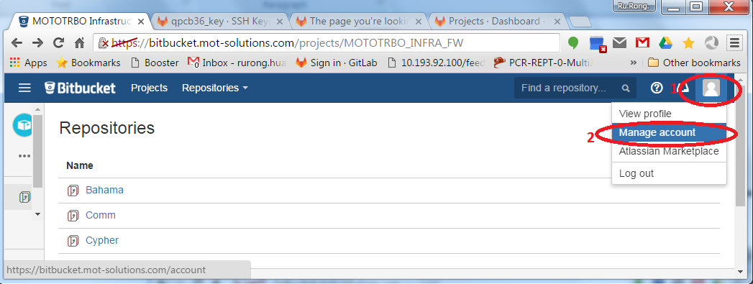

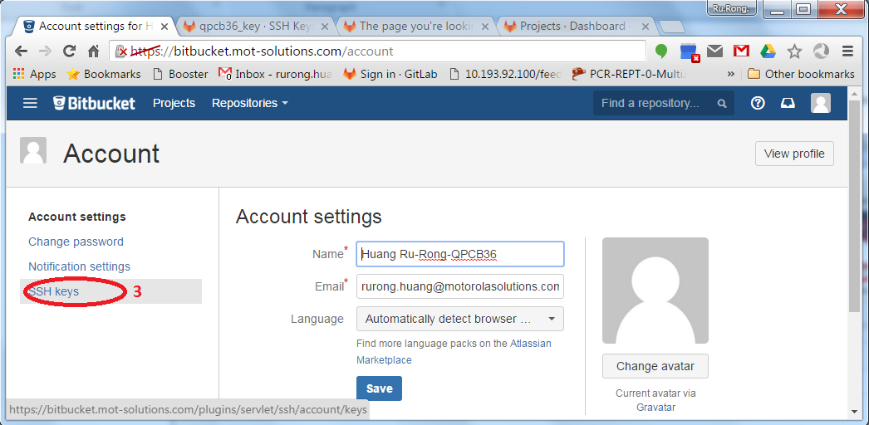

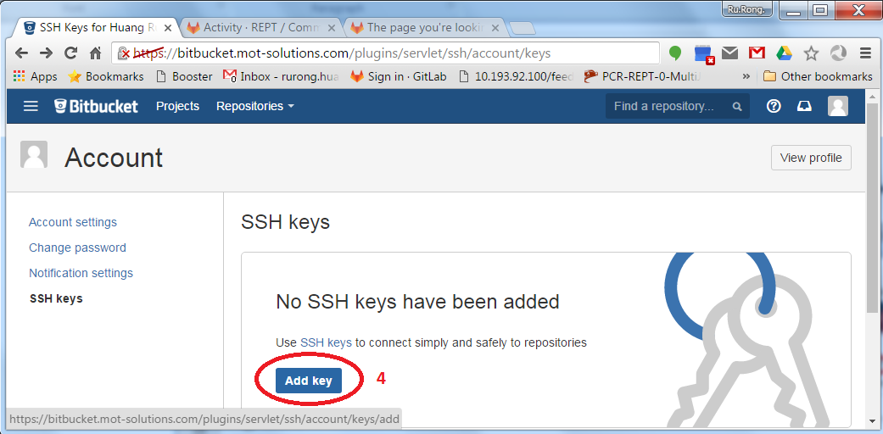

# 2. set pull & push URL

Open C:\Users\yourcorID\ .gitconfig. such as: C:\Users\QPCB36\.gitconfig

1. Append below configuration to .gitconfig file:

[url "git@gitmirror-cdc.mot-solutions.com:stash"]

insteadOf = ssh://git@bitbucket.mot-solutions.com:7999

[url "ssh://git@bitbucket.mot-solutions.com:7999"]

pushInsteadOf = [git@gitmirror-cdc.mot-solutions.com:stash](mailto:git@gitmirror-cdc.mot-solutions.com:stash)

for example:

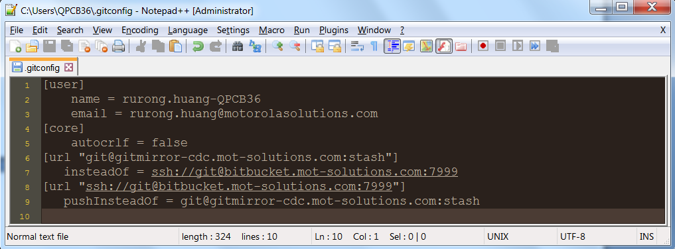

# 3. Migrate from old repo to current repo

open a Git bash console, input below commands to migrate to current repo.

*cmd> cd directory_of_Comm // replace the target directory with the real path name*

*cmd> git remote set-url origin* [git@gitmirror-cdc.mot-solutions.com](mailto:git@gitmirror-cdc.mot-solutions.com):stash/mototrbo_infra_fw/comm.git

*cmd> git remote set-url --push origin* ssh://git@bitbucket.mot-solutions.com:7999/mototrbo_infra_fw/comm.git

*cmd> cd directory_of_Bahama // replace the target directory with the real path name*

*cmd> git remote set-url origin* [git@gitmirror-cdc.mot-solutions.com](mailto:git@gitmirror-cdc.mot-solutions.com):stash/mototrbo_infra_fw/bahama.git

*cmd> git remote set-url --push origin* ssh://git@bitbucket.mot-solutions.com:7999/mototrbo_infra_fw/bahama.git

*cmd> cd directory_of_Cypher // replace the target directory with the real path name*

*cmd> git remote set-url origin* [git@gitmirror-cdc.mot-solutions.com](mailto:git@gitmirror-cdc.mot-solutions.com):stash/mototrbo_infra_fw/cypher.git

*cmd> git remote set-url --push origin* ssh://git@bitbucket.mot-solutions.com:7999/mototrbo_infra_fw/cypher.git

# 4. Clone new GIT repositories

## 4.1 use TortoiseGit

1. Make sure all the following three repositories reside in the same directory of your local PC;
2. Please repeat input below three URLs to clone three repositories in TortoiseGit showed as below diagram. The second red box should select the key file

[git@gitmirror-cdc.mot-solutions.com](mailto:git@gitmirror-cdc.mot-solutions.com):stash/mototrbo_infra_fw/comm.git

[git@gitmirror-cdc.mot-solutions.com](mailto:git@gitmirror-cdc.mot-solutions.com):stash/mototrbo_infra_fw/bahama.git

[git@gitmirror-cdc.mot-solutions.com](mailto:git@gitmirror-cdc.mot-solutions.com):stash/mototrbo_infra_fw/cypher.git

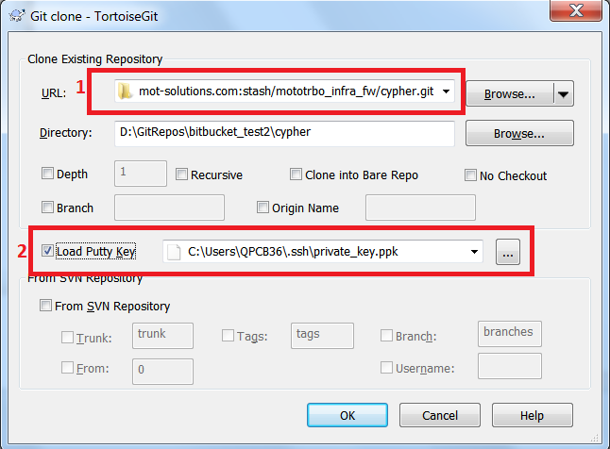

## 4.2 use Git Bash

1. Run below commands in Git Bash console.

cmd> git clone [git@gitmirror-cdc.mot-solutions.com](mailto:git@gitmirror-cdc.mot-solutions.com):stash/mototrbo_infra_fw/cypher.git

cmd> git clone [git@gitmirror-cdc.mot-solutions.com](mailto:git@gitmirror-cdc.mot-solutions.com):stash/mototrbo_infra_fw/comm.git

cmd> git clone [git@gitmirror-cdc.mot-solutions.com](mailto:git@gitmirror-cdc.mot-solutions.com):stash/mototrbo_infra_fw/bahama.git

# 5. How to submit CI

## 

* If you from Emerald, no impact for you, still use branch prefix with IR_Emerald to start your IR
* If you from NonEmrald, remote branch name prefix with IR_2.7 instead of IR_nonEmerald to trigger the CI, like below:

*cmd> git push origin DEV_BRANCH_NAME:IR_2.7_xxx*