* The site from which I took the tutorial <https://habr.com/ru/post/516408/>
* Information on git https://github.com/yankinndenis/dodofy

**In order to get rights for an already ready API, you need:**

* install the Google Client Library (apiclient) using composer:

composer require google/apiclient

“composer install --ignore-platform-reqs”

* Download the test.php file to the root
* Than need to refresh credentials.json here <https://console.developers.google.com/>

[Web client (auto created by Google Service)](https://console.cloud.google.com/apis/credentials/oauthclient/19032427473-br06le5lsp06p9c6o3u7dli9itreplom.apps.googleusercontent.com?project=scan-new)

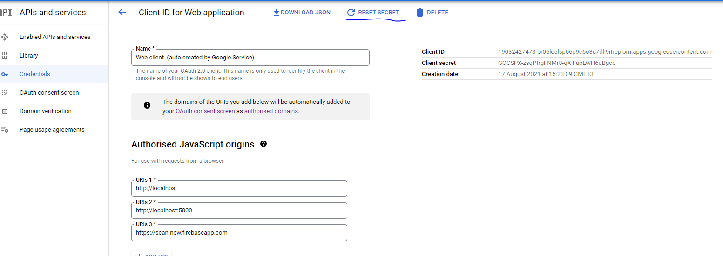

* Than need to download credentials.json

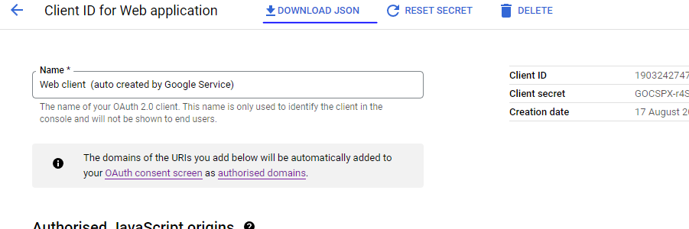

* Then move it to the root directory and name it "credentials.json"
* Open test.php in the console then copy the link and open in your browser.
* Allow any access and and copy the code from the url.

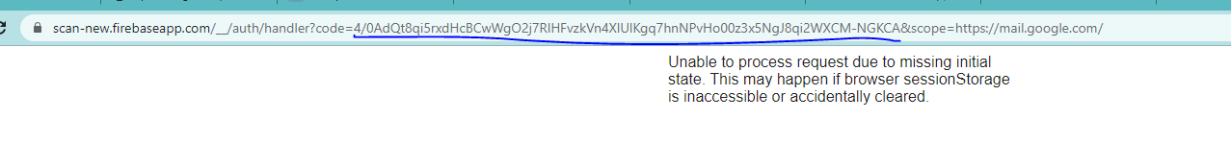

* Add code to the console

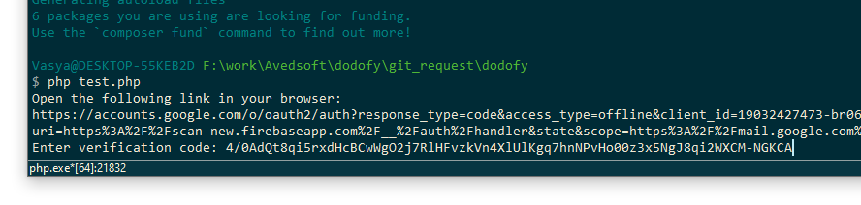

* Now you can transfer credentials.json and token.json to the plugin

**That’s all! You have updated your access.**