全面测试记录

积分信息查询全面测试:

Url：192.168.194.64:8888/rewardpoints/app/queryScore

个人积分日志表：per_integration_log
个人课程积分信息表：per_course_integration
个人积分有效期信息表：effective_integral
个人积分汇总表：per_integration_basis
个人日终跑批信息表：per_dayend_runbatch
个人积分兑换表：per_exchange_integration
个人培训班积分信息表：per_training_integration
个人积分配置表：per_integration_configure
个人作业积分信息表：per_task_integration
个人提交问题积分信息表：per_question_integration
个人问卷调查积分信息表：per_questionnaire_integration

一、查询个人积分汇总信息（例：用户00000，查询类型00000，注意：如查询列表userid是特殊号码：e3n6b4cgky8nxvaYxeKL+XB/zc5c7TgxSRgXt3lbuOQ=）：
输入：
{
"key": "fqTvHv6fyVijQXHyZvJKRHB/zc5c7TgxSRgXt3lbuOQ=",
"qrytmend": "20160101",
"qrytmbegin": "20100101",
"qrytype": "PYM3m+PSFGqcO155YmJkgg==",
"userid": "KKK/TZbJP2Y="
}

输出：
{
"code": "1000",
"contentlist": {
"last_time_score": "580",
"update_tm": "2018-12-28 19:06:33",
"score": "660",
"userid": "KKK/TZbJP2Y=",
"yesterday_score": "770"
}
}

二、查询个人积分变更日志信息（例：用户00000，查询类型10000）：

输入：
{
"key": "fqTvHv6fyVijQXHyZvJKRHB/zc5c7TgxSRgXt3lbuOQ=",
"qrytmend": "20160101",
"qrytmbegin": "20100101",
"qrytype": "yEwfABbezWrMOEFXo801cA==",
"userid": "KKK/TZbJP2Y=",
"pageSize": "2",
"pageNumber": "2"
}

输出：
{
"total": "74",
"num": "2",
"code": "1000",
"contentlist": [{
"total": "74",
"score_type": "HjBNpR+i8k8=",
"last_time_score": "740",
"update_tm": "",
"upd_score": "-50",
"score": "740",
"userid": "KKK/TZbJP2Y="
}, {
"total": "74",
"score_type": "ViaNFomId2Y=",
"last_time_score": "745",
"update_tm": "",
"upd_score": "-5",
"score": "735",
"userid": "KKK/TZbJP2Y="
}]
}

三、查询个人课程积分信息：每页条数pageSize，当前页数pageNumber（例：用户00000，查询类型20000）：

输入：
{
"key": "fqTvHv6fyVijQXHyZvJKRHB/zc5c7TgxSRgXt3lbuOQ=",
"qrytmend": "20160101",
"qrytmbegin": "20100101",
"qrytype": "jnVMspRtP967gydKwizFOw==",
"userid": "KKK/TZbJP2Y=",
"pageSize": "1",
"pageNumber": "10"
}

输出：

{
"total": "13",
"num": "1",
"code": "1000",
"contentlist": [
{
"total": "13",
"update_tm": "2018-09-18 11:37:28",
"learning_tm": "5",
"score": "5",
"userid": "KKK/TZbJP2Y=",
"comment_num": "5"
}
]
}

四、查询个人问题积分信息：每页条数pageSize，当前页数pageNumber（例：用户00000，查询类型30000）：
输入：
{
"key": "fqTvHv6fyVijQXHyZvJKRHB/zc5c7TgxSRgXt3lbuOQ=",
"qrytype": "QXMJ2B30Gc1MV+WMINbH3g==",
"qrytmend": "20160101",
"qrytmbegin": "20100101",
"userid": "KKK/TZbJP2Y=",
"pageSize": "10",
"pageNumber": "2"
}

输出：
{
"total": "11",
"num": "1",
"code": "1000",
"contentlist": [
{
"total": "11",
"update_tm": "",
"score": "",
"userid": "KKK/TZbJP2Y="
}
]
}

五、查询个人培训班积分信息：每页条数pageSize，当前页数pageNumber（例：用户00000，查询类型40000）：

输入：

{
"key": "fqTvHv6fyVijQXHyZvJKRHB/zc5c7TgxSRgXt3lbuOQ=",
"qrytype": "ipvMvhvlgR9Plh6V9EnJ/Q==",
"userid": "KKK/TZbJP2Y=",
"pageSize": "2",
"pageNumber": "1"
}

输出：
{
"total": "6",
"num": "2",
"code": "1000",
"contentlist": [
{
"total": "6",
"update_tm": "2018-12-26 10:26:54",
"score": "10",
"userid": "KKK/TZbJP2Y="
},
{
"total": "6",
"update_tm": "1",
"score": "2",
"userid": "KKK/TZbJP2Y="
}
]
}

六、查询个人积分兑换信息：每页条数pageSize，当前页数pageNumber（例：用户00000，查询类型50000）：

输入：
{
"key": "fqTvHv6fyVijQXHyZvJKRHB/zc5c7TgxSRgXt3lbuOQ=",
"qrytype": "RI2M+gFBMRyce3d6W5vw+g==",
"qrytmend": "20160101",
"qrytmbegin": "20100101",
"userid": "KKK/TZbJP2Y=",
"pageSize": "10",
"pageNumber": "1"
}

输出：
{
"total": "11",
"num": "10",
"code": "1000",
"contentlist": [
{
"total": "11",
"update_tm": "2018-12-28 18:52:03",
"score": "580",
"userid": "KKK/TZbJP2Y="
},
{
"total": "11",
"update_tm": "2018-12-28 18:46:05",
"score": "580",
"userid": "KKK/TZbJP2Y="
},
{
"total": "11",
"update_tm": "2018-12-28 11:20:23",
"score": "690",
"userid": "KKK/TZbJP2Y="
},
{
"total": "11",
"update_tm": "2018-12-28 11:20:16",
"score": "690",
"userid": "KKK/TZbJP2Y="
},
{
"total": "11",
"update_tm": "2018-12-28 09:54:16",
"score": "720",
"userid": "KKK/TZbJP2Y="
},
{
"total": "11",
"update_tm": "2018-12-27 20:25:49",
"score": "720",
"userid": "KKK/TZbJP2Y="
},
{
"total": "11",
"update_tm": "2018-12-27 20:25:07",
"score": "720",
"userid": "KKK/TZbJP2Y="
},
{
"total": "11",
"update_tm": "2018-12-27 20:14:39",
"score": "720",
"userid": "KKK/TZbJP2Y="
},
{
"total": "11",
"update_tm": "2018-12-27 20:11:51",
"score": "720",
"userid": "KKK/TZbJP2Y="
},
{
"total": "11",
"update_tm": "2018-12-27 20:07:18",
"score": "720",
"userid": "KKK/TZbJP2Y="
}
]
}

七、查询个人问卷调查积分信息：每页条数pageSize，当前页数pageNumber（例：用户00000，查询类型60000）：

输入：
{
"key": "fqTvHv6fyVijQXHyZvJKRHB/zc5c7TgxSRgXt3lbuOQ=",
"qrytype": "jd6SBnCqUU9G+dtS2iPPCA==",
"qrytmend": "20160101",
"qrytmbegin": "20100101",
"userid": "KKK/TZbJP2Y=",
"pageSize": "2",
"pageNumber": "1"
}

输出：
{
"total": "7",
"num": "2",
"code": "1000",
"contentlist": [
{
"total": "7",
"update_tm": "2018-12-24 18:07:38",
"score": "5",
"userid": "KKK/TZbJP2Y="
},
{
"total": "7",
"update_tm": "",
"score": "1",
"userid": "KKK/TZbJP2Y="
}
]
}

八、查询个人作业积分信息：每页条数pageSize，当前页数pageNumber（例：用户00000，查询类型70000）：

输入：
{
"key": "fqTvHv6fyVijQXHyZvJKRHB/zc5c7TgxSRgXt3lbuOQ=",
"qrytype": "haehRf4ynZhJl09r5d9L3Q==",
"qrytmend": "20160101",
"qrytmbegin": "20100101",
"userid": "KKK/TZbJP2Y=",
"pageSize": "2",
"pageNumber": "1"
}

输出：
{
"total": "6",
"num": "2",
"code": "1000",
"contentlist": [
{
"total": "6",
"update_tm": "2018-12-28 18:37:49",
"score": "5",
"userid": "KKK/TZbJP2Y="
},
{
"total": "6",
"update_tm": "3",
"score": "3",
"userid": "KKK/TZbJP2Y="
}
]
}

积分信息变更全面测试:

Url：192.168.194.64:8888/rewardpoints/app/updScore
- 个人登陆积分变更（例：用户00000，变更类型00001）：
输入：
{
"key": "fqTvHv6fyVijQXHyZvJKRHB/zc5c7TgxSRgXt3lbuOQ=",
"updtype": "wt5YqDq06SM=",
"userid": "KKK/TZbJP2Y="
}

输出：

{
"code": "1000",
"contentlist": [
{
"last_time_score": "660",
"update_tm": "2019-01-02 14:11:52",
"upd_score": "10",
"score": "670",
"userid": "KKK/TZbJP2Y="
}
]
}

流程图：（见后文）

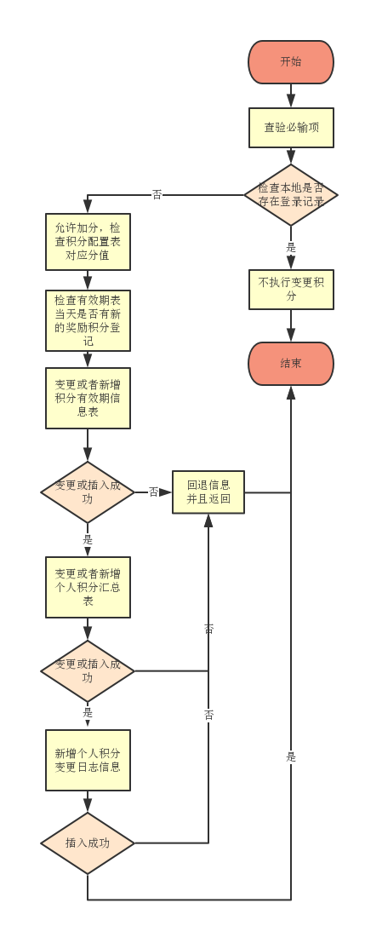
- 个人课程学习积分变更（例：用户00000，变更类型00002）：
输入：
{
"key": "fqTvHv6fyVijQXHyZvJKRHB/zc5c7TgxSRgXt3lbuOQ=",
"updtype": "sjQJ/SMWFT8=",
"userid": "KKK/TZbJP2Y=",
"courseid": "uB+5XZIhgD+2/Xi42TLm7bqPxuI0gM5fnyjnjLEHiyw6/M+3fVTx2g=="
}

输出：

{
"code": "1000",
"contentlist": [
{
"last_time_score": "670",
"update_tm": "2019-01-02 15:18:47",
"upd_score": "300",
"score": "970",
"userid": "KKK/TZbJP2Y="
}
]
}

流程图：（见后文）

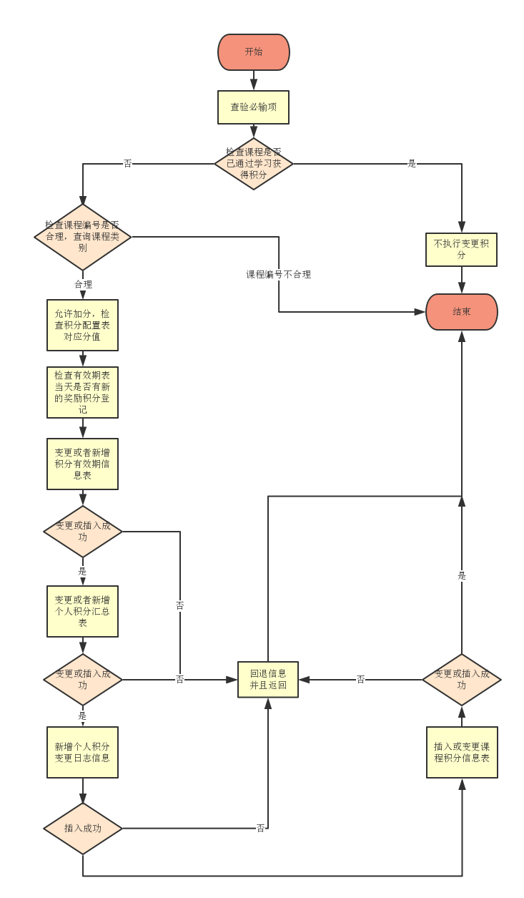

- 个人课程评价积分变更（例：用户00000，变更类型00003）：
输入：
{
"key": "fqTvHv6fyVijQXHyZvJKRHB/zc5c7TgxSRgXt3lbuOQ=",
"updtype": "shzKJAmLy4M=",
"userid": "KKK/TZbJP2Y=",
"courseid": "kMj/oZ4IyDOpAzfO6zGxtNfrC5vkzMi5lTcNSuNAUA46/M+3fVTx2g=="
}

输出：

{
"code": "1000",
"contentlist": [
{
"last_time_score": "970",
"update_tm": "2019-01-02 15:22:35",
"upd_score": "80",
"score": "1050",
"userid": "KKK/TZbJP2Y="
}
]
}
流程图：（见后文）

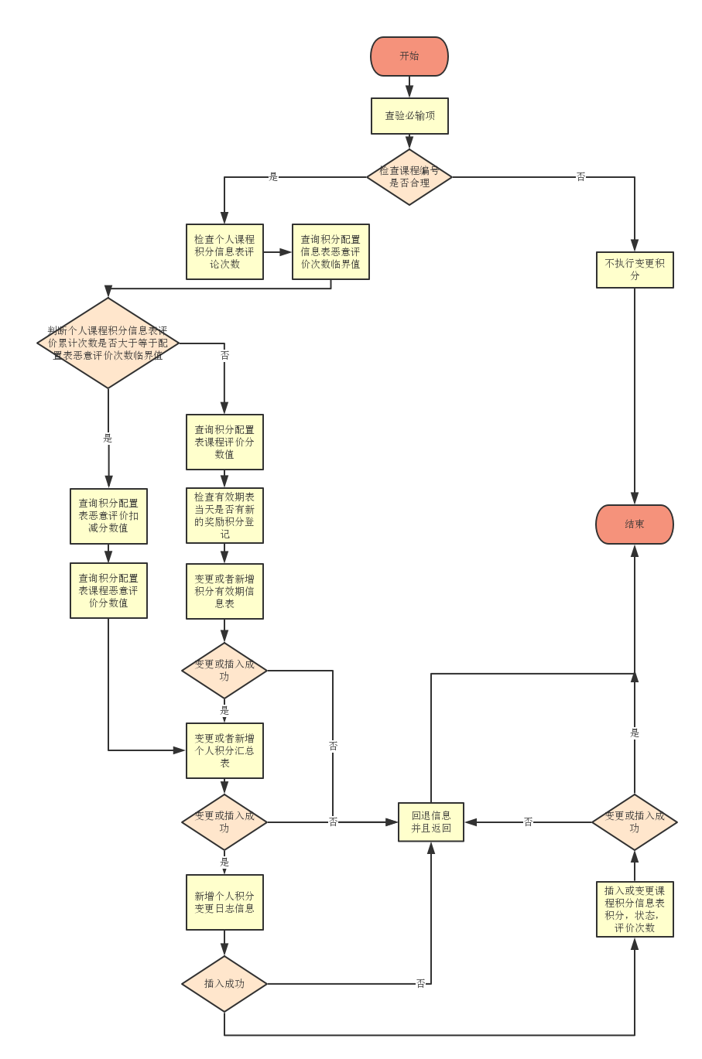

- 个人问卷调查积分变更（例：用户00000，变更类型00005）：
输入：
{
"key": "fqTvHv6fyVijQXHyZvJKRHB/zc5c7TgxSRgXt3lbuOQ=",
"updtype": "P1VBdcMXXis=",
"userid": "KKK/TZbJP2Y=",
"questionnaireid": "kMj/oZ4IyDOpAzfO6zGxtNfrC5vkzMi5lTcNSuNAUA46/M+3fVTx2g=="
}

输出：

{
"code": "1000",
"contentlist": [
{
"last_time_score": "1230",
"update_tm": "2019-01-02 16:00:39",
"upd_score": "5",
"score": "1235",
"userid": "KKK/TZbJP2Y="
}
]
}

流程图：（见后文）

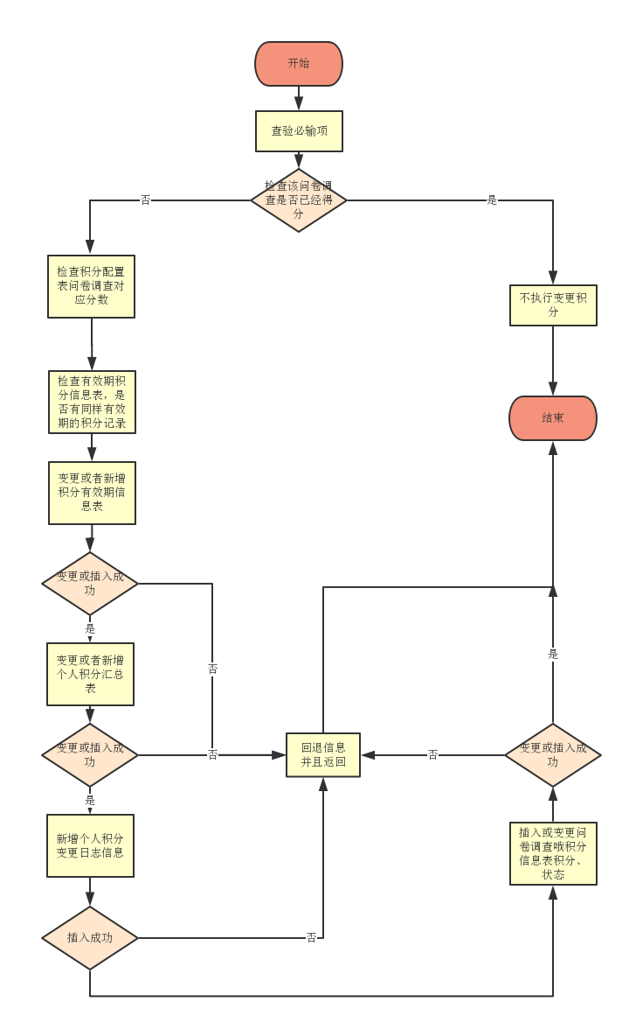

- 用户作业被置为精华非精华积分变更（例：用户00000，变更类型00007）：
输入：
{
"key": "fqTvHv6fyVijQXHyZvJKRHB/zc5c7TgxSRgXt3lbuOQ=",
"updtype": "ViaNFomId2Y=",
"userid": "KKK/TZbJP2Y=",
"taskid": "uB+5XZIhgD+2/Xi42TLm7bqPxuI0gM5fnyjnjLEHiyw6/M+3fVTx2g=="
}

输出：

{
"code": "1000",
"contentlist": [
{
"last_time_score": "1100",
"update_tm": "2019-01-03 18:15:49",
"upd_score": "-5",
"score": "1095",
"userid": "KKK/TZbJP2Y="
}
]
}

流程图：（见后文）

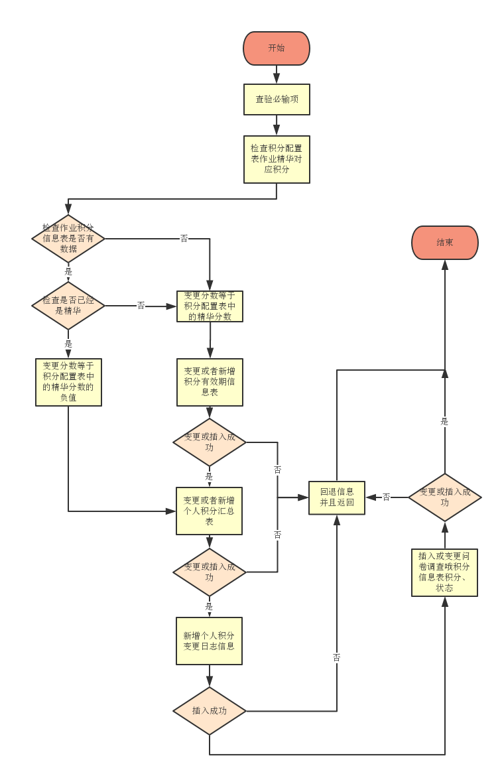

- 个人问题点赞积分变更（例：用户00000，变更类型00008）：
输入：
{
"key": "fqTvHv6fyVijQXHyZvJKRHB/zc5c7TgxSRgXt3lbuOQ=",
"updtype": "inn6CmPV5sA=",
"userid": "KKK/TZbJP2Y=",
"questionid": "kMj/oZ4IyDOpAzfO6zGxtNfrC5vkzMi5lTcNSuNAUA46/M+3fVTx2g=="
}

输出：

{
"code": "1000",
"contentlist": [
{
"last_time_score": "1240",
"update_tm": "2019-01-02 16:54:54",
"upd_score": "5",
"score": "1245",
"userid": "KKK/TZbJP2Y="
}
]
}
流程图：（见后文）

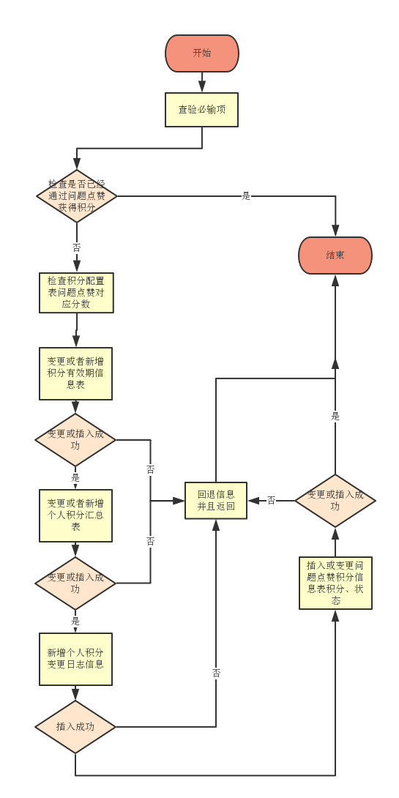

- 用户兑换积分变更（例：用户00000，变更类型00012）：
输入：
{
"key": "fqTvHv6fyVijQXHyZvJKRHB/zc5c7TgxSRgXt3lbuOQ=",
"updtype": "HjBNpR+i8k8=",
"userid": "KKK/TZbJP2Y=",
"exchangenum": "150"
}

输出：

{
"code": "1000",
"contentlist": [
{
"last_time_score": "1245",
"update_tm": "2019-01-02 17:03:47",
"upd_score": "-150",
"score": "1095",
"userid": "KKK/TZbJP2Y="
}
]
}

流程图：（见后文）

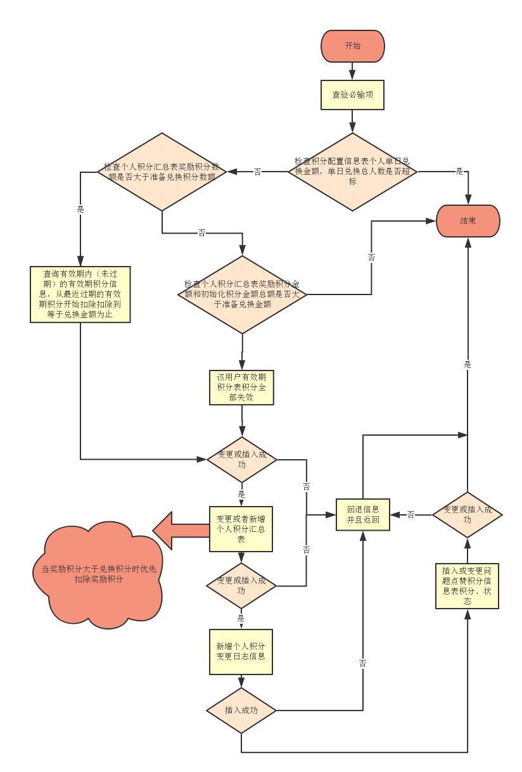
- 用户培训班结业积分变更（例：用户00000，变更类型00013）：
输入：
{
"key": "fqTvHv6fyVijQXHyZvJKRHB/zc5c7TgxSRgXt3lbuOQ="
"updtype": "yOzkQprH7To=",
"userid": "KKK/TZbJP2Y=",
"trainingid": "uB+5XZIhgD+2/Xi42TLm7bqPxuI0gM5fnyjnjLEHiyw6/M+3fVTx2g=="
}

输出：

{
"code": "1000",
"contentlist": [
{
"last_time_score": "1095",
"update_tm": "2019-01-02 17:28:06",
"upd_score": "5",
"score": "1100",
"userid": "KKK/TZbJP2Y="
}
]
}
流程图：（见后文）

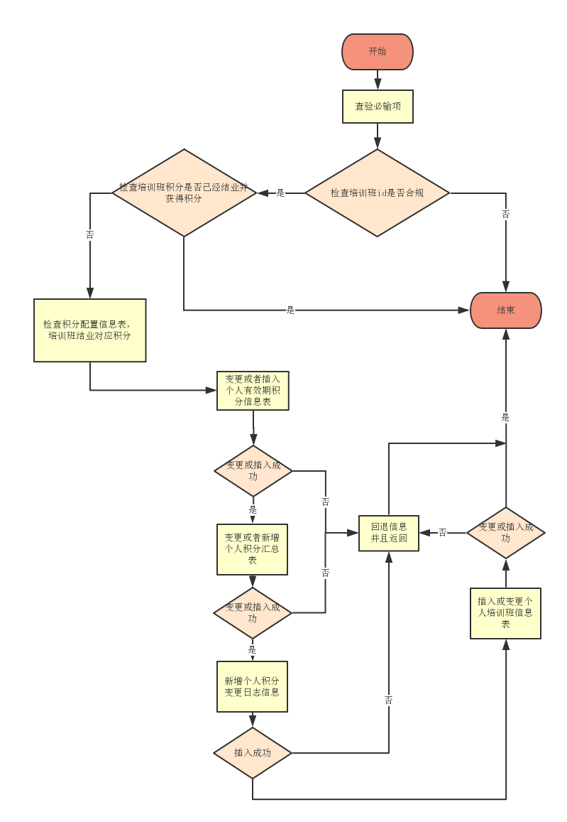

- 系统日终跑批积分变更：
系统日终跑批定是在凌晨1点，不需要手动出发，使用定时器自动触发。配置具体位置如下：
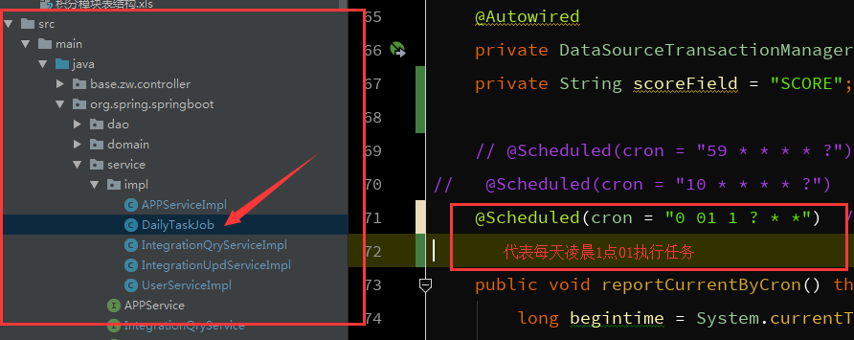

当前的数据信息如下：跑批的时间主要取决于系统的用户数：
在用户数小于50万时，跑批时间约等于1.5小时
在用户数小于250万时，跑批时间约等于7.5小时
以此类推。

