Phenotype-Guided Dissection of Fall-Related Pharmacovigilance Signals for Sedative-Hypnotics in Older Adults: A FAERS Active-Comparator Study

Abstract
Background: Falls in older adults are an important medication-safety concern, and sedative-hypnotics are commonly implicated. However, fall-related safety signals for sedative-hypnotics should not be treated as a simple present-or-absent risk. Different drugs may show distinct reporting magnitudes, robustness patterns, and clinical phenotypes that point to different fall-related pathways.
Objective: To determine how active-comparator refinement and phenotype profiling differentiate fall-related reporting signals across sedative-hypnotics in older adults.
Methods: We conducted a case-level pharmacovigilance study using the FDA Adverse Event Reporting System (FAERS) among reports involving adults aged 65–120 years. Target exposures included Z-drugs, benzodiazepines, orexin receptor antagonists, and other insomnia-related medications. The primary outcome was strict fall, defined using the MedDRA preferred terms “Fall” and “Drop attacks”. We first characterized full-database disproportionality signals and then refined these signals using active-comparator analyses, multivariable logistic regression, primary-suspect-only analyses, exclusion of mixed sedative-hypnotic exposure, reporting-region stratification, phenotype co-reporting analyses, and serious-outcome characterization. Co-reported preferred terms among strict-fall reports were grouped into clinically interpretable phenotype domains, including neurocognitive/consciousness, dizziness/syncope/hypotension, gait/balance, sedation/somnolence, and mixed-mechanism phenotypes. Evidence was synthesized across five domains comprising full-database disproportionality, active-comparator consistency, adjusted-model stability, exposure-definition sensitivity, and reporting-structure stability.
Results: Among 4,155,023 older-adult FAERS case reports, 125,126 reported strict fall. Full-database analyses showed elevated strict-fall reporting for Z-drugs, zopiclone, zolpidem, and benzodiazepines. Zopiclone showed the highest full-database disproportionality estimate, whereas zolpidem showed a strong and consistently supported focal signal across comparative analyses. In fully adjusted active-comparator models, zolpidem remained associated with higher strict-fall reporting than other Z-drugs, benzodiazepines, and orexin receptor antagonists, with adjusted ORs of 1.34, 1.54, and 3.11, respectively. Z-drugs also remained higher than benzodiazepines and orexin receptor antagonists after adjustment. Phenotype analyses showed that strict-fall reports involving zolpidem were enriched for neurocognitive/consciousness, dizziness/syncope/hypotension, gait/balance, and mixed-mechanism co-reporting patterns. Serious outcomes and hospitalization were frequently co-reported among strict-fall reports involving Z-drugs, zolpidem, and benzodiazepines.
Conclusions: Fall-related reporting signals for sedative-hypnotics in older adults differed in both magnitude and phenotype structure. Zolpidem received high internal support across the evaluable evidence domains, whereas Z-drugs as a class showed moderate, context-sensitive support. Phenotype-guided active-comparator analysis provides a transparent strategy for prioritizing signals for surveillance and confirmatory research.
Keywords: FAERS; older adults; sedative-hypnotics; falls; pharmacovigilance; disproportionality analysis; active comparator; signal credibility

1 Introduction
Falls are a major safety outcome in older adults because they are common, clinically consequential, and potentially preventable. Globally, falls are the second leading cause of unintentional injury deaths, and adults older than 60 years account for the greatest number of fatal falls. The World Health Organization estimates that 37.3 million falls severe enough to require medical attention occur each year. In the United States, falls are the leading cause of injury among adults aged 65 years and older, with more than 14 million older adults reporting a fall each year [1,2]. Because falls often arise from interacting clinical, functional, environmental, and pharmacological factors, medication-related fall signals are particularly important for pharmacovigilance: they may be identifiable in post-marketing data and may guide subsequent risk minimization, medication review, and comparative safety research.
Sedative-hypnotic medications are central to this medication-safety problem in older adults. Benzodiazepines, non-benzodiazepine benzodiazepine receptor agonists commonly known as Z-drugs, orexin receptor antagonists, and other insomnia-related medications may be used in overlapping clinical contexts, but they should not be treated as a single homogeneous safety category. Their pharmacological targets, residual sedative effects, cognitive and psychomotor profiles, and real-world prescribing patterns differ. The 2023 American Geriatrics Society Beers Criteria recommend avoiding benzodiazepines in many older adults because older adults have increased sensitivity and because these drugs increase the risk of cognitive impairment, delirium, falls, fractures, and motor vehicle crashes. The same criteria also note that Z-drugs have adverse-event profiles similar to benzodiazepines in older adults, including delirium, falls, fractures, increased emergency department visits or hospitalizations, and motor vehicle crashes [3].
Evidence from observational studies and systematic reviews supports these concerns, while also showing why a more granular approach is needed. A systematic review and meta-analysis of Z-drugs in older adults found an increased risk of fractures and injuries and a possible increased risk of falls, but the available fall evidence was heterogeneous and limited. Additional meta-analytic and observational evidence has linked benzodiazepines, Z-drugs, and zolpidem with fall-related injuries, inpatient falls, and hip fracture in older populations [4–9]. These findings suggest that the key question is no longer simply whether sedative-hypnotics are related to falls in older adults. Rather, the more informative pharmacovigilance question is whether different sedative-hypnotics show different fall-related reporting patterns, and whether those patterns can be linked to clinically interpretable intermediate phenotypes.
This distinction is especially relevant for Z-drugs and zolpidem. Product labeling for zolpidem describes central nervous system depressant effects, next-day impairment, drowsiness, dizziness, reduced alertness, prolonged reaction time, and impaired driving; it also states that because zolpidem can cause drowsiness and decreased level of consciousness, older patients are at higher risk of falls [10]. Regulatory safety actions further highlight that Z-drugs may produce serious harm through altered awareness and complex sleep behaviors; the US Food and Drug Administration required boxed warnings for eszopiclone, zaleplon, and zolpidem after reports of serious injuries or death associated with complex sleep behaviors [11]. These external safety concerns point toward a plausible cognitive–motor pathway linking sedative-hypnotic exposure to falls: altered consciousness, impaired attention or reaction, dizziness, gait or balance disturbance, and mixed neurocognitive–motor impairment may act as intermediate phenotypes before a fall event is reported.
Spontaneous reporting systems such as the FDA Adverse Event Reporting System (FAERS) are useful for detecting post-marketing safety signals across large and diverse reporting environments, but they require careful interpretation. FDA notes that the existence of a report does not establish causation, that report information may not be medically verified, and that spontaneous reports cannot be used to estimate event incidence [12]. Traditional disproportionality analyses are therefore best understood as tools for detecting and prioritizing reporting signals rather than estimating clinical risk [13]. READUS-PV was developed because disproportionality analyses using individual case safety reports are widely used but can be incomplete, ambiguous, or misinterpreted when methods and results are not placed in the correct context [14].
For sedative-hypnotic-related falls, this means that a simple full-database reporting odds ratio ranking is insufficient. A full-database signal can identify a statistical excess of co-reporting, but it cannot determine whether the signal persists against clinically relevant comparators, whether it is sensitive to drug role or mixed exposure, whether it differs by reporting geography, or whether fall reports carry a coherent clinical phenotype. Active-comparator approaches can partly address this limitation by comparing drugs within more similar treatment contexts rather than against the entire reporting database, although report-based comparisons cannot reproduce a true new-user comparative cohort design [15–17]. Thus, in this setting, comparator choice is not only a statistical detail but a core part of the clinical question.
The remaining gap is not merely methodological; it is mechanistic and interpretive. Falls associated with sedative-hypnotics should not be viewed as a flat “present-or-absent” safety outcome. They can be examined using a drug–reporting phenotype framework that may help generate hypotheses regarding plausible fall-related pathways. First, pharmacovigilance analysis can identify which drug classes or individual drugs show stronger strict-fall reporting signals. Second, active-comparator analyses, multivariable adjustment, primary-suspect-only analyses, and clean-exposure sensitivity analyses can test whether those signals remain stable under alternative reporting and exposure assumptions. Third, co-reported preferred terms among strict-fall reports can be grouped into phenotype domains, such as neurocognitive or consciousness disturbance, dizziness or syncope or hypotension, gait or balance disturbance, sedation or somnolence, and mixed-mechanism patterns. This phenotype-fingerprint step moves the analysis beyond signal magnitude alone and asks whether a reporting signal has a clinically interpretable structure consistent with plausible fall pathways.
Therefore, this study examined how fall-related reporting signals for sedative-hypnotics in older adults change as the analysis moves from full-database screening to clinically relevant comparisons and phenotype profiling. We used a narrowly defined strict-fall endpoint and evaluated Z-drugs, benzodiazepines, orexin receptor antagonists, and other insomnia-related medications. The analysis proceeded through three linked stages: full-database signal detection, active-comparator refinement with multivariable and sensitivity analyses, and phenotype-guided interpretation of the leading signals. This design connected statistical signal strength with comparative stability and clinical phenotype structure.

2 Methods

2.1 Study Design and Data Source
This was a case-level pharmacovigilance study using the FDA Adverse Event Reporting System (FAERS). The study was designed to move from broad signal detection to phenotype-guided interpretation of fall-related reporting signals for sedative-hypnotics in older adults. The analytic framework followed a signal–stability–phenotype logic: first, we characterized which drugs or drug classes showed stronger strict-fall reporting signals; second, we tested whether these signals persisted in clinically relevant active-comparator, adjusted, and sensitivity analyses; third, we examined whether strict-fall reports carried co-reported phenotype fingerprints consistent with plausible cognitive–motor fall pathways.
FAERS quarterly files from 2004Q1 through 2025Q4 were used. The quarterly files were harmonized into annual case-level parquet tables before analysis. The DEMO, DRUG, REAC, OUTC, and INDI-derived tables were integrated by caseid to create the main analytic dataset. The dataset included demographic variables, reporting structure, target sedative-hypnotic exposures, strict-fall outcome status, co-reported phenotype variables, serious outcomes, comedication markers, and indication variables.
The overall study design and analytic workflow are summarized in Fig. 1.
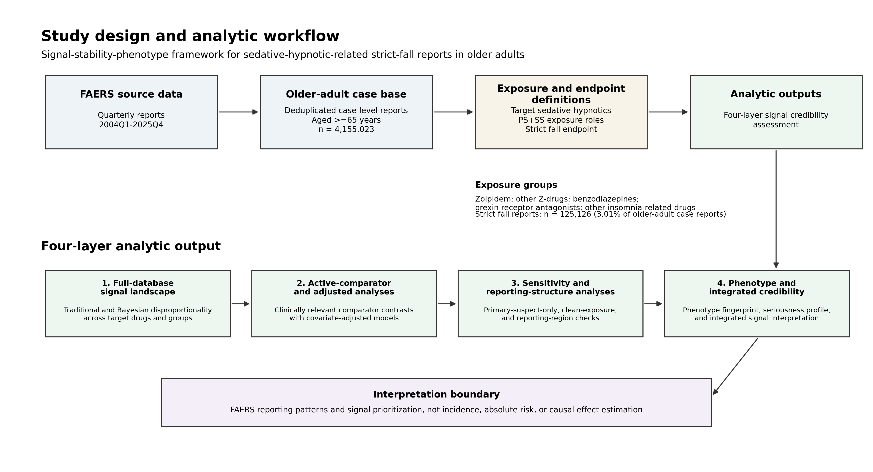
Fig. 1 Study design and analytic workflow. FAERS quarterly reports from 2004Q1 to 2025Q4 were harmonized into a deduplicated older-adult case base, followed by prespecified sedative-hypnotic exposure definitions and a strict-fall endpoint definition. The main analysis included 4,155,023 deduplicated case-level reports among adults aged >=65 years, of which 125,126 reports met the strict-fall endpoint definition. The analytic workflow was organized as a signal-stability-phenotype framework with four linked output layers: full-database signal landscape; active-comparator and adjusted analyses; sensitivity and reporting-structure analyses; and phenotype fingerprinting, serious-outcome profiling, and integrated signal credibility assessment. Findings should be interpreted as FAERS reporting patterns and signal-prioritization evidence, not as incidence, absolute clinical risk, or causal effect estimates. FAERS FDA Adverse Event Reporting System, PS primary suspect, SS secondary suspect.

2.2 Case-Level Deduplication and Eligibility Criteria
The unit of analysis was the FAERS case. Reports were eligible if the patient was aged 65–120 years. Reports with missing age, implausible age, or insufficient information to construct a case-level analytic record were excluded.
Case identifiers were converted to string format before merging. When multiple records with the same caseid remained in the harmonized annual case-level files, records were sorted by caseid, reporting year, quarter, and primaryid, and one representative record was retained to ensure that each caseid appeared only once in the main analysis dataset. Age was grouped into 65–74, 75–84, and ≥85 years. Sex was retained as the harmonized FAERS sex category available in the case-level analytic file; in the final analytic dataset, all eligible cases were coded as female or male, and no case had missing or unknown sex after harmonization. Reporting region was categorized as US, non-US, or unknown, using reporter country when available and occurrence country otherwise. Reporting years were grouped into regulatory periods of 2004–2012, 2013–2018, and 2019–2025 for descriptive analyses.

2.3 Target Drugs and Exposure Definition
The analysis focused on sedative-hypnotic and insomnia-related medications with clinical comparator relevance rather than conducting an untargeted all-drug screen. Target medications were grouped into four prespecified categories:
Z-drugs included zolpidem, eszopiclone, zaleplon, and zopiclone.
Benzodiazepines included temazepam, triazolam, lorazepam, diazepam, alprazolam, and clonazepam.
Orexin receptor antagonists included suvorexant, lemborexant, and daridorexant.
Other insomnia-related medications included trazodone, mirtazapine, doxepin, ramelteon, and melatonin.
Drug exposure was identified using a prespecified drug dictionary that included generic names, common brand names, salts or active ingredients, and spelling variants (Supplementary Table S1). The main exposure definition included reports in which the target drug was coded as primary suspect or secondary suspect in the FAERS DRUG table, hereafter referred to as PS+SS exposure. This definition was chosen to focus on drugs considered by the reporter to be potentially related to the adverse event, while avoiding unrestricted inclusion of all concomitant medications.
Primary-suspect-only exposure was used as a sensitivity definition. Cases reporting more than one target sedative-hypnotic drug or more than one target sedative-hypnotic class were flagged as mixed exposure. Mixed-exposure cases were retained for full-database signal landscape analyses but were excluded from clean active-comparator analyses when necessary to prevent the same case from contributing to both the exposure and comparator groups.

2.4 Phenotype Fingerprint Definition
Among reports meeting the strict-fall definition, co-reported MedDRA preferred terms were grouped into clinically interpretable phenotype domains [18]. These domains were designed to capture intermediate clinical patterns that could plausibly link sedative-hypnotic exposure to a fall event.
The phenotype domains were defined as follows:
Sedation/somnolence phenotype: somnolence or sedation.
Neurocognitive/consciousness phenotype: confusional state, delirium, or cognitive disorder.
Dizziness/syncope phenotype: dizziness or syncope.
Gait/balance phenotype: gait disturbance, ataxia, or coordination abnormal.
Hypotension phenotype: hypotension or orthostatic hypotension.
For the main phenotype-fingerprint analysis, dizziness/syncope and hypotension were interpreted together as a dizziness/syncope/hypotension pathway when clinically appropriate. A mixed-mechanism phenotype was defined as the presence of two or more mechanistic phenotype domains in the same strict-fall report. A report with none of the prespecified phenotype domains was classified as having no prespecified mechanistic phenotype co-reporting. The complete outcome and phenotype definitions are provided in Supplementary Table S2.

2.5 Covariates
Covariates included demographic variables, reporting-structure variables, medication-complexity variables, CNS comedication markers, and indication markers. Demographic and reporting variables included age group, sex, reporting year, quarter, country group, FAERS report type code, and electronic submission status. The report type code was kept as a reporting-structure variable and was not recoded as healthcare-professional versus non-healthcare-professional reporter status. Medication-complexity variables included the number of reported drugs, number of distinct drugs, polypharmacy, and polypharmacy defined as five or more drugs. CNS comedication markers included antidepressant, antipsychotic, opioid, and antiepileptic co-reporting. Indication variables included insomnia, anxiety, depression, pain, and epilepsy markers.
Covariates were derived at the case level and merged into the main analysis dataset by caseid. Missing binary indicators were set to false after case-level merging. Categorical variables were treated as factor variables in adjusted models. Covariates with insufficient variation in a given comparison dataset were skipped from that model and documented in the model-output tables.

2.6 Signal Landscape Analysis
The first analytic layer described the full-database strict-fall signal landscape. For each target drug and drug class, we calculated the number of exposed reports, the number of strict-fall reports, and the proportion of exposed reports with strict fall.
For each drug-event pair, a 2 × 2 table was constructed. Let a denote reports with both target exposure and strict fall, b reports with target exposure without strict fall, c reports without target exposure with strict fall, and d reports with neither target exposure nor strict fall. If any cell was zero, a Haldane–Anscombe continuity correction of 0.5 was applied to all four cells.
Reporting odds ratio (ROR) was calculated as:
ROR = (a/b)/(c/d)
with 95% confidence intervals calculated on the log scale.
Proportional reporting ratio (PRR) was calculated as:
PRR = [a/(a+b)]/[c/(c+d)]
with 95% confidence intervals calculated on the log scale.
The expected count was calculated as:
E = [(a+b)(a+c)]/(a+b+c+d)
The information component was calculated as:
IC = log₂(a/E)
and the lower 95% bound was approximated as:
IC₀₂₅ = IC - 1.96/[ln(2)√a]
We also calculated an observed-to-expected ratio (OE), defined as the observed number of exposed strict-fall reports divided by the expected number under the marginal distribution:
OE = a/E
An approximate lower one-sided bound (OE05) was calculated to provide a conservative summary of the observed-to-expected reporting pattern:
OE₀₅ = exp{ln(OE) - 1.645/√a}
Full-database disproportionality analyses were used as the signal-detection layer and were not interpreted as stand-alone evidence of clinical risk or causality. BCPNN signal-sensitivity results are reported in Supplementary Table S16.

2.7 Active-Comparator Signal Refinement
The second analytic layer placed each full-database signal within a clinically relevant treatment context. Comparator groups were selected according to the question addressed by each contrast. Within-class Z-drug comparisons evaluated agent-level heterogeneity; benzodiazepines represented an established GABAergic sedative-hypnotic comparator; orexin receptor antagonists represented a mechanistically distinct insomnia-treatment comparator; and other insomnia-related medications represented a broader therapeutic comparator. Recent pharmacovigilance research has shown that comparator definition and calendar period can materially shape signal estimates [17,19], making the comparator framework a central component of the analysis.
Clean active-comparator analyses restricted each comparison to reports exposed to only one of the two comparator groups. The mutually exclusive design created clearly separated comparison sets and allowed the relative prominence of strict-fall reporting to be evaluated within each treatment context.
The primary active-comparator analyses included:
zolpidem-only versus other Z-drugs-only;
zolpidem-only versus benzodiazepines-only;
zolpidem-only versus orexin receptor antagonists-only;
zolpidem-only versus other insomnia-related medications-only;
Z-drugs-only versus benzodiazepines-only;
Z-drugs-only versus orexin receptor antagonists-only;
benzodiazepines-only versus orexin receptor antagonists-only;
other insomnia-related medications-only versus orexin receptor antagonists-only.
Supplementary within-class comparisons were performed for individual Z-drugs and selected benzodiazepines when case counts were sufficient. For each active-comparator contrast, restricted RORs and 95% confidence intervals were calculated to quantify the relative prominence of strict-fall reporting within the corresponding comparator set.

2.8 Multivariable Adjustment
Multivariable logistic regression was used to evaluate whether active-comparator signals persisted after adjustment for demographic, reporting-structure, comedication, and indication-related factors. For each active-comparator dataset, the dependent variable was strict-fall reporting status. The main independent variable was exposure group, with the comparator group as reference.
Three models were considered:
Crude model: exposure group only.
Model 1: adjusted for age group, sex, and reporting year.
Model 2: further adjusted for reporting-source variables, including country or region group, reporter type, and electronic submission status.
Model 3: fully adjusted for demographic, time, reporting-source, medication, and indication variables, including age group, sex, reporting year, country or region group, reporter type, electronic submission status, polypharmacy, antidepressant co-reporting, antipsychotic co-reporting, opioid co-reporting, antiepileptic co-reporting, and indication markers for insomnia, anxiety, depression, pain, and epilepsy.
Adjusted odds ratios (ORs), 95% confidence intervals, and p values were reported. The fully adjusted model was used as the primary adjusted estimate in the main text. Variables with insufficient variation or causing model instability were excluded from individual models as needed and documented in the model-output tables.

2.9 Sensitivity and Reporting-Context Analyses
Calendar time was characterized using the periods 2004–2012, 2013–2018, and 2019–2025. The most recent period incorporated the 2019 FDA boxed-warning action for complex sleep behaviors involving eszopiclone, zaleplon, and zolpidem [11]. Reporting year was included in adjusted models when estimable, and period distributions were summarized across comparator groups to place the principal contrasts within their regulatory and market context.
Prespecified sensitivity analyses were conducted to test whether the main signals depended on exposure-role definition, mixed sedative-hypnotic exposure, or reporting geography.
First, PS-only analyses were performed by restricting target exposure to drugs coded as primary suspect. These analyses tested whether signals persisted when the exposure definition was narrowed to drugs most strongly suspected by the reporter.
Second, analyses excluding mixed sedative-hypnotic exposure were performed. These analyses removed reports involving more than one target sedative-hypnotic drug or drug class, thereby testing whether the signal was driven by co-reporting of multiple sedative-hypnotics.
Third, reporting-region stratified analyses were performed by comparing US and non-US reports. These analyses assessed whether key contrasts, particularly zolpidem versus other Z-drugs, differed by reporting geography and possible drug-use context. Detailed sensitivity results are reported in Supplementary Tables S3–S5.

2.10 Serious Outcome Characterization
Serious outcomes were evaluated among strict-fall reports involving each target drug or drug class. Serious outcome variables were derived from the FAERS OUTC table and included any serious outcome, death, hospitalization, disability, life-threatening outcome, required intervention, congenital anomaly, and other serious outcome.

2.11 Phenotype-Fingerprint Analysis
Phenotype-fingerprint analyses were conducted among strict-fall reports involving zolpidem-only, other Z-drugs without zolpidem, and benzodiazepines-only. For each group, we calculated the proportion of strict-fall reports with each phenotype component: sedation/somnolence, neurocognitive/consciousness, dizziness/syncope/hypotension, gait/balance, visual disturbance, mixed phenotype, and no mechanistic co-phenotype.
Chi-square tests were used to compare phenotype distributions across drug groups. Exploratory logistic regression models were also fitted for selected phenotype components, using zolpidem-only, other Z-drugs-only, or benzodiazepines-only as exposure groups and adjusting sequentially for demographic, reporting, medication, and indication variables. Descriptive distributions and chi-square tests are reported in Supplementary Tables S6–S7, adjusted models in Supplementary Table S8, and drug-level profiles and crude contrasts in Supplementary Tables S9–S10. These analyses were intended to characterize phenotype structure among fall reports, not to infer temporal order or causal mechanisms.

2.12 Internal-Support Framework
We developed a prespecified exploratory framework to summarize internal support for an elevated strict-fall reporting signal across five domains: full-database disproportionality, active-comparator consistency, adjusted-model stability, exposure-definition sensitivity, and reporting-structure stability. The resulting internal-support score ranged from 0 to 9 points.
Domains without sufficient evidence were recorded as not available rather than assigned zero points. Both the obtained score and the available maximum were therefore reported. Signals were classified as having high, moderate, low, or insufficient internal support according to the prespecified score, evidence availability, and consistency requirements.
Phenotype coherence and external evidence were presented separately as contextual modifiers and did not contribute to the numerical score. Component-level evidence details are reported in Supplementary Table S14, with leave-one-domain-out and threshold-sensitivity analyses in Supplementary Tables S17–S18.

2.13 Supplementary Phenotype Clustering
Phenotype clustering was conducted as a supplementary exploratory analysis among sedative-hypnotic strict-fall reports. This analysis extended the primary signal–stability–phenotype framework by examining heterogeneity within the fall-report case series. Clustering results are presented in Supplementary Tables S11–S13.
For phenotype clustering, binary indicators for co-reported phenotype components, serious-outcome components, and medication-complexity variables were used. Candidate k-means clustering solutions with k = 3–6 were evaluated. The final solution was selected based on interpretability, avoidance of very small clusters, silhouette score, and stability against agglomerative clustering. Principal component analysis was used for visualization. Cluster labels were assigned post hoc according to dominant phenotype, seriousness, and medication-complexity patterns. Clustering results were interpreted as hypothesis-generating.

3 Results

3.1 Study Population and Strict-Fall Reports
A total of 4,155,023 deduplicated FAERS case reports involving adults aged 65 years or older were included, of which 125,126 reported a strict-fall event, corresponding to 3.01% of all eligible reports. The overall age and sex distribution is reported in Supplementary Table S15. Among the mutually exclusive sedative-hypnotic comparator groups used for active-comparator analyses, strict-fall reporting was highest for zolpidem-only reports and lowest for orexin receptor antagonist-only reports (Table 1). The comparator groups also differed in reporting geography, reporting structure, polypharmacy, CNS co-medication, and insomnia indication, supporting the need for covariate-adjusted analyses rather than relying on crude comparisons alone.
Under the primary-suspect plus secondary-suspect exposure definition, the mutually exclusive active-comparator dataset included 5,904 zolpidem-only reports, 5,459 other Z-drugs-only reports, 24,408 benzodiazepines-only reports, 2,507 orexin receptor antagonist-only reports, and 13,111 other insomnia-related drug-only reports. The corresponding numbers of strict-fall reports were 745, 438, 1,989, 57, and 926, respectively. Sex unknown was 0.0% in each comparator group because the final case-level analytic dataset contained only harmonized female or male sex categories.

Table 1. Characteristics of mutually exclusive sedative-hypnotic comparator groups among older-adult FAERS reports.
Comparator group | Reports, n | Strict-fall reports, n (%) | Age >=85, % | Female, % | US report, % | 2019-2025, % | Expedited report, % | Polypharmacy >=5 drugs, % | Antidepressant co-reporting, % | Opioid co-reporting, % | Insomnia indication, %
Zolpidem-only | 5,904 | 745 (12.6) | 16.1 | 62.0 | 42.7 | 40.7 | 75.2 | 42.3 | 16.6 | 16.7 | 42.5
Other Z-drugs-only | 5,459 | 438 (8.0) | 17.6 | 61.4 | 51.9 | 31.1 | 50.0 | 56.7 | 14.0 | 12.4 | 55.9
Benzodiazepines-only | 24,408 | 1,989 (8.1) | 15.0 | 66.3 | 39.5 | 53.0 | 81.9 | 52.9 | 24.3 | 22.8 | 10.3
Orexin receptor antagonists-only | 2,507 | 57 (2.3) | 17.6 | 58.5 | 73.6 | 47.9 | 27.8 | 21.9 | 6.7 | 4.4 | 86.8
Other insomnia-related drugs-only | 13,111 | 926 (7.1) | 20.8 | 61.3 | 27.7 | 52.6 | 84.7 | 57.8 | 69.4 | 12.7 | 17.4

Note: Comparator groups are mutually exclusive under the PS+SS exposure definition and require one sedative-hypnotic group per report; zolpidem-only additionally requires one target sedative-hypnotic drug. Percentages are column percentages within each comparator group. Strict-fall percentages are FAERS reporting proportions within the comparator group, not incidence or absolute clinical risk. The full descriptive version, including age 75-84 years, non-US reports, sex unknown, antipsychotic co-reporting, and other adjustment variables, is provided in Supplementary Table S15. FAERS report type code was not interpreted as healthcare-professional reporter status; therefore the main table reports expedited report status rather than healthcare-professional reporter status. Because of the very large sample size, p values were not reported for Table 1.

3.2 The Initial Signal Landscape Revealed Marked Between- and Within-Class Heterogeneity
The full-database analysis identified a clear gradient in strict-fall reporting rather than a uniform signal across sedative-hypnotics (Table 2; Fig. 2). At the class level, Z-drugs showed the highest strict-fall reporting proportion (11.04%) and the strongest disproportionality estimate [reporting odds ratio (ROR) 4.04, 95% confidence interval (CI) 3.83–4.25], followed by benzodiazepines (8.87%; ROR 3.18, 95% CI 3.05–3.31) and other insomnia-related medications (7.92%; ROR 2.79, 95% CI 2.63–2.95). Orexin receptor antagonists had a lower strict-fall reporting proportion (2.33%; ROR 0.77, 95% CI 0.60–0.99). The direction of these findings was broadly consistent across ROR, proportional reporting ratio, information component, and observed-to-expected reporting measures.
Substantial heterogeneity was also observed within drug classes. Zopiclone had the highest individual-drug signal, with strict falls reported in 15.46% of exposed reports (ROR 5.91, 95% CI 5.42–6.46), followed by zolpidem (12.68%; ROR 4.71, 95% CI 4.40–5.03) and lorazepam (11.64%; ROR 4.27, 95% CI 3.99–4.56). In contrast, eszopiclone showed a lower-than-background reporting pattern (1.37%; ROR 0.45, 95% CI 0.33–0.61), while the estimate for zaleplon was imprecise because only four strict-fall reports were available. Thus, the screening analysis identified both class-level differences and pronounced heterogeneity among individual Z-drugs.

Table 2. Full-database strict-fall disproportionality signals for main exposure groups.
Target | Exposed reports, n | Strict-fall reports, n | Strict-fall within exposure, % | ROR (95% CI) | PRR (95% CI) | IC025 | OE05
Z-drugs | 14,600 | 1,612 | 11.0 | 4.04 (3.83-4.25) | 3.70 (3.53-3.88) | 1.80 | 3.52
Zolpidem | 7,773 | 986 | 12.7 | 4.71 (4.40-5.03) | 4.24 (4.00-4.49) | 1.98 | 4.00
Zopiclone | 3,822 | 591 | 15.5 | 5.91 (5.42-6.46) | 5.15 (4.79-5.55) | 2.24 | 4.80
Other Z-drugs | 7,040 | 638 | 9.1 | 3.22 (2.97-3.49) | 3.02 (2.80-3.25) | 1.48 | 2.82
Benzodiazepines | 29,058 | 2,576 | 8.9 | 3.18 (3.05-3.31) | 2.98 (2.88-3.10) | 1.50 | 2.85
Orexin receptor antagonists | 2,741 | 64 | 2.3 | 0.77 (0.60-0.99) | 0.78 (0.61-0.99) | -0.72 | 0.63
Other insomnia-related drugs | 16,568 | 1,312 | 7.9 | 2.79 (2.63-2.95) | 2.65 (2.51-2.79) | 1.32 | 2.51

Note: ROR = reporting odds ratio; PRR = proportional reporting ratio; IC025 = lower bound for the information component; OE05 = approximate lower one-sided bound for the observed-to-expected reporting ratio. Values describe reporting disproportionality, not incidence or causal risk.

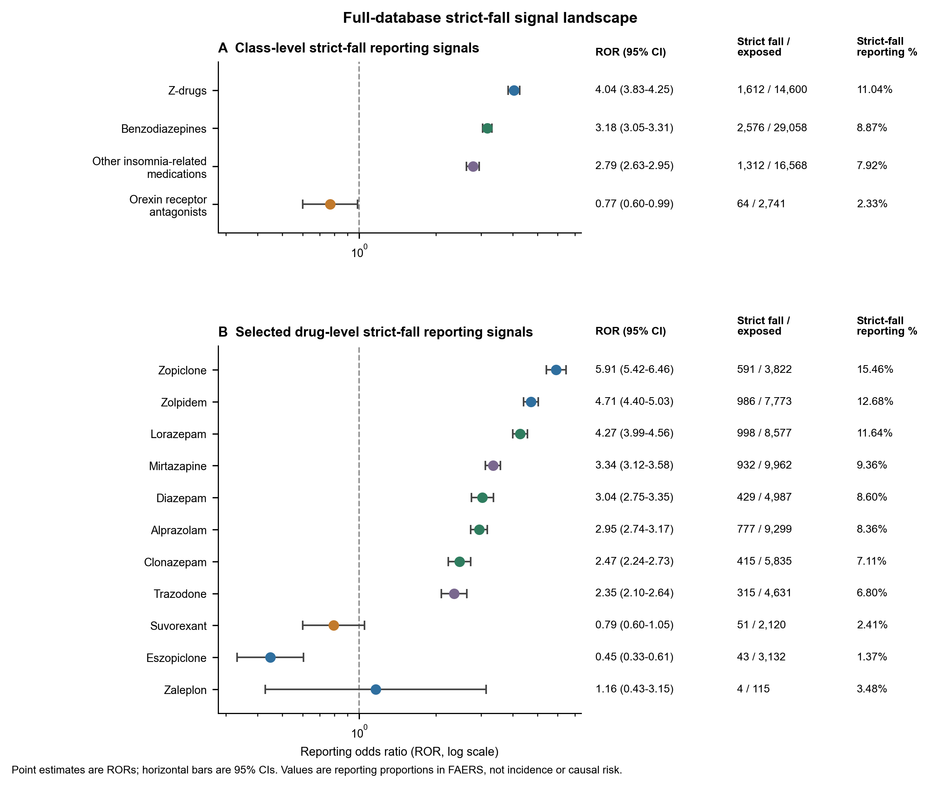
Fig. 2. Full-database strict-fall signal landscape. Forest plot showing reporting odds ratios (RORs) and 95% confidence intervals for strict-fall reporting signals under the full FAERS background. Panel A shows class-level signals for Z-drugs, benzodiazepines, orexin receptor antagonists, and other insomnia-related medications. Panel B shows selected individual-drug signals chosen to illustrate both high-signal and lower-signal patterns. Right-side columns report the number of strict-fall reports divided by all exposed reports and the corresponding strict-fall reporting proportion. These values describe FAERS reporting patterns and should not be interpreted as incidence, absolute risk, or causal effects.

3.3 Active-Comparator Analyses Refined Broad Signals into Drug-Specific Contrasts
The signal landscape was next restricted to mutually exclusive, clinically relevant comparator groups (Table 3; Fig. 3). Among 5,904 zolpidem-only reports, 745 (12.62%) included a strict fall. This proportion was higher than that among other Z-drug-only reports (438/5,459; 8.02%; ROR 1.66, 95% CI 1.46–1.87), benzodiazepine-only reports (1,989/24,408; 8.15%; ROR 1.63, 95% CI 1.49–1.78), orexin receptor antagonist-only reports (57/2,507; 2.27%; ROR 6.21, 95% CI 4.72–8.16), and other insomnia-related medication-only reports (926/13,111; 7.06%; ROR 1.90, 95% CI 1.72–2.10).
The class-level comparisons showed a similar broad ordering. Strict falls were reported in 10.35% of Z-drug-only reports, compared with 8.15% of benzodiazepine-only reports (ROR 1.30, 95% CI 1.21–1.40) and 2.27% of orexin receptor antagonist-only reports (ROR 4.96, 95% CI 3.79–6.50). Benzodiazepines were also more frequently co-reported with strict falls than orexin receptor antagonists (ROR 3.81, 95% CI 2.92–4.98).
However, the within-class analyses showed that zolpidem was not the highest-signal Z-drug. Zolpidem had a lower strict-fall reporting proportion than zopiclone (12.62% vs 16.05%; zolpidem-versus-zopiclone ROR 0.76, 95% CI 0.66–0.86), but a markedly higher proportion than eszopiclone (12.62% vs 1.23%; ROR 11.56, 95% CI 8.25–16.20). The comparison with zaleplon was inconclusive because of sparse events (ROR 2.06, 95% CI 0.74–5.69). These findings separated a broad Z-drug class signal into distinct drug-level reporting patterns.

3.4 Sequential Adjustment and Sensitivity Analyses Distinguished Reproducible from Context-Dependent Contrasts
The zolpidem contrasts with benzodiazepines, orexin receptor antagonists, and other insomnia-related medications remained elevated across sequential regression models (Table 3; Fig. 3). In the fully adjusted model, the odds ratios (ORs) were 1.54 (95% CI 1.39–1.71) for zolpidem versus benzodiazepines, 3.11 (95% CI 2.28–4.25) for zolpidem versus orexin receptor antagonists, and 3.06 (95% CI 2.67–3.50) for zolpidem versus other insomnia-related medications. The within-Z-drug comparison was more sensitive to model specification: the estimate attenuated after demographic, temporal, and reporting-source adjustment (ORs 1.12 and 1.11, respectively), but was again above unity after additional adjustment for polypharmacy, central nervous system co-medications, and recorded indications (fully adjusted OR 1.34, 95% CI 1.16–1.55).
At the class level, the fully adjusted OR was 1.34 (95% CI 1.23–1.47) for Z-drugs versus benzodiazepines, 2.61 (95% CI 1.94–3.51) for Z-drugs versus orexin receptor antagonists, and 2.65 (95% CI 1.96–3.58) for benzodiazepines versus orexin receptor antagonists. In contrast, the crude difference between other insomnia-related medications and orexin receptor antagonists attenuated to the null after full adjustment (OR 1.01, 95% CI 0.72–1.43), indicating that the refinement steps did not preserve every initial signal.
The primary-suspect-only analysis continued to support the zolpidem contrasts with other Z-drugs (ROR 8.19, 95% CI 5.92–11.32), benzodiazepines (ROR 1.37, 95% CI 1.22–1.54), and orexin receptor antagonists (ROR 5.17, 95% CI 3.89–6.88). By contrast, the Z-drug-versus-benzodiazepine class comparison reversed under the primary-suspect-only definition (ROR 0.85, 95% CI 0.76–0.95), demonstrating sensitivity of this class-level contrast to reported drug role. Excluding mixed Z-drug and mixed sedative-hypnotic exposures produced estimates closely aligned with the primary analysis.
Country-stratified analyses further localized the instability of the within-Z-drug contrast. In US reports, zolpidem was more frequently co-reported with strict falls than other Z-drugs (9.48% vs 1.10%; ROR 9.46, 95% CI 6.48–13.80), whereas no clear difference was observed in non-US reports (15.02% vs 15.61%; ROR 0.95, 95% CI 0.83–1.10). In contrast, the zolpidem comparisons with benzodiazepines and orexin receptor antagonists remained elevated in both US and non-US strata. Collectively, these analyses indicated that the cross-class zolpidem contrasts were more reproducible than the zolpidem-versus-other-Z-drugs contrast, which depended strongly on reporting context.

Table 3. Active-comparator strict-fall contrasts and fully adjusted estimates.
Comparison | Analysis reports, n | Exposure strict-fall, % | Comparator strict-fall, % | Crude ROR (95% CI) | Fully adjusted OR (95% CI)
Zolpidem-only vs other Z-drugs-only | 11,363 | 12.6 | 8.0 | 1.66 (1.46-1.87) | 1.34 (1.16-1.55)
Zolpidem-only vs benzodiazepines-only | 30,312 | 12.6 | 8.1 | 1.63 (1.49-1.78) | 1.54 (1.39-1.71)
Zolpidem-only vs orexin antagonists-only | 8,411 | 12.6 | 2.3 | 6.21 (4.72-8.16) | 3.11 (2.28-4.25)
Zolpidem-only vs other insomnia-related drugs-only | 19,015 | 12.6 | 7.1 | 1.90 (1.72-2.10) | 3.06 (2.67-3.50)
Z-drugs-only vs benzodiazepines-only | 35,852 | 10.4 | 8.1 | 1.30 (1.21-1.40) | 1.34 (1.23-1.47)
Z-drugs-only vs orexin antagonists-only | 13,951 | 10.4 | 2.3 | 4.96 (3.79-6.50) | 2.61 (1.94-3.51)
Benzodiazepines-only vs orexin antagonists-only | 26,915 | 8.1 | 2.3 | 3.81 (2.92-4.98) | 2.65 (1.96-3.58)

Note: Active-comparator analyses used mutually exclusive exposure groups. Fully adjusted models included demographic, reporting-structure, medication-complexity, CNS co-medication, and indication variables when estimable.

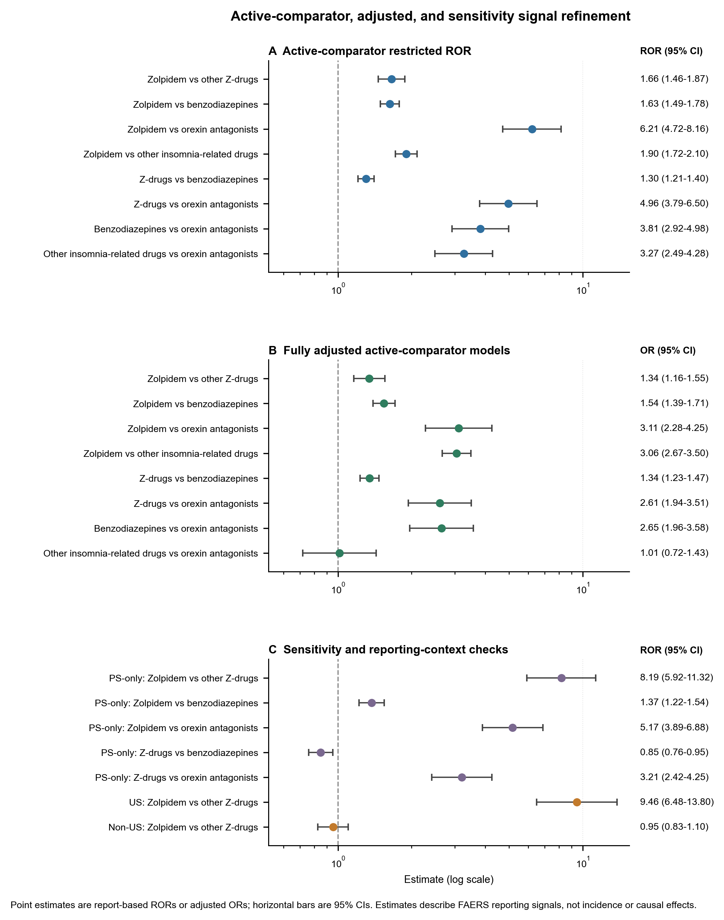
Fig. 3. Active-comparator, adjusted, and sensitivity signal refinement. Forest plot summarizing report-based refinement of strict-fall reporting signals. Panel A shows restricted reporting odds ratios (RORs) from mutually exclusive active-comparator analyses. Panel B shows fully adjusted odds ratios (ORs) from Model 3 active-comparator logistic regression models. Panel C shows selected sensitivity and reporting-context checks, including primary-suspect-only analyses and US/non-US reporting-region stratification. Points represent RORs or ORs, and horizontal bars represent 95% confidence intervals. These estimates describe FAERS reporting-signal patterns and should not be interpreted as incidence, absolute risk, or causal effects.

3.5 Strict-Fall Reports Involving Zolpidem Carried a Distinct Neurocognitive–Motor Phenotype Fingerprint
Phenotype analyses included 745 zolpidem-only, 438 other Z-drug-only, and 1,989 benzodiazepine-only strict-fall reports (Table 4; Fig. 4). Among zolpidem-only fall reports, neurocognitive/consciousness-related terms were co-reported in 38.12%, dizziness/syncope/hypotension-related terms in 22.01%, gait/balance-related terms in 18.12%, and sedation/somnolence-related terms in 7.52%. More than one predefined phenotype domain was present in 22.95% of zolpidem reports, whereas 41.21% contained none of the predefined mechanistic co-phenotypes.
The phenotype composition differed from that of other Z-drugs. Other Z-drug-only fall reports had lower proportions of sedation/somnolence (3.88%), neurocognitive/consciousness (15.53%), and gait/balance (8.45%) co-reporting, and a higher proportion without any predefined mechanistic co-phenotype (60.73%). Benzodiazepine-only fall reports showed a different profile, with greater sedation/somnolence co-reporting (17.19%) and the highest proportion of dizziness/syncope/hypotension terms (28.00%), while neurocognitive/consciousness and gait/balance terms were present in 27.40% and 17.24%, respectively. Phenotype distributions differed across the three groups for sedation/somnolence, neurocognitive/consciousness, dizziness/syncope/hypotension, gait/balance, and the mutually exclusive primary phenotype classification; visual disturbance was uncommon and did not differ clearly between groups.
The differences in neurocognitive and motor phenotypes persisted after adjustment. Compared with other Z-drugs, zolpidem fall reports had higher adjusted odds of neurocognitive/consciousness co-reporting (OR 3.50, 95% CI 2.50–4.91) and gait/balance co-reporting (OR 2.74, 95% CI 1.73–4.34). Compared with benzodiazepines, zolpidem was also associated with greater neurocognitive/consciousness (OR 1.89, 95% CI 1.52–2.35) and gait/balance (OR 1.51, 95% CI 1.14–1.99) co-reporting, but with lower sedation/somnolence co-reporting (OR 0.43, 95% CI 0.30–0.61). Dizziness/syncope/hypotension did not differ clearly between zolpidem and either comparator after adjustment.
Drug-level clean-exposure profiles reinforced the distinction between signal magnitude and phenotype structure. Despite having the highest full-database strict-fall signal, zopiclone fall reports contained fewer neurocognitive/consciousness (14.82%) and gait/balance (7.79%) co-phenotypes than zolpidem reports, and more frequently lacked any of the predefined mechanistic co-phenotypes (62.56% vs 41.21%) (Supplementary Table S9). Thus, the zolpidem pattern was characterized less by greater co-reporting of simple sedation and more by enrichment of neurocognitive and gait/balance features.

Table 4. Phenotype profile and selected clinical outcomes among mutually exclusive sedative-hypnotic strict-fall report groups.
Group | Fall reports, n | Neurocognitive/consciousness, % | Dizziness/syncope/hypotension, % | Gait/balance, % | Sedation/somnolence, % | Mixed phenotype, % | Any predefined mechanistic phenotype, % | Hospitalization, % | Death, %
Zolpidem only | 745 | 38.1 | 22.0 | 18.1 | 7.5 | 23.0 | 58.8 | 74.5 | 6.6
Other Z-drugs only | 438 | 15.5 | 24.7 | 8.4 | 3.9 | 12.6 | 39.3 | 74.2 | 6.8
Benzodiazepines only | 1,989 | 27.4 | 28.0 | 17.2 | 17.2 | 23.4 | 55.1 | 75.8 | 5.0

Note: Phenotype and clinical-outcome percentages use strict-fall reports in each mutually exclusive exposure group as the denominator. The basic phenotype domains are not mutually exclusive; a report may contribute to more than one domain, so phenotype percentages within a row do not sum to 100%. Mixed phenotype indicates the presence of at least two predefined phenotype domains, whereas any predefined mechanistic phenotype indicates the presence of at least one. Hospitalization and death are co-reported outcomes within the selected fall case series and should not be interpreted as incidence, absolute risk, or causal effects
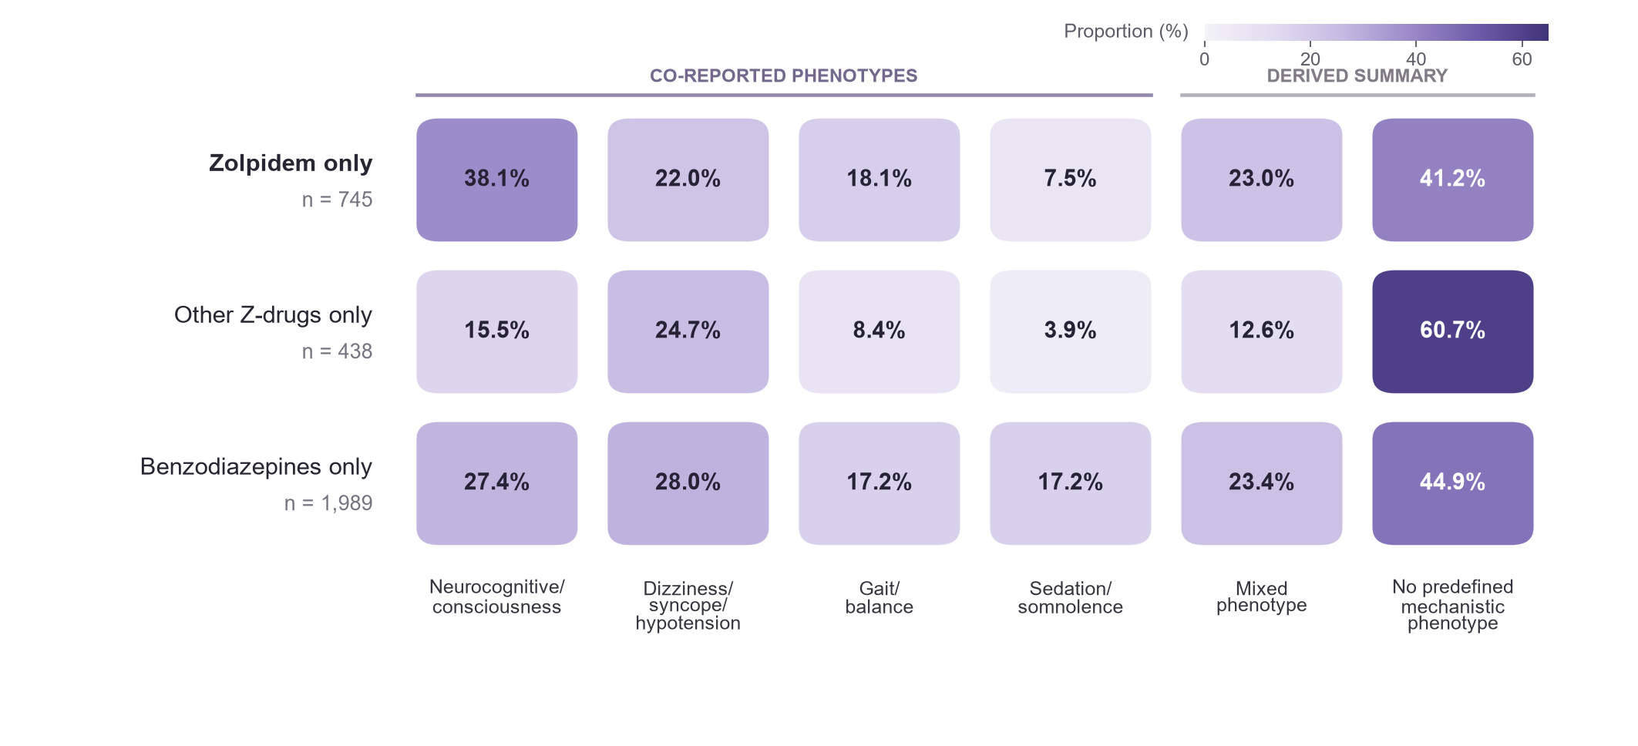
Fig. 4. Phenotype fingerprint of strict-fall reports across mutually exclusive sedative-hypnotic exposure groups. Heatmap cells show the proportion of strict-fall reports containing each prespecified co-reported phenotype. Percentages were calculated within zolpidem-only, other Z-drug-only, and benzodiazepine-only strict-fall reports. The basic phenotype domains were not mutually exclusive; therefore, percentages within a row do not sum to 100%. Mixed phenotype denotes at least two predefined phenotype domains, and no predefined mechanistic phenotype denotes none of the predefined domains. Darker shading indicates a higher within-group reporting proportion. The heatmap is descriptive; adjusted pairwise phenotype comparisons are reported in Supplementary Table S8.

3.6 Serious-Outcome Co-Reporting Identified the Clinical Priority of the Fall Case Series
Serious outcomes were common among strict-fall reports involving the higher-signal drug groups, although these proportions describe the selected fall case series rather than outcome incidence after exposure. Among Z-drug strict-fall reports, 97.27% included at least one serious outcome, 76.74% included hospitalization, and 6.08% included death. The corresponding proportions for zolpidem were 97.16%, 76.37%, and 5.27%, and those for benzodiazepines were 97.09%, 76.79%, and 4.70%; hospitalization and death co-reporting proportions for the mutually exclusive groups are summarized in Table 4. Zopiclone strict-fall reports had a hospitalization co-reporting proportion of 79.86% and a death co-reporting proportion of 7.95%.
Only 64 strict-fall reports involved orexin receptor antagonists; 79.69% included a serious outcome and 42.19% included hospitalization. Given the small case series and the selective nature of spontaneous reporting, these differences were treated as descriptive pharmacovigilance-prioritization information rather than comparative estimates of clinical severity.

3.7 Internal-Support Classification
Zolpidem received high internal support, with 8 of 9 points. Z-drugs as a class received moderate support because the PS-only comparison with benzodiazepines reversed direction and reporting-structure results were inconsistent. Benzodiazepines and other insomnia-related drugs also received moderate support. Evidence was insufficient for other Z-drugs and orexin receptor antagonists because only a limited subset of the prespecified domains was evaluable. Full component-level scoring and evidence availability are reported in Supplementary Table S14.
Support classifications were unchanged across alternative case-count and confidence-interval thresholds. In leave-one-domain-out analyses, the zolpidem classification changed from high to moderate after omission of any of four major scored domains, indicating that its high-support classification reflected convergence across multiple analytical layers.

3.8 Integrated Signal and Phenotype Interpretation
The successive analyses separated three features that were not interchangeable: signal magnitude, robustness across reporting conditions, and phenotype support. Zopiclone produced the largest full-database and within-class strict-fall disproportionality estimates, but its fall reports were less enriched for the predefined neurocognitive and gait/balance phenotypes. Zolpidem showed a somewhat lower crude signal than zopiclone, but had the broadest evaluable support across cross-class active comparisons and a distinct neurocognitive–gait/balance phenotype pattern. Its comparison with other Z-drugs, however, remained sensitive to model specification and reporting geography. Benzodiazepines showed a persistent class-level fall-reporting signal with a phenotype profile containing more sedation and dizziness/syncope/hypotension co-reporting than zolpidem. Orexin receptor antagonists formed a lower reporting background in this dataset, but their smaller report volume precluded interpretation as a comparative safety advantage.

4 Discussion
This study identified a structured pattern of fall-related reporting across sedative-hypnotic drug classes and individual agents in older adults. Zolpidem showed a prominent full-database signal, with 986 strict-fall reports among 7773 exposed reports and an ROR of 4.71 (95% CI 4.40–5.03). Z-drugs as a class and benzodiazepines also showed elevated reporting, whereas orexin receptor antagonists formed a lower-signal comparison group. The active-comparator, adjusted, and phenotype analyses then separated these broad class-level patterns into clinically interpretable drug-specific profiles.
The prominent signals observed for Z-drugs and benzodiazepines align with geriatric safety guidance and prior evidence linking these medications with cognitive impairment, psychomotor effects, falls, fractures, and fall-related injuries [3–9]. The present study advances this evidence by resolving a broad class-level concern into a multilayer signal profile. Full-database disproportionality established the initial signal magnitude, active comparators and adjusted models characterized comparative stability, and phenotype profiling connected the leading signals with neurocognitive, consciousness, dizziness, and gait-related features. This integrated structure is the central contribution of the study.
Zolpidem achieved the highest internal-support classification, although leave-one-domain-out analyses showed that this classification depended on convergence across several analytical domains. This finding supports prioritization of the signal while emphasizing that no single analysis was sufficient to establish the high-support tier.
The class-level Z-drug signal was supported by the main active-comparator and adjusted analyses, but its moderate classification reflected sensitivity to exposure definition and reporting structure. In particular, the PS-only comparison with benzodiazepines reversed direction.
Within the Z-drug class, the analysis revealed distinct agent-level profiles. Zopiclone showed a higher strict-fall reporting proportion than zolpidem in the mutually exclusive comparison, whereas zolpidem showed markedly higher reporting than eszopiclone and a numerically higher estimate than zaleplon. Reporting geography and market distribution contributed additional structure to these contrasts, particularly for zopiclone, whose use was concentrated outside the United States. The class-level GABAergic hypnotic signal therefore comprised two complementary patterns: a broadly supported zolpidem signal across comparator analyses and a prominent zopiclone signal shaped by within-class and regional reporting context.
Several pharmacological and clinical pathways help explain the observed patterns. Benzodiazepines and Z-drugs act through positive allosteric modulation of GABA$_A$ receptor signaling and can contribute to residual sedation, reduced alertness, impaired psychomotor performance, dizziness, altered coordination, impaired postural control, and instability during nocturnal awakening. Age-related pharmacokinetic and pharmacodynamic changes, multimorbidity, frailty, and concurrent central nervous system-active medications can amplify these effects in older adults [3–10]. The phenotype analysis identified co-reporting patterns that were compatible with these pathways: 58.8% of zolpidem and 55.1% of benzodiazepine strict-fall reports contained at least one prespecified mechanistically relevant phenotype. The enrichment of consciousness, dizziness, gait, balance, injury, and serious-outcome features supplied the clinical structure underlying the leading statistical signals.
Orexin receptor antagonists formed the clearest lower-signal comparison group in the analysis. Their mechanism differs from that of benzodiazepines and Z-drugs: they promote sleep by attenuating wake-promoting orexin signaling instead of directly enhancing GABAergic inhibition. Experimental and randomized studies have also examined postural stability and next-morning cognitive or psychomotor performance with orexin receptor antagonists relative to zolpidem [20–25]. The combination of a distinct pharmacological pathway, lower FAERS disproportionality, and emerging comparative evidence makes this class an important reference point for future sedative-hypnotic safety research in older adults.
The seriousness profile strengthened the clinical priority of the identified signals. Hospitalization was recorded in approximately three quarters of strict-fall reports involving zolpidem, Z-drugs, or benzodiazepines, showing that the leading signals were frequently embedded in clinically consequential reports. These findings support prioritizing Z-drugs and benzodiazepines for continued surveillance, focused case review, and comparative safety studies. Drug class, individual agent, concurrent central nervous system-active medications, and accompanying phenotypes together provide a practical structure for reviewing fall-related reports. This approach aligns with international falls guidance emphasizing structured medication review and assessment of fall-risk-increasing medications [26].
This study has several strengths. First, it evaluated a large longitudinal FAERS dataset covering more than two decades and focused specifically on older adults, a population particularly susceptible to drug-related functional adverse events. Second, the analysis applied a prespecified strict-fall outcome focused on explicitly coded fall events. Third, signal detection incorporated multiple disproportionality measures, reducing reliance on a single disproportionality threshold. Fourth, mutually exclusive exposure groups and active comparators enabled clinically interpretable comparisons across treatment contexts. Fifth, adjusted models, PS-only analyses, exclusion of mixed exposures, and reporting-source stratification tested the consistency of the key findings. Finally, the prespecified exploratory framework separated core internal statistical support from phenotype and external-evidence modifiers and made context-sensitive or contradictory findings visible.
Several limitations must also be acknowledged. First, FAERS is a spontaneous reporting system without a reliable denominator representing the number of treated patients or person-time at risk. Consequently, RORs, proportional reporting ratios, information components, and observed-to-expected measures quantify reporting disproportionality; they do not estimate incidence, absolute risk, relative clinical risk, or causal effects [12–14,27–29]. Second, the database is affected by under-reporting, duplicate or incomplete reports, stimulated reporting, notoriety bias, differential reporting by healthcare professionals and consumers, changes in labeling, and secular changes in clinical practice. Differences in market age are especially important when comparing established GABAergic hypnotics with more recently introduced orexin receptor antagonists.
Residual confounding by indication and patient characteristics represents an additional limitation. Insomnia, anxiety, neuropsychiatric illness, cognitive impairment, frailty, nocturia, impaired mobility, and previous falls may independently increase the probability of a fall and may also influence selection of a particular hypnotic. Sleep disturbance itself has been associated with falls in older adults, further complicating attribution of the observed reports to pharmacological exposure alone [30–33]. Incomplete characterization of concomitant medication use is another limitation. Although selected central nervous system-active co-medications were included as covariates, FAERS generally lacks reliable information on dose, duration, adherence, treatment initiation, switching, deprescribing, and the temporal relationship between individual drugs and reported events. Residual confounding from polypharmacy is therefore likely.
The internal-support framework is an exploratory evidence-synthesis approach developed for signal prioritization within the present FAERS analysis.
Overall, the study applies a structured approach for moving from signal detection to signal prioritization. Repeatedly supported GABAergic hypnotic signals emerge as priorities for detailed case review and real-world comparative studies, while the lower orexin-antagonist signal defines a focused comparative research direction.

5 Conclusion
By integrating full-database disproportionality, active-comparator analyses, multivariable adjustment, and complementary sensitivity analyses, this study provides a structured assessment of sedative-hypnotic strict-fall reporting signals in older adults. Zolpidem received the highest internal support, whereas Z-drugs as a class and benzodiazepines showed moderate or context-sensitive support. The framework makes both convergent and inconsistent evidence visible and provides a practical structure for pharmacovigilance prioritization and subsequent validation in independent longitudinal data.

Supplementary Materials
The supplementary package is organized in four layers. Supplementary Tables S1–S2 provide the drug dictionary, matching terms, and outcome and phenotype definitions. Supplementary Tables S3–S5 report PS-only, mixed-exposure-exclusion, and reporting-region sensitivity analyses. Supplementary Tables S6–S10 provide phenotype distributions, statistical tests, adjusted phenotype models, and drug-level phenotype contrasts. Supplementary Tables S11–S18 contain exploratory clustering, evidence-component details, full comparator characteristics, BCPNN sensitivity results, leave-one-domain-out summaries, and threshold-sensitivity results.

References
- World Health Organization. Falls. World Health Organization; 2021. https://www.who.int/news-room/fact-sheets/detail/falls. Accessed June 23, 2026.
- Centers for Disease Control and Prevention. Older Adult Falls Data. Centers for Disease Control and Prevention. https://www.cdc.gov/falls/data-research/index.html. Accessed June 23, 2026.
- 2023 American Geriatrics Society Beers Criteria(R) Update Expert Panel. American Geriatrics Society 2023 updated AGS Beers Criteria(R) for potentially inappropriate medication use in older adults. J Am Geriatr Soc. 2023;71(7):2052-2081. doi:10.1111/jgs.18372.
- Treves N, Perlman A, Kolenberg Geron L, Asaly A, Matok I. Z-drugs and risk for falls and fractures in older adults: a systematic review and meta-analysis. Age Ageing. 2018;47(2):201-208. doi:10.1093/ageing/afx167.
- Donnelly K, Bracchi R, Hewitt J, Routledge PA, Carter B. Benzodiazepines, Z-drugs and the risk of hip fracture: a systematic review and meta-analysis. PLoS One. 2017;12(4):e0174730. doi:10.1371/journal.pone.0174730.
- Seppala LJ, Wermelink AMAT, de Vries M, et al. Fall-risk-increasing drugs: a systematic review and meta-analysis. II. Psychotropics. J Am Med Dir Assoc. 2018;19(4):371.e11-371.e17. doi:10.1016/j.jamda.2017.12.098.
- Berry SD, Lee Y, Cai S, Dore DD. Nonbenzodiazepine sleep medication use and hip fractures in nursing home residents. JAMA Intern Med. 2013;173(9):754-761. doi:10.1001/jamainternmed.2013.3795.
- Tom SE, Wickwire EM, Park Y, Albrecht JS. Nonbenzodiazepine sedative hypnotics and risk of fall-related injury. Sleep. 2016;39(5):1009-1014. doi:10.5665/sleep.5742.
- Kolla BP, Lovely JK, Mansukhani MP, Morgenthaler TI. Zolpidem is independently associated with increased risk of inpatient falls. J Hosp Med. 2013;8(1):1-6. doi:10.1002/jhm.1985.
- US Food and Drug Administration. Ambien (zolpidem tartrate) tablets, for oral use: prescribing information. US Food and Drug Administration; 2019. https://www.accessdata.fda.gov/drugsatfda_docs/label/2019/019908s046lbl.pdf. Accessed July 13, 2026.
- US Food and Drug Administration. Certain prescription insomnia medicines: new boxed warning due to risk of serious injuries caused by complex sleep behaviors. US Food and Drug Administration; 2019. https://www.fda.gov/safety/medical-product-safety-information/certain-prescription-insomnia-medicines-new-boxed-warning-due-risk-serious-injuries-caused. Accessed July 13, 2026.
- US Food and Drug Administration. FDA Adverse Event Reporting System (FAERS) database. US Food and Drug Administration. https://www.fda.gov/drugs/drug-approvals-and-databases/fda-adverse-event-reporting-system-faers-database. Accessed July 13, 2026.
- Bate A, Evans SJW. Quantitative signal detection using spontaneous ADR reporting. Pharmacoepidemiol Drug Saf. 2009;18(6):427-436. doi:10.1002/pds.1742.
- Fusaroli M, Salvo F, Begaud B, et al. The REporting of A Disproportionality Analysis for DrUg Safety Signal Detection Using Individual Case Safety Reports in PharmacoVigilance (READUS-PV): explanation and elaboration. Drug Saf. 2024;47(6):585-599. doi:10.1007/s40264-024-01423-7.
- Lund JL, Richardson DB, Sturmer T. The active comparator, new user study design in pharmacoepidemiology: historical foundations and contemporary application. Curr Epidemiol Rep. 2015;2(4):221-228. doi:10.1007/s40471-015-0053-5.
- Hernan MA, Robins JM. Using big data to emulate a target trial when a randomized trial is not available. Am J Epidemiol. 2016;183(8):758-764. doi:10.1093/aje/kwv254.
- Gravel CA, Douros A. Considerations on the use of different comparators in pharmacovigilance: a methodological review. Br J Clin Pharmacol. 2023;89(9):2671-2676. doi:10.1111/bcp.15802.
- Brown EG, Wood L, Wood S. The medical dictionary for regulatory activities (MedDRA). Drug Saf. 1999;20(2):109-117. doi:10.2165/00002018-199920020-00002.
- Gravel CA, Bai W, Douros A. Comparators in pharmacovigilance: a quasi-quantification bias analysis. Drug Saf. 2024;47:809-819. doi:10.1007/s40264-024-01433-5.
- De Crescenzo F, D'Alo GL, Ostinelli EG, et al. Comparative effects of pharmacological interventions for the acute and long-term management of insomnia disorder in adults: a systematic review and network meta-analysis. Lancet. 2022;400(10347):170-184. doi:10.1016/S0140-6736(22)00878-9.
- Murphy P, Kumar D, Zammit G, Rosenberg R, Moline M. Safety of lemborexant versus placebo and zolpidem: effects on auditory awakening threshold, postural stability, and cognitive performance in healthy older participants in the middle of the night and upon morning awakening. J Clin Sleep Med. 2020;16(5):765-773. doi:10.5664/jcsm.8294.
- Rosenberg R, Murphy P, Zammit G, et al. Comparison of lemborexant with placebo and zolpidem tartrate extended release for the treatment of older adults with insomnia disorder: a phase 3 randomized clinical trial. JAMA Netw Open. 2019;2(12):e1918254. doi:10.1001/jamanetworkopen.2019.18254.
- Herring WJ, Connor KM, Snyder E, et al. Suvorexant in elderly patients with insomnia: pooled analyses of data from phase III randomized controlled clinical trials. Am J Geriatr Psychiatry. 2017;25(7):791-802. doi:10.1016/j.jagp.2017.03.004.
- Fietze I, Mayleben D, Laharnar N, et al. Efficacy and safety of daridorexant in older and younger adults with insomnia disorder: a secondary analysis of a randomized placebo-controlled trial. Drugs Aging. 2022;39(10):795-810. doi:10.1007/s40266-022-00977-4.
- Pan G, Ni L, Yan H, Yao L. Association between the use of orexin receptor antagonists and falls or fractures: a meta-analysis. J Psychiatr Res. 2024;176:393-402. doi:10.1016/j.jpsychires.2024.06.029.
- Montero-Odasso M, van der Velde N, Martin FC, et al. World guidelines for falls prevention and management for older adults: a global initiative. Age Ageing. 2022;51(9):afac205. doi:10.1093/ageing/afac205.
- European Medicines Agency. Guideline on good pharmacovigilance practices (GVP): Module IX-Signal management (Rev 1). European Medicines Agency; 2017. https://www.ema.europa.eu/en/human-regulatory-overview/post-authorisation/pharmacovigilance-post-authorisation/good-pharmacovigilance-practices.
- Cutroneo PM, Sartori D, Tuccori M, et al. Conducting and interpreting disproportionality analyses derived from spontaneous reporting systems. Front Drug Saf Regul. 2023;3:1323057. doi:10.3389/fdsfr.2023.1323057.
- Khouri C, Fusaroli M, Salvo F, Raschi E. Interpretation of pharmacovigilance disproportionality analyses. Clin Pharmacol Ther. 2023;114(4):806-807. doi:10.1002/cpt.2951.
- Stone KL, Ancoli-Israel S, Blackwell T, et al. Actigraphy-measured sleep characteristics and risk of falls in older women. Arch Intern Med. 2008;168(16):1768-1775. doi:10.1001/archinte.168.16.1768.
- Min Y, Kirkwood CK, Mays DP, Slattum PW. The effect of sleep medication use and poor sleep quality on risk of falls in community-dwelling older adults in the US: a prospective cohort study. Drugs Aging. 2016;33(2):151-158. doi:10.1007/s40266-015-0339-9.
- Min Y, Nadpara PA, Slattum PW. The association between sleep problems, sleep medication use, and falls in community-dwelling older adults: results from the Health and Retirement Study 2010. J Aging Res. 2016;2016:3685789. doi:10.1155/2016/3685789.
- Chen TY, Lee S, Buxton OM. A greater extent of insomnia symptoms and physician-recommended sleep medication use predict fall risk in community-dwelling older adults. Sleep. 2017;40(11):zsx142. doi:10.1093/sleep/zsx142.

