by Clyde

What is RevisionFinder? What does it do?
Revisionfinder is a tool for checking up on how your changes have propagated in Cryptic’s systems. RevisionFinder is designed to answer questions like “Is this change that I made on any Live servers? QA servers? Has it even been built anywhere?”

When you enter an SVN revision number, or a Gimme revision number along with its branch name, RevisionFinder will tell you:
- Which types of builder have processed your revision
- The name of the first builder and the start time of the build in each category
- Which types of server are running patches that include your change
- The earliest known instance including your revision for each server type, specifying the server name and the date/time the patch was first seen active by RevisionFinder.
- A history of known deployments that would feature your revision

This information is presented as a set of tables. The first table tells you whether your change has been built. The second table tells you whether your change has been deployed anywhere. The bottom table will give you a full history of deployments containing your change, in case you need that much detail.
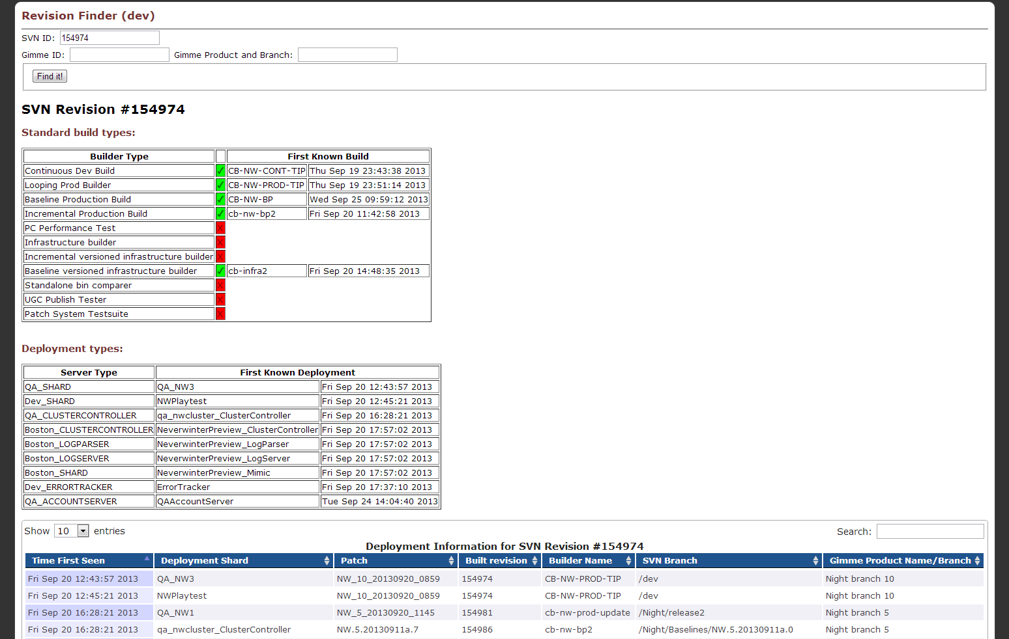
Example of a RevisionFinder result page
How do I set up an instance of RevisionFinder?
When deploying RevisionFinder on a machine, you’ll need to create a folder at C:/RevisionFinder and place RevisionFinder.exe inside. You will also need the web interface resources located in Subversion at “http://code/svn/dev/data/server/RevisionFinder” as well as the MCP web interface resources which you can copy from AccountServer or something.
Inside the RevisionFinder folder you’ll also need to create a config file at C:/RevisionFinder/localdata/server/RevisionFinder/rfConfig.txt
(If this file does not exist when RevisionFinder is run, a file with default values will be created so you can see what the parameters are, and edit them. The defaults may not be very useful, though.)
This configuration (a textparser struct) specifies the following:
- “Basedir” or Base Directory
  - Folder inside localdata where RevisionFinder will keep the data it aggregates.
- “Builderpagebaseurl” or Builder Page Base URL
  - Base URL for the builders page
- “Builderpageurl” or Builder Page URL
  - Full URL for the builder monitor page, with the textparser=1 option.
- “Critsysurls” or Critical Sys(tem) URLs
  - One or more URLs to ControllerTracker CriticalSystems pages, with the textparser=1 option.
- “Critsyscatnames” or Critical System Category Names
  - These act like nicknames for the specified ControllerTrackers. These strings are appended to the server type for servers found on the corresponding ControllerTracker
  - There need to be as many of these as there are “Critsysurl”s specified, and should be in the same order as their matching entries.
- “Buildertypeorder” or Builder Type Order
  - This parameter specifies the builder types that appear in the checklist on RevisonFinder’s results page. They will appear in the same order specified, and each one should match the full type string given for a builder on the builders page.

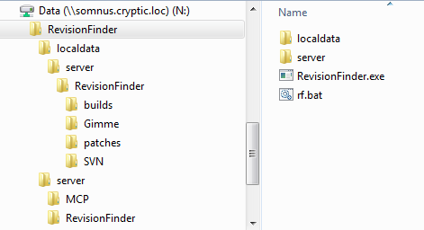
Folder structure for RevisionFinder

At the time I’m writing this document, a complete package resides at N:/RevisionFinder which can be dropped onto a machine and has a handy batch file for running RevisionFinder with a useful configuration. The package also has some pre-aggregated data, and a filled-out rfConfig.txt.
Of particular note when running RevisionFinder is that the rf.bat file included in the package will run two instances of the program. In addition to waiting for web requests, RevisionFinder will also periodically gather data on revisions, builds, and patches. This process can block and slow down the processing of requests, so RevisionFinder has a command line option to disable either request handling or data aggregation. The program can then be run twice, to be able to handle requests even while gathering data.

How does RevisionFinder work?
As alluded to above, RevisionFinder has two main functional components: Request handling and data aggregation.
The data aggregation process periodically gathers information on revisions, builds, patches, and deployments. First, RevisionFinder checks the builders page for the build history of the listed builders. For each build, the full build information is recorded and a text file is created for the latest revision on that build’s branch, and references the build information stored separately. Then, the Critical Systems pages of ControllerTrackers listed in rfConfig.txt are checked for their patch information. RevisionFinder will then record the patch names, each containing a list of the machines they were seen on and the time they were seen. (The Critical Systems pages don’t provide the time that the patch was deployed.)
The data aggregation process will also keep a history of mergeinfo between different SVN branches. The process makes a series of mergeinfo queries via system_w_output to determine the links between stored revisions. As requests to http://code can create significant delays, this part of the process can take around 15 minutes and RevisionFinder does this less frequently than the rest of its data gathering.
Request handling is performed using the information generated by the data aggregation process, and can run parallel to it since it doesn’t need to write any files. When an SVN revision is entered, RevisionFinder will first check with Subversion to see which branch the given revision number was a commit to. RevisionFinder will then start from that branch, and check each file it has stored in that branch until a merge has been reached. The search will then switch to the merge destination branches and continue, going forward along commits until the present data is reached. Each “hit” in the search results is a time that RevisionFinder had seen the requested change feature in a build, which would create a patch that is then installed on a server.

What are these source files?
RevisionFinder was created based on the structure of AccountServer and will have some structural similarities. Here are descriptions for the more relevant source files for RevisionFinder:
- revisionMain.c
  - Starts the program, contains the main loop.
- RevisionFinder.c
  - Contains data aggregation other than mergeinfo, and program initialization. The configuration file is loaded here.
- RevisionFinder.h
  - Contains structs. So many.
- wiRevisions.c
  - Request handling lies within.
  - Receives the request, traverses the stored data and compiles a response struct, returns that response through Clearsilver.
- rfSvnUtil.c
  - Contains functions for updating stored merge information.
- rfUtil.c
  - Some miscellaneous functions for dealing with relevant structs inside EArrays
- rfMergeInfoCache.c
  - Contains methods for grabbing the mergeinfo property of a folder in SVN, and caches the results because asking things of Subversion on http://code can be real slow.
  - Is not actually used right now. Kept because it could be useful later and was a pain to write.

