**DOCUMENTATION**

**About The Project:**

Customer service bot is a bot that uses artificial intelligence (AI) and machine learning to answer basic customer questions via a business messenger. It can recognize and answer multiple forms of the same question and can be trained to give instant responses using your preferred voice or text.

Here's why:

* AI chatbots use your existing information and resources, like FAQs or knowledge base articles, to help answer and resolve your customers’ questions.
* They can recognize and answer multiple forms of the same question and can be trained to give instant responses using your preferred voice and tone.
* Chatbots offers instant resolutions *Your business can offer 24/7 conversational support *Chatbots continuously learn
* You can tailor answers to different types of customers
* Your team has more context on each customer
* A consistent user experience is created

Chatbots and AI received a major facelift in recent years. The once futuristic-yet-a-pain-in-the-butt digital assistants are being fueled with more data to better serve customers and drive sales.

**Built With**

* nlkt
* newspaper

## **Getting Started**

To run the project you need to follow the steps:

**Prerequisites:**

Pip3 install newspaper

Pip3 install nltk

Extra steps:

* Create conda environment and create project in this environment
* After installing requirements in above Modules LIST
* Download the project using the git clone -https://github.com/yannamnaveenreddy/Customer_care_bot
* To set the console channel Timeout in seconds
  + And set DEFAULT_STREAM_READING_TIMEOUT_IN_SECONDS=20

**Usage**

IBM estimates that 265 billion customer support tickets and calls are made globally every year, resulting in $1.3 trillion in customer service costs. IBM also referenced a Chatbots Magazine figure purporting that implementing customer service AI solutions, such as chatbots, into service workflows can reduce a business’ spend on customer service by 30 percent. Here are the key areas for how customer service chatbots help businesses to deliver better support.

* Deliver instant customer support
* 24×7 availability
* Deliver seamless hybrid support along with live chat
* Easy scalability
* Reduce your cost of customer support with bots
* Reduce support tickets
* Collect customer feedback & information
* Automate your social media support
* Minimize IVR frustrations
* Better chatbot support = higher customer happiness!!

**Import All Libraries :**

*Some of the libraries should install by using pip. Eg: nltk, Article.*

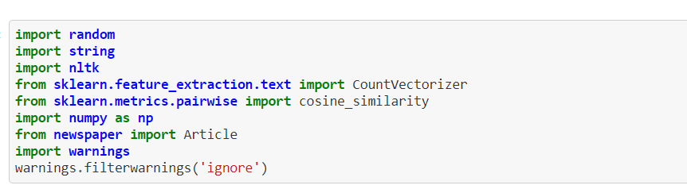

**Path Setting to online article:**

*We need to a lot the article link here so that the bot can analyse the article answer to our questions.*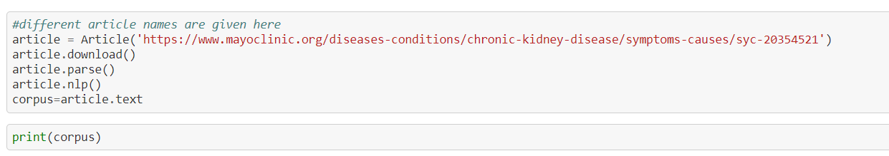

**Analyze the data:**

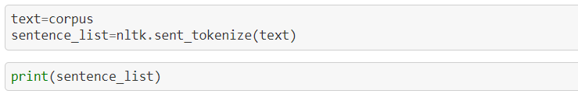

**Greeting response:**

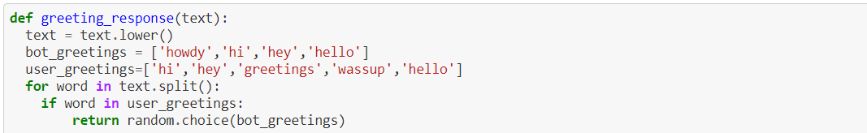

**Bot Response:**

*Bot Response by the analyses of the article and give the response to the user*

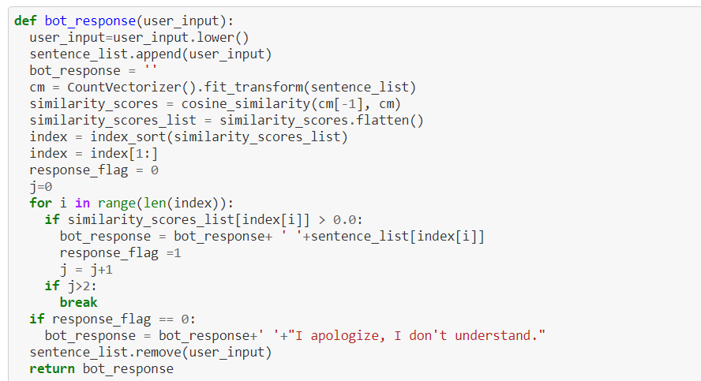

**End of chat:**

*When we give bye , break, thank you… the customer care bot consider it as end of chat and responed as chat with you later and end the chat.*

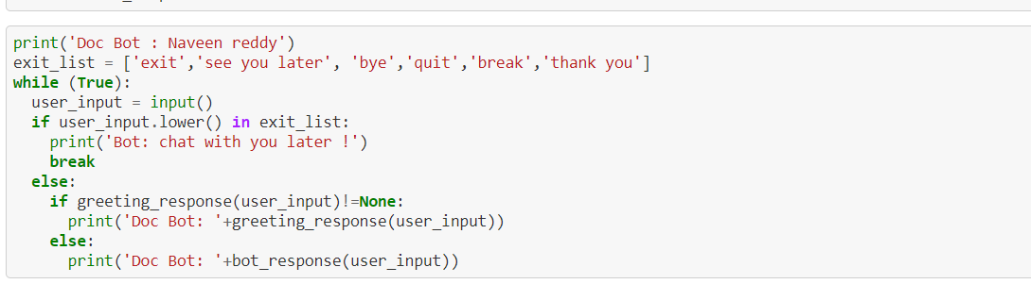

**Sample execution Output:**

*It is the way of conversion by bot when we give the machine learning link*

*Eg:* *https://www.javatpoint.com/machine-learning.*

