VLSI Internship Task 1
Introduction to VLSI Design Flow and Basic Digital Logic Implementation
Submitted By
Name: Yannam Yaswanth Reddy
Student ID: MT4885
Internship: MainCrafts VLSI Internship
Task: Task 1

> CONTENTS
- Introduction to VLSI
- VLSI Design Flow
- Digital Logic Gates
- Truth Tables
- Logic Gate Implementations
- Half Adder
- Simulation Results
- Conclusion

1. Introduction to VLSI
VLSI stands for Very Large Scale Integration. It is the process of integrating millions of transistors into a single chip. VLSI technology is widely used in modern electronic devices such as microprocessors, memory chips, smartphones, computers, and communication systems.
The main objective of VLSI is to improve speed, reduce power consumption, and minimize the size of electronic circuits. VLSI technology plays a major role in the semiconductor industry and modern digital systems.
2. VLSI Design Flow
The VLSI design flow consists of different stages involved in semiconductor chip design.
Steps in VLSI Design Flow
- System Specification
- Architecture Design
- RTL Design
- Functional Verification
- Logic Synthesis
- Physical Design
- Fabrication
- Testing and Verification
The VLSI design flow helps engineers design efficient, reliable, and optimized integrated circuits.

3. Digital Logic Gates
Logic gates are the basic building blocks of digital electronics. They perform logical operations using binary inputs and produce binary outputs.
The following logic gates were implemented using Logisim software:
- AND Gate
- OR Gate
- NOT Gate
- NAND Gate
- NOR Gate
- XOR Gate
- XNOR Gate

4. Truth Tables
AND Gate
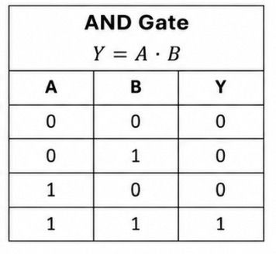

OR Gate

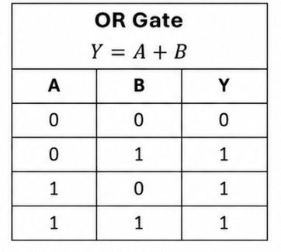

NOT Gate
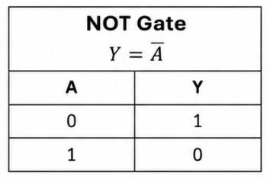

NAND Gate

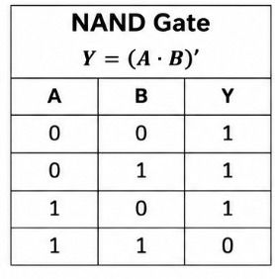

NOR Gate
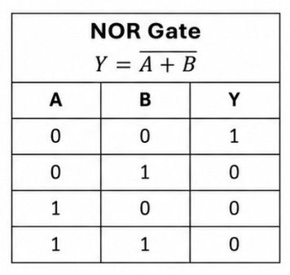

XOR Gate

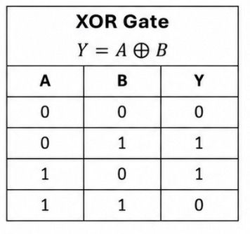

XNOR Gate
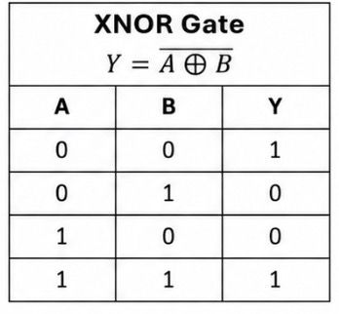

5. Logic Gate Implementations
All the above logic gates were implemented and simulated successfully using Logisim software. Different combinations of binary inputs were applied to verify the outputs according to their respective truth tables.
Screenshots of all implemented logic gates are included in this report. (Black indicates that the LED is off and red is on)
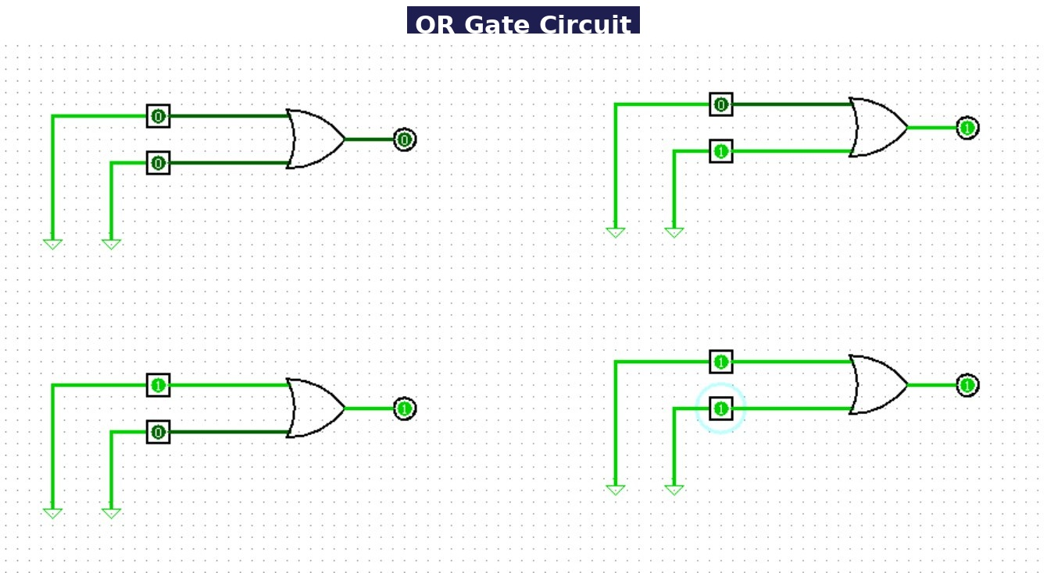
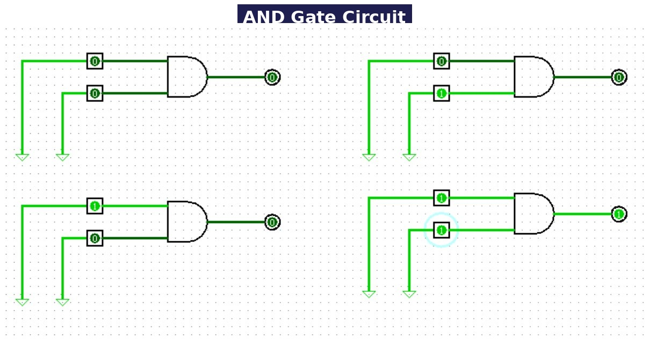

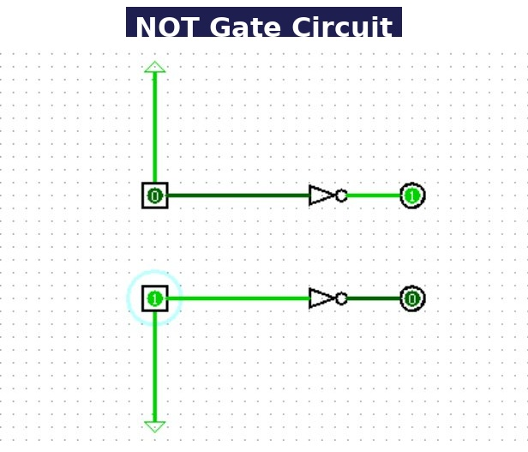
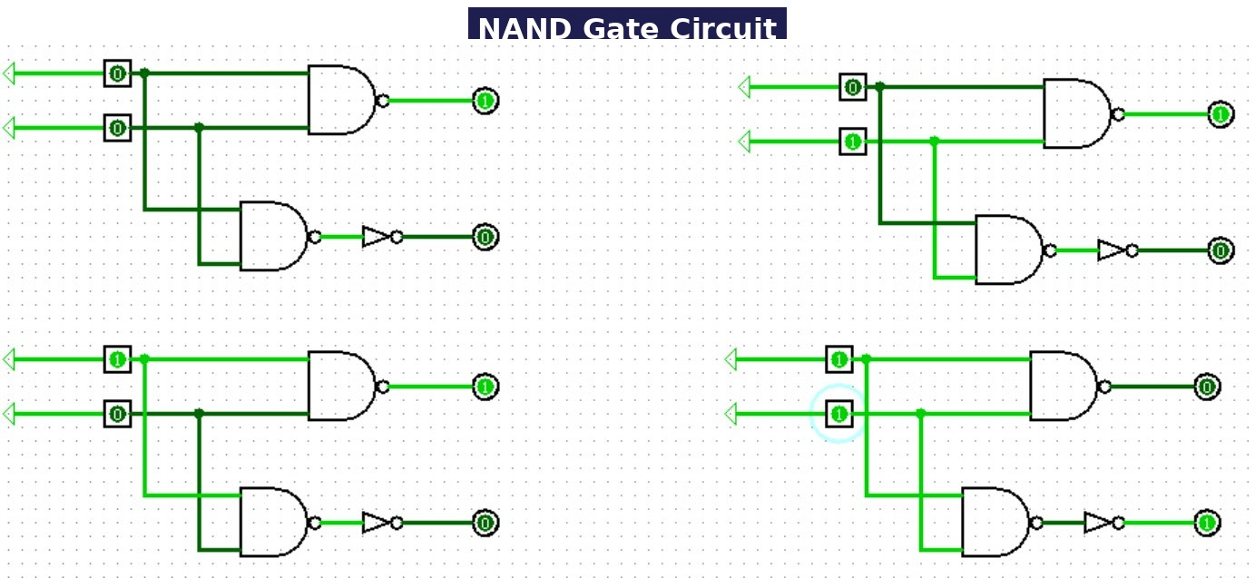

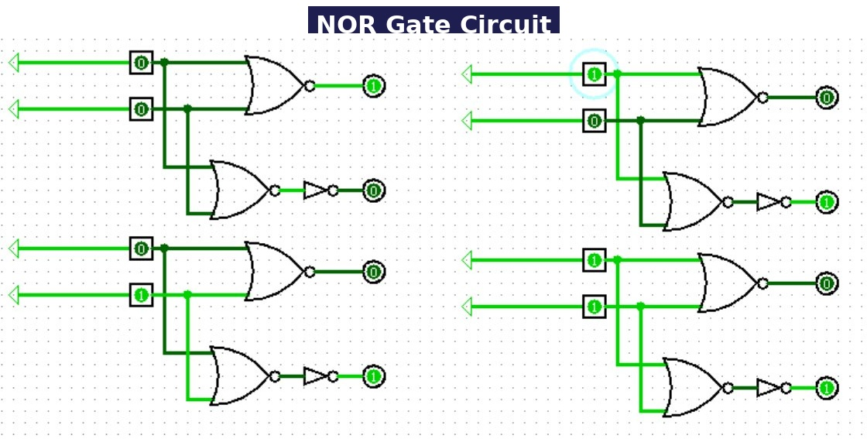

6. Half Adder
A Half Adder is a combinational logic circuit used to perform the addition of two single-bit binary numbers.
It consists of:
- Two inputs: A and B
- Two outputs: Sum and Carry

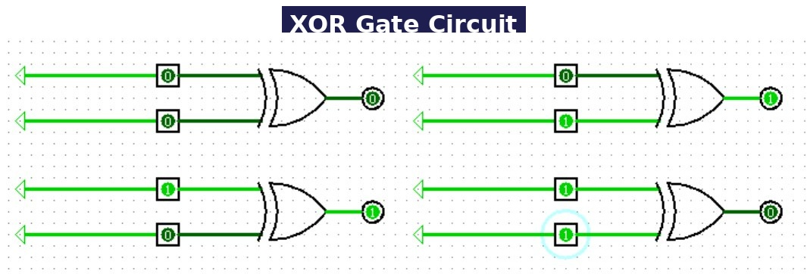

Half Adder Implementation
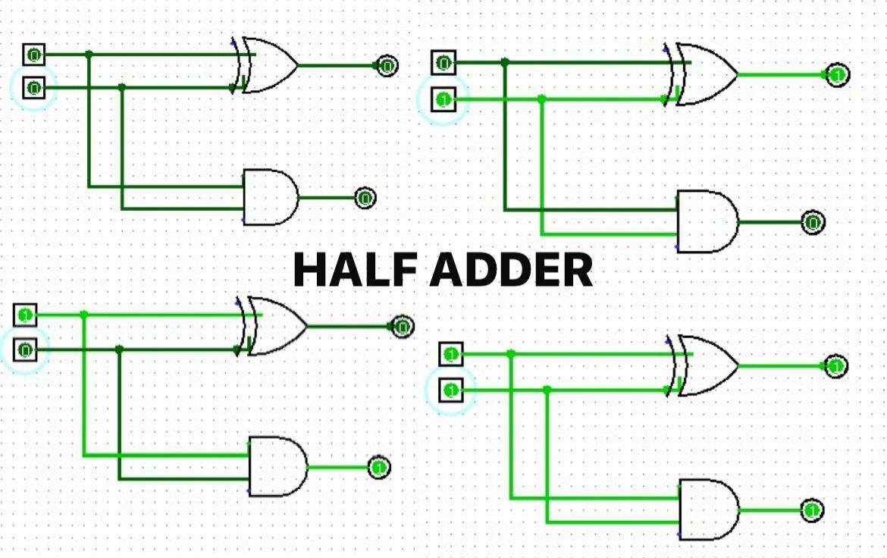

The Half Adder circuit was implemented using:
- XOR gate for generating the Sum output
- AND gate for generating the Carry output
The circuit was simulated in Logisim and verified successfully using different input combinations.

7. Simulation Results
All the logic gates and the Half Adder circuit were successfully simulated using Logisim software.
The obtained outputs matched the expected truth tables and verified the correct working of the circuits.
Screenshots of the circuits and simulation outputs are attached in this report.

8. Conclusion
In this task, the fundamentals of VLSI design flow and digital logic circuits were studied and implemented successfully.
Basic logic gates such as AND, OR, NOT, NAND, NOR, XOR, and XNOR were simulated using Logisim. A Half Adder circuit was also designed and verified using truth tables.
This task helped in understanding:
- Basics of VLSI
- Digital logic design
- Logic gate implementation
- Combinational circuits
- Circuit simulation using Logisim
The internship task provided practical exposure to digital electronics and introductory VLSI concepts.

