VLSI Internship Task 2

Introduction to Verilog HDL and RTL Design of
Basic Combinational Circuits

Submitted By

Name: Yannam Yaswanth Reddy
Student ID: MT4885
Internship: MainCrafts VLSI Internship
Task: Task 2

► CONTENTS
- Introduction to Verilog HDL
- Tools Used
- Circuits Implemented
- Logic Gate Implementations and Verilog Code
- Half Adder
- Full Adder
- Simulation Results (Waveforms)
- Conclusion

1. Introduction to Verilog HDL
Verilog HDL (Hardware Description Language) is a standardized language used to model and design digital electronic systems. It allows engineers to describe digital circuits at different levels of abstraction including behavioral, RTL (Register Transfer Level), and gate-level.

RTL (Register Transfer Level) design describes the flow of data between registers and the logical operations performed on that data. It is one of the most widely used methods for designing digital circuits in the VLSI domain.

In this task, Verilog HDL was used to implement and simulate basic combinational logic circuits using RTL modeling techniques. Each circuit was tested using a dedicated testbench and verified through simulation waveforms.

2. Tools Used

- Verilog HDL – Hardware Description Language for RTL design
- EDA Playground – Online platform for writing and simulating Verilog code
- EPWave – Waveform viewer used to analyze simulation outputs
- GitHub – Version control and code repository

All designs were compiled and simulated using the Icarus Verilog (iverilog) simulator available on EDA Playground.

3. Circuits Implemented

The following combinational logic circuits were designed, coded in Verilog HDL, and simulated:

- AND Gate
- OR Gate
- NOT Gate
- NAND Gate
- NOR Gate
- XOR Gate
- XNOR Gate
- Half Adder
- Full Adder

4. Logic Gate Implementations and Verilog Code
Each gate was implemented as a separate Verilog module along with a testbench for simulation. The design module defines the logic and the testbench applies all input combinations to verify correct output.

4.1 AND Gate

The AND gate produces a HIGH output only when both inputs are HIGH.

Truth Table:

A | B | Y (A AND B)
0 | 0 | 0
0 | 1 | 0
1 | 0 | 0
1 | 1 | 1

Verilog Design Code:
module AND_Gate(
input A,
input B,
output Y
);

assign Y = A & B;

endmodule

Testbench Code:
module tb_AND_Gate;

reg A, B;
wire Y;

AND_Gate uut (
.A(A),
.B(B),
.Y(Y)
);

initial begin
$dumpfile("wave.vcd");
$dumpvars(0);
end

initial begin
$monitor("A=%b B=%b Y=%b", A, B, Y);

A=0; B=0;
#10 A=0; B=1;
#10 A=1; B=0;
#10 A=1; B=1;
#10 $finish;
end

endmodule

4.2 OR Gate

The OR gate produces a HIGH output when at least one input is HIGH.

Truth Table:

A | B | Y (A OR B)
0 | 0 | 0
0 | 1 | 1
1 | 0 | 1
1 | 1 | 1

Verilog Design Code:
module OR_Gate(
input A,
input B,
output Y
);

assign Y = A | B;

endmodule

Testbench Code:
module tb_OR_Gate;

reg A, B;
wire Y;

OR_Gate uut (
.A(A),
.B(B),
.Y(Y)
);

initial begin
$dumpfile("wave.vcd");
$dumpvars(0, tb_OR_Gate);

A=0; B=0;
#10 A=0; B=1;
#10 A=1; B=0;
#10 A=1; B=1;

#10 $finish;
end

endmodule

4.3 NOT Gate

The NOT gate (Inverter) produces an output that is the complement of the input.

Truth Table:

A | Y (NOT A)
0 | 1
1 | 0

Verilog Design Code:
module NOT_Gate(
input A,
output Y
);

assign Y = ~A;

endmodule

4.4 NAND Gate

The NAND gate is the complement of the AND gate. It produces a LOW output only when both inputs are HIGH.

Truth Table:

A | B | Y (A NAND B)
0 | 0 | 1
0 | 1 | 1
1 | 0 | 1
1 | 1 | 0

Verilog Design Code:
module NAND_Gate(
input A,
input B,
output Y
);

assign Y = ~(A & B);

endmodule

Testbench Code:
module tb_NAND_Gate;

reg A, B;
wire Y;

NAND_Gate uut (
.A(A),
.B(B),
.Y(Y)
);

initial begin
$dumpfile("wave.vcd");
$dumpvars(0, tb_NAND_Gate);

A=0; B=0;
#10 A=0; B=1;
#10 A=1; B=0;
#10 A=1; B=1;

#10 $finish;
end

endmodule

4.5 NOR Gate

The NOR gate is the complement of the OR gate. It produces a HIGH output only when both inputs are LOW.

Truth Table:

A | B | Y (A NOR B)
0 | 0 | 1
0 | 1 | 0
1 | 0 | 0
1 | 1 | 0

Verilog Design Code:
module NOR_Gate(
input A,
input B,
output Y
);

assign Y = ~(A | B);

endmodule

Testbench Code:
module tb_NOR_Gate;

reg A, B;
wire Y;

NOR_Gate uut (
.A(A),
.B(B),
.Y(Y)
);

initial begin
$dumpfile("wave.vcd");
$dumpvars(0, tb_NOR_Gate);

A=0; B=0;
#10 A=0; B=1;
#10 A=1; B=0;
#10 A=1; B=1;

#10 $finish;
end

endmodule

4.6 XOR Gate

The XOR gate produces a HIGH output when the inputs are different from each other.

Truth Table:

A | B | Y (A XOR B)
0 | 0 | 0
0 | 1 | 1
1 | 0 | 1
1 | 1 | 0

Verilog Design Code:
module XOR_Gate(
input A,
input B,
output Y
);

assign Y = A ^ B;

endmodule

Testbench Code:
module tb_XOR_Gate;

reg A, B;
wire Y;

XOR_Gate uut (
.A(A),
.B(B),
.Y(Y)
);

initial begin
$dumpfile("wave.vcd");
$dumpvars(0, tb_XOR_Gate);

A=0; B=0;
#10 A=0; B=1;
#10 A=1; B=0;
#10 A=1; B=1;

#10 $finish;
end

endmodule

4.7 XNOR Gate

The XNOR gate produces a HIGH output when both inputs are the same.

Truth Table:

A | B | Y (A XNOR B)
0 | 0 | 1
0 | 1 | 0
1 | 0 | 0
1 | 1 | 1

Verilog Design Code:
module XNOR_Gate(
input A,
input B,
output Y
);

assign Y = ~(A ^ B);

endmodule

Testbench Code:
module tb_XNOR_Gate;

reg A, B;
wire Y;

XNOR_Gate uut (
.A(A),
.B(B),
.Y(Y)
);

initial begin
$dumpfile("wave.vcd");
$dumpvars(0, tb_XNOR_Gate);

A=0; B=0;
#10 A=0; B=1;
#10 A=1; B=0;
#10 A=1; B=1;

#10 $finish;
end

endmodule

5. Half Adder
A Half Adder is a combinational logic circuit used to perform the addition of two single-bit binary numbers.

It consists of:
- Two inputs: A and B
- Two outputs: Sum and Carry

Half Adder Implementation
The Half Adder circuit was implemented using:
- XOR gate for generating the Sum output
- AND gate for generating the Carry output

Truth Table:

A | B | Sum | Carry
0 | 0 | 0 | 0
0 | 1 | 1 | 0
1 | 0 | 1 | 0
1 | 1 | 0 | 1

Verilog Design Code:
module Half_Adder(
input A,
input B,
output Sum,
output Carry
);

assign Sum = A ^ B;
assign Carry = A & B;

endmodule

Testbench Code:
module tb_Half_Adder;

reg A, B;
wire Sum, Carry;

Half_Adder uut (
.A(A),
.B(B),
.Sum(Sum),
.Carry(Carry)
);

initial begin
$dumpfile("wave.vcd");
$dumpvars(0, tb_Half_Adder);

A=0; B=0;
#10 A=0; B=1;
#10 A=1; B=0;
#10 A=1; B=1;

#10 $finish;
end

endmodule

6. Full Adder
A Full Adder is a combinational logic circuit that adds three binary bits: two input bits (A and B) and a carry-in bit (Cin). It produces a Sum output and a Carry output.

It consists of:
- Three inputs: A, B, and Cin (Carry-in)
- Two outputs: Sum and Carry

Full Adder Implementation
The Full Adder was implemented using the following Boolean expressions:
- Sum = A XOR B XOR Cin
- Carry = (A AND B) OR (B AND Cin) OR (A AND Cin)

Truth Table:

A | B | Cin | Sum | Carry
0 | 0 | 0 | 0 | 0
0 | 0 | 1 | 1 | 0
0 | 1 | 0 | 1 | 0
0 | 1 | 1 | 0 | 1
1 | 0 | 0 | 1 | 0
1 | 0 | 1 | 0 | 1
1 | 1 | 0 | 0 | 1
1 | 1 | 1 | 1 | 1

Verilog Design Code:
module Full_Adder(
input A,
input B,
input Cin,
output Sum,
output Carry
);

assign Sum = A ^ B ^ Cin;
assign Carry = (A & B) | (B & Cin) | (A & Cin);

endmodule

Testbench Code:
module tb_Full_Adder;

reg A, B, Cin;
wire Sum, Carry;

Full_Adder uut (
.A(A),
.B(B),
.Cin(Cin),
.Sum(Sum),
.Carry(Carry)
);

initial begin
$dumpfile("wave.vcd");
$dumpvars(0, tb_Full_Adder);

A=0; B=0; Cin=0;
#10 A=0; B=0; Cin=1;
#10 A=0; B=1; Cin=0;
#10 A=0; B=1; Cin=1;
#10 A=1; B=0; Cin=0;
#10 A=1; B=0; Cin=1;
#10 A=1; B=1; Cin=0;
#10 A=1; B=1; Cin=1;

#10 $finish;
end

endmodule

7. Simulation Results (Waveforms)
All the logic gates, Half Adder, and Full Adder circuits were successfully simulated using EDA Playground with Icarus Verilog. The waveform outputs were analyzed using EPWave and confirmed the correct operation of each circuit.

7.1 AND Gate Waveform
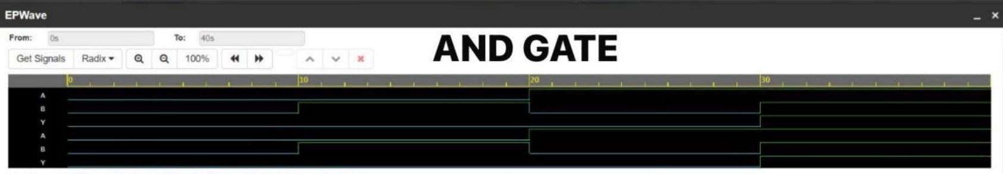

7.2 OR Gate Waveform
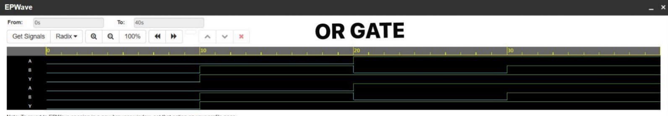

7.3 NAND Gate Waveform
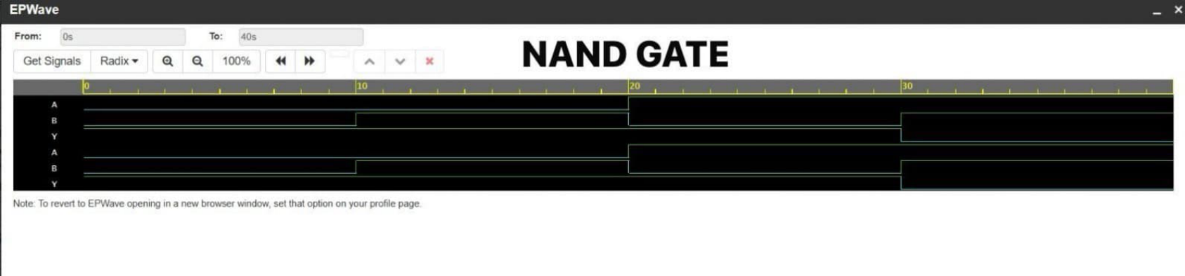

7.4 NOR Gate Waveform
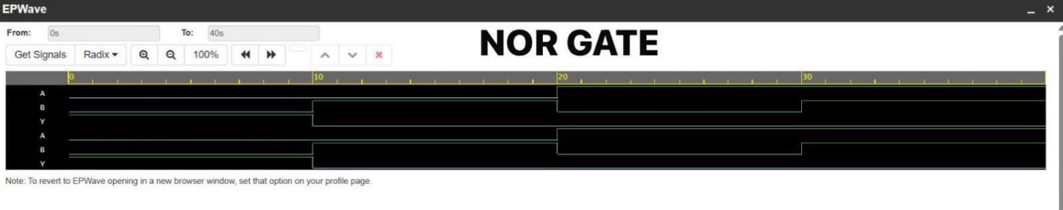

7.5 XOR Gate Waveform
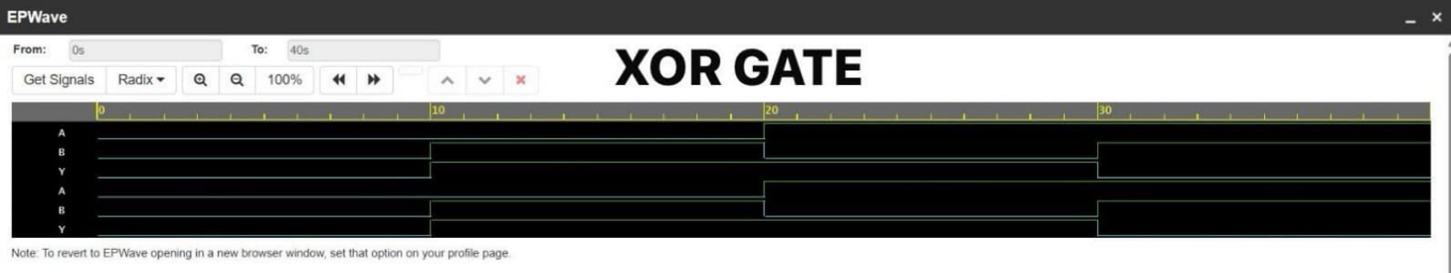

7.6 XNOR Gate Waveform
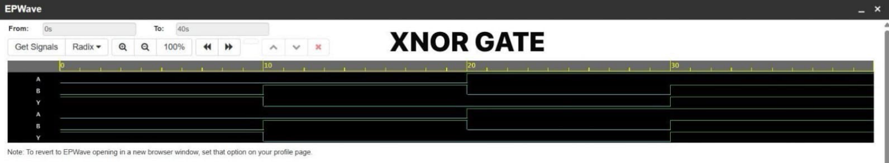

7.7 Half Adder Waveform
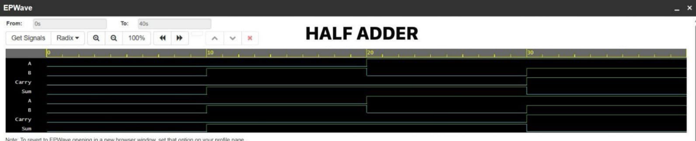

7.8 Full Adder Waveform
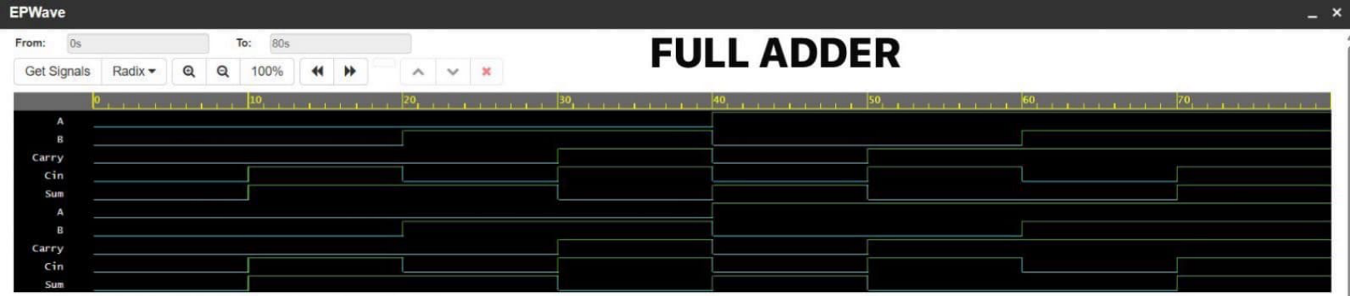

8. Conclusion
In this task, the fundamentals of Verilog HDL and RTL design were studied and implemented successfully.

Basic logic gates such as AND, OR, NOT, NAND, NOR, XOR, and XNOR were designed using Verilog and simulated on EDA Playground. Additionally, a Half Adder and a Full Adder circuit were implemented and verified using truth tables and waveform analysis.

This task helped in understanding:
- Basics of Verilog HDL syntax and module structure
- RTL modeling techniques for combinational circuits
- Testbench development and simulation methodology
- Waveform analysis and verification using EPWave
- Combinational logic design principles

The internship task provided practical exposure to digital circuit design using Verilog HDL and strengthened the understanding of VLSI design fundamentals.

