RL Lab 3 - Monte Carlo & Temporal Difference predictions

1. Monte Carlo prediction on blackjack

1.1. Monte Carlo prediction
Can you interpret the 3D value function graph?
Please attach the graph to your answer.

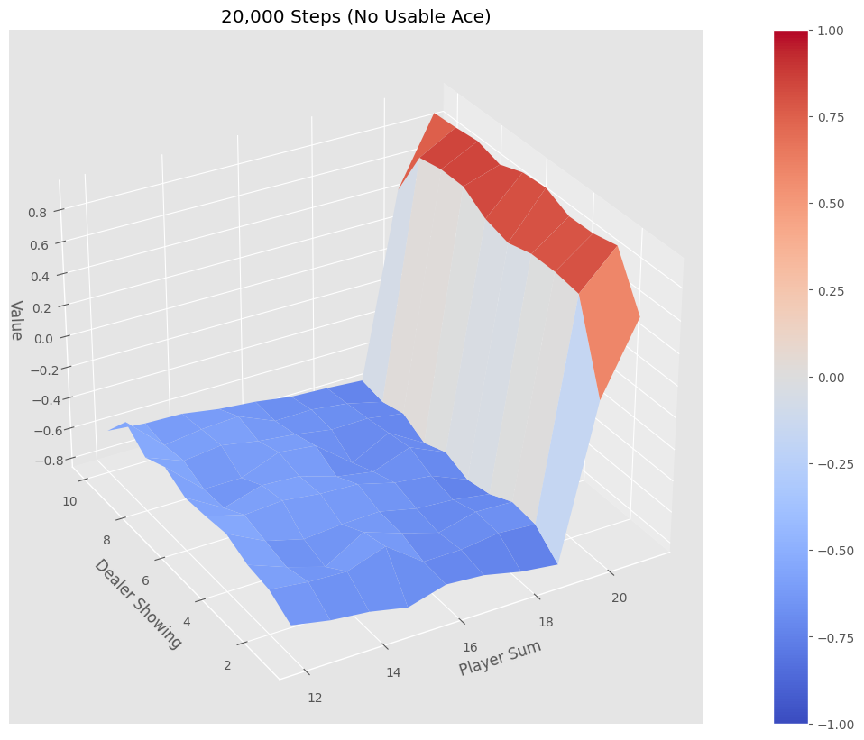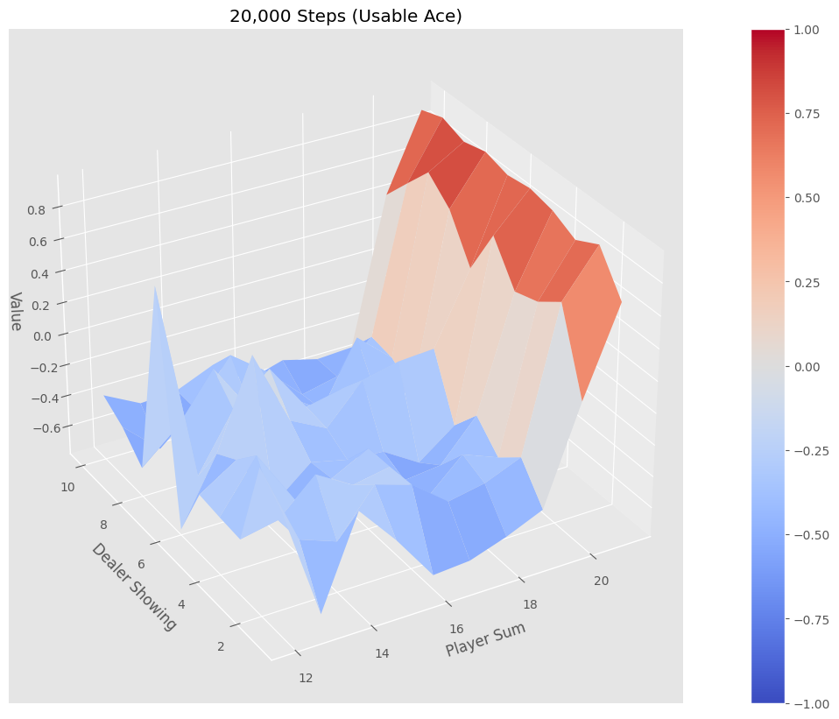

On the graphs we have 3 axes:
- The dealer showing representing the card the dealer has face revealed on the table
- Player Sum representing the sum of the player's cards
- The value or expected return from that state with the current policy
The can see that when the player doesn't have a usable ace (card value = 11), the surface is relatively smooth between 1x10 (dealer) and 12x19 (player) with values very close to -1. This means these states are losing on average, no matter what the dealer is showing. Then we can see a sharp increase in value when the player's sum is between 18 - 19 and again a relatively smooth surface but close to the 20 - 21, because it is probabilistically very hard for the dealer to beat 20 or 21 and this is true with or without a usable ace as we can see on the second plot. On the other hand, the landscape within the 1x10 - 12x19 boundaries becomes very rugged when the player has a usable ace. The values get closer to 0 rather than -1 with spikes in value which reflect the fact the The game becomes less punishing as its more difficult to bust.

1.2. Monte Carlo prediction on multiple episodes
What's the effect of the number of episodes (num_episodes) on the learned value function?
Please attach the graph to your answer.

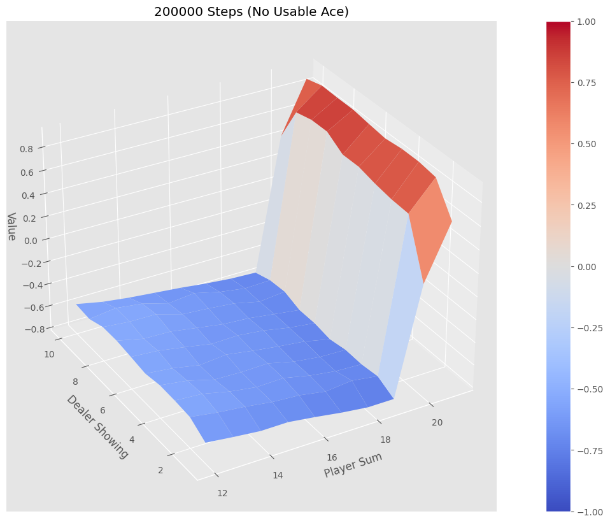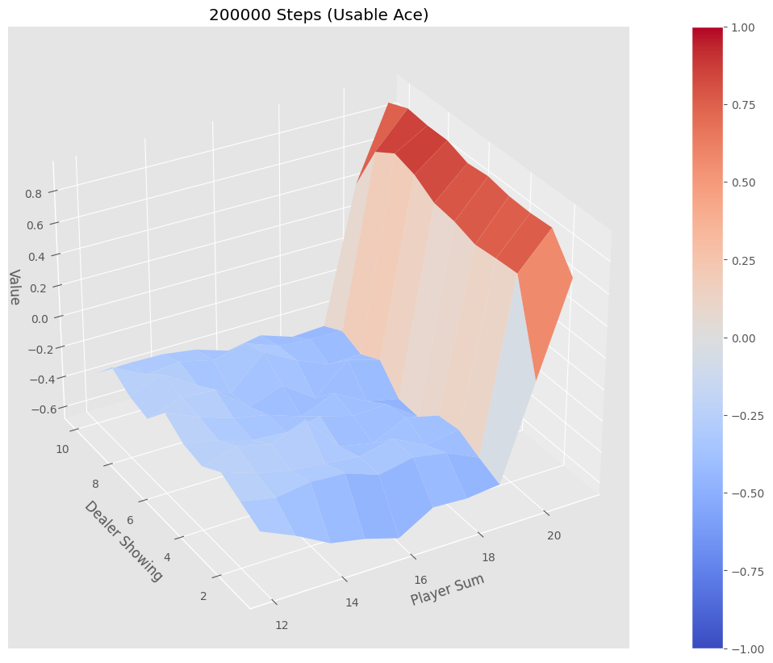
With more episodes, there is less noise and less bias in the estimated values so the surfaces are smoother and don't vary as much.

2. Temporal Difference

1. Comment on the effects of the number of episodes on TD's estimated value graph and interpret the results.
Please attach the graph to your answer.

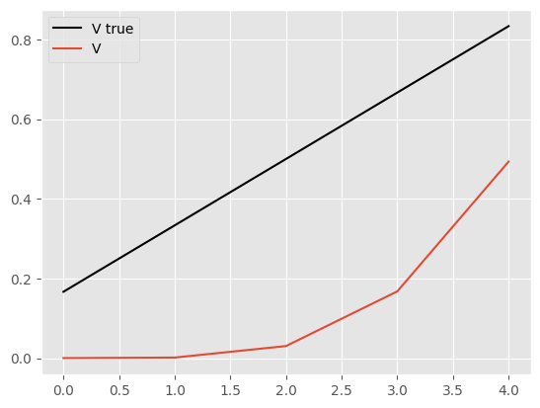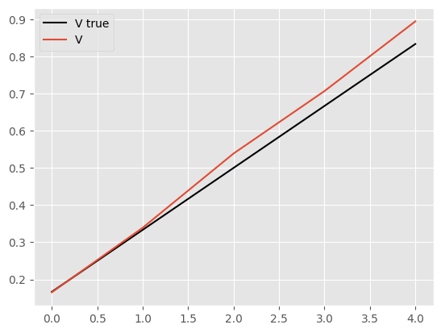

As the number of episodes increases, TD’s estimated value converges to the true value. This reflects the fact TD updates propagate future rewards backward, therefore reducing bias and allowing the estimated value function to start matching more and more the true value function.

2. Comment on the effects of the step size on the empirical RMS error and explain the results.
Compare TD and MC performances and interpret, i.e., give your intuitions as to why one is outperforming the other.
Please attach the graph to your answer.

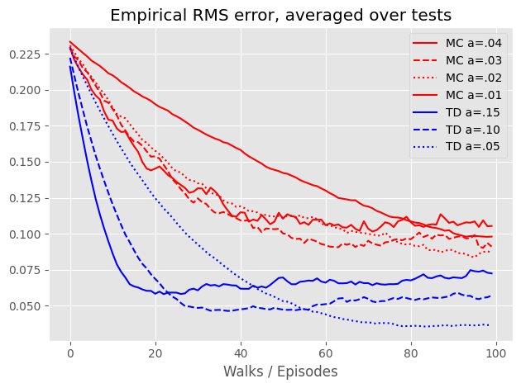
We can see on the graph that TD eRMSE forms a sort of elbow around 20 episodes which gets more pronounced as the step size alpha increases. MC shows a slight curve over the 100 episodes, which gets more pronounced as well with higher step size. TD reaches lower eRMSE than MC at every step size on a 100 episodes. This demonstrates TD has a much faster learning rate on this case than MC. This is because despite being biased, the variance with TD is lower than MC, which leads to better empirical performance in finite time.

