RL Lab 4 - MC control, Q Learning and expected SARSA

1. Monte Carlo Control on blackjack (Section 1)

1.1. Comment on the policy plot and interpret the results. Please attach the graph to your answer.

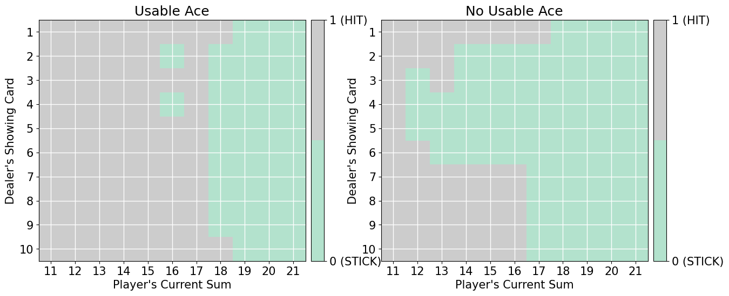
The policy heatmaps show its optimal to stick when player's current sum is at least 18, no matter the dealer's showing card when the player has a usable ace. Otherwise, hitting is preferred. We can see two exceptions when the player's sum is 16 when the dealer is showing a 4 or a 2. However these are probably due to the dealer busting exceptionnally, so noise rather than relevant to the strategy. With no usable ace, the decision boundary depends more on the dealer’s card. When the dealer shows 4 or 6, sticking around 16 or 17 is a better strategy because these are cards on which the dealer busts more often so letting the dealer draw is often the better option. When the dealer shows 9, 10 or Ace, the agent tends to hit until higher sums like 18 or 20, because standing on 16 or 17 against a strong card loses too often. Overall, the no-ace policy is more conservative than the usable ace policy.

2. Solving the cliff world (Section 4)

2.1. Comment on the evolution of the sum of rewards during learning and the cells' number of visits. Compare the 2 algorithms and interpret the results. Please attach the graph to your answer.

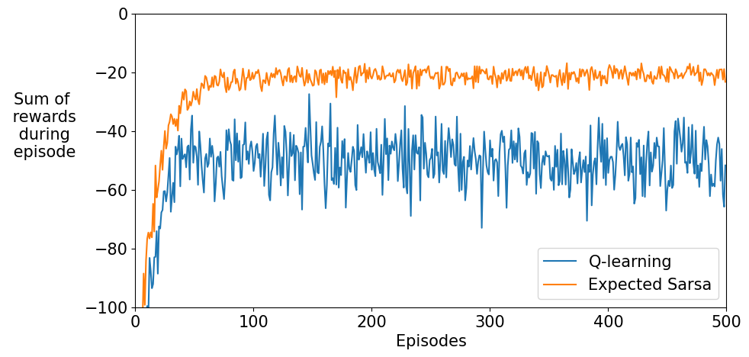
At the beginning, both algorimths start around -100 because the agent explores and often falls into the cliff. Expected SARSA curve improves rapidly and stabilizes around approximately −20. This is due to the fact expected SARSA is on-policy, meaning it assumes epsilon greedy and will explore in "safe" way,avoiding random exploratory action whch could lead to falling into acliff. Its curve is smooth with relatively low variance, while Q-learning also improves but remains much more variable nd stabilizes much lower around -50. Even after convergence, the total reward fluctuates a lot because it sometimes takes random actions leading to getting into the cliff more often, leading to worse penalties.

2.2. Comment on the effects of the step size on the average sum of rewards per episode. Compare the 2 algorithms and interpret the results. Please attach the graph to your answer.

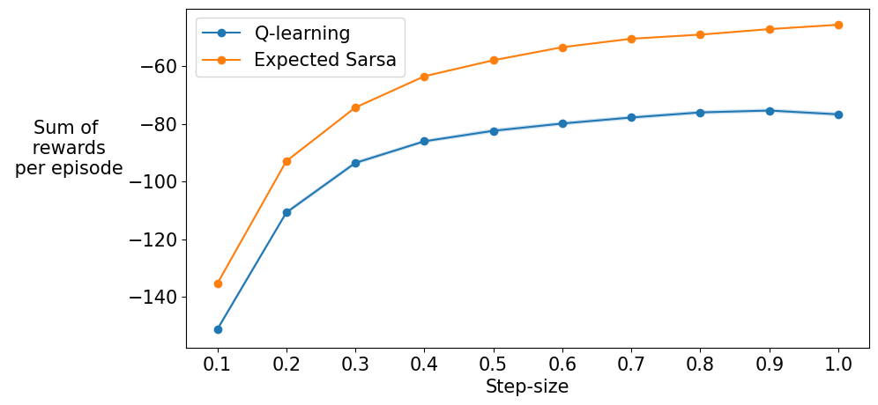
Both the Q-learning and Expected SARSA curve grow steadily with diminishing returns as step-size increases, with the sum of rewards being lower at every point for Q-Learning. This means the average sum of rewards per episode improves as step size increases. With small step size, learning is slow, values update conservatively, which means the agent continues to fall into the cliff more often and this in turn leads to very negative returns. With a larger step size, the agent adapts faster, fall less often from the cliff, which results in higher returns.

