RL Lab 5 - Value Function Approximation and Control

Section 2: SARSA Agent

1. Please upload the graph corresponding to the evolution of the average number of steps per episode throughout the training. Comment on the graph.

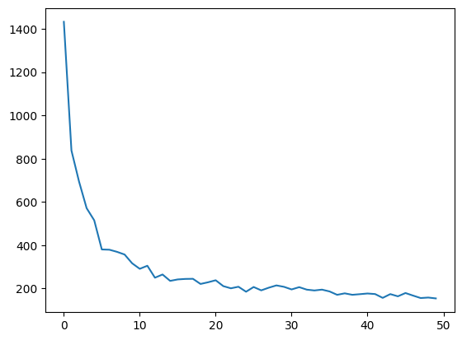

From episode 0 to ~5, we can see a steep decrease of the average number of steps from above 1400 to ~300 ~400. This represents how the SARSA agent rapidly learns paths that reach the goal in fewer steps. The curve on the graph forms an elbow around episode 5. The decrease becomes much smoother as the agent reaches a stable policy and marginal improvements become significantly less impactful.

2. Comment on the graph showing the influence of the tiles' configuration on the agent's learning and interpret the results. Please attach the corresponding graph to your answer.
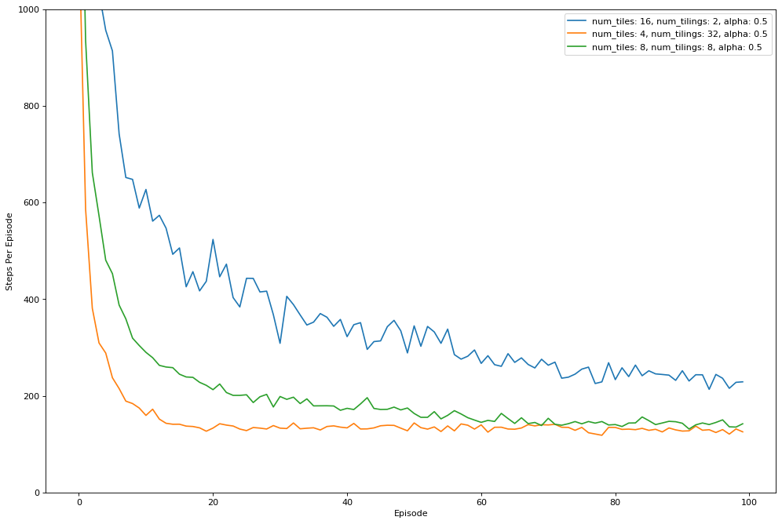

With num_tiles = 4 and num_tilings = 32 (orange), the agent improves the fastest and converges to the lowest number of steps per episode (around ~120 ~140), which shows this policy is more effective and stable. With num_tiles = 8 and num_tilings = 8 (green), the agent also learns well but reaches a plateau higher (~140 ~170), suggesting a reasonable trade-off between generalization and resolution. In contrast, with num_tiles = 16 and num_tilings 2 (blue), learning becomes noticeably slower, is noisier, and converges to a much higher plateau (~220 ~280). This is consistent with a representation that is too fine but lacks enough overlapping tilings to generalize smoothly. Therefore, updates don’t propagate well to nearby states, so learning is less efficient.

