Neural network design

Yann DURIEZ

# Section 1

## How well does your classification work? Plot the misclassification rate for each category onto the same plot.

The accuracy is not bad, but it is very irregular.

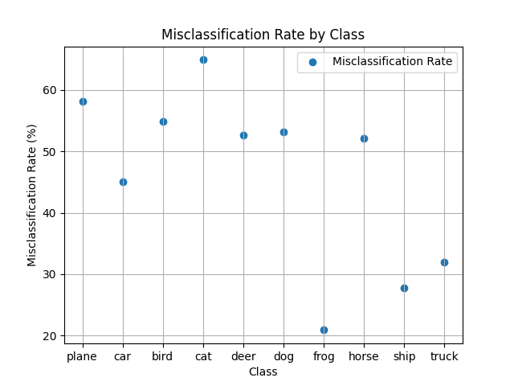

## Calculate the confusion matrix for the image classification task.

Confusion Matrix:

[[ 0 0 0 0 231 260 267 242 0 0]

[ 0 0 0 0 260 256 238 246 0 0]

[ 0 0 0 0 252 245 240 263 0 0]

[ 0 0 0 0 265 252 243 240 0 0]

[ 0 0 0 0 257 258 244 241 0 0]

[ 0 0 0 0 233 256 272 239 0 0]

[ 0 0 0 0 239 262 228 271 0 0]

[ 0 0 0 0 251 231 262 256 0 0]

[ 0 0 0 0 261 243 246 250 0 0]

[ 0 0 0 0 251 237 260 252 0 0]]

## Explain what Autograd is and how it works?

Autograd from pytorch is an automatic differentiation engine that powers neural networks training. Its aim is to compute the gradients of the neural network from all the recorded data. It plots a graph and using chain rule, it can automatically reach its goal.

While performing the forward pass, it plots a first graph, and calculates the gradients. These ones are then evaluated in the backwards pass.

# Section 2

For this part, I have followed the tutorial demanded and ended up with these results:

0m 50s (5000 5%) 3.2501

1m 34s (10000 10%) 3.0434

2m 22s (15000 15%) 3.3159

3m 10s (20000 20%) 2.6469

3m 51s (25000 25%) 2.2382

4m 35s (30000 30%) 2.8028

5m 16s (35000 35%) 2.9449

6m 3s (40000 40%) 2.0122

6m 43s (45000 45%) 2.4829

7m 24s (50000 50%) 3.1049

8m 4s (55000 55%) 3.0899

8m 48s (60000 60%) 2.1728

9m 37s (65000 65%) 2.4986

10m 25s (70000 70%) 2.5486

11m 7s (75000 75%) 2.5347

11m 49s (80000 80%) 1.7945

12m 39s (85000 85%) 3.0398

13m 19s (90000 90%) 1.8471

14m 4s (95000 95%) 2.0723

14m 45s (100000 100%) 2.5372

Rakinov

Uartonov

Santovov

Garter

Eres

Roster

Sartan

Para

Artin

Cha

Han

Iue

## What is RNN?

RNN is the Recurrent Neural Network. It uses sequential data or time series data. It is usually used is speech recognition or natural language processing. They recognize data’s sequential characteristics and use patterns to predict the next likely scenario.

## Why do we use RNN when we are working with text?

As explained before, RNN are working with sequential data. Text is a sequence of words, then this kind of neural network is good at understanding and predicting texts.

## In your opinion, how well does the text generation work?

Recurrent Neural Networks are used to predict or understand texts. They can generate texts by running them in a loop, and keeping in track of the model internal state at each occurrence.

In my opinion, RNN is one of the best type of Neural Network to do this kind of work. At least, I think that working with sequential data is necessary to generate text.

## Name three other domains where RNNs are suitable model types for regression/classification

* Time series Analysis: forecasting temporal dependency of a domain (stock price, weather...)
* Speech recognition: Working to audio files, it can recognize words and sentences in different language
* Video analysis and action recognition: they can recognize gestures (signs language), actions (video surveillance) …