Amazon Sales Report — Executive Summary
Data Analysis & Business Recommendations | Prepared using Python (pandas, matplotlib) with AI-assisted analysis
$78.6M  Total Revenue | 128,942  Orders Analyzed | 14.2%  Avg Cancellation Rate | Mar–Jun 2022  Time Period

Overview
This report analyzes 128,942 Amazon marketplace orders (March–June 2022) to identify revenue drivers, operational issues, and regional patterns. The goal is to surface actionable findings for business decision-making, not just describe the data.

Key Findings
- Revenue concentration: "Set" and "kurta" categories generate over 65% of total revenue ($39.2M and $21.3M respectively) — the business is heavily dependent on two product lines.
- Cancellation rate is consistent (~14%) across nearly all product categories, indicating a store-wide issue rather than a category-specific one.
- Merchant-fulfilled orders cancel at a notably higher rate (17.5%) than Amazon-fulfilled orders (12.8%) — a 4.7-point gap despite similar order values.
- Daily order volume dropped ~16% after May 1st (from ~1,588 to ~1,329 orders/day) with no recovery through June — pricing and cancellation rates stayed flat, pointing to a demand-side cause.
- Smaller markets (Bihar, Jammu & Kashmir, Rajasthan) show 10-15% higher average order values than high-volume states (Maharashtra, Tamil Nadu), suggesting different regional purchasing behavior.

Dashboard
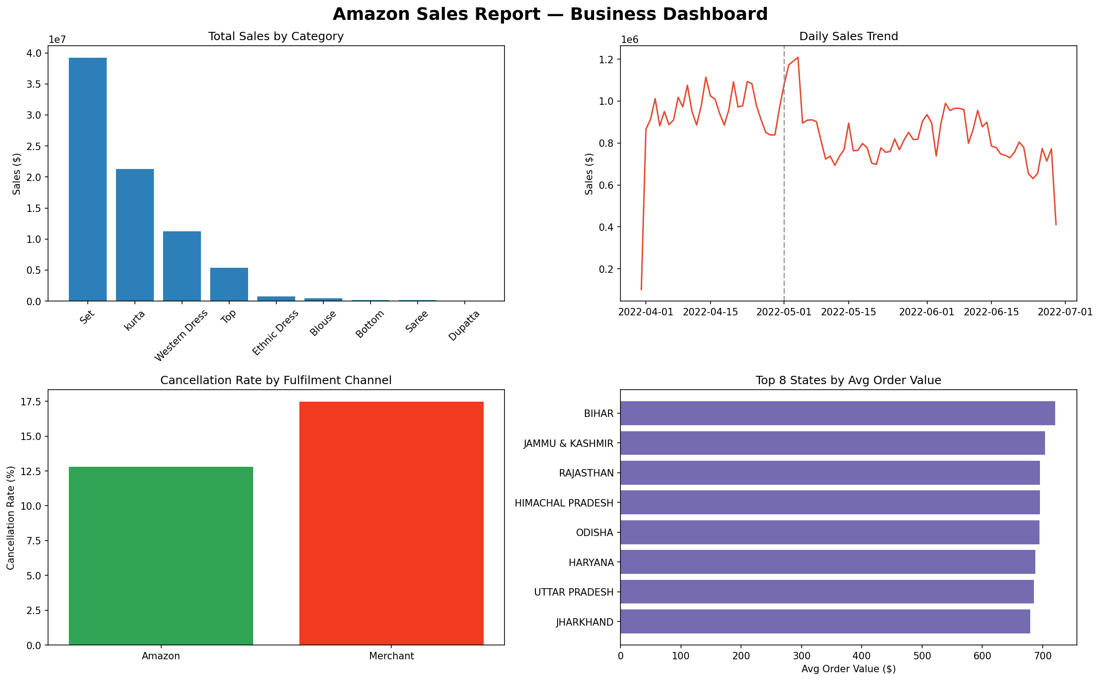

Recommendations
- Investigate the May 1st demand drop with the marketing team — check for a lapsed campaign, ad spend change, or seasonal shift, since order volume (not price or cancellations) is the driver.
- Shift a greater share of Merchant-fulfilled orders to Amazon fulfillment, or audit Merchant-side processing delays, to close the 4.7-point cancellation gap.
- Reduce reliance on "Set" and "kurta": test demand for mid-tier categories (Western Dress, Top) to diversify revenue.
- Consider region-specific pricing or bundling — high-volume urban markets may respond better to value bundles than flat pricing.

Methodology
Data was cleaned to handle missing values (documented per field), standardized date formats, and deduplicated. Analysis was performed in Python (pandas, matplotlib) with AI used as a coding and validation assistant; all business interpretations and recommendations were independently reasoned through by the analyst.

