***[The difference between 'git merge' and 'git rebase'](http://stackoverflow.com/questions/16666089/whats-the-difference-between-git-merge-and-git-rebase)***

Suppose originally there were 3 commits, A,B,C:



Then developer Dan created commit D, and developer Ed created commit E:

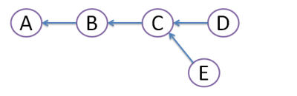

Obviously, this conflict should be resolved somehow. For this, there are 2 ways:

**MERGE**:

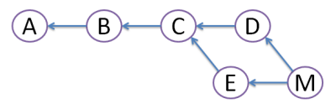

Both commits D and E are still here, but we create merge commit M that inherits changes from bothD and E. However, this creates diamond shape, which many people find very confusing.

**REBASE**:

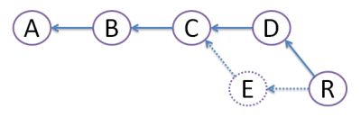

We create commit R, which actual file content is identical to that of merge commit M above. But, we get rid of commit E, like it never existed (denoted by dots - vanishing line). Because of this obliteration, E should be local to developer Ed and should have never been pushed to any other repository. Advantage of rebase is that diamond shape is avoided, and history stays nice straight line.