Aufgabe 1

a)

| P | P |  | P |  |  |  | P |  |  |  |  |
| --- | --- | --- | --- | --- | --- | --- | --- | --- | --- | --- | --- |
| 0001 | 0010 | 0011 | 0100 | 0101 | 0110 | 0111 | 1000 | 1001 | 1010 | 1011 | 1100 |
| 1 | 1 | 0 | 0 | 1 | 0 | 0 | 1 | 1 | 0 | 1 | 1 |

b)

| P | P |  | P |  |  |  | P |  |  |  |  |
| --- | --- | --- | --- | --- | --- | --- | --- | --- | --- | --- | --- |
| 0001 | 0010 | 0011 | 0100 | 0101 | 0110 | 0111 | 1000 | 1001 | 1010 | 1011 | 1100 |
| 0 | 0 | 1 | 0 | 1 | 0 | 0 | 1 | 1 | 0 | 1 | 1 |

| P | P |  | P |  |  |  | P |  |  |  |  |
| --- | --- | --- | --- | --- | --- | --- | --- | --- | --- | --- | --- |
| 0001 | 0010 | 0011 | 0100 | 0101 | 0110 | 0111 | 1000 | 1001 | 1010 | 1011 | 1100 |
| 1 | 1 | 0 | 0 | 0 | 1 | 1 | 1 | 0 | 1 | 1 - 0 | 0 |

Aufgabe 2

a)

Zur Absicherung werden 9 (4 davon Prüfbits) zusätzliche Bits benötigt.

b)

m = 8

ld(m) + 2 = 5 entspricht 62,5%

m = 16

ld(16) + 2 = 6 enspricht 37,5%

m = 32

ld(32) + 2 = 7 enspricht 21,875%

m = 64

ld(64) + 2 = 8 enspricht 12,5%

m = 128

ld(128) + 2 = 9 enspricht 7%

Aufgabe 3

---

Aufgabe 4

a)

(⌐x1 ˄ ⌐x2 ˄ ⌐x3) ˅(x1 ˄ ⌐x2 ˄ ⌐x3) ˅ (x1 ˄ x2 ˄ ⌐x3)

b)

(x1 ˅ x2 ˅ ⌐x3) ˄ (x1 ˅ ⌐x2 ˅ x3) ˄ (x1 ˅ ⌐x2 ˅ ⌐x3)

Aufgabe 5

a)

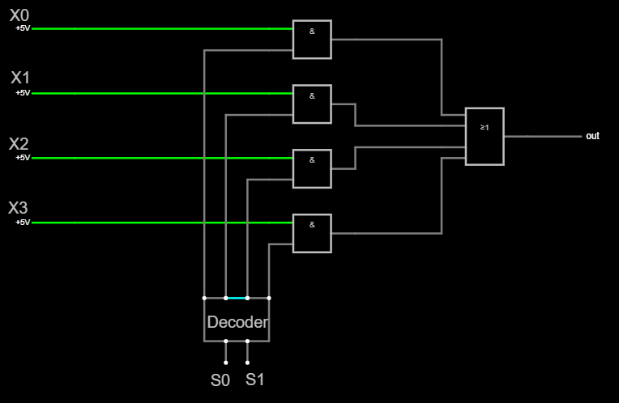

b)

Multiplexer