Test Plan v1

Home Page:

Functionality:

This page is event driven reducing the need for input validation.

|  |  |  |
| --- | --- | --- |
| Function | Testing Method | Result? |
| Cursor should be visible. | Start the program and move mouse around to check if cursor is visible. | The cursor is visible even when exiting the game page (where the cursor is made invisible) |
| Images/Text should display correctly. | Start the program and check the page against its wireframe to check positioning, and source images/text to check if the correct images/text are used and if the images/text look right. | Images and Text display as desired |
| Settings button should switch the page to the settings page when clicked. | Click on the button to check if the page changes and then use the wireframes to check that the correct page is now active. | Settings button switches to the settings page when clicked and only when clicked |
| Instructions button should switch the page to the instructions page when clicked. | Click on the button to check if the page changes and then use the wireframes to check that the correct page is now active. | Instructions button switches to the instructions page when clicked and only when clicked |
| Game button should switch the page to the game page when clicked. | Click on the button to check if the page changes and then use the wireframes to check that the correct page is now active. | Game button switches to the game page when clicked and only when clicked |
| Exit button should close the program when clicked. | Click on the button to check if the program stops running. Press the escape key to check if the program stops running. | Exit button quits the game immediately when (and only when)  clicked |
| All buttons should enlarge slightly when the cursor is over them (not including the exit button). | Move the cursor over the buttons to check if the button gets larger. | All buttons become larger when the mouse is over them and return to their original size when not |

Usability:

A user survey will be taken on the clarity and usability of the layout.

|  |  |
| --- | --- |
| Aspect | Achieved? |
| Consistency: is the same font used, same look throughout the program? |  |
| Clarity: are the elements labelled in an understandable way? |  |
| Ease of use: are the buttons an appropriate size/do the buttons have appropriate positioning to make them easy to click? |  |

Settings Page:

Functionality:

This page is event driven reducing the need for input validation.

|  |  |  |
| --- | --- | --- |
| Function | Testing Method | Result? |
| Cursor should be visible. | Start the program and move mouse around to check if cursor is visible. | Cursor is visible |
| Images/Text should display correctly. | Start the program and check the page against its wireframe to check positioning, and source images/text to check if the correct images/text are used and if the images/text looks right. | All Text and Images display as desired |
| Music Button should toggle whether the music is playing, when clicked.  The text on the button will also change to show the state of the music. | Code will be added that prints the state of the music to the console. Click on the button and check the console to see if the music state and the text on the button have changed as expected. | Music button changes the musicstate variable as expected(when clicked).  Text on the Button changes as expected (when clicked) |
| Music type Button should toggle the music that is playing, when clicked.  The text on the button will also change to show the music type selected. | Code will be added that prints the music file name to the console. Click on the button and check the console to see if the music file name and the text on the button have changed as expected. | Music type button changes the musictype variable as expected(when clicked).  Text on the Button changes as expected (when clicked) |
| Sound Effects Button should toggle whether the sound effects are used, when clicked.  The text on the button will also change to show the state of the sound effects. | Code will be added that prints the state of the sound effects to the console. Click on the button and check the console to see if the sound effects state and text on the button have changed as expected. | Sound Effects button changes the sound effects variable as expected(when clicked).  Text on the Button changes as expected (when clicked) |
|  | NOTE: GRAPHICS BUTTON WAS REMOVED |  |
| Graphics Button should toggle the images that are used, when clicked.  The text on the button will also change to show the state of the graphics. | Code will be added that prints the state of the graphics to the console. Click on the button and check the console to see if the graphics state and text on the button have changed as expected. | Graphics button changes the graphics variable as expected(when clicked).  Text on the Button changes as expected (when clicked) |
| Back button should switch the page to the home page when clicked. | Click on the button to check if the page changes and then use the wireframes to check that the correct page is now active. | Back button switches the page to the Home page only when clicked  Also the settings file is updated |
| Exit button and escape key should close the program when clicked. | Click on the button to check if the program stops running. Press the escape key to check if the program stops running. | Game quits when (and only when) exit button is clicked |
| All buttons should enlarge slightly when the cursor is over them (not including the exit button). | Move the cursor over the buttons to check if the button gets larger. | All buttons become larger when the mouse is over them and return to their original size when the mouse is not over them |
| Should take in settings file and read the content into a set of variables. Should validate the files existence | Print the variables once taken in to have a look at the values of the variables. Delete the file to makesure a new file is created in its place | Settings file is taken in and manipulated correctly, if the file doesn’t exist, it is created and filled with default values. |
| Settings file should be output (only when a setting has been changed) when the back button is clicked | Change a setting, click the back button and then look at the file to ensure that the corresponding setting has changed. | Settings file is updated correctly when the back button is clicked. |

Usability:

A user survey will be taken on the clarity and usability of the layout.

|  |  |
| --- | --- |
| Aspect | Achieved? |
| Consistency: is the same font used, same look throughout the program? |  |
| Clarity: are the elements labelled in an understandable way? |  |
| Ease of use: are the buttons an appropriate size/do the buttons have appropriate positioning to make them easy to click? |  |

Instructions Page:

Functionality:

This page is event driven reducing the need for input validation.

|  |  |  |
| --- | --- | --- |
| Function | Testing Method | Result? |
| Cursor should be visible. | Start the program and move mouse around to check if cursor is visible. | Cursor is Visible |
| Images/Text should display correctly. | Start the program and check the page against its wireframe to check positioning, and source images/text to check if the correct images/text are used and if the images/text looks right. | All text and images display as expected |
| Back button should switch the page to the home page when clicked. | Click on the button to check if the page changes and then use the wireframes to check that the correct page is now active. | Back button switches to the home page when (and only when) clicked |
| Exit button should close the program when clicked. | Click on the button to check if the program stops running. Press the escape key to check if the program stops running. | Game quits when (and only when) exit button is clicked |
| All buttons should enlarge slightly when the cursor is over them (not including the exit button). | Move the cursor over the buttons to check if the button gets larger. | The back button enlarges when the mouse is over it, and returns to it’s original size when not |

Usability:

A user survey will be taken on the clarity and usability of the layout.

|  |  |
| --- | --- |
| Aspect | Achieved? |
| Consistency: is the same font used, same look throughout the program? |  |
| Clarity: are the elements labelled in an understandable way. Are the instructions clear and easy to understand? |  |
| Ease of use: are the buttons an appropriate size/do the buttons have appropriate positioning to make them easy to click? |  |

Game Page:

Functionality:

This page is event driven reducing the need for input validation, the required validation will be mentioned.

|  |  |  |
| --- | --- | --- |
| Function | Testing Method | Result? |
|  | Note: As the game is event based (key presses and sprite interactions) there is very little normal, extreme and exceptional test data |  |
| Cursor should be visible. | Start the program and move mouse around to check if cursor is visible. | Cursor is not visible |
| Images/Text should display correctly. | Start the program and check the page against its wireframe to check positioning, and source images/text to check if the correct images/text are used and if the images/text looks right. Play the game and loose a life to check if the lifes text changes correct and a life image dispears. | Text and images display and update as expected |
| The current and highest scores should be displayed at the top of the screen | Start the game and check against the wireframe to check positioning, input a high score into the scores file and print the current score to a console to check the scores being displayed are correct. | Highest score text updates correctly  Highest score text displays the correct value  Both texts display as expects |
| There should be 3 different types of alien each section will hold a different type of alien, the lowest 2 rows of aliens and give 10 points, the next 2 rows give 20 points and the top row gives 30 points. | Start the game. ‘kill’ a column of aliens checking the current score increases appropriately for each alien ‘death’. | All aliens appear in the correct positions, aliens die as expected,  Aliens reward the correct amount of points |
| There should also be a mother ship alien that occasionally moves across the top of the page and gives either 50, 100, 150 or 300 points. | Start the game. ‘kill’ the motherships checking that the current score increases appropriately. | Mother ship appears at random intervals, also randomly gives out one of the stated amounts of points |
| The aliens should all move together, moving from side to side until any alien reaches an edge at which point the aliens will shift down a row and change the direction of their movement (side to side). The movement speed should increase. When the aliens reach the ‘bunkers’ the game should end. | Start the game. Start the game and observe the aliens moving making sure the movement is correct. Check that the game does end when the first alien reaches the bunker. | Aliens all move as expected.  Game ends when expected |
| There will be 2 different types of projectile the aliens can fire. Fast(bolt) and slow(arrow) projectiles. The different projectiles will have different images and movement speeds (they move down at this speed). Both projectiles will instantly ‘kill’ the player when they come into contact (with the player) decreasing the lives count by one. The colour of the projectiles changes depending on the y position, white while in the middle section, green while at the bottom section (from the top of the bunkers and below). The aliens will randomly ‘shoot’ one of these projectiles arrow more often than bolt, the rate at which the aliens ‘shoot’ should increase as the game progresses. When either projectile touches a bunker it should blow up and destroy a bit of the bunker where it touched it. The projectiles should disappear when they reach the bottom of the game page | Start the game and observe the alien projectiles to ensure they behave as expected. | Both projectiles behave as expected, they change colour when they get below the top of the bunkers, the bolt moves faster than the arrow, they have different images that both animate as desired.  The aliens shoot the projectiles at the desired rates, slow at first getting faster but still at unpredictable intervals.  The arrows are also shot more often than the bolts  Projectiles ‘blow up’ and ‘destroy’ a nearby chunk of a bunker when they hit one.  Projectiles kills the player on contact  Projectiles disappear when at the bottom of the game area |
|  | THIS FEATURE WAS REMOVED |  |
| There will be a system in place that makes the aliens’ projectiles are shot accurately as opposed to randomly, although there will be some randomness involved. | Start and observe the game to ensure the aliens shoot the projectiles as expected, moving the player around to ensure the behaviour is consistent. | This does not occur |
| The player will only be able to move side to side and will not be able to move past the edges of the page. The controls will be A/D or / . ‘A’ and the left arrow key will move the player to the left. ‘D’ and the right arrow key will move the player to the right. Only one input will be allowed at a time ‘A’ or ‘D’ or left or right, all other inputs will be ignored. | Start the game. Use the ‘A’ and ‘D’ keys to move the player character from edge to edge ensuring the player character stops as expected (Normal). Attempt to use both ‘A’ and ‘D’ at the same to make sure the player character does not ‘glitch’. Do the same using the left and right arrow keys. Use both the ‘A’ and left arrow key at the same time to ensure the speed of movement does not change. Do the same with ‘D’ and the right arrow key (Exceptional). Press any other keys (excluding the escape key and space bar) to ensure nothing happens (Extreme). | The player only moves left or right, the user can not make it move up or down. Either a or the left arrow makes the player move to the left at the correct speed (even if both are pressed).  Either d or the right arrow makes the player move to the right at the correct speed (even if both are pressed).  When both keys are pressed at the same time the player moves to the left, no matter what. THIS BUG IS ACCEPTABLE  Other key presses (excluding space and esc) have no effect, as desired. |
| There will only be one type of player projectile (shot), the shot will move upward at a constant speed and instantly ‘kill’ any alien it comes into contact with and will then disappear so as not to accidentally ‘kill’ more than one alien, the shot will also disappear when in contact with a bunker. The colour of the shot will change depending on the y position, green while in the bottom section, white while in the middle section and red in the top section. When shot the x co-ordinate of the projectile will be that of the player at the time of shooting. There will be a 1 second shot ‘cool down’ between shots although no limit to the number of shots. The space bar will ‘shoot’ the projectile.  The projectile should disappear when it reaches the top of the game area | Start the game. Press the spacebar to ensure the projectile appears in the expect place, move the player around and do the same. Attempt to ‘shoot’ as frequently as possible to check the cool-down time works and that the shot only appears if there currently isn’t one in already moving. Shoot an alien to ensure the shot disappears when in contact and the alien ‘dies’. Shoot a bunker to ensure it the shot disappears. | Projectile appears where the player is when space bar is pressed (only if there is not already a player projectile in existance).  When a projectile comes into contact with an alien the projectile disappears and the alien dies, though sometimes when the projectile hits the edge of the alien sprite the alien does not die I AM UNABLE TO FIX THIS BUG  When a projectile comes into contact with a bunker, it ‘blows up’ and ‘destroys’ a small chunk of the bunker where it hit, though sometimes when hitting the edge it just passes straight through I AM UNABLE TO FIX THIS BUG  When a projectile reaches the top of the page it disappears  The projectile is green when bellow the top of the bunkers and white when above |
| When the player dies the game will pause while the player death animation plays and the player life count will decrement, then the player character will reappear in the ‘home’ position (x middle of the page) and the game will continue. When the player runs out of lives the game will end. | Start the game and get hit by a projectile to ensure the correct behaviour is carried out at player death. Repeat until the lives counter is 0 to ensure the game ends when expected. | When the player is it, the game stops and the player death animation is played. After the player re-appears in the home position  If the player dies 3 times the game ends |
| There will be 4 ‘bunkers’. These bunkers will stop any type of projectiles (player shots included) but when a bunker stops a projectile the projectile will ‘blow up’ a section of the bunker. | Start the game and move the player character underneath a bunker, shoot the bunker to ensure the projectile stops and the bunker has an appropriate section ‘blown up’. Wait for all three types of projectile to hit a bunker to ensure all disappear and ‘blow up’ and appropriate section of the bunker. | All projectile types ‘blow up’ when they come into contact with a bunker. When the projectiles ‘blows up’ an appropriate section of the bunker. Though sometimes when hitting the edge it just passes straight through I AM UNABLE TO FIX THIS BUG |
| When the game is over the program will check if the current score is higher than any of the scores in the high score file, if so it will switch to the high score input page, if not it will switch to the high score display page. | Delete the highscores file, play a game and make sure the highscore input page starts even if not points were scored.  Input 10 highscores in the file and play the game with no score to make sure the highscore display page starts.  Then make one of the scores 0 and play the game making sure to get a score greater than 0 to check that the highscore input page starts | Deleted highscores file:  Highscore input page is started and once initials are entered highscores file is created correctly  10 highscores:  Highscore display page starts and displays all 10 highscores correctly  New highscore:  Highscore input page is started and new score is put in correct position |
| Exit button should close the program when clicked. | Click on the button to check if the program stops running. Press the escape key to check if the program stops running. | Game quits when (and only when) exit button is pressed |
| Should take in settings file and read the content into a set of variables.  All settings should be used correctly, music and sound effects settings should change the respective function | Print the values once taken in to have a look at the values of the variables. | Settings file is taken in and used correctly, when the musicstate is true the correct selected background music is player (determined by musictype) and when sound effects is true the sound effects are played. When music state is false music doesn’t play and when sound effects if false the sound effects do not play |
| The game should restart correctly when being run for a second, third, forth …. time | Play through the game, once the game is over click on the New Game button on the highscore display page | The game restarts as it should, score is set to 0, no projectiles are active, player lives are set to 3 player is moved to home position, settings are re-checked etc…. |

Usability:

A user survey will be taken on the clarity and usability of the layout.

|  |  |
| --- | --- |
| Aspect | Achieved? |
| Consistency: same look throughout the program. |  |
| Ease of use: is there too much lag on the controls, are the aliens to small to hit, do the projectiles or aliens move too fast, is the player movement speed too fast or too slow. |  |

High Score Input Page:

Functionality:

|  |  |  |
| --- | --- | --- |
| Function | Testing Method | Result? |
| Cursor should be visible. | Start the program and move mouse around to check if cursor is visible. | Visible |
| Images/Text should display correctly. | Start the program and check the page against its wireframe to check positioning, and source images/text to check if the correct images/text are used and if the images/text looks right. | Text displays correctly |
| Skip button should switch the page to the high score display page when clicked. | Click on the button to check if the page changes and then use the wireframes to check that the correct page is now active. | Page is changed to the highscore display page without adding the new highscore |
| The currently selected initials place will be indicated but a flashing underline. Only alpha key presses will put a character into the currently selected initial place. The back space key will remove the character from the currently selected initials place. | On the page use the right and left arrow keys to select an initial place and ensure the underline is flashing. Press any Alpha key to ensure the correct character is input in the selected initials place (expected). Press any non-alpha keys to ensure the character is not input (extreme). | Correct underline flashes, when all three initials have been input no underlines flash.  Only alpha characters are added as initials, all other key presses (excluding enter and backspace) are ignored.  The backspace removes the last added initials and moves back the currently selected place.  The enter key submits the highscore and initials only if 3 initials have been input. |
| Exit button should close the program when clicked. | Click on the button to check if the program stops running. Press the escape key to check if the program stops running. | Program closes when exit button is clicked (and only then) |
| All buttons should enlarge slightly when the cursor is over them (not including the exit button). | Move the cursor over the buttons to check if the button gets larger. | All buttons become larger when the mouse is over them and return to their original size when not |

Usability:

A user survey will be taken on the clarity and usability of the layout.

|  |  |
| --- | --- |
| Aspect | Achieved? |
| Consistency: is the same font used, same look throughout the program? |  |
| Clarity: are the elements labelled in an understandable way? Is the indication for the currently selected initial place clear enough. |  |
| Ease of use: are the buttons an appropriate size/do the buttons have appropriate positioning to make them easy to click? |  |

High Score Display Page:

Functionality:

|  |  |  |
| --- | --- | --- |
| Function | Testing Method | Result? |
| Cursor should be visible. | Start the program and move mouse around to check if cursor is visible. | Cursor is visible |
| Images/Text should display correctly. | Start the program and check the page against its wireframe to check positioning, and source images/text to check if the correct images/text are used and if the images/text looks right. | Text displays correctly |
| Home button should switch the page to the home page when clicked. | Click on the button to check if the page changes and then use the wireframes to check that the correct page is now active. | Home button switches the game to the home page when clicked |
| New Game button should reset the game page then switch the page to the game page, when clicked. | Click on the button to check if the page changes and then use the wireframes to check that the correct page is now active and that the game page has been reset. | New Game button switches the game to the game page and starts a new game when clicked |
| Exit button should close the program when clicked. | Click on the button to check if the program stops running. Press the escape key to check if the program stops running. | Program closes when exit button is clicked (and only then) |
| All buttons should enlarge slightly when the cursor is over them (not including the exit button). | Move the cursor over the buttons to check if the button gets larger. | All buttons become larger when the mouse is over them and return to their original size when not |

Usability:

A user survey will be taken on the clarity and usability of the layout.

|  |  |
| --- | --- |
| Aspect | Achieved? |
| Consistency: is the same font used, same look throughout the program? |  |
| Clarity: are the elements labelled in an understandable way? |  |
| Ease of use: are the buttons an appropriate size/do the buttons have appropriate positioning to make them easy to click? |  |

Settings Page v1:

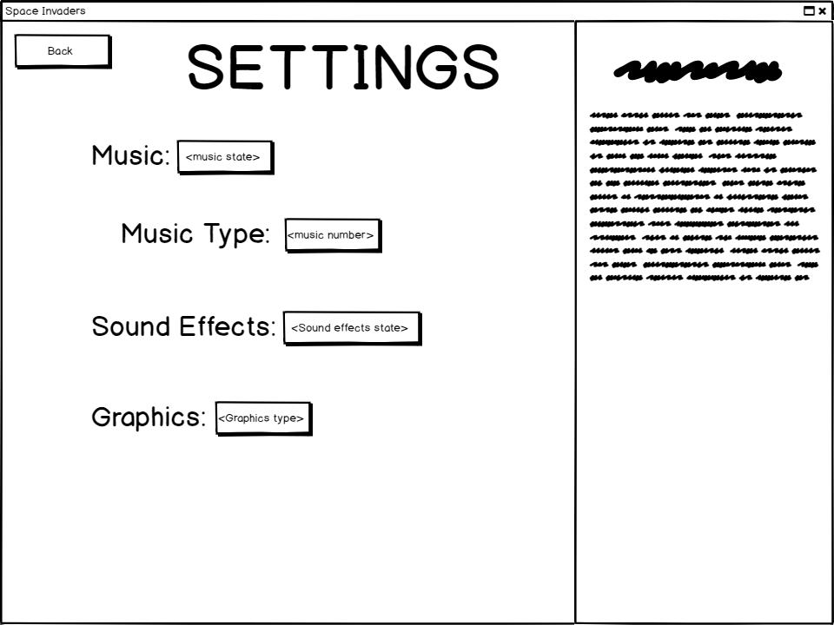

Title

Buttons Description Title

Labels Description Text

Background

Title:

Font-size: 72px

Colour: white

Font-family: cosmic-aliens (ca)

Content: “SETTINGS”

Buttons:

Size: 113x42px (normal), 133x58px (large)

Content: 1-2 word description of function.

Font-size: 16px

Font-family: cosmic-aliens (ca)

Input: click detection, hover detection.

Output: size will change size when cursor is hovering over it, will change the sate of its respective setting/ change the page to the homepage (back button).

Labels:

Font-size: 32px

Colour: white

Font-family: cosmic-aliens (ca)

Content: name of respective setting

Background:

Size: 960x720

Image: black with white spots to mimic stars and white bar 299px from the left.

Description Title:

Font-size: 28px

Colour: white

Font-family: cosmic-aliens (ca)

Content: name of respective setting

Description Text:

Font-size: 16px

Colour: white

Font-family: cosmic-aliens (ca)

Content: description of respective setting states