**reactance** is the opposition of a circuit element to a *change* in [current](https://en.wikipedia.org/wiki/Electric_current) or [voltage](https://en.wikipedia.org/wiki/Voltage), due to that element's [inductance](https://en.wikipedia.org/wiki/Inductance) or [capacitance](https://en.wikipedia.org/wiki/Capacitance).

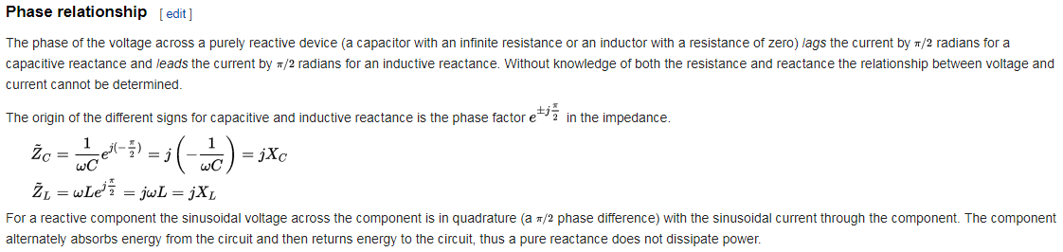In [phasor](https://en.wikipedia.org/wiki/Phasor) analysis, reactance is used to compute amplitude and phase changes of [sinusoidal](https://en.wikipedia.org/wiki/Sine_wave) [alternating current](https://en.wikipedia.org/wiki/Alternating_current) going through a circuit element. It is denoted by the symbol {\displaystyle \scriptstyle {X}}. An ideal [resistor](https://en.wikipedia.org/wiki/Resistor) has zero reactance, whereas ideal [inductors](https://en.wikipedia.org/wiki/Inductor) and [capacitors](https://en.wikipedia.org/wiki/Capacitor) have zero resistance – that is, respond to current only by reactance. The magnitude of the reactance of an inductor rises in proportion to a rise in frequency, while the magnitude of the reactance of a capacitor decreases in proportion to a rise in frequency. As frequency goes up, inductive reactance goes up and capacitive reactance goes down.

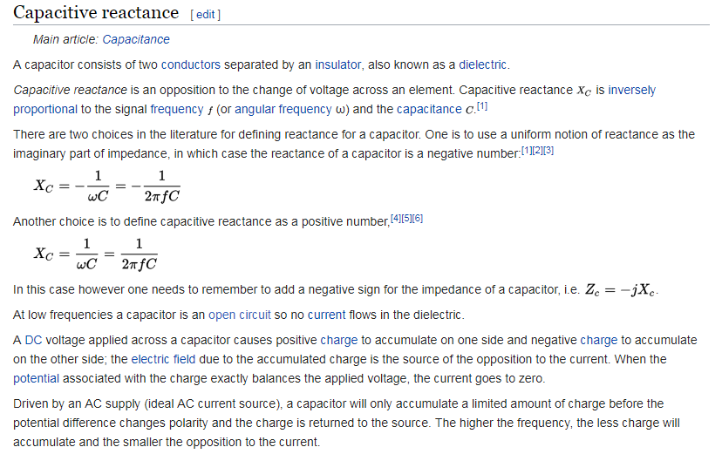

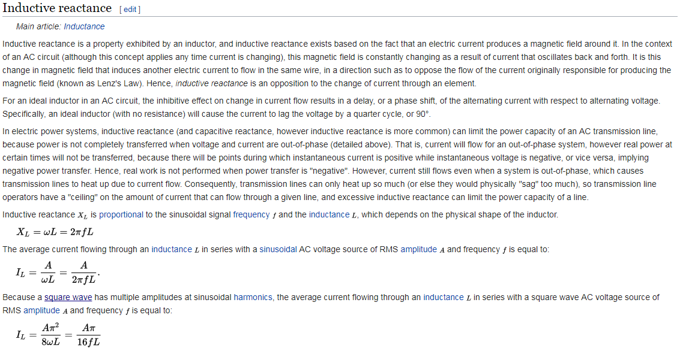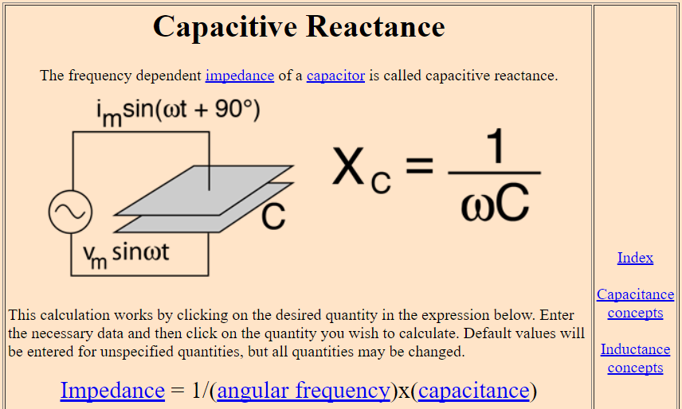

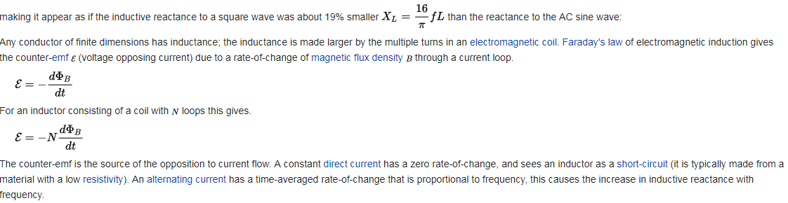

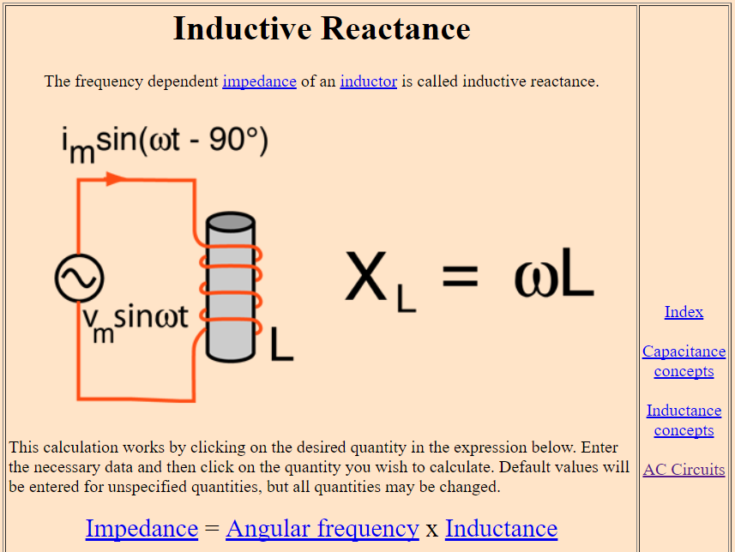

An **LC circuit**, also called a **resonant circuit**, **tank circuit**, or **tuned circuit**, is an [electric circuit](https://en.wikipedia.org/wiki/Electric_circuit) consisting of an [inductor](https://en.wikipedia.org/wiki/Inductor), represented by the letter L, and a [capacitor](https://en.wikipedia.org/wiki/Capacitor), represented by the letter C, connected together. The circuit can act as an electrical [resonator](https://en.wikipedia.org/wiki/Resonator), an electrical analogue of a [tuning fork](https://en.wikipedia.org/wiki/Tuning_fork), storing energy oscillating at the circuit's [resonant frequency](https://en.wikipedia.org/wiki/Resonant_frequency).

LC circuits are used either for generating signals at a particular frequency, or picking out a signal at a particular frequency from a more complex signal; this function is called a [bandpass filter](https://en.wikipedia.org/wiki/Bandpass_filter). They are key components in many electronic devices, particularly radio equipment, used in circuits such as [oscillators](https://en.wikipedia.org/wiki/Electronic_oscillator), [filters](https://en.wikipedia.org/wiki/Electronic_filter), [tuners](https://en.wikipedia.org/wiki/Tuner_(electronics)) and [frequency mixers](https://en.wikipedia.org/wiki/Frequency_mixer).

An LC circuit is an idealized model since it assumes there is no dissipation of energy due to [resistance](https://en.wikipedia.org/wiki/Electrical_resistance). Any practical implementation of an LC circuit will always include loss resulting from small but non-zero resistance within the components and connecting wires. The purpose of an LC circuit is usually to oscillate with minimal [damping](https://en.wikipedia.org/wiki/Damping), so the resistance is made as low as possible.

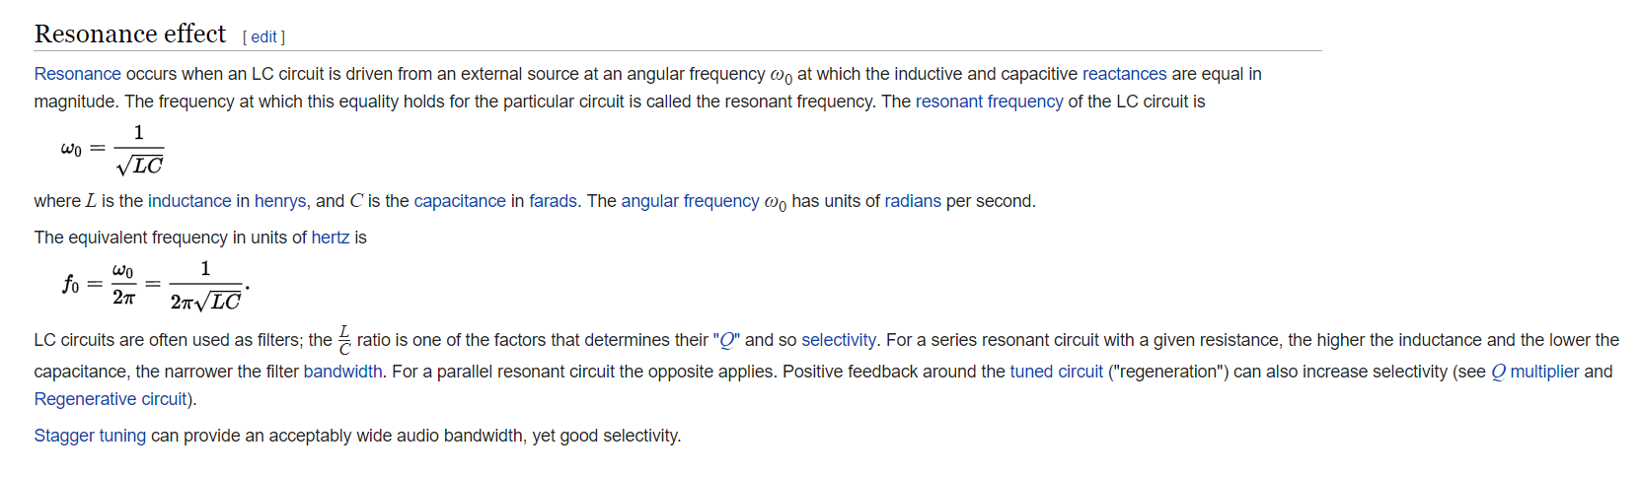The two-element LC circuit described above is the simplest type of **inductor-capacitor network** (or **LC network**). It is also referred to as a *second order LC circuit* to distinguish it from more complicated (higher order) LC networks with more inductors and capacitors. Such LC networks with more than two reactances may have more than one [resonant frequency](https://en.wikipedia.org/wiki/Resonant_frequency).

