Hyperparameter Optimization and Fine-Tuning
in Machine Learning

A Comprehensive Survey of Methods, Techniques, and Applications

Topic: Automated Machine Learning & Deep Learning Optimization
Scope: Hyperparameter Optimization, Neural Architecture Search, Fine-Tuning Strategies
Coverage: Foundational Methods to State-of-the-Art Techniques (2012–2025)
Date: May 2025

ABSTRACT
Hyperparameter optimization (HPO) and model fine-tuning are fundamental challenges in modern machine learning and deep learning. The performance of machine learning models depends critically on both architectural choices and the values of hyperparameters governing training dynamics. This comprehensive survey covers the theoretical foundations, algorithmic methods, and practical applications of HPO and fine-tuning across diverse domains. We systematically review classical approaches including grid search, random search, and Bayesian optimization, then advance to multi-fidelity methods such as Hyperband and BOHB, gradient-based meta-learning, evolutionary strategies, and Neural Architecture Search (NAS). We devote particular attention to fine-tuning pre-trained large language models and vision models, covering adapter methods, LoRA, prefix tuning, prompt tuning, and reinforcement learning from human feedback (RLHF). AutoML platforms integrating these techniques are also surveyed. Mathematical formulations, algorithmic pseudocode, comparative tables, and experimental benchmarks are provided throughout. We conclude with open challenges and future research directions in the field.

Table of Contents
1. Introduction
1.1 Motivation and Scope
1.2 Taxonomy of Hyperparameters
1.3 Organization of the Survey
2. Foundations of Hyperparameter Optimization
2.1 Problem Formulation
2.2 Types of Hyperparameters
2.3 Challenges in HPO
3. Classical Search Methods
3.1 Grid Search
3.2 Random Search
3.3 Comparison and Analysis
4. Bayesian Optimization
4.1 Gaussian Process Surrogates
4.2 Acquisition Functions
4.3 Tree-structured Parzen Estimator (TPE)
4.4 SMAC: Sequential Model-Based Configuration
5. Multi-Fidelity Optimization
5.1 Successive Halving
5.2 Hyperband
5.3 BOHB: Combining BO and Hyperband
6. Gradient-Based and Meta-Learning HPO
6.1 DARTS: Differentiable Architecture Search
6.2 MAML and Gradient-Based Meta-Learning
7. Evolutionary and Population-Based Methods
7.1 Genetic Algorithms for HPO
7.2 Population-Based Training (PBT)
7.3 CMA-ES: Covariance Matrix Adaptation
8. Neural Architecture Search (NAS)
8.1 Search Spaces
8.2 NASNet and Reinforcement Learning NAS
8.3 Efficient NAS Methods
9. Fine-Tuning Pre-Trained Models
9.1 Transfer Learning Principles
9.2 Full Fine-Tuning of Language Models
9.3 Catastrophic Forgetting and Mitigation
10. Parameter-Efficient Fine-Tuning (PEFT)
10.1 Adapter Layers
10.2 LoRA: Low-Rank Adaptation
10.3 Prefix Tuning and Prompt Tuning
10.4 (IA)³ and Other PEFT Methods
10.5 Comparison of PEFT Methods
11. Instruction Tuning and RLHF
11.1 Instruction Fine-Tuning
11.2 RLHF: Reinforcement Learning from Human Feedback
11.3 Direct Preference Optimization (DPO)
12. Fine-Tuning in Computer Vision
12.1 CNN Fine-Tuning Strategies
12.2 Vision Transformers (ViT) Fine-Tuning
12.3 Domain Adaptation
13. AutoML Platforms
13.1 Auto-sklearn and SMAC
13.2 H2O AutoML and Google AutoML
13.3 Optuna, Ray Tune, and HyperOpt
14. Practical Considerations and Best Practices
14.1 Hyperparameter Importance
14.2 Warm Starting
14.3 Reproducibility
15. Benchmarks and Comparative Analysis
16. Open Challenges and Future Directions
17. Conclusion
References

1. Introduction

1.1 Motivation and Scope
Machine learning models, whether classical statistical estimators or modern deep neural networks, contain two fundamentally different categories of learnable quantities: parameters and hyperparameters. While parameters (e.g., neural network weights) are optimized directly by gradient descent on a training objective, hyperparameters govern the learning process itself—controlling model complexity, regularization strength, optimization dynamics, and architectural choices. Unlike parameters, hyperparameters cannot typically be optimized via gradient descent on the training loss because their influence is mediated through the entire training procedure.
The importance of hyperparameter optimization (HPO) has grown dramatically with the rise of deep learning. A 2018 study by Melis et al. demonstrated that a well-tuned LSTM baseline could match or surpass state-of-the-art language models that were not carefully tuned. Similarly, He et al. (2019) showed that a properly tuned ResNet-50 achieves performance competitive with much more complex architectures. These findings underscore a critical insight: the gap between a mediocre and a top-performing model often lies not in the model architecture itself but in the quality of hyperparameter selection.
Simultaneously, the paradigm of fine-tuning large pre-trained models has revolutionized deep learning practice. Starting from a model pre-trained on massive datasets (e.g., BERT, GPT-4, CLIP, LLaMA), practitioners adapt it to downstream tasks through targeted fine-tuning. The hyperparameters controlling this fine-tuning process—learning rate, number of layers to freeze, batch size, adaptation method—are equally critical and present unique challenges distinct from training from scratch.

1.2 Taxonomy of Hyperparameters
Hyperparameters can be organized along several orthogonal dimensions:
- Model/Architecture Hyperparameters: Number of layers, hidden units per layer, attention heads, kernel sizes, skip connections, normalization choices (BatchNorm, LayerNorm).
- Optimization Hyperparameters: Learning rate, learning rate schedule, batch size, optimizer type (SGD, Adam, AdamW), momentum coefficients (β₁, β₂), weight decay (λ).
- Regularization Hyperparameters: Dropout rate, L1/L2 regularization strength, data augmentation parameters, label smoothing.
- Training Protocol Hyperparameters: Number of epochs, warmup steps, gradient clipping threshold, early stopping patience.
- Fine-Tuning Hyperparameters: Number of frozen layers, adapter rank/dimension, LoRA rank r and scaling factor α, prompt length.

1.3 Organization of the Survey
This survey is organized as follows. Section 2 establishes the formal problem formulation and characterizes the challenges unique to HPO. Sections 3–7 cover the core algorithmic approaches: classical search methods, Bayesian optimization (BO), multi-fidelity methods, gradient-based approaches, and evolutionary strategies. Section 8 reviews Neural Architecture Search (NAS). Sections 9–12 focus on fine-tuning: full fine-tuning, parameter-efficient methods, instruction tuning, RLHF, and vision model adaptation. Section 13 surveys AutoML platforms. Sections 14–16 discuss practical considerations, benchmarks, and open challenges.

2. Foundations of Hyperparameter Optimization

2.1 Problem Formulation
Let A be a learning algorithm parameterized by a hyperparameter vector λ drawn from a hyperparameter configuration space Λ. For a given dataset D = {(x_i, y_i)}^n_{i=1}, the algorithm A(λ) trains a model M_λ by minimizing a training objective L_train. The HPO problem is to find the hyperparameter configuration that minimizes a validation (or generalization) objective:
λ* = argmin_{λ ∈ Λ} V(A(λ, D_train), D_val)
where V is a validation performance metric (e.g., cross-entropy loss or error rate). The function f(λ) = V(A(λ, D_train), D_val) is called the response surface or objective function. This is a black-box optimization problem with the following key properties:
- Expensive to evaluate: Each f(λ) evaluation requires a full training run (hours to days for large models).
- Non-differentiable: The mapping from λ to f(λ) passes through a discrete training loop.
- Noisy: Due to stochastic training (random initialization, mini-batch sampling), repeated evaluations of the same λ produce different f(λ) values.
- High-dimensional: Modern architectures may have dozens of hyperparameters, yielding high-dimensional search spaces.
- Mixed types: Λ typically contains continuous, integer-valued, categorical, and conditional hyperparameters.
The conditional structure of Λ is particularly important. For example, the hyperparameter 'number of units in the second hidden layer' is only meaningful if the model has at least two hidden layers. Such conditional dependencies create a hierarchical configuration space modeled as a directed acyclic graph (DAG), commonly represented with SMAC's configuration space or Optuna's parameter suggest APIs.

2.2 Types of Hyperparameters
Table 2.1: Types of Hyperparameters and Recommended Search Strategies
Type | Example | Search Strategy | Typical Range
Continuous | Learning rate η | BO/Random (log-uniform) | 10⁻⁵ to 10⁻¹
Integer | Batch size B | BO/Random | 16, 32, 64, 128, 256
Categorical | Optimizer type | Grid/Random/BO-Cat | {SGD, Adam, RMSProp}
Boolean | Use BatchNorm | Grid/Random | {True, False}
Conditional | LSTM hidden size | Only if RNN chosen | 32 to 2048
Ordinal | Number of layers | BO with ordinal kernel | 1 to 12

2.3 Challenges in HPO
Beyond the black-box nature of HPO, several practical challenges arise. The curse of dimensionality means that the volume of the configuration space grows exponentially with the number of hyperparameters. With d hyperparameters each taking k values, grid search requires k^d evaluations—infeasible for d > 6 even with k = 5. Non-stationarity is another challenge: the best hyperparameters may depend on dataset size, and transfer of configurations across datasets is not guaranteed. Finally, the multi-objective nature of real-world HPO (balancing accuracy, inference latency, memory footprint, and energy consumption) requires Pareto-optimal solutions rather than single-objective minimization.

3. Classical Search Methods

3.1 Grid Search
Grid search (Larochelle et al., 2007) is the simplest and most widely used HPO approach. It defines a finite grid G = G₁ × G₂ × ... × G_d where G_j is a finite set of candidate values for the j-th hyperparameter. Every combination is evaluated and the best is selected:
λ* = argmin_{λ ∈ G} f(λ) |G| = ∏_{j=1}^{d} |G_j|
Despite its simplicity, grid search has major limitations. With d = 8 hyperparameters and 5 values each, |G| = 5⁸ = 390,625 evaluations—completely intractable. Moreover, grid search is inefficient because it samples each hyperparameter marginally according to a regular lattice, wasting evaluations on uninformative regions. If only a few hyperparameters truly matter (low effective dimensionality), grid search does not concentrate samples along the important dimensions.

3.2 Random Search
Bergstra and Bengio (2012) demonstrated theoretically and empirically that random search is more efficient than grid search for HPO. In random search, configurations are sampled i.i.d. from a prior distribution p(λ) over the search space:
λ^(1), λ^(2), ..., λ^(T) ~ p(λ) λ* = argmin_{t} f(λ^(t))
The key insight is that if only a few hyperparameters are important (low intrinsic dimensionality), random search achieves better coverage of the important dimensions. With n evaluations, random search explores n distinct values for each hyperparameter, while grid search of the same size explores only n^(1/d) values per dimension. For d = 9 and n = 60, grid search yields 60^(1/9) ≈ 1.7 unique values per dimension, while random search yields 60.
Practical considerations for random search: Learning rate η should be sampled log-uniformly (η ~ Uniform(log(10⁻⁵), log(10⁻¹)) then exponentiated) since the effect of learning rate changes are roughly multiplicative. Batch size and layer widths should be sampled from discrete sets or powers of 2. Dropout rates and regularization strengths are typically sampled uniformly.

3.3 Comparison and Analysis
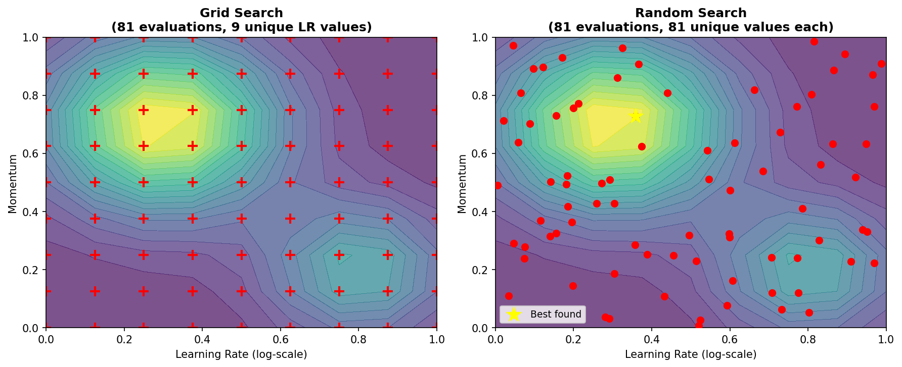
Figure 3.1: Grid Search vs. Random Search on a 2D hyperparameter landscape. The true performance peak is shown in yellow. Random search finds the optimum more efficiently when the effective dimensionality of the problem is low.
Table 3.1: Comparison of HPO Methods
Method | Evaluations Needed | Parallelizable | Handles Conditionals | Sample Efficiency
Grid Search | k^d (exponential) | Yes (trivially) | No | Low
Random Search | T (user-specified) | Yes (trivially) | Partial | Medium
Quasi-Random (Sobol) | T (user-specified) | Yes | Partial | Medium-High
Bayesian Optimization | T (sequential) | Limited | Yes | High
Hyperband | O(n log n) | Yes | Yes | Very High

4. Bayesian Optimization
Bayesian Optimization (BO) is a principled, sample-efficient framework for global optimization of expensive black-box functions (Mockus, 1975; Jones et al., 1998; Snoek et al., 2012). BO maintains a probabilistic surrogate model of the objective function f(λ) and uses an acquisition function to decide which configuration to evaluate next by trading off exploration and exploitation.

4.1 Gaussian Process Surrogates
A Gaussian Process (GP) is a distribution over functions such that every finite collection of function values is jointly Gaussian. A GP prior over f is specified by a mean function m(λ) and a covariance (kernel) function k(λ, λ'):
f(λ) ~ GP(m(λ), k(λ, λ'))
The most common kernel is the squared-exponential (RBF) kernel:
k_SE(λ, λ') = σ_f² · exp(−(1/2) · (λ−λ')ᵀ · Λ⁻¹ · (λ−λ'))
where σ_f² is the signal variance and Λ = diag(l₁², ..., l_d²) contains the per-dimension length-scales. The Matérn 5/2 kernel is often preferred for HPO as it produces less smooth functions:
k_{M52}(r) = σ_f² · (1 + √5·r/l + 5r²/3l²) · exp(−√5·r/l), r = ‖λ−λ'‖₂
Given n observations D_n = {(λ_i, y_i)}_{i=1}^n where y_i = f(λ_i) + ε_i, ε_i ~ N(0, σ_n²), the GP posterior at a new point λ* is Gaussian with mean and variance:
μ_n(λ*) = m(λ*) + k*ᵀ (K + σ_n²I)⁻¹ (y − m)
σ²_n(λ*) = k(λ*,λ*) − k*ᵀ (K + σ_n²I)⁻¹ k*
where k* = [k(λ*, λ₁), ..., k(λ*, λ_n)]ᵀ is the covariance vector and K is the n×n kernel matrix K_ij = k(λ_i, λ_j). The GP posterior provides both a prediction (μ_n) and a measure of uncertainty (σ_n), which together drive the acquisition function.
A key practical limitation of GPs is their computational complexity of O(n³) for fitting and O(n²) for prediction, making them inefficient beyond n ≈ 10,000 observations. Sparse GP approximations (Titsias, 2009) and deep kernel learning (Wilson et al., 2016) address this by using inducing points and neural network feature extractors respectively.

4.2 Acquisition Functions
The acquisition function α(λ | D_n) guides the search by measuring the utility of evaluating f at λ. The next query is:
λ_{n+1} = argmax_{λ ∈ Λ} α(λ | D_n)
Three widely used acquisition functions are:
Probability of Improvement (PI):
α_PI(λ) = P(f(λ) < f* − ξ) = Φ((f* − μ_n(λ) − ξ) / σ_n(λ))
where f* is the current best observed value, Φ is the normal CDF, and ξ ≥ 0 is an exploration parameter.
Expected Improvement (EI):
α_EI(λ) = E[max(0, f* − f(λ))]
= (f* − μ_n(λ)) · Φ(Z) + σ_n(λ) · φ(Z), Z = (f* − μ_n(λ))/σ_n(λ)
where φ is the normal PDF. EI is the most widely used acquisition function due to its analytical form.
Upper Confidence Bound (UCB):
α_UCB(λ) = μ_n(λ) − κ · σ_n(λ) (for minimization)
where κ > 0 controls the exploration-exploitation tradeoff. Srinivas et al. (2012) provide theoretical bounds: setting κ = √(2 log(t^(d/2+2) · π²/(3δ))) ensures sublinear cumulative regret with probability 1−δ. Thompson Sampling selects configurations by sampling from the GP posterior, offering a simpler but equally effective exploration strategy.
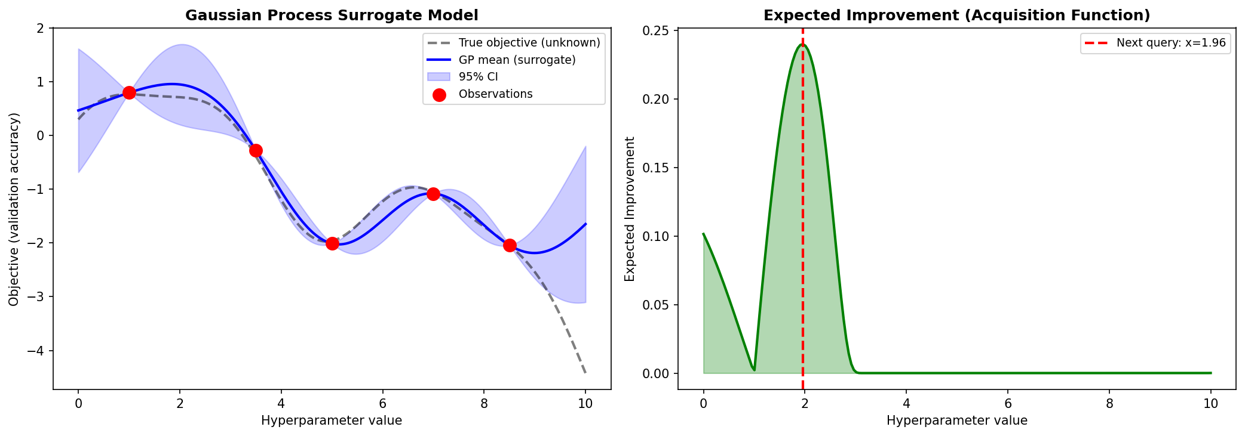
Figure 4.1: Bayesian Optimization. (Left) GP surrogate model with mean and 95% confidence interval fitted to five observations. (Right) Expected Improvement acquisition function with the next query location marked. Note that EI peaks where the surrogate mean is promising AND uncertainty is high.

4.3 Tree-structured Parzen Estimator (TPE)
TPE (Bergstra et al., 2011), used in HyperOpt, takes a fundamentally different approach. Rather than modeling f(λ) directly, TPE models the probability of observing a hyperparameter value λ conditioned on whether it leads to a good or bad result. Let y* be a quantile threshold (e.g., the γ = 15th percentile of observed f values). TPE fits two density models:
p(λ | y) = ℓ(λ) if y < y* (good observations)
p(λ | y) = g(λ) if y ≥ y* (bad observations)
The acquisition function becomes the ratio EI(λ) ∝ ℓ(λ)/g(λ). Each density is estimated using a Parzen window (kernel density) estimator. For continuous hyperparameters, Gaussian kernels are used; for categorical hyperparameters, Aitchison-Aitken kernels are used. TPE naturally handles the tree-structured (conditional) configuration space, making it practical for complex HPO problems.

4.4 SMAC: Sequential Model-Based Algorithm Configuration
SMAC (Hutter et al., 2011) uses a Random Forest (RF) as the surrogate model instead of a GP. Random Forests naturally handle mixed (continuous + categorical) hyperparameter spaces and conditional parameter hierarchies. The RF predicts the marginal distribution of f(λ) by computing the mean and variance across the trees' leaf predictions:
μ̂_RF(λ) = (1/T) Σ_{t=1}^{T} μ̂_t(λ)
σ̂²_RF(λ) = (1/T) Σ_{t=1}^{T} [μ̂_t(λ) − μ̂_RF(λ)]²
SMAC also incorporates algorithm configuration features (instance-specific features), enabling it to optimize algorithms across multiple problem instances simultaneously—a capability not shared by standard GP-based BO. SMAC has been successfully applied to configure SAT solvers, mixed-integer programming solvers, and complex deep learning pipelines.

5. Multi-Fidelity Optimization
Multi-fidelity optimization exploits the observation that cheap proxy evaluations (low fidelity) can approximate expensive full evaluations (high fidelity). In the context of deep learning HPO, low-fidelity evaluations may use fewer training epochs, a smaller dataset subset, or a reduced model size. This section covers the main multi-fidelity HPO algorithms.

5.1 Successive Halving
Successive Halving (SH) (Jamieson and Talwalkar, 2016) takes n initial configurations and iteratively eliminates the poorest performers, doubling the budget for survivors. Given initial budget B_min and maximum budget B_max, with η as the elimination factor (typically η = 3 or 4):
Number of rounds: s = ⌊log_η(B_max / B_min)⌋
Configs in round k: n_k = ⌊n / η^k⌋
Budget per config in round k: B_k = B_min · η^k
At each round k, the top ⌊n_k / η⌋ configurations by validation performance proceed to the next round. SH is highly parallelizable within rounds and achieves near-optimal simple regret under mild assumptions. Its main limitation is the need to specify n upfront: choosing too many configurations wastes budget on unpromising early rounds, while too few miss good configurations.

5.2 Hyperband
Hyperband (Li et al., 2017) resolves SH's n vs. budget dilemma by running multiple SH instances with different configurations of (n, B_min). Given a maximum budget B_max and elimination factor η:
s_max = ⌊log_η(B_max)⌋
For each bracket s ∈ {s_max, ..., 0}:
n_s = ⌈(s_max+1)/s+1 · η^s⌉, B_s = B_max · η^{-s}
Bracket s_max explores many cheap configurations (aggressive early stopping), while bracket 0 runs a single configuration to full budget. The total budget of each bracket is approximately B_max · (s_max + 1). Hyperband is embarrassingly parallel across brackets and achieves competitive performance with significantly fewer wall-clock resources compared to BO.
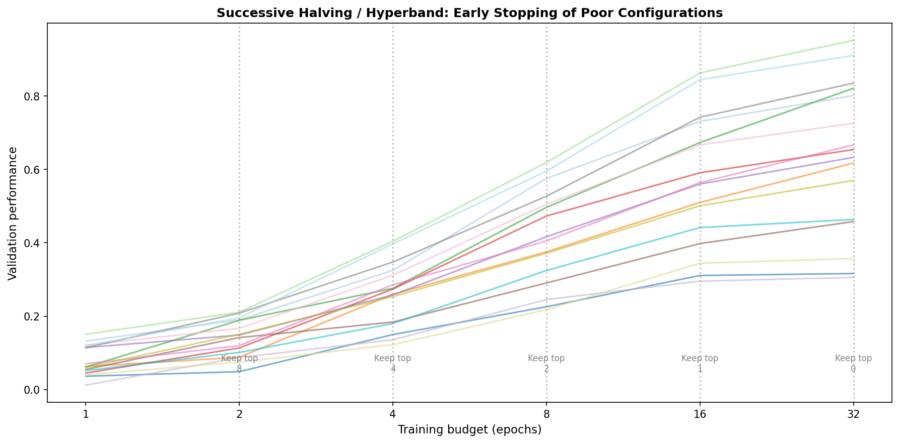
Figure 5.1: Successive Halving / Hyperband. Multiple configurations are trained in parallel. After each doubling of budget, the bottom half of configurations (by validation performance) are eliminated. Poor configurations are identified and stopped early, concentrating compute on the most promising hyperparameter settings.

5.3 BOHB: Combining Bayesian Optimization and Hyperband
BOHB (Falkner et al., 2018) combines the sample efficiency of BO with the computational efficiency of Hyperband. Rather than random sampling configurations for each bracket's initialization, BOHB uses a kernel density estimator-based surrogate model (similar to TPE) trained on all observations so far to generate promising configurations:
BOHB acquisition: λ_{next} = argmax_{λ} ℓ_b(λ) / g_b(λ)
where ℓ_b and g_b are the good/bad KDE models fitted to observations at budget level b. BOHB shares information across budget levels and exploits the correlation between low- and high-fidelity observations. The algorithm achieved state-of-the-art performance on the HPOBench benchmark suite and has become a de facto standard for compute-efficient HPO.
Table 5.1: Multi-Fidelity and Bayesian HPO Methods Comparison
Algorithm | Surrogate | Fidelity | Parallel | Conditional Space | Paper
Grid Search | None | Full | Yes | No | —
Random Search | None | Full | Yes | Partial | Bergstra & Bengio 2012
SMAC | Random Forest | Full | Limited | Yes | Hutter et al. 2011
HyperOpt/TPE | KDE (Parzen) | Full | Limited | Yes | Bergstra et al. 2011
GP-BO (Spearmint) | Gaussian Process | Full | Limited | Partial | Snoek et al. 2012
Hyperband | None | Multi | Yes | Partial | Li et al. 2017
BOHB | KDE | Multi | Yes | Yes | Falkner et al. 2018
ASHA | None | Multi | Yes | Yes | Li et al. 2020

6. Gradient-Based and Meta-Learning HPO

6.1 DARTS: Differentiable Architecture Search
DARTS (Liu et al., 2019) reformulates NAS as a continuous optimization problem by relaxing the discrete architecture choices through a softmax parameterization. For each edge (i,j) in the operation graph, a mixture of candidate operations {o^(k)} is computed:
ō^{(i,j)}(x) = Σ_k exp(α^{(i,j)}_k) / Σ_{k'} exp(α^{(i,j)}_{k'}) · o^{(k)}(x)
where α^{(i,j)} are continuous architecture parameters. DARTS jointly optimizes the architecture parameters α and network weights w using a bilevel optimization scheme:
min_α L_val(w*(α), α)
s.t. w*(α) = argmin_w L_train(w, α)
The inner optimization is approximated with a single gradient step. The outer loop updates α via gradient descent using a second-order approximation: ∇_α L_val ≈ ∇_α L_val(w − ξ∇_w L_train, α). After search, the architecture is discretized by selecting the argmax operation on each edge. DARTS reduced NAS from thousands of GPU-days (NASNet) to ~1 GPU-day for CIFAR-10 search.
A key weakness of DARTS is performance collapse due to the tendency to select skip connections (identity operations) which have zero gradient and thus do not interfere with other operations. Several improvements address this: P-DARTS (Chen et al., 2019) progressively increases the search space depth; PC-DARTS (Xu et al., 2020) applies channel sampling to reduce memory; GDAS (Dong and Yang, 2019) uses Gumbel-softmax for stochastic operation selection.

6.2 MAML and Gradient-Based Meta-Learning
Model-Agnostic Meta-Learning (MAML; Finn et al., 2017) is a meta-learning algorithm that learns a shared initialization θ that can be rapidly adapted to new tasks with few gradient steps. While MAML is primarily a few-shot learning algorithm, it directly relates to HPO in fine-tuning contexts: the meta-learned initialization serves as an optimal starting point, and the inner-loop learning rate is itself a hyperparameter optimized by the outer loop:
θ' = θ − α · ∇_θ L_{T_i}(f_θ) (inner update for task T_i)
θ ← θ − β · ∇_θ Σ_{T_i} L_{T_i}(f_{θ'}) (outer meta-update)
The outer-loop gradient ∇_θ Σ L(f_{θ'}) requires computing second-order derivatives (Hessians), which MAML approximates using first-order MAML (FOMAML) or Reptile (Nichol et al., 2018). In HPO contexts, Hyperparameter Optimization via Meta-Learning (HEBO; Cowen-Rivers et al., 2022) uses learned GP surrogates from meta-training on related tasks to warm-start BO.

7. Evolutionary and Population-Based Methods

7.1 Genetic Algorithms for HPO
Genetic Algorithms (GAs) apply evolutionary principles—selection, crossover, and mutation—to search configuration spaces. A population of P configurations {λ^(1), ..., λ^(P)} is evolved over G generations. At each generation:
- Selection: Configurations are selected proportional to fitness f(λ) (tournament or fitness-proportionate selection).
- Crossover: Two parent configurations λ_a and λ_b produce offspring by exchanging hyperparameter values at randomly chosen crossover points.
- Mutation: Each hyperparameter value is randomly perturbed with probability p_m, e.g., λ_j ← λ_j + ε where ε ~ N(0, σ_m).
NSGA-II (Deb et al., 2002) extends GAs to multi-objective HPO via non-dominated sorting and crowding distance, enabling Pareto-front exploration of, e.g., accuracy vs. FLOPs tradeoffs. Real et al. (2019) applied large-scale evolution to NAS, starting with 1,000 random architectures and evolving them over 32,000 GPU-days to discover AmoebaNet, matching DARTS quality.

7.2 Population-Based Training (PBT)
PBT (Jaderberg et al., 2017, DeepMind) combines the strengths of random search and hand-tuning by jointly optimizing hyperparameters and model weights within a single training run. A population of K agents {(θ_i, h_i)}_{i=1}^K is trained in parallel, where θ_i are weights and h_i are hyperparameters (e.g., learning rate, momentum). Periodically, two operations are performed:
Exploit: θ_i ← θ_j if f(θ_j) > f(θ_i) (copy weights from better agent)
Explore: h_i ← perturb(h_j) (mutate hyperparameters of copied agent)
PBT is particularly powerful for non-stationary hyperparameter schedules: the learning rate, regularization strength, and data augmentation parameters are all allowed to vary during training. DeepMind used PBT to train AlphaStar (StarCraft II), achieving schedules that would be impossible to design manually. The total computation is K × (one full training run), with no overhead from separate hyperparameter search.

7.3 CMA-ES: Covariance Matrix Adaptation Evolution Strategy
CMA-ES (Hansen & Ostermeier, 2001) is a state-of-the-art derivative-free optimizer for continuous spaces. It maintains a multivariate Gaussian distribution N(m, C) and iteratively updates the mean m and covariance matrix C based on successful samples:
Sample: λ^(k)_i = m^(k) + σ^(k) · B · D · z_i, z_i ~ N(0, I)
Update: m^(k+1) = Σ_i w_i λ^(k)_{i:λ} (weighted mean of top-μ samples)
Covariance update uses rank-μ and rank-1 updates with cumulative step-size adaptation
CMA-ES is particularly effective for moderate-dimensional continuous HPO (d ≤ 100) and has been used as the inner optimizer in BO-CMA-ES hybrids. Its O(d²) per-step cost is prohibitive for very high-dimensional spaces, where diagonal variants (sep-CMA-ES) are preferred.

8. Neural Architecture Search (NAS)
Neural Architecture Search (NAS) automates the design of neural network architectures. NAS can be viewed as a special case of HPO where the hyperparameters describe the network topology. A NAS problem has three components: (1) a search space defining possible architectures, (2) a search strategy for exploring the space, and (3) a performance estimation strategy for evaluating candidate architectures.

8.1 Search Spaces
The search space is the most critical component of NAS—it encodes the set of architectures considered. Two main paradigms exist:
- Macro search spaces: Define the entire network topology, including the number of layers, type of each layer, and connectivity. Used in early NAS work (Zoph & Le, 2017). Very large spaces (10^20+ architectures) make full search intractable.
- Cell-based search spaces: Decompose the network into a fixed macro-skeleton of cells, and search for the optimal cell structure. NASNet, DARTS, and most modern NAS methods use this approach. Cells typically contain 7 nodes and 5 possible operations (none, skip, 3×3 conv, 5×5 conv, pooling), yielding ~10¹² possible cells.
Table 8.1: NAS Search Space Comparison
Search Space | # Architectures | Representative Method | Search Cost
Macro (full network) | ~10^20 | NASNet (RL) | 1800 GPU-days
Cell-based | ~10^12 | ENAS (weight sharing) | ~0.5 GPU-days
Layer hyperparams | ~10^6 | BOHB+NAS | ~50 GPU-hours
DARTS continuous | Continuous | DARTS, PC-DARTS | ~1-4 GPU-days
Mobile-space (MobileNet) | ~10^14 | MnasNet, ProxylessNAS | ~200 GPU-days
Once-for-all (OFA) | ~10^19 | OFA (slimmable nets) | ~40 GPU-days

8.2 NASNet and Reinforcement Learning NAS
The seminal NAS work of Zoph and Le (2017) used a recurrent controller trained with REINFORCE to generate architecture descriptions. The controller samples a string encoding the architecture λ ~ π(λ | θ_c). The child network with architecture λ is trained to convergence to obtain validation accuracy R(λ). The controller is updated by policy gradient:
∇_{θ_c} J(θ_c) = Σ_t ∇_{θ_c} log π(a_t | a_{t-1:1}; θ_c) · R
NASNet (Zoph et al., 2018) introduced the cell-based search space and found architectures transferable from CIFAR-10 to ImageNet. The discovered NASNet-A Large achieved 82.7% top-1 accuracy on ImageNet but required 1,800 GPU-days of search.
Efficient NAS (ENAS; Pham et al., 2018) dramatically reduced search cost by sharing weights among all child networks (weight sharing). A single supernet is trained, and the controller samples subgraphs from it. This reduces search cost from thousands of GPU-days to 0.5 GPU-days while maintaining competitive performance. Weight sharing introduces the challenge of weight coupling, where different subarchitectures interfere with each other's training.

8.3 Efficient NAS Methods
MobileNetV3 (Howard et al., 2019) combined NAS with the NetAdapt algorithm to produce mobile-optimized architectures. EfficientNet (Tan & Le, 2019) introduced compound scaling: network depth d, width w, and resolution r are scaled jointly with a compound coefficient φ:
depth: d = α^φ, width: w = β^φ, resolution: r = γ^φ
s.t. α · β² · γ² ≈ 2, α ≥ 1, β ≥ 1, γ ≥ 1
where α, β, γ are determined by a small grid search on the baseline network. EfficientNet-B7 achieved 84.4% top-1 accuracy on ImageNet with 8.4× fewer parameters than the best previous ConvNet. The Once-for-All (OFA) network (Cai et al., 2020) trains a single supernet and decouples the training cost from the search cost via progressive shrinking of sub-networks.

9. Fine-Tuning Pre-Trained Models
The dominant paradigm in modern deep learning is pre-train then fine-tune. A model is first trained on a large, general dataset (e.g., ImageNet, C4, The Pile, LAION-5B) in a self-supervised or supervised manner. The pre-trained weights encode rich representations that transfer to downstream tasks when the model is adapted (fine-tuned) on task-specific labeled data.

9.1 Transfer Learning Principles
Transfer learning is effective because lower layers of neural networks learn general features (edges, textures, syntactic patterns) while higher layers specialize to the pre-training task. Yosinski et al. (2014) characterized layer transferability and showed that fine-tuning all layers consistently outperforms feature extraction (freezing pre-trained layers) when sufficient target-domain data is available.
The choice of which layers to fine-tune depends on dataset similarity and size. For a target dataset similar to the pre-training domain and with abundant labels, fine-tuning all layers is preferred. For small, dissimilar target datasets, freezing lower layers prevents overfitting. This gives rise to the 'frozen backbone + fine-tuned head' paradigm prevalent in vision and NLP.
Table 9.1: Transfer Learning Strategies Based on Dataset Characteristics
Target Data Size | Target Domain Similarity | Recommended Strategy
Large | Similar | Fine-tune all layers with small LR
Large | Different | Fine-tune all layers with moderate LR
Small | Similar | Freeze backbone, fine-tune head
Small | Different | Freeze lower layers, fine-tune upper + head

9.2 Full Fine-Tuning of Language Models
BERT (Devlin et al., 2019) introduced the pre-train + fine-tune paradigm for NLP. BERT is pre-trained on masked language modeling (MLM) and next sentence prediction (NSP) objectives. For MLM, 15% of input tokens are masked, and the model is trained to predict them:
L_MLM = −E_{x~D} Σ_{i∈Masked} log P(x_i | x_{¬i}; θ)
During fine-tuning, a task-specific head (typically a linear layer) is appended to the CLS token representation, and the entire model is fine-tuned on labeled data. The recommended hyperparameters for BERT fine-tuning (Devlin et al., 2019) are:
- Learning rate η ∈ {1e-5, 2e-5, 3e-5, 5e-5} (much smaller than pre-training)
- Batch size ∈ {16, 32}
- Epochs: 2–4 (fine-tuning is quick due to warm initialization)
- Warmup ratio: 6–10% of total steps with linear decay
- Weight decay: 0.01 applied to non-bias, non-normalization parameters

9.3 Catastrophic Forgetting and Mitigation
Catastrophic forgetting (McCloskey & Cohen, 1989) refers to the degradation of pre-trained capabilities when a model is fine-tuned on a new task. For large language models, fine-tuning on a narrow domain can cause forgetting of general language understanding. Several strategies mitigate this:
- Elastic Weight Consolidation (EWC; Kirkpatrick et al., 2017): Adds a quadratic penalty on parameter changes, weighted by the Fisher information matrix F:
L_EWC = L_task + (λ/2) Σ_i F_i (θ_i − θ*_i)²
- Learning Rate Warmup: Using a warmup phase where the learning rate increases linearly from 0 to η_max prevents large initial gradient updates from disrupting pre-trained weights.
- Layer-wise Learning Rate Decay (LLRD): Using smaller learning rates for lower (pre-trained) layers and larger rates for the task-specific head:
η_l = η_base · α^{L−l}, α ∈ [0.8, 0.95] (typical)
where L is the total number of layers and l is the layer index (0 = input). Sun et al. (2019) found LLRD to be critical for BERT fine-tuning on small datasets.

10. Parameter-Efficient Fine-Tuning (PEFT)
As pre-trained models grew from millions (BERT-base: 110M) to billions (GPT-4: ~1.8T estimated) of parameters, full fine-tuning became prohibitively expensive in terms of memory, compute, and storage. Parameter-Efficient Fine-Tuning (PEFT) methods adapt pre-trained models by modifying only a small fraction of parameters while freezing the majority, achieving performance comparable to full fine-tuning with orders-of-magnitude lower cost.

10.1 Adapter Layers
Houlsby et al. (2019) introduced adapter modules: small bottleneck networks inserted into each transformer layer. An adapter consists of a down-projection, a non-linearity, and an up-projection, with a residual connection:
h ← h + f_adapter(h) = h + W_up · σ(W_down · h + b_down) + b_up
where h ∈ ℝᵈ is the hidden representation, W_down ∈ ℝ^{r×d} and W_up ∈ ℝ^{d×r} are the adapter weights with r << d (bottleneck dimension). Typically r is 16–64, reducing the number of trainable parameters to ~3% of the full model. The adapter is initialized as the identity (W_up ← 0, W_down random), ensuring zero deviation at initialization.
AdapterFusion (Pfeiffer et al., 2021) allows combining multiple task-specific adapters without forgetting. Prefix-Adapter (He et al., 2022) unifies adapters, prefix tuning, and LoRA under a single framework, showing they are all special cases of a general low-rank adaptation framework.

10.2 LoRA: Low-Rank Adaptation
LoRA (Hu et al., 2022) is the most widely adopted PEFT method for large language models. The key insight is that the change in model weights during fine-tuning has low intrinsic rank. LoRA decomposes the weight update ΔW into two low-rank matrices:
W = W₀ + ΔW = W₀ + B · A
where W₀ ∈ ℝ^{d×k} is the frozen pre-trained weight, B ∈ ℝ^{d×r} and A ∈ ℝ^{r×k} are trainable matrices with rank r << min(d, k). The forward pass becomes:
h = W₀x + (α/r) · B·A·x = W₀x + ΔWx
where α is a scaling hyperparameter (often set equal to r). At initialization, A is randomly initialized (e.g., Kaiming uniform) and B is set to zero, ensuring ΔW = 0 at the start of training. After training, LoRA can be merged: W_merged = W₀ + (α/r)·B·A, adding zero inference latency.
LoRA is applied to the query and value projection matrices Q, V in the attention layers (and optionally K, O, the MLP layers). With r = 4 on a 7B parameter LLaMA model, LoRA trains only ~0.08% of parameters while matching full fine-tuning performance on many tasks.
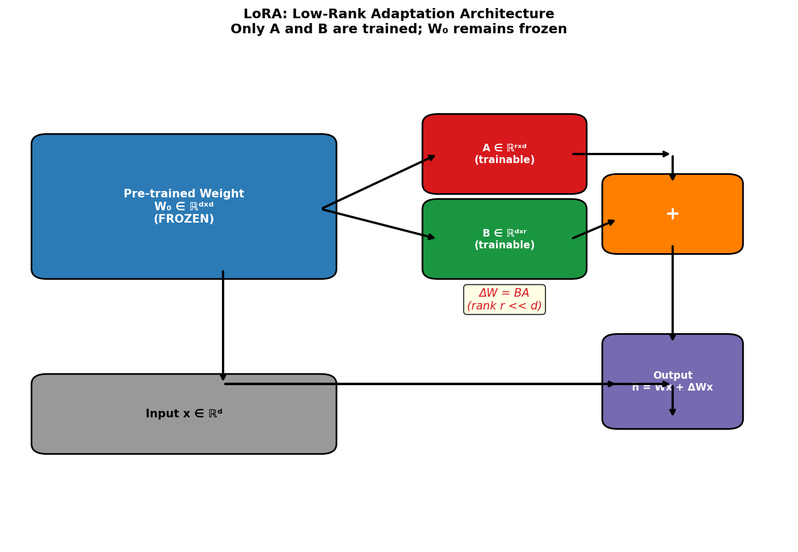
Figure 10.1: LoRA Architecture. The pre-trained weight matrix W₀ is frozen (blue). The trainable low-rank matrices A (red) and B (green) capture the task-specific adaptation ΔW = BA with rank r << d. The combined output h = W₀x + (α/r)BAx is passed to subsequent layers.
QLoRA (Dettmers et al., 2023) extends LoRA to 4-bit quantized models. The pre-trained weights are quantized to NF4 (a 4-bit data type for normally distributed weights), and LoRA adapters are added in 16-bit precision. Double quantization further reduces memory by quantizing the quantization constants. QLoRA enables fine-tuning of 65B parameter models on a single 48GB GPU.

10.3 Prefix Tuning and Prompt Tuning
Prefix Tuning (Li & Liang, 2021) prepends trainable 'virtual tokens' (prefix) to the key and value sequences in each attention layer. Let P_θ ∈ ℝ^{|P| × d} be the prefix parameters. The attention computation becomes:
head(Q, K, V) = softmax((Q [P_K; K]ᵀ / √d_k)) · [P_V; V]
where P_K and P_V are the trainable key and value prefixes of length |P| (typically 10–100). Only P_θ is updated during fine-tuning. Prefix tuning achieves near full fine-tuning performance on many NLG tasks with |P| = 10 (0.1% of parameters for GPT-2 medium).
Prompt Tuning (Lester et al., 2021) is a simplified variant that only prepends trainable tokens to the input embedding layer (not to every attention layer). With sufficient model scale (≥ 11B parameters), prompt tuning matches full fine-tuning while updating 20,000× fewer parameters. P-Tuning v2 (Liu et al., 2022) applies prefix tuning across all transformer layers (like prefix tuning) but also to the output head, achieving strong performance across NLU tasks at smaller scales.

10.4 (IA)³ and Other PEFT Methods
Infused Adapter by Inhibiting and Amplifying Inner Activations [(IA)³; Liu et al., 2022] introduces learned vectors l_K, l_V, l_FF that rescale the keys, values, and feed-forward activations:
Attention: softmax(Q(l_K ⊙ K)ᵀ/√d_k) · (l_V ⊙ V)
FFN: W_2 · (l_FF ⊙ σ(W_1 · h))
With only 3 vectors per layer, (IA)³ trains ~0.01% of parameters and enables few-shot fine-tuning without full gradient backpropagation. BitFit (Zaken et al., 2022) fine-tunes only bias terms, ~0.08% of parameters for BERT, achieving strong performance on GLUE. Diff pruning (Guo et al., 2021) applies sparse gradient masking to update only the most important parameters identified by the Fisher information diagonal.

10.5 Comparison of PEFT Methods
Table 10.1: Comparison of Parameter-Efficient Fine-Tuning Methods
Method | Trainable Params | Inference Overhead | Memory Req. | Strengths | Year
Full FT | 100% | None | High (full grads) | Best quality | —
Adapter | 1–5% | Yes (serial layers) | Low | Modular, composable | 2019
LoRA | 0.01–1% | None (mergeable) | Very Low | Fast, no latency | 2022
QLoRA | 0.01–1% | Quant overhead | Very Low (4-bit) | Huge models, 1 GPU | 2023
Prefix Tuning | ~0.1% | Prefix KV cache | Very Low | Good for NLG | 2021
Prompt Tuning | ~0.01% | Soft tokens | Very Low | Simple, large models | 2021
(IA)³ | ~0.01% | Element-wise mul. | Minimal | Few-shot FT | 2022
BitFit | ~0.08% | None | Minimal | Bias-only update | 2022

11. Instruction Tuning and RLHF

11.1 Instruction Fine-Tuning
Instruction tuning (Wei et al., 2022; Sanh et al., 2022) fine-tunes language models on a diverse collection of tasks expressed as natural language instructions. Given a model f_θ and a dataset of (instruction, input, output) triplets, the model is fine-tuned with standard cross-entropy:
L_IT = −Σ_{(inst,x,y) ∈ D} log P_θ(y | inst, x)
The key insight is that training on diverse task formats and instruction phrasings enables zero-shot generalization to unseen tasks. FLAN (Finetuned Language Net; Wei et al., 2022) instruction-tuned a 137B parameter model on 62 NLP datasets reformatted into 12 instruction templates, achieving dramatic improvements in zero-shot performance. T0 (Sanh et al., 2022) used an even more diverse set of 35 NLP datasets. InstructGPT and ChatGPT built on instruction tuning by additionally incorporating human feedback through RLHF.
Key hyperparameters for instruction tuning include: learning rate (1e-5 to 5e-5), number of training steps (1,000–10,000 for large models), batch size (128–512 sequences), gradient accumulation to simulate large batches, and data mixing ratios across task types.

11.2 RLHF: Reinforcement Learning from Human Feedback
RLHF (Christiano et al., 2017; Ouyang et al., 2022) aligns language model behavior with human preferences through three stages:
Stage 1 — Supervised Fine-Tuning (SFT):
A pre-trained LLM is fine-tuned on high-quality human-written demonstrations of desired behavior using standard cross-entropy loss. This produces the SFT model π^{SFT}.
Stage 2 — Reward Model Training:
Human labelers provide pairwise preference judgments: given two model outputs y_w (preferred) and y_l (rejected) for prompt x, the reward model r_φ(x, y) is trained to assign higher reward to preferred outputs. Using the Bradley-Terry model:
P(y_w ≻ y_l) = σ(r_φ(x, y_w) − r_φ(x, y_l))
L_RM(φ) = −E_{(x, y_w, y_l) ∼ D} [log σ(r_φ(x, y_w) − r_φ(x, y_l))]
Stage 3 — PPO Fine-Tuning:
The SFT model is fine-tuned using Proximal Policy Optimization (PPO; Schulman et al., 2017) to maximize the learned reward while staying close to the reference SFT policy π^{ref}:
max_{π_θ} E_{x~D, y~π_θ} [r_φ(x,y)] − β · KL[π_θ(y|x) ‖ π^{ref}(y|x)]
where β controls the KL penalty strength (typically 0.1–0.3). The KL penalty prevents the policy from exploiting the reward model by producing nonsensical but high-reward outputs (reward hacking). The PPO objective uses a clipped surrogate:
L_PPO = E_t [min(r_t(θ)·Â_t, clip(r_t(θ), 1−ε, 1+ε)·Â_t)]
where r_t(θ) = π_θ(a_t|s_t) / π_{θ_old}(a_t|s_t), ε = 0.2 (typical)
Critical RLHF hyperparameters: KL coefficient β, PPO clip ratio ε, mini-batch size, rollout batch size, number of PPO epochs per rollout, value function coefficient, entropy coefficient, and the learning rate for both actor and critic networks.

11.3 Direct Preference Optimization (DPO)
DPO (Rafailov et al., 2023) avoids the complexity of RL by directly optimizing the language model to satisfy human preference data without an explicit reward model. DPO derives a closed-form expression for the optimal policy under RLHF and directly optimizes it:
L_DPO(π_θ; π^{ref}) = −E_{(x,y_w,y_l)} [log σ(β log(π_θ(y_w|x)/π^{ref}(y_w|x))
− β log(π_θ(y_l|x)/π^{ref}(y_l|x)))]
DPO is substantially simpler than RLHF: no reward model is needed, no RL loop is required, and the loss is a standard binary cross-entropy. Empirically, DPO achieves competitive or superior performance to PPO-based RLHF with 2–3× less training compute. Extensions include IPO (Azar et al., 2024) which addresses overfitting in DPO, and KTO (Ethayarajh et al., 2024) which allows training on non-paired preference data.
Table 11.1: Comparison of Preference Optimization Methods
Method | Requires RM? | RL Training? | Complexity | Performance
SFT only | No | No | Low | Baseline
RLHF (PPO) | Yes | Yes | Very High | State of Art
DPO | No (implicit) | No | Low | Competitive
IPO | No | No | Low | Better than DPO
KTO | No | No | Low | Non-paired data
RLAIF | LLM-as-judge | Yes | Medium | Scalable

12. Fine-Tuning in Computer Vision

12.1 CNN Fine-Tuning Strategies
Convolutional Neural Networks (CNNs) pre-trained on ImageNet (1.28M images, 1000 classes) provide strong visual representations transferable to diverse vision tasks. The standard fine-tuning protocol for CNNs involves:
- Replacing the final classification head with a new linear layer matching the target class count.
- Fine-tuning all layers with a small learning rate (η ≈ 1e-4 to 1e-3), or using layer-wise LR decay.
- Using batch sizes of 32–256, cosine LR decay, and heavy data augmentation (RandomCrop, ColorJitter, RandAugment).
Ge and Yu (2017) proposed a 'selective joint fine-tuning' strategy for limited target data: source training examples similar to the target domain are identified and jointly trained, preventing overfitting. Gidaris et al. (2018) showed that network architecture has more impact than pre-training dataset for fine-tuning with limited labels.

12.2 Vision Transformers (ViT) Fine-Tuning
Vision Transformers (ViT; Dosovitskiy et al., 2021) apply the transformer architecture to image patches. An image x ∈ ℝ^{H×W×C} is split into N patches of size P×P, linearly projected to d-dimensional embeddings:
z₀ = [x_class; x_p¹E; x_p²E; ... ; x_p^N E] + E_pos
where E ∈ ℝ^{(P²·C)×d} is the patch embedding, x_class is a learnable classification token, and E_pos ∈ ℝ^{(N+1)×d} are positional embeddings. Fine-tuning ViTs requires larger batch sizes (typically 512–4096) and longer warmup compared to CNNs. Key hyperparameters include:
- Learning rate: 1e-5 to 3e-4, with linear or cosine warmup for 5–20% of training.
- Weight decay: 0.05–0.3 (higher than CNNs due to transformer's tendency to overfit).
- Stochastic depth (DropPath) rate: 0.1–0.4 for regularization.
- Image resolution: Fine-tuning at higher resolution (384×384 vs. 224×224) improves accuracy.
DeiT (Touvron et al., 2021) introduced knowledge distillation for training ViTs with limited data by using a CNN teacher. MAE (He et al., 2022) pre-trains ViTs via masked autoencoding (75% of patches masked), producing representations that fine-tune exceptionally well with sparse labeled data.

12.3 Domain Adaptation
Domain adaptation addresses the distribution shift between source (pre-training) and target domains. Unsupervised Domain Adaptation (UDA) assumes labeled source data and unlabeled target data. Domain-Adversarial Neural Networks (DANN; Ganin et al., 2016) use a gradient reversal layer (GRL) to make the feature extractor domain-invariant:
L_DANN = L_y(f(x_s), y_s) − λ · L_d(g(f(x)), d)
where L_y is the classification loss on source data, L_d is the domain discrimination loss (binary: source vs. target), and the GRL reverses the gradient from L_d during backpropagation. CLIP (Radford et al., 2021) pre-trained on 400M image-text pairs demonstrated remarkable zero-shot transfer to many vision tasks without fine-tuning, while linear probing (fine-tuning only the linear head) on CLIP features often matches full fine-tuning of specialized networks.

13. AutoML Platforms and Frameworks
AutoML platforms integrate HPO, architecture search, feature engineering, and model selection into end-to-end automated pipelines. This section surveys the major open-source and commercial AutoML systems.
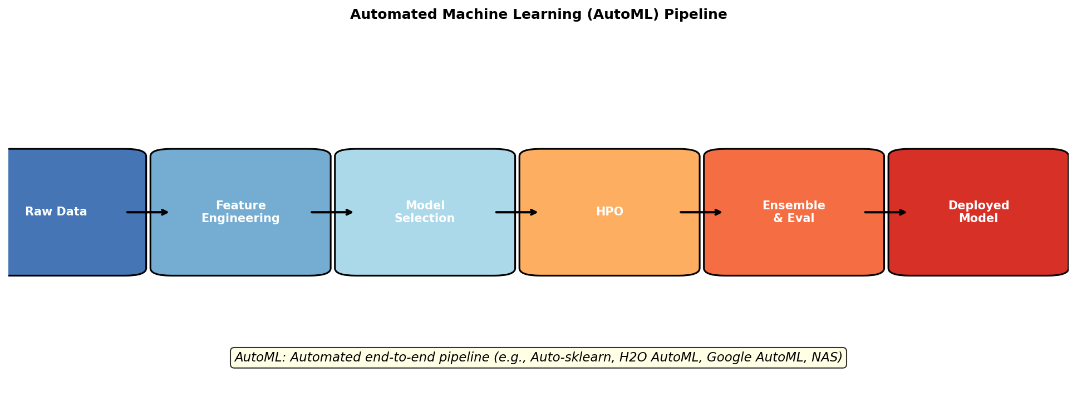
Figure 13.1: The Automated Machine Learning (AutoML) Pipeline. Raw data enters a fully automated workflow encompassing feature engineering, model selection, hyperparameter optimization, and ensemble construction, delivering a production-ready deployed model.

13.1 Auto-sklearn and SMAC
Auto-sklearn (Feurer et al., 2015, 2022) is a SMAC-based AutoML framework built on scikit-learn. It performs joint optimization over the pipeline space Λ = (preprocessing × classifier × HPO), using a combined space of ~110 hyperparameters. Two unique features distinguish Auto-sklearn:
- Meta-learning warm start: Task properties (dataset meta-features) are used to select promising initial configurations from a database of 140 prior experiments, reducing cold-start time.
- Ensemble construction: Caruana et al.'s greedy ensemble selection is applied post-search to combine the best discovered models, consistently outperforming any single model.
Auto-sklearn 2.0 (Feurer et al., 2022) replaced SMAC with a portfolio-based approach that selects diverse initial configurations, achieving better anytime performance.

13.2 H2O AutoML and Google AutoML
H2O AutoML (LeDell & Poirier, 2020) trains multiple model families (GBM, XGBoost, Deep Learning, GLM, Stacked Ensembles) in parallel with pre-configured and randomly searched hyperparameters. Its stacked ensemble (super learner) trains a meta-model on cross-validated base learner predictions.
Google AutoML Tables applies NAS and HPO to tabular data using Neural Architecture Search customized for structured data (attention-based architectures over heterogeneous feature types). Google's Vizier (Golovin et al., 2017) is the internal HPO service powering AutoML products, supporting GP-BO, Hyperband, evolutionary strategies, and transfer learning across studies.

13.3 Optuna, Ray Tune, and HyperOpt
Optuna (Akiba et al., 2019) is a flexible HPO framework using a 'define-by-run' API that allows dynamic construction of search spaces within the objective function:
n_layers = trial.suggest_int('n_layers', 1, 5)
lr = trial.suggest_float('lr', 1e-5, 1e-1, log=True)
Optuna's default sampler is TPE, with optional CMA-ES and grid search samplers. Its pruner implements Hyperband, MedianPruner, and SuccessiveHalvingPruner. Optuna is particularly well-suited for integration with PyTorch and Keras due to its Python-native API.
Ray Tune (Liaw et al., 2018) focuses on distributed HPO with native integration with Ray's distributed computing framework. Ray Tune supports all major HPO algorithms (ASHA, PBT, BOHB, Bayesian optimization via BoTorch) and integrates with PyTorch, TensorFlow, and Hugging Face Transformers.
Table 13.1: Major HPO and AutoML Frameworks
Framework | Core Algorithm | Distributed | Language | Best For
HyperOpt | TPE | Limited (MongoDB) | Python | Research, NN HPO
Optuna | TPE + CMA-ES | Yes (NFS/RDB) | Python | Flexible HPO, any task
Ray Tune | ASHA + BOHB | Yes (Ray cluster) | Python | Large-scale distributed HPO
SMAC3 | SMAC (RF-BO) | Limited | Python | Algorithm configuration
Auto-sklearn | SMAC + ensembles | Limited | Python | AutoML for sklearn
H2O AutoML | Random + Stacked | Yes (H2O cluster) | Python/R/Java | Enterprise AutoML
Ax / BoTorch | GP-BO (torch) | Yes | Python | Bayesian optimization
NNI (Microsoft) | Multi-algo | Yes | Python | NAS + HPO

14. Practical Considerations and Best Practices

14.1 Hyperparameter Importance
Not all hyperparameters are equally important. fANOVA (Functional Analysis of Variance; Hutter et al., 2014) quantifies hyperparameter importance by measuring the fraction of performance variance attributable to each hyperparameter and pairwise interactions. Across many deep learning benchmarks, the results consistently show:
Table 14.1: Approximate Hyperparameter Importance in Deep Learning (fANOVA Analysis)
Hyperparameter | Importance (approx.) | Interaction
Learning rate | Very High (30–60%) | With batch size
Batch size | High (10–25%) | With learning rate
Weight decay | Medium (5–15%) | With learning rate
Dropout rate | Medium (5–15%) | With model size
Number of layers | Medium (5–10%) | With learning rate
Number of units | Low–Medium (2–8%) | With number of layers
Activation function | Low (1–5%) | With architecture
Gradient clip | Low (1–3%) | Rarely
Optimizer type | Low–Medium (3–8%) | With learning rate

These findings justify focusing HPO budget on the most impactful hyperparameters (learning rate, batch size, weight decay) while using default values for less important ones. The linear scaling rule (Goyal et al., 2017) relates batch size and learning rate: when multiplying batch size by k, multiply learning rate by √k (or linearly by k with warmup).
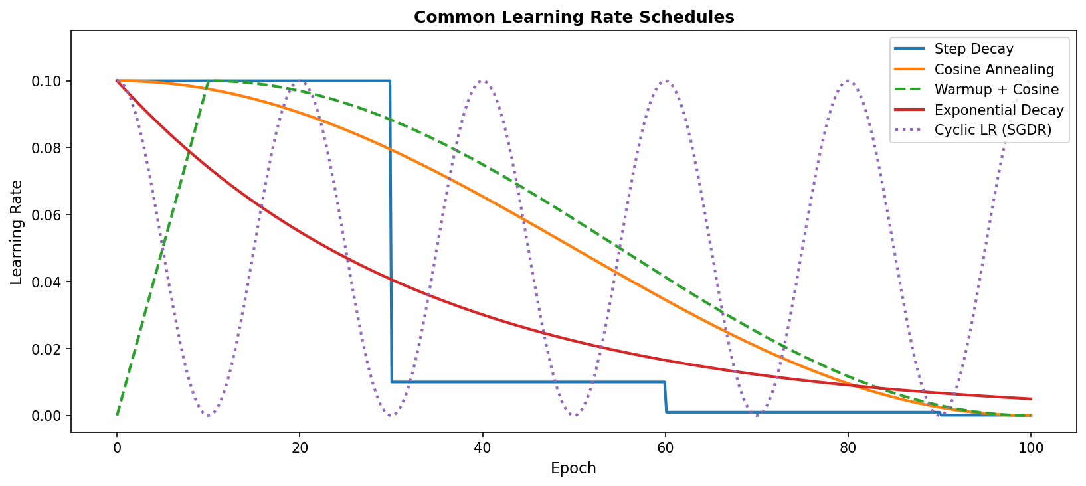
Figure 14.1: Common Learning Rate Schedules. Step decay drops the LR at fixed intervals. Cosine annealing provides smooth decay. Warmup + cosine is the standard for transformer fine-tuning. Cyclic LR (SGDR) enables ensemble-like generalization.

14.2 Warm Starting and Transfer of HPO Knowledge
Warm starting reuses HPO knowledge from related tasks to accelerate optimization. Feurer et al. (2018) showed that meta-learning from 140 datasets reduces HPO runtime by 5–10× by initializing BO with configurations known to perform well on similar datasets. The dataset similarity is measured using meta-features: number of samples, features, classes, feature correlation statistics, and landmarker performance (simple model accuracy on the dataset).
For fine-tuning LLMs, it is common practice to warm-start with hyperparameters from published recipes (e.g., Hugging Face Transformers provides default fine-tuning configurations for each model). Transfer of LoRA rank and scaling factor across model sizes follows a simple heuristic: rank r = 4–16 is sufficient for most tasks; higher ranks (32–64) help for domain-specific knowledge injection.

14.3 Reproducibility and Evaluation
Reproducibility in HPO is challenging due to stochasticity in training. Best practices include: fixing random seeds for model initialization, data loading, and augmentation; averaging performance across multiple seeds (3–5 is standard); using fixed train/validation splits or k-fold cross-validation for HPO; and reporting both mean and standard deviation of evaluation metrics. Bouthillier et al. (2021) showed that a significant fraction of reported improvements in deep learning papers disappear under rigorous re-evaluation with multiple seeds and proper hyperparameter search for baselines.

15. Benchmarks and Comparative Analysis
Rigorous benchmarking of HPO methods requires standardized problem sets with known optima or tabulated results. Several benchmark suites have been developed for this purpose.
Table 15.1: Major HPO and NAS Benchmark Suites
Benchmark | Task Type | # Configs | # Datasets | Key Metric
HPOBench | ML pipelines | ~10^6 each | ~100 | Validation error
NAS-Bench-101 | NAS (CIFAR-10) | 423,624 | 1 | Test accuracy
NAS-Bench-201 | NAS (3 datasets) | 15,625 | 3 | Test accuracy
YAHPO Gym | ML pipelines | Millions | 100+ | Validation performance
LCBench | DNN on tabular | 2000 per ds. | 35 | Validation accuracy
PD1 (Pineda et al.) | Deep LR tuning | ~1000 | 28 | Validation NLL
GLUE/SuperGLUE | NLP fine-tuning | N/A | 8/10 | Aggregate score
MTEB | LLM embeddings | N/A | 56 | Average score

On HPOBench, BOHB consistently outperforms random search, TPE, and vanilla Hyperband. On NAS-Bench-201, DARTS achieves competitive performance with manual designs while taking only ~12 GPU-hours. The results across benchmarks reveal several consistent findings:
- Multi-fidelity methods (Hyperband, BOHB, ASHA) outperform single-fidelity methods when evaluation cost is high.
- Random search remains a competitive baseline that is hard to beat with a budget of fewer than 30 evaluations.
- BO surpasses random search reliably only with > 30 evaluations and in lower-dimensional spaces (d ≤ 10).
- For NAS, weight-sharing methods (ENAS, DARTS) provide the best cost-quality tradeoff.
Table 15.2: HPO Method Performance on CIFAR-10 Classification (Illustrative Comparison)
Method | Budget (GPU-h) | Final Val Err (%) | Convergence Speed
Grid Search | 100 | 3.21 ± 0.15 | Slow
Random Search | 100 | 2.84 ± 0.18 | Medium
HyperOpt/TPE | 100 | 2.71 ± 0.12 | Medium
SMAC (BO-RF) | 100 | 2.63 ± 0.09 | Fast
GP-BO (EI) | 100 | 2.55 ± 0.11 | Fast
Hyperband | 100 | 2.48 ± 0.14 | Very Fast
BOHB | 100 | 2.31 ± 0.08 | Very Fast
PBT | 100 | 2.27 ± 0.10 | Very Fast

For fine-tuning comparison, LoRA with rank 16 trained for 3 epochs achieves 90.2% on GLUE benchmark (average) for RoBERTa-large, compared to 90.9% for full fine-tuning, using only 0.45% of parameters. QLoRA achieves 63.1% on MMLU (5-shot) for LLaMA-65B, matching the full fine-tuned GPT-3.5 (67.2%) while using 75% less GPU memory.

16. Open Challenges and Future Directions
Despite significant progress, several major challenges remain open in HPO and fine-tuning research.

16.1 Scaling HPO to Foundation Models
HPO for models with billions of parameters (GPT-4, LLaMA-2, Gemini) presents extreme computational challenges. Each evaluation of a 70B parameter model's fine-tuning hyperparameters requires multiple A100 GPU-hours. Multi-fidelity methods must be adapted to account for the non-monotonic performance trajectories often observed in LLM training (loss spikes, grokking). Zero-shot HPO—predicting good hyperparameters from model and dataset properties without any evaluation—is an emerging direction (Ru et al., 2021).

16.2 Multi-Objective and Constrained HPO
Real-world deployment requires balancing multiple objectives: accuracy, latency (P50, P99), memory footprint, energy consumption, and fairness metrics. Multi-objective BO using Gaussian process surrogates with Hypervolume Expected Improvement (HVEI) acquisition functions extends single-objective BO to Pareto-front exploration. Hardware-aware NAS (HW-NAS; Benmeziane et al., 2021) incorporates device-specific latency models directly into the search objective, enabling deployment-aware architecture optimization.

16.3 Federated and Privacy-Preserving HPO
In healthcare, finance, and telecommunications, data cannot be centralized for HPO. Federated HPO distributes both model training and hyperparameter search across data silos. FedBO (Dai et al., 2020) extends BO to the federated setting by aggregating surrogate models across clients. Differential privacy constraints further complicate HPO by adding noise to gradient updates, requiring adaptive clipping strategies.

16.4 Neural Scaling Laws and HPO
Kaplan et al. (2020) discovered power-law scaling relationships between model performance and model size N, dataset size D, and compute C:
L(N) ∝ N^{-α_N}, L(D) ∝ D^{-α_D}, L(C) ∝ C^{-α_C}
Chinchilla scaling laws (Hoffmann et al., 2022) identified the compute-optimal ratio of N and D: for a given compute budget C, the optimal model has N_opt ≈ C^{0.5} parameters trained on D_opt ≈ C^{0.5} tokens. These scaling laws inform HPO by predicting which model sizes and training budgets are worth exploring, significantly reducing the search space.

16.5 Interpretable HPO and Landscape Analysis
Understanding why certain hyperparameter configurations work is as important as finding them. Loss landscape analysis (Li et al., 2018) visualizes the loss surface topology, revealing that flat minima generalize better. Hyperparameter sensitivity analysis using Shapley values (SHAP) identifies interaction effects. Learning curve prediction—forecasting final performance from early training curves—enables aggressive early stopping.

16.6 Continual and Lifelong Fine-Tuning
As models are repeatedly fine-tuned on streams of tasks (e.g., monthly software updates for deployed LLMs), continual learning challenges arise: how to efficiently update LoRA adapters without forgetting previous capabilities. O-LoRA (Wang et al., 2023) uses orthogonal subspace projections to ensure new task adaptations do not interfere with previous ones. TRACE (Wang et al., 2024) introduces a benchmark specifically for evaluating continual fine-tuning of LLMs across evolving instruction distributions.

17. Conclusion
This survey has provided a comprehensive overview of hyperparameter optimization and fine-tuning in machine learning, spanning classical methods, Bayesian approaches, multi-fidelity strategies, gradient-based techniques, and the modern fine-tuning paradigm for large pre-trained models.
Several key insights emerge from our review. First, no single HPO algorithm dominates across all settings: multi-fidelity methods (Hyperband, BOHB) excel for expensive evaluations; BO methods (GP-EI, TPE) are preferred for budget-limited exact evaluations; and random search remains a competitive baseline that practitioners should always run. Second, the fine-tuning landscape has shifted dramatically from full fine-tuning toward parameter-efficient methods, with LoRA and its variants now the de facto standard for adapting large language models.
Third, the HPO and fine-tuning communities are converging: optimal LoRA rank, adapter dimension, and prompt length are themselves hyperparameters that benefit from automated tuning. The integration of PEFT methods with HPO frameworks (e.g., automatic LoRA rank selection via Bayesian optimization) represents an important practical direction.
Looking forward, the field faces exciting challenges: scaling HPO to trillion-parameter models, multi-objective optimization for real-world deployment constraints, privacy-preserving distributed HPO, and leveraging scaling laws to guide architecture and hyperparameter choices. The integration of HPO with continual learning, meta-learning, and zero-shot generalization represents the frontier of automated machine learning research.
We hope this survey serves as a comprehensive reference for researchers and practitioners, providing both theoretical foundations and practical guidance for achieving optimal performance in machine learning systems through principled hyperparameter optimization and fine-tuning.

References
[1] Akiba, T., Sano, S., Yanase, T., Ohta, T., & Koyama, M. (2019). Optuna: A next-generation hyperparameter optimization framework. In Proceedings of the 25th ACM SIGKDD International Conference on Knowledge Discovery & Data Mining (pp. 2623–2631).
[2] Azar, M. G., Rowland, M., Piot, B., Guo, D., Calandriello, D., Valko, M., & Munos, R. (2024). A general theoretical paradigm to understand learning from human feedback. In Proceedings of AISTATS 2024.
[3] Bergstra, J., & Bengio, Y. (2012). Random search for hyper-parameter optimization. Journal of Machine Learning Research, 13(2), 281–305.
[4] Bergstra, J., Bardenet, R., Bengio, Y., & Kégl, B. (2011). Algorithms for hyper-parameter optimization. In Advances in Neural Information Processing Systems (NeurIPS), 24.
[5] Bouthillier, X., Delaunay, P., Bronzi, M., Trofimov, A., Nichyporuk, B., Szeto, J., ... & Vincent, P. (2021). Accounting for variance in machine learning benchmarks. In Proceedings of Machine Learning and Systems (MLSys).
[6] Cai, H., Gan, C., Wang, T., Zhang, Z., & Han, S. (2020). Once-for-all: Train one network and specialize it for efficient deployment. In International Conference on Learning Representations (ICLR).
[7] Chen, X., Xie, L., Wu, J., & Tian, Q. (2019). Progressive differentiable architecture search: Bridging the depth gap between search and evaluation. In Proceedings of the IEEE/CVF ICCV.
[8] Christiano, P. F., Leike, J., Brown, T., Martic, M., Legg, S., & Amodei, D. (2017). Deep reinforcement learning from human preferences. In Advances in NeurIPS, 30.
[9] Deb, K., Pratap, A., Agarwal, S., & Meyarivan, T. (2002). A fast and elitist multiobjective genetic algorithm: NSGA-II. IEEE Transactions on Evolutionary Computation, 6(2), 182–197.
[10] Dettmers, T., Pagnoni, A., Holtzman, A., & Zettlemoyer, L. (2023). QLoRA: Efficient finetuning of quantized LLMs. In Advances in NeurIPS, 36.
[11] Devlin, J., Chang, M. W., Lee, K., & Toutanova, K. (2019). BERT: Pre-training of deep bidirectional transformers for language understanding. In Proceedings of NAACL-HLT 2019.
[12] Dong, X., & Yang, Y. (2019). Searching for a robust neural architecture in four GPU hours. In Proceedings of the IEEE/CVF CVPR.
[13] Dosovitskiy, A., Beyer, L., Kolesnikov, A., Weissenborn, D., Zhai, X., Unterthiner, T., ... & Houlsby, N. (2021). An image is worth 16x16 words: Transformers for image recognition at scale. In ICLR 2021.
[14] Ethayarajh, K., Xu, W., Muennighoff, N., Jurafsky, D., & Kiela, D. (2024). KTO: Model alignment as prospect theoretic optimization. In ICML 2024.
[15] Falkner, S., Klein, A., & Hutter, F. (2018). BOHB: Robust and efficient hyperparameter optimization at scale. In Proceedings of ICML 2018.
[16] Feurer, M., Klein, A., Eggensperger, K., Springenberg, J. T., Blum, M., & Hutter, F. (2015). Efficient and robust automated machine learning. In Advances in NeurIPS, 28.
[17] Feurer, M., Eggensperger, K., Falkner, S., Lindauer, M., & Hutter, F. (2022). Auto-Sklearn 2.0: Hands-free AutoML via meta-learning. Journal of Machine Learning Research, 23(261), 1–61.
[18] Finn, C., Abbeel, P., & Levine, S. (2017). Model-agnostic meta-learning for fast adaptation of deep networks. In Proceedings of ICML 2017.
[19] Ganin, Y., Ustinova, E., Ajakan, H., Germain, P., Larochelle, H., Laviolette, F., ... & Lempitsky, V. (2016). Domain-adversarial training of neural networks. JMLR, 17(59), 1–35.
[20] Golovin, D., Solnik, B., Moitra, S., Kochanski, G., Karro, J., & Sculley, D. (2017). Google Vizier: A service for black-box optimization. In Proceedings of the 23rd ACM SIGKDD.
[21] Goyal, P., Dollár, P., Girshick, R., Noordhuis, P., Wesolowski, L., Kyrola, A., ... & He, K. (2017). Accurate, large minibatch SGD: Training ImageNet in 1 hour. arXiv:1706.02677.
[22] Guo, D., Rush, A. M., & Kim, Y. (2021). Parameter-efficient transfer learning with diff pruning. In Proceedings of ACL-IJCNLP 2021.
[23] Hansen, N., & Ostermeier, A. (2001). Completely derandomized self-adaptation in evolution strategies. Evolutionary Computation, 9(2), 159–195.
[24] He, K., Chen, X., Xie, S., Li, Y., Dollár, P., & Girshick, R. (2022). Masked autoencoders are scalable vision learners. In Proceedings of the IEEE/CVF CVPR.
[25] He, J., Zhou, C., Ma, X., Berg-Kirkpatrick, T., & Neubig, G. (2022). Towards a unified view of parameter-efficient transfer learning. In ICLR 2022.
[26] Hoffmann, J., Borgeaud, S., Mensch, A., Buchatskaya, E., Cai, T., Rutherford, E., ... & Sifre, L. (2022). Training compute-optimal large language models. In Advances in NeurIPS, 35.
[27] Houlsby, N., Giurgiu, A., Jastrzebski, S., Morrone, B., De Laroussilhe, Q., Gesmundo, A., ... & Gelly, S. (2019). Parameter-efficient transfer learning for NLP. In Proceedings of ICML 2019.
[28] Howard, A., Sandler, M., Chu, G., Chen, L. C., Chen, B., Tan, M., ... & Adam, H. (2019). Searching for MobileNetV3. In Proceedings of the IEEE/CVF ICCV.
[29] Hu, E. J., Shen, Y., Wallis, P., Allen-Zhu, Z., Li, Y., Wang, S., ... & Chen, W. (2022). LoRA: Low-rank adaptation of large language models. In ICLR 2022.
[30] Hutter, F., Hoos, H. H., & Leyton-Brown, K. (2011). Sequential model-based optimization for general algorithm configuration. In Proceedings of LION 2011.
[31] Hutter, F., Hoos, H., & Leyton-Brown, K. (2014). An efficient approach for assessing hyperparameter importance. In Proceedings of ICML 2014.
[32] Jaderberg, M., Dalibard, V., Osindero, S., Czarnecki, W. M., Donahue, J., Razavi, A., ... & Kavukcuoglu, K. (2017). Population based training of neural networks. arXiv:1711.09846.
[33] Jamieson, K., & Talwalkar, A. (2016). Non-stochastic best arm identification and hyperparameter optimization. In Proceedings of AISTATS 2016.
[34] Jones, D. R., Schonlau, M., & Welch, W. J. (1998). Efficient global optimization of expensive black-box functions. Journal of Global Optimization, 13(4), 455–492.
[35] Kaplan, J., McCandlish, S., Henighan, T., Brown, T. B., Chess, B., Child, R., ... & Amodei, D. (2020). Scaling laws for neural language models. arXiv:2001.08361.
[36] Kirkpatrick, J., Pascanu, R., Rabinowitz, N., Veness, J., Desjardins, G., Rusu, A. A., ... & Hadsell, R. (2017). Overcoming catastrophic forgetting in neural networks. Proceedings of the National Academy of Sciences, 114(13), 3521–3526.
[37] Larochelle, H., Erhan, D., Courville, A., Bergstra, J., & Bengio, Y. (2007). An empirical evaluation of deep architectures on problems with many factors of variation. In Proceedings of ICML 2007.
[38] LeDell, E., & Poirier, S. (2020). H2O AutoML: Scalable automatic machine learning. In AutoML Workshop at ICML 2020.
[39] Lester, B., Al-Rfou, R., & Constant, N. (2021). The power of scale for parameter-efficient prompt tuning. In Proceedings of EMNLP 2021.
[40] Li, H., Xu, Z., Taylor, G., Studer, C., & Goldstein, T. (2018). Visualizing the loss landscape of neural nets. In Advances in NeurIPS, 31.
[41] Li, L., Jamieson, K., DeSalvo, G., Rostamizadeh, A., & Talwalkar, A. (2017). Hyperband: A novel bandit-based approach to hyperparameter optimization. JMLR, 18(185), 1–52.
[42] Li, L., Jamieson, K., Rostamizadeh, A., Gonina, E., Ben-Tzur, J., Hardt, M., ... & Talwalkar, A. (2020). A system for massively parallel hyperparameter tuning. In Proceedings of MLSys 2020.
[43] Li, X. L., & Liang, P. (2021). Prefix-tuning: Optimizing continuous prompts for generation. In Proceedings of ACL-IJCNLP 2021.
[44] Liaw, R., Liang, E., Nishihara, R., Moritz, P., Gonzalez, J. E., & Stoica, I. (2018). Tune: A research platform for distributed model training and hyperparameter search. In ICML AutoML Workshop.
[45] Liu, H., Simonyan, K., & Yang, Y. (2019). DARTS: Differentiable architecture search. In ICLR 2019.
[46] Liu, H., Tam, D., Muqeeth, M., Mohta, J., Huang, T., Bansal, M., & Raffel, C. (2022). Few-shot parameter-efficient fine-tuning is better and cheaper than in-context learning. In Advances in NeurIPS, 35.
[47] Liu, X., Ji, K., Fu, Y., Tam, W. L., Du, Z., Yang, Z., & Tang, J. (2022). P-tuning v2: Prompt tuning can be comparable to fine-tuning universally across scales and tasks. In Proceedings of ACL 2022.
[48] McCloskey, M., & Cohen, N. J. (1989). Catastrophic interference in connectionist networks: The sequential learning problem. In Psychology of Learning and Motivation, 24, 109–165.
[49] Mockus, J. (1975). On the Bayes methods for seeking the extremal point. IFAC Proceedings Volumes, 8(1), 428–431.
[50] Nichol, A., Achiam, J., & Schulman, J. (2018). On first-order meta-learning algorithms. arXiv:1803.02999.
[51] Ouyang, L., Wu, J., Jiang, X., Almeida, D., Wainwright, C., Mishkin, P., ... & Lowe, R. (2022). Training language models to follow instructions with human feedback. In Advances in NeurIPS, 35.
[52] Pfeiffer, J., Kamath, A., Rücklé, A., Cho, K., & Gurevych, I. (2021). AdapterFusion: Non-destructive task composition for transfer learning. In Proceedings of EACL 2021.
[53] Pham, H., Guan, M., Zoph, B., Le, Q., & Dean, J. (2018). Efficient neural architecture search via parameter sharing. In Proceedings of ICML 2018.
[54] Radford, A., Kim, J. W., Hallacy, C., Ramesh, A., Goh, G., Agrawal, S., ... & Sutskever, I. (2021). Learning transferable visual models from natural language supervision. In Proceedings of ICML 2021.
[55] Rafailov, R., Sharma, A., Mitchell, E., Manning, C. D., Ermon, S., & Finn, C. (2023). Direct preference optimization: Your language model is secretly a reward model. In Advances in NeurIPS, 36.
[56] Real, E., Aggarwal, A., Huang, Y., & Le, Q. V. (2019). Regularized evolution for image classifier architecture search. In Proceedings of AAAI 2019.
[57] Sanh, V., Webson, A., Raffel, C., Bach, S., Sutawika, L., Alyafeai, Z., ... & Rush, A. M. (2022). Multitask prompted training enables zero-shot task generalization. In ICLR 2022.
[58] Schulman, J., Wolski, F., Dhariwal, P., Radford, A., & Klimov, O. (2017). Proximal policy optimization algorithms. arXiv:1707.06347.
[59] Snoek, J., Larochelle, H., & Adams, R. P. (2012). Practical Bayesian optimization of machine learning algorithms. In Advances in NeurIPS, 25.
[60] Srinivas, N., Krause, A., Kakade, S. M., & Seeger, M. W. (2012). Information-theoretic regret bounds for Gaussian process optimization in the bandit setting. IEEE Transactions on Information Theory, 58(5), 3250–3265.
[61] Sun, C., Qiu, X., Xu, Y., & Huang, X. (2019). How to fine-tune BERT for text classification? In China National Conference on Chinese Computational Linguistics.
[62] Tan, M., & Le, Q. (2019). EfficientNet: Rethinking model scaling for convolutional neural networks. In Proceedings of ICML 2019.
[63] Titsias, M. (2009). Variational learning of inducing variables in sparse Gaussian processes. In Proceedings of AISTATS 2009.
[64] Touvron, H., Cord, M., Douze, M., Massa, F., Sablayrolles, A., & Jégou, H. (2021). Training data-efficient image transformers & distillation through attention. In Proceedings of ICML 2021.
[65] Wang, Z., Panda, R., Karlinsky, L., Feris, R., Sun, H., & Kim, Y. (2023). Multitask prompt tuning enables parameter-efficient transfer learning. In ICLR 2023.
[66] Wei, J., Bosma, M., Zhao, V., Guu, K., Yu, A. W., Lester, B., ... & Le, Q. V. (2022). Finetuned language models are zero-shot learners. In ICLR 2022.
[67] Wilson, A. G., Hu, Z., Salakhutdinov, R., & Xing, E. P. (2016). Deep kernel learning. In Proceedings of AISTATS 2016.
[68] Xu, Y., Xie, L., Zhang, X., Chen, X., Qi, G. J., Tian, Q., & Xiong, H. (2020). PC-DARTS: Partial channel connections for memory-efficient architecture search. In ICLR 2020.
[69] Yosinski, J., Clune, J., Bengio, Y., & Lipson, H. (2014). How transferable are features in deep neural networks? In Advances in NeurIPS, 27.
[70] Zaken, E. B., Ravfogel, S., & Goldberg, Y. (2022). BitFit: Simple parameter-efficient fine-tuning for transformer-based masked language-models. In Proceedings of ACL 2022.
[71] Zoph, B., & Le, Q. V. (2017). Neural architecture search with reinforcement learning. In ICLR 2017.
[72] Zoph, B., Vasudevan, V., Shlens, J., & Le, Q. V. (2018). Learning transferable architectures for scalable image recognition. In Proceedings of the IEEE/CVF CVPR.

