Narrow-leaved lupin yields are more stable when mixed cropped with oats OR Multi-environment assessment reveals higher yield stability and performance in narrow-leaved lupin and oat mixed cropping
¹ Research group Extension Arable Crops, Competence Division Plant and Plant Products, Agroscope, Zurich, Switzerland
² serbia ³ Sustainable Agroecosystems, Department of Environmental Systems Science, ETH Zurich, Zurich, Switzerland ⁴ jki ⁵ dh ⁶ Seminar for Statistics, Department of Mathematics, ETH Zurich, Zurich, Switzerland
✉ Corresponding author: susanne.vogelgsang@agroscope.admin.ch
keywords: Narrow-leaved lupin, oat, mixed cropping, yield stability, intercropping, biodiversity

COPY PASTE EVERYTHING AGAIN: INTRO METHOD RESULTS REFERENCES

Abstract

Introduction
Global demand for protein‐rich plants is growing while climate volatility continues to undermine
the year-to-year reliability of monocultures (Ismail et al., 2020; Raseduzzaman and Jensen,
2017). Mixed cropping of cereals with grain legumes has re-emerged as a promising strategy to
buffer yield risk, decrease fertiliser dependence and improve resource-use eﬀiciency (Kumawat
et al., 2022). Narrow-leaved lupin (NLL, Lupinus angustifolius L.) is among the few temperate
grain legumes that combine high seed protein with the ability to thrive on nutrient poor soils
(Lopez-Bellido and Fuente, 1986); however, its sole-crop yield is notoriously unstable (Reckling
et al., 2018). Oat (Avena sativa L.) offers complementary morphology, rapid early growth and
serves as a cereal break crop (e.g. Danso et al., 1993; Pálmason et al., 1992). Integrating the
two species in mixed cropping therefore addresses both agronomic resilience and nutritional
targets at farm and food-system level.
Decades of work on genotype × cropping-system interactions have demonstrated that perform-
ance gains from cereal × legume mixtures depend on both the mixed varieties and the environ-
ment in which they were evaluated (e.g. (Demie et al., 2022)). Meta-analyses consistently report
mean land-equivalent ratios (LER) between 1.2 and 1.3 for cereal–legume mixtures, indicating
a median 24% land-use advantage over pure stands (Demie et al., 2022). grain yield stability
has been assessed with both static and dynamic metrics; in many cases mixtures outperform
monocultures, yet the magnitude and drivers of this stability remain equivocal (Raseduzzaman
and Jensen, 2017; Weih et al., 2021). In parallel, agronomic theory predicts that excessive ver-
tical stratification within a canopy can impair light interception, potentially offsetting mixture
advantages (Demie et al., 2022).
Despite this theoretical foundation, robust multi-environment evidence for oat × NLL mixtures
is scarce. Previous trials have often been confined to single locations, or ad-hoc varietal choices,
leaving unresolved (i) whether crop-level indices such as the crop-performance ratio (CPR)
corroborate classical LER assessments, (ii) how canopy height difference between the variet-
ies influence performance and (iii) whether the expected grain yield stability gains of mixed
cropping materialise across contrasting European agro-climates. Addressing these gaps is crit-
ical, since legumes are pivotal to climate-change mitigation strategies and nitrogen-fertiliser
reduction roadmaps (Rahman et al., 2022).
Accordingly, we expect the
- Mixed stands to achieve LER >1, indicating superior land use compared with pure stands.
- Total CPR and the oat CPR to exceed unity, reflecting an overall mixed cropping advantage.
- A larger canopy height difference between the species to diminish total yield.
- Oat × NLL mixed cropping to increase both static and dynamic grain yield stability across
the locations relative to the corresponding pure stands.

Methods

Varieties
Three spring narrow-leaved lupin (NLL) and three spring oat varieties were chosen based on the breeders fact sheets. Branching, spring-NLLs and early-maturing spring oat varieties were selected to increase the chances of coincidental ripening. The selected, NLL varieties were
- Lunabor, bred by Saatzucht Steinach in Germany
- Probor, bred by Saatzucht Steinach in Germany
- Jowisz (synonym: Jupiter), bred by HR Smolic in Poland
And the selected, early maturing spring oat varieties were
- Bison, Hauptsaaten für die Rheinprovinz GmbH, Germany, medium tall
- Lion, Nordsaat Saatzucht GmbH, Germany, medium tall
- Troll, Saatzucht Bauer GmbH & Co. KG, Germany, short

Treatments and experimental design
The NLL and oat varieties were cultivated as spring crops in pure and mixed stands. The pure oat stands were fertilised according to the local guidelines (Table 2). In the mixed stands, each NLL variety was co-cultivated with each oat variety in a replacement design; The NLLs were sown at 90% of their pure stand’s density, whereas the oats, due to their high competitiveness, were sown at 10% of their pure stand’s density (Böhm et al., 2008; Kato-Noguchi et al., 1994) (Table 1). The sowing amounts were adapted to the germination rate evaluated two weeks before sowing according to the producer’s provided germination information.
Table 1
Treatments of the study: Narrow-leaved lupin and oat varieties, the stand (pure versus mixed), sowing ratios, respective sowing densities and corresponding amount of seeds per hectare. For the two numbers present in the mixed treatments, the first one refers to the narrow-leaved lupins, the second one to the oats. The optimal sowing density of the oat crop varied depending on the local recommendations.

Treatment | Stand | Sowing ratios (%) | Sowing density (plantsm²) | Amount (kgha⁻¹)
Bison | pure | 100 | 300 - 400 | 168 - 224
Lion | pure | 100 | 300 - 400 | 121 - 161
Troll | pure | 100 | 300 - 400 | 110 - 147
Lunabor | pure | 100 | 120 | 220
Probor | pure | 100 | 120 | 170
Jowisz | pure | 100 | 120 | 214
Lunabor × Bison | mixed | 90, 10 | 108 / 30 - 40 | 198 / 17 - 22
Lunabor × Lion | mixed | 90, 10 | 108 / 30 - 40 | 198 / 12 - 16
Lunabor × Troll | mixed | 90, 10 | 108 / 30 - 40 | 198 / 11 - 15
Probor × Bison | mixed | 90, 10 | 108 / 30 - 40 | 153 / 17 - 22
Probor × Lion | mixed | 90, 10 | 108 / 30 - 40 | 153 / 12 - 16
Probor × Troll | mixed | 90, 10 | 108 / 30 - 40 | 153 / 11 - 15
Jowisz × Bison | mixed | 90, 10 | 108 / 30 - 40 | 193 / 17 - 22
Jowisz × Lion | mixed | 90, 10 | 108 / 30 - 40 | 193 / 12 - 16
Jowisz × Troll | mixed | 90, 10 | 108 / 30 - 40 | 193 / 11 - 15
The fields of this two-year study were arranged as a randomised complete block design (RCBD), consisting of four blocks. To lower the border effect to a minimum, each treatment was sown in three adjacent plots and only the middle plot was scored and harvested. The size of each harvested plot was seven square metres (Figure 1).
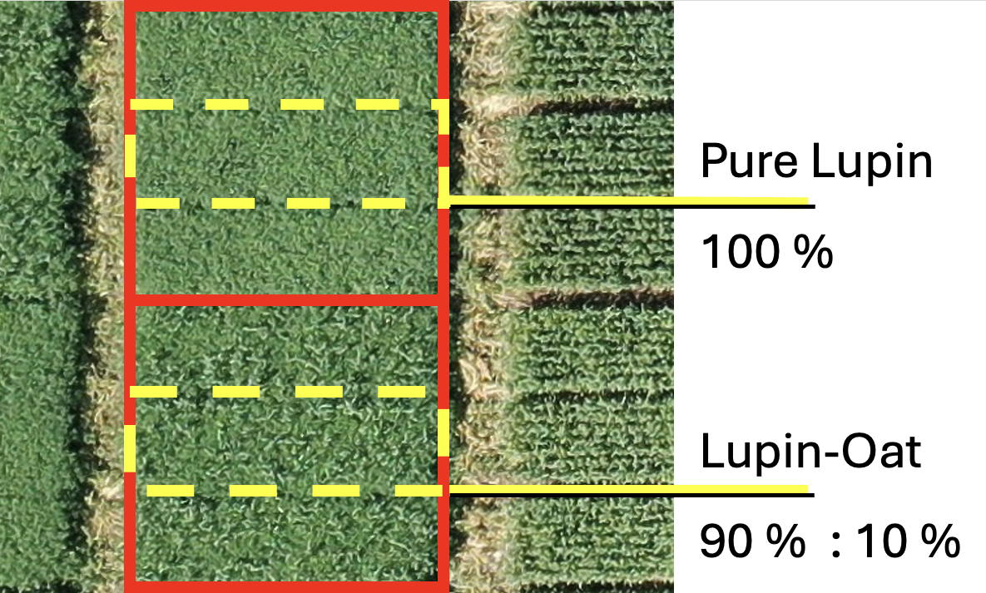
Figure 1: Figure 1: Arrangement of plots to reduce border effects. The red line enfolds the three plots of the same treatment while the yellow dashed line enfolds the harvested plot. Between adjacent treatments, a 1.2-metre corridor was mowed.

Site, husbandry and weather data
The sites were located in Germany (Bad Vilbel and Gross Lüsewitz), Serbia (Novi Sad) and in Switzerland (Seegräben and Reckenholz) and were chosen based on their differing latitude, longitude, soil type (Table 2) and weather (Table 3). The fields were ploughed harrowed before sowing. Before sowing, the NLL seeds were inoculated with sterile peat inoculum containing the rhizobium bacterium Bradyrhizobium lupinus. The inoculum was produced by Legume Technology Ltd, Nottinghamshire, UK. The same batch of inoculum was used in both years and stored dry and under exclusion of humidity at 10°C. After the inoculation, every 7m² plot was sown individually in rows with 18 cm spacing. The plots were sown with a plot sowing tractor and RTK-GPS-orientation. Spring-tine and shallow inter-row cultivation was performed for the mechanical weeding. Chemical weed-management was performed by applying product (in location xy). The pure oats were fertilised during late tillering, before the elongation stage, according to local guidelines.
Table 2
Field characteristics and husbandry measures per location and year.

Location and year | Latitude (°N) | Longitude (°E) | Pre-crop | Pre-pre-crop | Sowing | Weeding 1 | Weeding 2 | Oat fertilisation (kg N) | Pest intervention | Harvest | Soil-type
Bad Vilbel 2022
Bad Vilbel 2023
Bad Vilbel 2024
Gross Lüsewitz 2022
Gross Lüsewitz 2023
Gross Lüsewitz 2024
Novi Sad 2023
Novi Sad 2024
Novi Sad 2025
Reckenholz 2022 | 47.4 | 8.5 | Silage maize | Flower strip | March 4 | March 21 (mechanical) | April 5 (mechanical) | 27.5 |  | July 12 | Loamy clay
Reckenholz 2023 | 47.4 | 8.5 | Silage maize | Artificial pasture | February 16 | February 22 (mechanical) | April 4 (mechanical) | 30 |  | July 10 | Loamy clay
Seegräben 2022 | 47.3 | 8.9 | Silage maize | Winter wheat | March 10 | March 17 (mechanical) | March 31 (mechanical) | 27.5 |  | July 19 | Sandy loam
Seegräben 2023 | 47.4 | 8.9 | Silage maize | Winter barley | February 22 | March 1 (mechanical) | April 5 (mechanical) | 30 |  | July 19 | Sandy loam

Table 3
Weather data in the cultivation seasons 2022, 2023 and 2024, retrieved from the closest weather stationss. The distance of the weather station to the site was 0.25 to maximum 5 km. Data were retrieved daily and the average temperature and humidity as well as the sum of precipitation across the cultivation period were calculated.

Location and year | Mean temperature (°C) | Precipitation sum (mm)
Bad Vilbel 2022 | 13.4 | 174
Bad Vilbel 2023 | 13.1 | 293
Bad Vilbel 2024 | 13.8 | 402
Gross Lüsewitz 2022 | 11.8 | 234
Gross Lüsewitz 2023 | 11.8 | 258
Gross Lüsewitz 2024 | 13 | 367
Novi Sad 2023 | 10.4 | 97
Novi Sad 2024 | 10.1 | 271
Novi Sad 2025 | 13.9 | 126
Seegräben 2022 | 14.1 | 504
Seegräben 2023 | 13.8 | 500
Reckenholz 2022 | 17.7 | 244
Reckenholz 2023 | 17.4 | 362

On-field phenotyping
Final plant canopy heights of the NLLs and oats were scored before harvesting.

Harvest and post-harvest analyses
The crops were harvested with a plot combine harvester. The samples were then dried to a moisture content below 13%. In mixed treatments, the oats were separated from the NLLs with grain cleaners, where a 6mm oval-cut sieve was deployed. The cleaned samples were weighted to measure the partial and total yields.

Statistical analysis

Data preparation and calculations
Based on the primary data, productivity metrics were calculated to assess the partial land equivalent ratio of each crop in mixture (par_LERcrop), the land equivalent ratio of the mixture (LER), the crop performance ratio of each crop (CPRcrop), and the total CPR (CPR) (Zustovi et al., 2024):
$${\text{par_LER}}_{\text{crop}}=\frac{{\text{Yield}}_{\text{crop, mixed}}}{{\text{Yield}}_{\text{crop, pure}}}$$
$$LER={\text{par_LER}}_{\text{lupin}}+{\text{par_LER}}_{\text{oat}}$$
$${\text{CPR}}_{\text{crop}}=\frac{Y_{\text{crop, mix}}}{p_{\text{crop}}×Y_{\text{crop, pure}}}$$
$$\text{CPR}={\text{CPR}}_{\text{oat}}+{\text{CPR}}_{\text{lupin}}$$
Where:
${\text{Yield}}_{\text{crop, mixed}}$ is the yield of the crop in mixture (t ha⁻¹),
${\text{Yield}}_{\text{crop, pure}}$ is the yield of the same crop in pure stand (t ha⁻¹),
$p_{\text{crop}}$ is the proportion of the crop’s sowing density in the mixture relative to its pure stand, and
$\text{crop}$ represents either NLL or oat.
Those metrics allowed to compare the mixed cropping system’s land use and crop performance relative to their monocropping equivalents. By definition, the LER in pure stands is one, the CPR of a crop that does not benefit nor suffer from mixed cropping is also one, and the CPR of a mixture of two crops that do not interact with each other in mixture is two.

Modelling
The response variables were analysed using linear mixed-effects models. Four model-classes M1-M4 were designed to suit the target-variables (Table 8). The treatment, year, site, and their interaction effects were modelled as fixed effects and the block within a field as a random effect. The models were fitted using the lme4 package within the R programming language (Bates et al., 2015; Team, 2025). Inferences were calculated using the lmerTest package, which provides the shatterweights degree of freedom adjustment for the type-III ANOVA and the contest-function, which was used to test linear contrasts (Kuznetsova et al., 2017). The contrast sum parametrisation was used to allow the interpretability of the regression coefficients to the population mean, but partially fitted intercepts were used for each group in case of the M2 and M4 models (R syntax: “y~0+group”). Post-hoc pairwise comparisons were performed to assess varietal differences.
Table 4
Statistical models deployed to analyse the data. The characteristics explain the details of the model. Each response variable (attribute) in the present study was analysed with one or more of the models listed in the table.

Model | Characteristics
M1 | This model answered if the response variable differed in mixtures and pure NLLs (or analogously oats) across all varieties. It performed an ANOVA using the NLL/oat-variety and the binary variable stand = mixed. This model considered each species separately.
M2 | M2 answered if the response variable differed in mixtures and pure NLLs or oats. Here, this was achieved by computing the linear contrasts of each pure NLL/oat variety with the mean of its respective mixtures. This model considered each species separately.
M3 | On the subset of only mixed plots, M3 performed a two-way (mixed) ANOVA with the factors oat variety and NLL variety (adjusting for site, year, and block). This model considered both species together.
M4 | M4 answered the question, if the estimated value of the treatments with mixed stands (e.g. the land equivalent ratio) was significantly different from an expected value (e.g. LER = 1) after a Bonferroni correction (with the respective 12 coefficients).

Robustification
To mitigate the influence of outliers, the outlier weights were automatically adapted using the weights from the analogous model derived by the rlmer function of the robustlmm package (Koller, 2016). Target outliers were selected by applying the bounded influence function of huber loss. This application of the robustification is indicated in the supplemented materials, Appendix A (robustify = TRUE).

Static yield stability
To assess treatment‐level differences in the static yield stability, the coefficient of variation (CV) of the partial NLL, partial oat and the total yield for each treatment were calculated. The CV was computed using the standard deviation and mean of total yield, following the implementation in the metan package (Olivoto, 2020):
$${\text{CV}}_{\text{mean}}=\frac{{\text{SD}}_{\text{value}}}{{\text{Mean}}_{\text{value}}+{10}^{-6}}×100$$
where meanvalue is the mean total yield across treatment, year and location, and SDvalue​ is the corresponding standard deviation. The small constant (10⁻⁶) prevents division by zero for extremely low SDvalue. The resulting per‐treatment CV values were arranged into a one‐column response matrix, and the corresponding treatment labels were stored in a factor data frame. A permutational multivariate analysis of variance (PERMANOVA) was then applied to the matrix using Euclidean distances and 999 permutations via the adonis2 function in the vegan package with treatment as the sole predictor (Oksanen et al., 2001). To further identify which treatments differed significantly in their CV, post‐hoc pairwise PERMANOVA tests using the pairwise adonis2 function from the pairwiseAdonis package were run, also with 999 permutations and Benjamini–Hochberg correction for multiple testing (Arbizu, 2020).

Dynamic yield stability
The dynamic yield stability across environments (location × year) was assessed using the Finlay–Wilkinson regression approach, also known as joint regression (Finlay and Wilkinson, 1963). In this framework, each treatment’s mean yield across environments was regressed against an environmental index (mean environment yield minus grand mean). The resulting slope coefficient, b1​, represents genotype responsiveness to the environment, where b1 ​≈ 1 implies average stability, b1 ​> 1 indicates high responsiveness (yield rises in favorable environments) and b1 ​< 1 indicates stability but limited responsiveness. The analysis was implemented using the ge_reg() function from the metan R package (Olivoto, 2020), which performs the regression-based stability analysis according to Eberhart and Russell (1966).
To analyse the genotype by environment, i.e. treatment by location, interactions and quantify yield stability, the additive main effects and multiplicative interaction (AMMI) model was applied (Gauch, 1992; Zobel et al., 1988). The AMMI model decomposed the observed total yield response $Y_{ij}$​ of treatment $i$ in location $j$ into additive main effects for treatment and location, plus multiplicative interaction effects captured by principal components (IPCs):
$$Y_{ij}=μ+G_{i}+E_{j}+\sum_{k=1}^{N}{λ_{k}} γ_{ik} δ_{jk}+ε_{ij}$$
Where:
$μ$ is the grand mean,
$G_{i}$ and $E_{j}$ are the treatment and location main effects,
$λ_{k}$ is the singular value of the $k^{th}$ interaction principal component (IPCA),
$γ_{ik}$ and $δ_{jk}$ are the treatment and location scores for the $k^{th}$ IPCA, and
$ε_{ij}$ is the residual term.
The weighted average of absolute scores (waas) was computed to summarize multi‐dimensional interaction effects into a single stability index, following Olivoto et al. (2019) as implemented in the metan R package (Olivoto (2020)):
$${\text{WAAS}}_{i}=\sum_{k=1}^{N}{w_{k}} |{\text{IPCA}}_{ik}|$$
Where $w_{k}$ is the proportion of the interaction sum of squares explained by the $k^{th}$ IPCA.
Lower waas values indicate greater yield stability across environments, whereas higher waas values reflect higher treatment × location interaction effects and thus lower stability. Treatments were visualized in AMMI biplots (IPCA1 × IPCA2) and total yield × waas plots.

Results

Yield
In Reckenholz, the most productive environment, median grain yields of the pure oat stands ranged between 4.9 and 5.4 tha⁻¹. Pure NLL stands produced 2.8 – 3.6 tha⁻¹, while the oat NLL mixtures reached 3.7–4.8 t ha⁻¹ of total yield (Figure 2). Gross Lüsewitz and Seegräben exhibited similar yields to Reckenholz in pure oat stands, however, the NLL yields and compound yields were lower (p < 0.001). Reckenholz and Seegräben exhibited the highest NLL yields in pure stands compared with the other locations (p < 0.001). The compound yields of Bad Vilbel and Novi Sad were lower across all observed treatments in the year 2022 than the compound yields of Reckenholz, Seegräben or Gross Lüsewitz (p < 0.001), whereas in 2023, only the compound yield of Gross Lüsewitz was significantly lower than the yields recorded in Novi Sad, Reckenholz and Seegräben. Further, the yields of all NLL and oat varieties in pure stands and their partial yields in mixed stands differed significantly (p < 0.001, p < 0.05 for Jowisz - Troll, respectively). Across all locations the averaged yields of pure NLL and oat stands were not significantly different from the averaged yields across all mixtures. Regarding the proportion of the partial NLL yield in mixtures, Bad Vilbel and Seegräben exhibited higher NLL than oat proportions of 62 and 59% across all years, respectively, whereas the proportions of the NLL yield in mixtures amounted to 35, 29 and 24% in Gross Lüsewitz, Novi Sad and Reckenholz, respectively (p < 0.001). A strong year effect was apparent, resulting in an elevated proportion of the NLL yield by 16% in 2022 and 7% in 2023 across all mixtures, respectively. Additionally, an oat-interaction effect could be detected, resulting in an increased NLL proportion by 5% if the NLL were mixed with Troll, and a decreased proportion by -4.6% if the NLL were mixed with Lion.
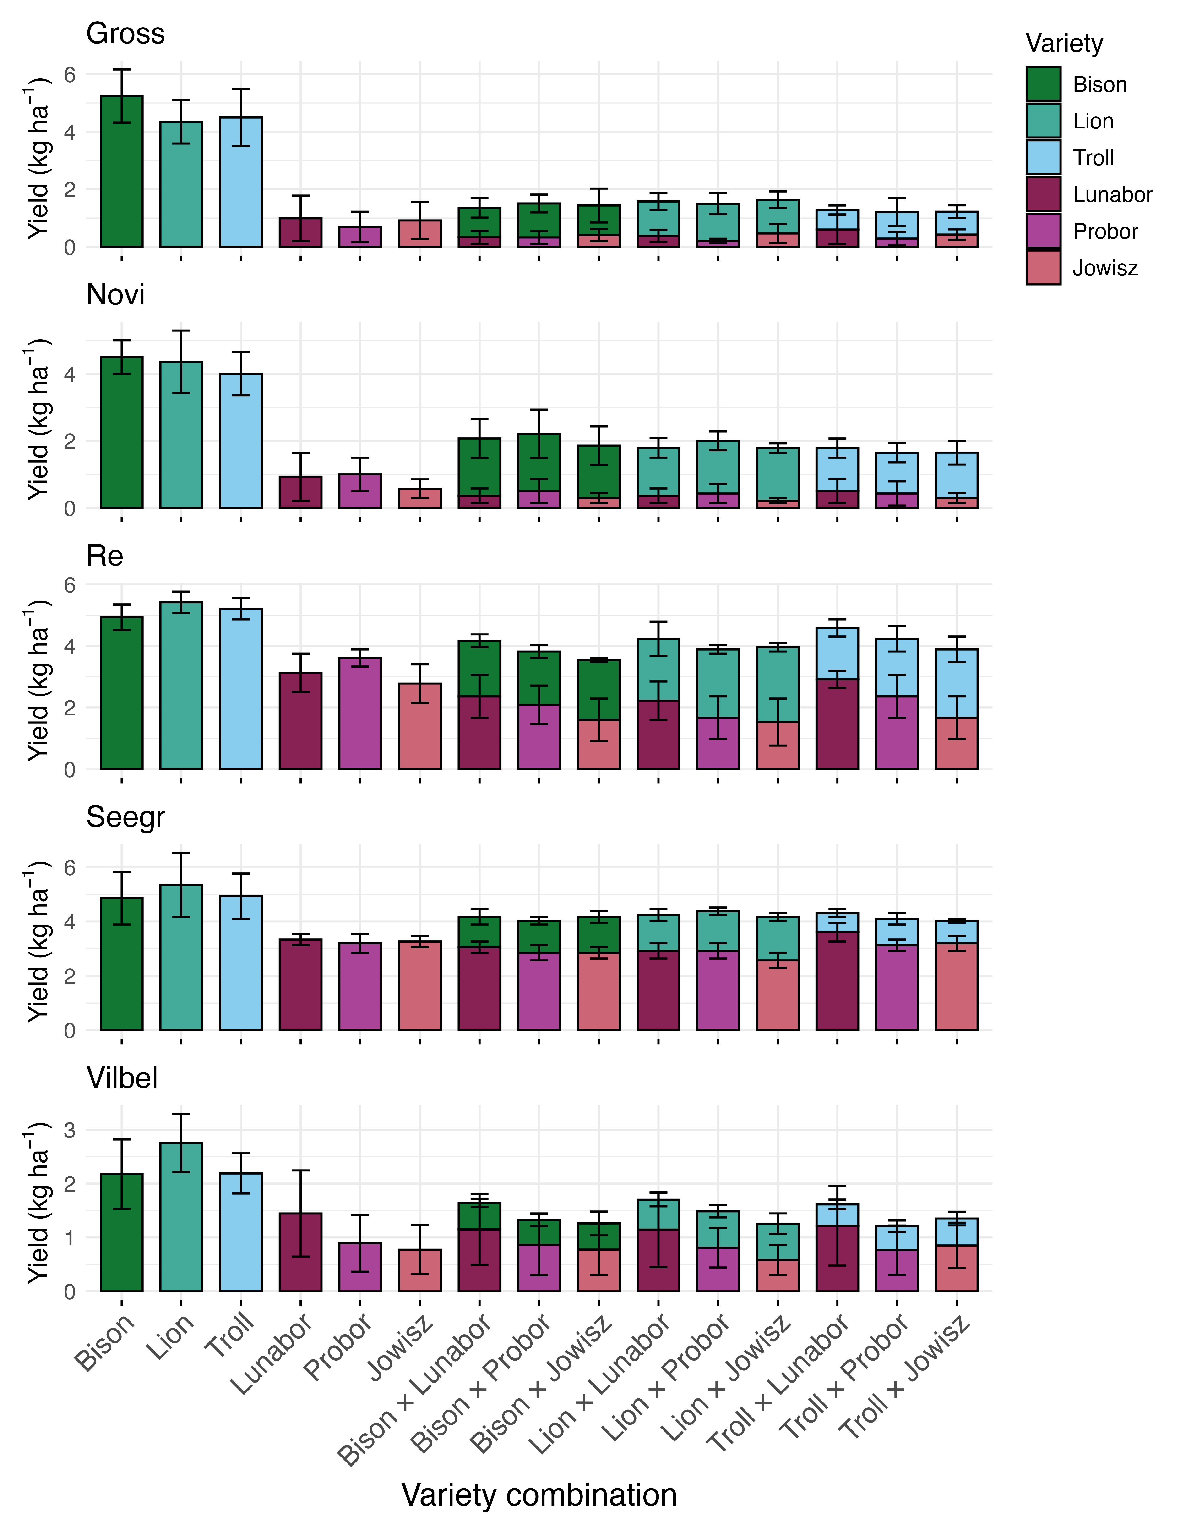
Figure 2: Yield overview of pure and mixed oat and narrow-leaved lupin stands by location, Gross (Gross Lüsewitz) and Vilbel (Bad Vilbel) are located in Germany, Novi (Novi Sad) in Serbia and Re (Reckenholz) and Seegr (Seegräben) in Switzerland. For all graphs, the median value is represented by the bar height, and the variability (median absolute deviation) by the whiskers. In mixed stands, the lower bar represents the partial lupin values, the upper bar the partial oat values and the whiskers refer to the variance of the individual components of the partial yields of narrow-leaved lupins or oats.

Yield performance assessment
The land equivalent ratio (LER) assessed across all locations, years and treatments did not differ from the expected value of 1 on a treatment, nor location level. Additionally, no significant difference could be detected between any pairs of mixed stand treatments or pairs of environments. The two treatments Lunabor x Troll and Probor Bison did not exhibit a partial NLL LER below the expected value of 0.9 (corresponding to their sowing proportion of the optimal density in pure stands), whereas the partial NLL LER of all other mixed stands was below the expected value. Additionally, the locations Novi Sad and Reckenholz exhibited significantly lower partial NLL LERs across all treatments and years amounting to a reduction of 0.11 and 0.2 compared with the other locations, respectively (p < 0.01). Conversely, all partial LERs of the oats in mixed stands were elevated above the expected value of 0.1 (again corresponding to their sowing proportion of the optimal density in pure stands) (p < 0.001) and Reckenholz exhibited a significantly elevated partial oat LER across all treatments and years of +0.13 (p < 0.001).
Similarly to the partial LER of NLL and oat, the crop performance ratio (CPR) of NLLs did not differ significantly from the expected value (E = 1) across treatments, locations or years. Conversely, the CPR of oats was significantly elevated across all mixed treatments (p < 0.001), ranging from 3.4 in case of Troll mixed with Lunabor and 4.2 in case of Lion mixed with Jowisz. The CPR of Lion was higher than the CPR of Troll in all treatments but in case of the family comparison of Troll x Jowisz and Lion x Lunabor (p < 0.05). Further, the CPR of oats were significantly lower in the years 2022 and 2023 compared with 2024 (-1 and -0.6, respectively, p < 0.001) and significantly higher at the location Reckenholz compared with all other locations (+1.3, p < 0.001). In absence of any treatment effects, the total CPR was elevated above the expected value (E = 2) for all mixed stands, amounting to 4.6 on average (p < 0.001), driven by the high oat CPR. The year and location effects of the oat CPR also translated into the total CPR of the mixture, being significantly lower in the years 2022 and 2023 (-1 and -0.5, respectively, p < 0.01) and significantly higher at the location Reckenholz (+1, p < 0.01). In contrast to the CPR of oat, the total CPR showed no significant differences among oat varieties.

Plant height
Height regressions on both crops did not reveal any NLL or oat height difference between pure and mixed stands. The NLLs Lunabor and Jowisz both grew 58 cm tall, compared with Probor reaching 53 cm in final height (p < 0.001). Whereas the heights of the oat varieties were signficantly different, with Bison, Lion and Troll averaging at 105, 100 and 80 cm in height, respectively (p < 0.01). This resulted in a overall canopy height difference from the oat height to the NLL height of 49 cm for Bison, 45 cm for Lion and 24 cm for Troll, locations and treatments (p < 0.001), respectively. The canopy height difference between the oat and NLL crop in mixed stands did not explain any yield variation between the NLL yield, the oat yield or the compound yield. Nonetheless, the canopy height difference accounted for a decrease in the NLL proportion of 0.2% per every cm of final height difference of the oat and NLL canopy (p < 0.005).

Yield stability

Static yield stability
The static yield stability, expressed as the coefficient of variation (CV) calcualted on a treatment basis across all locations and years unveiled the partial NLL yield of the treatment Troll x Probor to be less stable than the other NLL yields, i.e. the CV of the partial NLL yield in the Troll x Probor treatment was significantly higher than all other CVs recorded (p < 0.05) (Table 1). Instead, the CV of the oat yields did not differ between any of the pure and mixed stands. And in contrast to the comparably identical CVs of pure and mixed stands of the NLL and oat yields, the CV of the total yield allowed grouping of the treatments into two groups: The total yields of all pure oat stands (Bison, Lion, Troll), and the mixed stands of Bison x Probor, Lion x Lunabor, Lion x Probor, and Lion x Jowisz exhibited higher yield stability than the pure stands of NLLs and the other mixed stands with Troll and Bison (p < 0.05).
Table 5
Coefficient of variation (CV) of the pure and mixed stands summarised across the locations and years. In pure stands, one coefficient of variation is provided for the respective crop, which also corresponds to the CV of the respective total yield. In mixed stands, the coefficient of variation is depicted for the yield components (partial yield) of NLL and oat plus the CV of the total yield. Letters correspond to the significance grouping of the pair-wise post-hoc tests (p < 0.05).

Treatment | CV lupin yield | CV oat yield | CV total yield
Bison | NA | 15.6a | 15.6a
Lion | NA | 14.4a | 14.4a
Troll | NA | 15.8a | 15.8a
Lunabor | 33.5a | NA | 33.5b
Probor | 33.3a | NA | 33.3b
Jowisz | 31a | NA | 32.0b
Bison x Lunabor | 32.5a | 21.4a | 21.8b
Bison x Probor | 30.7a | 14.5a | 14.1a
Bison x Jowisz | 36.6a | 22.9a | 19.3b
Lion x Lunabor | 30.7a | 18.1a | 13.9a
Lion x Probor | 26.1a | 16.5a | 15.1a
Lion x Jowisz | 35a | 15.2a | 10.8a
Troll x Lunabor | 29a | 23.6a | 16.9b
Troll x Probor | 43b | 21.6a | 18.8b
Troll x Jowisz | 28.2a | 21.3a | 17.2b

Dynamic yield stability
The Finlay–Wilkinson regression coefficients (b1) for the total yield significantly differed from the expected value of one for all mixed stands of Lion: Lion x Lunabor and Lion x Jowisz exhibiting b1 values of 0.97 and 0.98 (p < 0.001), indicating a slight buffering capacity to the environmental influence, whereas Lion x Probor’s b1 value was slightly elevated to 1.03 (p < 0.001), which indicates higher responitivity to environmental changes. All other treatments exhibited average responsiveness, i.e. b1 was not different from one. The b1 values for the (partial) NLL yields again revealed mostly average responsiveness, but Bison x Lunabor, Bison x Probor and Lion x Lunabor that exhibited a slight buffering capacity to the environmental influence with b1 values ranging from 0.9 - 0.95 (p < 0.001). Conversely, the partial NLL yield in the mixed treatment of Troll x Lunabor has shown a slightly elevated responsiveness at 1.1 (p < 0.005). Similarly, the b1 values for the (partial) oat yields did only differ from the expected value of one for the treatment Lion x Lunabor, amounting to 0.78 indicating below-average responsiveness to the environment. Further, the Finlay–Wilkinson regression indicated a significant general variety effect (p < 0.001) and an absence of a general variety‑by‑environment interaction for the total and NLL yields. By contrast, the oat yield did not differ significantly by variety or by the variety‑by‑environment interaction.
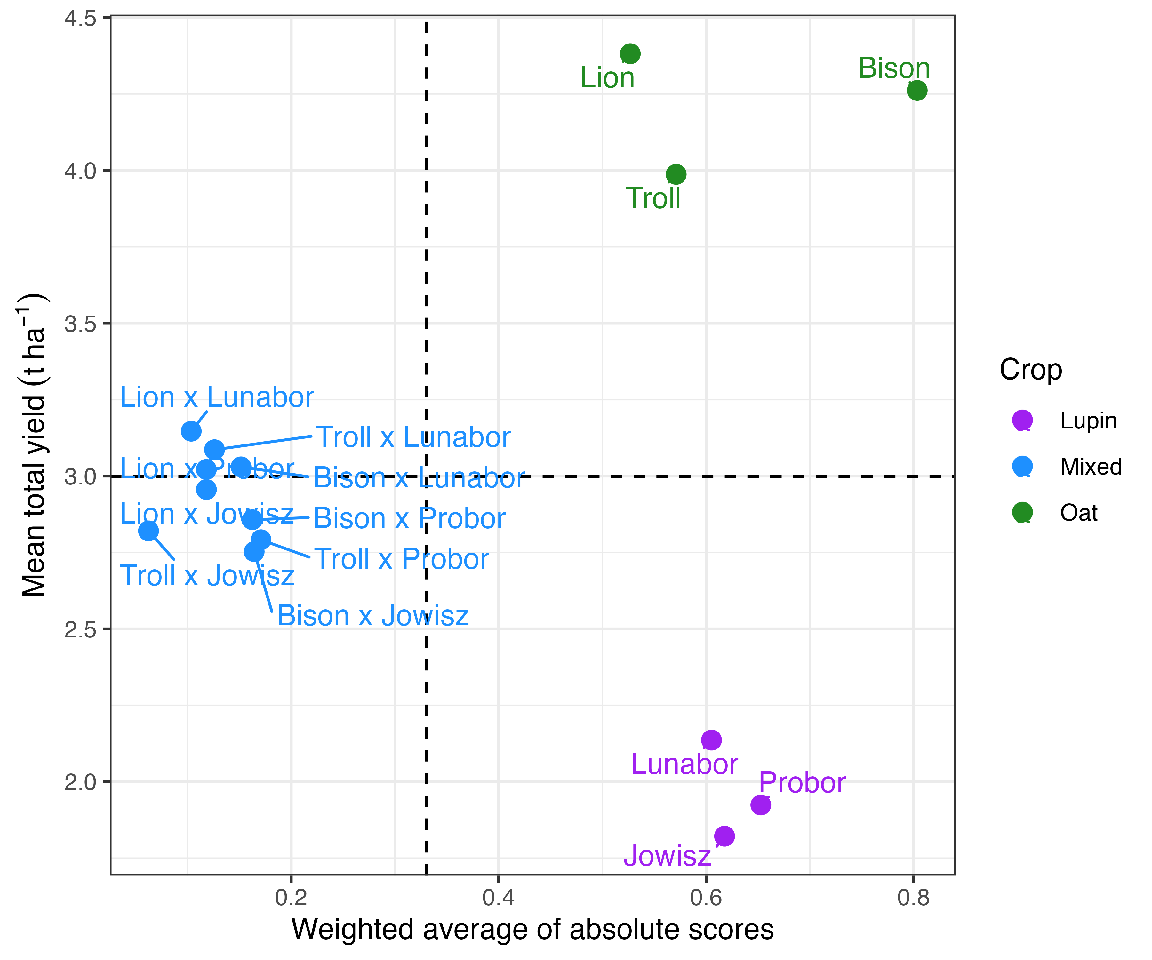
Figure 3: Recorded mean total yields (tha⁻¹) plotted against their weighted average of absolute scores (waas). The yield x waas plot shows the results of the pure and mixed stands across the years 2022 - 2024 in the pure stands of the three oat varieties (Bison, Lion, Troll) and narrow-leaved lupin varieties (Lunabor, Probor, Jowisz) and their mixed stands. Each point represents one measurement. Higher weighted average of absolute scores mean the treatment responded more strongly to the environment.
The additive main effects and multiplicative interaction (ammi) model unveiled two groups according to the weighted average of absolute scores (waas): The waas of all pure stands of NLLs and oats, ranged between 0.49 and 0.76, whereas the waas of all mixed stands was one magnitude lower, ranging from 0.032 to 0.084, indicating the mixture’s higher stabilities across locations and years, due to their weaker interaction with the environment (Figure 3). Across the assessed interaction principal components (IPCs), IPC1 distinguishes between the two groups of locations Novi Sad and Gross Lüsewitz (negative loadings) versus Bad Vilbel and Seegräben (positive loadings) (Figure 4). Additionally, IPC1 clearly distinguished the NLLs (positive loadings) from the oats (negative loadings). By contrast, IPC2 distinguished the location Reckenholz from the others, and showed slight variation across the mixed treatments in terms of their loadings. With regards to the factor loading of IPC1 and IPC2, the two mixtures Lion x Lunabor and Troll Jowisz plotted closest to the origin (0,0). These two treatments interacted less with the locations and years and were thus exhibiting a more stable performance across all five locations.
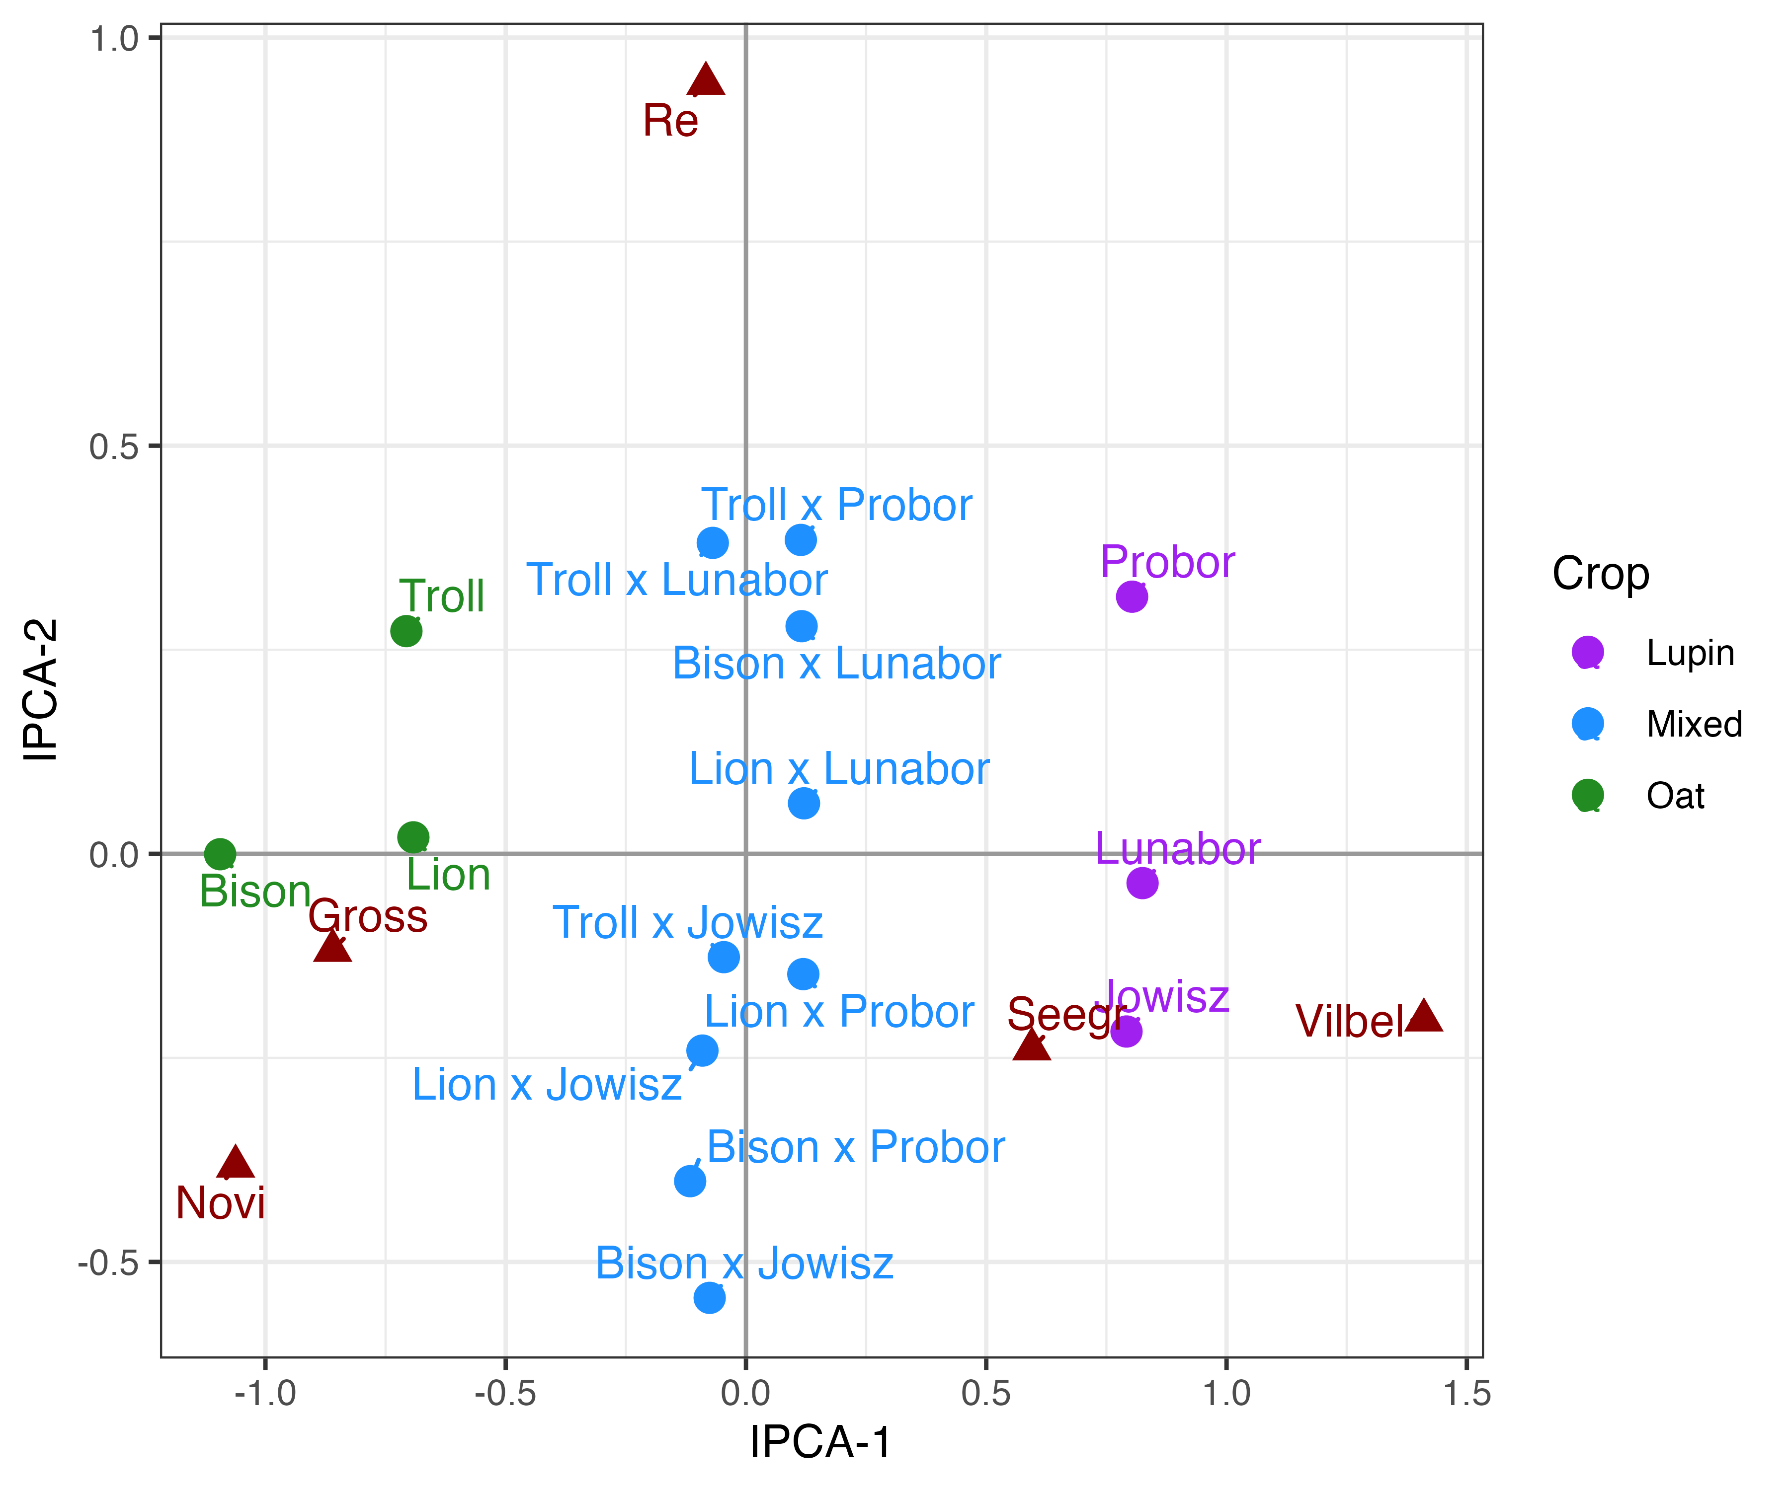
Figure 4: The additive main effects and multiplicative interaction (AMMI) biplot of the treatment (circles) and location (triangles) scores on the first two interaction principal components for total yield in pure and mixed stands, illustrates the relative performance and stability of all treatments across five locations. The following location acronyms were used: Gross (Gross Lüsewitz), Novi (Novi Sad), Vilbel (Bad Vilbel), Re (Reckenholz) and Seegr (Seegräben).

References
Andow, D.A., 1991. Vegetational diversity and arthropod population. Annu. rev. entomol 36, 561–566.
Arbizu, M.P., 2020. pairwiseAdonis: Pairwise multilevel comparison using adonis. R package version 0.4.
Aschemann-Witzel, J., Gantriis, R.F., Fraga, P., Perez-Cueto, F.J.A., 2021. Plant-based food and protein trend from a business perspective: Markets, consumers, and the challenges and opportunities in the future. Critical Reviews in Food Science and Nutrition 61, 3119–3128. https://doi.org/10.1080/10408398.2020.1793730
Baghestani, A., Lemieux, C., Leroux, G.D., Baziramakenga, R., Simard, R.R., 1999. Determination of allelochemicals in spring cereal cultivars of different competitiveness. Weed Science 47, 498–504. https://doi.org/10.1017/S0043174500092171
Bates, D., Mächler, M., Bolker, B., Walker, S., 2015. Fitting Linear Mixed-Effects Models Using Lme4. Journal of Statistical Software 67. https://doi.org/10.18637/jss.v067.i01
Bedoussac, L., Justes, E., 2010. The efficiency of a durum wheat-winter pea intercrop to improve yield and wheat grain protein concentration depends on N availability during early growth. Plant and Soil 330, 19–35. https://doi.org/10.1007/s11104-009-0082-2
Begna, S., Angadi, S., Mesbah, A., Umesh, R.M., Stamm, M., 2021. Forage Yield and Quality of Winter Canola–Pea Mixed Cropping System. Sustainability 13, 2122. https://doi.org/10.3390/su13042122
Böhm, H., Bramm, A., Aulrich, K., Rühl, G., 2008. Effect of different sowing densities in mixed cultivation of blue lupin (Lupinus Angustifolius) with spring crops on yield and quality, in: Lupins for Health and Wealth-Proceedings of the 12th International Lupin Conference. International Lupin Association, Fremantle, Western Australia.
Civitello, D.J., Cohen, J., Fatima, H., Halstead, N.T., Liriano, J., McMahon, T.A., Ortega, C.N., Sauer, E.L., Sehgal, T., Young, S., Rohr, J.R., 2015. Biodiversity inhibits parasites: Broad evidence for the dilution effect. Proceedings of the National Academy of Sciences 112, 8667–8671. https://doi.org/10.1073/pnas.1506279112
Demie, D.T., Döring, T.F., Finckh, M.R., Van Der Werf, W., Enjalbert, J., Seidel, S.J., 2022. Mixture Genotype Effects in Cereal/Legume Intercropping. Frontiers in Plant Science 13, 846720. https://doi.org/10.3389/fpls.2022.846720
Ding, W., Clode, P.L., Lambers, H., 2019. Is pH the key reason why some Lupinus species are sensitive to calcareous soil? Plant and Soil 434, 185–201. https://doi.org/10.1007/s11104-018-3763-x
Dourmap, C., Fustec, J., Naudin, C., Carton, N., Tcherkez, G., 2025. White lupin: Improving legume-based protein production via intercropping. https://doi.org/10.22541/au.173679744.40722459/v1
Eberhart, S.A., Russell, W.A., 1966. Stability Parameters for Comparing Varieties¹. Crop Science 6, 36–40. https://doi.org/10.2135/cropsci1966.0011183X000600010011x
Erisman, J.W., Sutton, M.A., Galloway, J., Klimont, Z., Winiwarter, W., 2008. How a century of ammonia synthesis changed the world. Nature Geoscience 1, 636–639. https://doi.org/10.1038/ngeo325
Evans, J., O’Connor, G.E., Turner, G.L., Bergersen, F.J., 1987. Influence of mineral nitrogen on nitrogen fixation by lupin (Lupinus Angustifolius) as assessed by 15N isotope dilution methods. Field Crops Research 17, 109–120. https://doi.org/10.1016/0378-4290(87)90086-4
Finch, S., Collier, R.H., 2000. Integrated pest management in field vegetable crops in northern Europe — with focus on two key pests. Crop Protection 19, 817–824. https://doi.org/10.1016/S0261-2194(00)00109-5
Finlay, K., Wilkinson, G., 1963. The analysis of adaptation in a plant-breeding programme. Australian Journal of Agricultural Research 14, 742. https://doi.org/10.1071/AR9630742
Gauch, H.G., 1992. Statistical Analysis of Regional Yield Trials: AMMI Analysis of Factorial Designs. Elsevier.
Gaudin, A.C.M., Tolhurst, T.N., Ker, A.P., Janovicek, K., Tortora, C., Martin, R.C., Deen, W., 2015. Increasing Crop Diversity Mitigates Weather Variations and Improves Yield Stability. PLOS ONE 10, e0113261. https://doi.org/10.1371/journal.pone.0113261
Gronle, A., Lux, G., Böhm, H., Schmidtke, K., Wild, M., Demmel, M., Brandhuber, R., Wilbois, K.-P., Heß, J., 2015. Effect of ploughing depth and mechanical soil loading on soil physical properties, weed infestation, yield performance and grain quality in sole and intercrops of pea and oat in organic farming. Soil and Tillage Research 148, 59–73. https://doi.org/10.1016/j.still.2014.12.004
Hauggaard-Nielsen, H., Jensen, E.S., 2005. Facilitative Root Interactions in Intercrops. Plant and Soil 274, 237–250. https://doi.org/10.1007/s11104-004-1305-1
Hauggaard-Nielsen, H., Jørnsgaard, B., Kinane, J., Jensen, E.S., 2008. Grain legume–cereal intercropping: The practical application of diversity, competition and facilitation in arable and organic cropping systems. Renewable Agriculture and Food Systems 23, 3–12. https://doi.org/10.1017/S1742170507002025
Hildebrandt, T.M., Nunes Nesi, A., Araújo, W.L., Braun, H.-P., 2015. Amino Acid Catabolism in Plants. Molecular Plant 8, 1563–1579. https://doi.org/10.1016/j.molp.2015.09.005
Huang, T., Döring, T.F., Zhao, X., Weiner, J., Dang, P., Zhang, M., Zhang, M., Siddique, K.H.M., Schmid, B., Qin, X., 2024. Cultivar mixtures increase crop yields and temporal yield stability globally. A meta-analysis. Agronomy for Sustainable Development 44, 28. https://doi.org/10.1007/s13593-024-00964-6
Jensen, E.S., Carlsson, G., Hauggaard-Nielsen, H., 2020. Intercropping of grain legumes and cereals improves the use of soil N resources and reduces the requirement for synthetic fertilizer N: A global-scale analysis. Agronomy for Sustainable Development 40, 5. https://doi.org/10.1007/s13593-020-0607-x
Kato-Noguchi, H., Kosemura, S., Yamamura, S., Mizutani, J., Hasegawa, K., 1994. Allelopathy of oats. I. Assessment of allelopathic potential of extract of oat shoots and identification of an allelochemical. Journal of Chemical Ecology 20, 309–314. https://doi.org/10.1007/BF02064439
Kim, S.W., Less, J.F., Wang, L., Yan, T., Kiron, V., Kaushik, S.J., Lei, X.G., 2019. Meeting Global Feed Protein Demand: Challenge, Opportunity, and Strategy. Annual Review of Animal Biosciences 7, 221–243. https://doi.org/10.1146/annurev-animal-030117-014838
Koller, M., 2016. Robustlmm : An R Package for Robust Estimation of Linear Mixed-Effects Models. Journal of Statistical Software 75. https://doi.org/10.18637/jss.v075.i06
Kumawat, A., Bamboriya, S.D., Meena, R.S., Yadav, D., Kumar, A., Kumar, S., Raj, A., Pradhan, G., 2022. Legume-based inter-cropping to achieve the crop, soil, and environmental health security, in: Advances in Legumes for Sustainable Intensification. Elsevier, pp. 307–328. https://doi.org/10.1016/B978-0-323-85797-0.00005-7
Kuznetsova, A., Brockhoff, P.B., Christensen, R.H.B., 2017. lmerTest Package: Tests in Linear Mixed Effects Models. Journal of Statistical Software 82. https://doi.org/10.18637/jss.v082.i13
Landschoot, S., Zustovi, R., Dewitte, K., Randall, N.P., Maenhout, S., Haesaert, G., 2024. Cereal-legume intercropping: A smart review using topic modelling. Frontiers in Plant Science 14, 1228850. https://doi.org/10.3389/fpls.2023.1228850
Lauk, R., Lauk, E., 2006. Yields in vetch-wheat mixed crops and sole crops of wheat. Agronomy Research 4, 37–44.
Li, C., Hoffland, E., Kuyper, T.W., Yu, Y., Li, H., Zhang, C., Zhang, F., Van Der Werf, W., 2020. Yield gain, complementarity and competitive dominance in intercropping in China: A meta-analysis of drivers of yield gain using additive partitioning. European Journal of Agronomy 113, 125987. https://doi.org/10.1016/j.eja.2019.125987
Li, C., Stomph, T.-J., Makowski, D., Li, H., Zhang, C., Zhang, F., Van Der Werf, W., 2023. The productive performance of intercropping. Proceedings of the National Academy of Sciences 120, e2201886120. https://doi.org/10.1073/pnas.2201886120
Lin, B.B., 2011. Resilience in Agriculture through Crop Diversification: Adaptive Management for Environmental Change. BioScience 61, 183–193. https://doi.org/10.1525/bio.2011.61.3.4
Lithourgidis, A.S., Dordas, C.A., Damalas, C.A., Vlachostergios, D.N., 2011. Annual intercrops: An alternative pathway for sustainable agriculture. Australian journal of crop science 5, 396–410.
Liu, H., Struik, P.C., Zhang, Y., Jing, J., Stomph, T.-J., 2023. Forage quality in cereal/legume intercropping: A meta-analysis. Field Crops Research 304, 109174. https://doi.org/10.1016/j.fcr.2023.109174
Loreau, M., Hector, A., 2001. Partitioning selection and complementarity in biodiversity experiments. Nature 412, 72–76. https://doi.org/10.1038/35083573
Lucas, M.M., Stoddard, F.L., Annicchiarico, P., Frías, J., Martínez-Villaluenga, C., Sussmann, D., Duranti, M., Seger, A., Zander, P.M., Pueyo, J.J., 2015. The future of lupin as a protein crop in Europe. Frontiers in Plant Science 6, 1–6. https://doi.org/10.3389/fpls.2015.00705
Malézieux, E., Crozat, Y., Dupraz, C., Laurans, M., Makowski, D., Ozier-Lafontaine, H., Rapidel, B., Tourdonnet, S., Valantin-Morison, M., 2009. Mixing plant species in cropping systems: Concepts, tools and models. A review. Agronomy for Sustainable Development 29, 43–62. https://doi.org/10.1051/agro:2007057
Mousavi, S.R., Eskandari, H., 2011. A General Overview on Intercropping and Its Advantages in Sustainable Agriculture.
Muranyi, I.S., Volke, D., Hoffmann, R., Eisner, P., Herfellner, T., Brunnbauer, M., Koehler, P., Schweiggert-Weisz, U., 2016. Protein distribution in lupin protein isolates from Lupinus angustifolius L. Prepared by various isolation techniques. Food Chemistry 207, 6–15. https://doi.org/10.1016/j.foodchem.2016.03.073
Oelbermann, M., Regehr, A., Echarte, L., 2015. Changes in soil characteristics after six seasons of cereal–legume intercropping in the Southern Pampa. Geoderma Regional 4, 100–107. https://doi.org/10.1016/j.geodrs.2015.01.002
Oksanen, J., Simpson, G.L., Blanchet, F.G., Kindt, R., Legendre, P., Minchin, P.R., O’Hara, R.B., Solymos, P., Stevens, M.H.H., Szoecs, E., Wagner, H., Barbour, M., Bedward, M., Bolker, B., Borcard, D., Borman, T., Carvalho, G., Chirico, M., De Caceres, M., Durand, S., Evangelista, H.B.A., FitzJohn, R., Friendly, M., Furneaux, B., Hannigan, G., Hill, M.O., Lahti, L., Martino, C., McGlinn, D., Ouellette, M.-H., Ribeiro Cunha, E., Smith, T., Stier, A., Ter Braak, C.J.F., Weedon, J., 2001. Vegan: Community Ecology Package. https://doi.org/10.32614/CRAN.package.vegan
Olivoto, T., 2020. Metan: Multi Environment Trials Analysis. https://doi.org/10.32614/CRAN.package.metan
Olivoto, T., Lúcio, A.D.C., Da Silva, J.A.G., Sari, B.G., Diel, M.I., 2019. Mean Performance and Stability in Multi-Environment Trials II: Selection Based on Multiple Traits. Agronomy Journal 111, 2961–2969. https://doi.org/10.2134/agronj2019.03.0221
Pálmason, F., Danso, S.K.A., Hardarson, G., 1992. Nitrogen accumulation in sole and mixed stands of sweet-blue lupin (Lupinus Angustifolius L.), ryegrass and oats. Plant and Soil 142, 135–142. https://doi.org/10.1007/BF00010183
Pelzer, E., Hombert, N., Jeuffroy, M.-H., Makowski, D., 2014. Meta-Analysis of the Effect of Nitrogen Fertilization on Annual Cereal–Legume Intercrop Production. Agronomy Journal 106, 1775–1786. https://doi.org/10.2134/agronj13.0590
Pradhan, G., Meena, R.S., Kumar, S., Jhariya, M.K., Khan, N., Shukla, U.N., Singh, A.K., Sheoran, S., Kumar, S., 2022. Legumes for eco-friendly weed management in agroecosystem, in: Advances in Legumes for Sustainable Intensification. Elsevier, pp. 133–154. https://doi.org/10.1016/B978-0-323-85797-0.00033-1
Rao, M.R., Rego, T.J., Willey, R.W., 1987. Response of cereals to nitrogen in sole cropping and intercropping with different legumes. Plant and Soil 101, 167–177. https://doi.org/10.1007/BF02370641
Raseduzzaman, Md., Jensen, E.S., 2017. Does intercropping enhance yield stability in arable crop production? A meta-analysis. European Journal of Agronomy 91, 25–33. https://doi.org/10.1016/j.eja.2017.09.009
Renard, D., Tilman, D., 2019. National food production stabilized by crop diversity. Nature 571, 257–260. https://doi.org/10.1038/s41586-019-1316-y
Roman, L., Tsochatzis, E., Tarin, K., Röndahl, E.M., Ottosen, C.-O., Corredig, M., 2023. Compositional Attributes of Blue Lupin (Lupinus Angustifolius) Seeds for Selection of High-Protein Cultivars. Journal of Agricultural and Food Chemistry 71, 17308–17320. https://doi.org/10.1021/acs.jafc.3c04804
Sedláková, K., Straková, E., Suchý, P., Krejcarová, J., Herzig, I., 2016. Lupin as a perspective protein plant for animal and human nutrition – a review. Acta Veterinaria Brno 85, 165–175. https://doi.org/10.2754/avb201685020165
Staniak, M., Bjarszczuk, Ksiezak, J., 2014. The assessment of weed infestation of oats–pea mixtures grown in organic farm. Journal of Research and Application in Agricultural Engineering 59.
Team, R.C., 2025. A Language and Environment for Statistical Computing.
Tegeder, M., Masclaux-Daubresse, C., 2018. Source and sink mechanisms of nitrogen transport and use. New Phytologist 217, 35–53. https://doi.org/10.1111/nph.14876
Tooker, J.F., Frank, S.D., 2012. Genotypically diverse cultivar mixtures for insect pest management and increased crop yields. Journal of Applied Ecology 49, 974–985. https://doi.org/10.1111/j.1365-2664.2012.02173.x
Trenbath, B.R., 1993. Intercropping for the management of pests and diseases. Field Crops Research 34, 381–405. https://doi.org/10.1016/0378-4290(93)90123-5
Verret, V., Gardarin, A., Pelzer, E., Médiène, S., Makowski, D., Valantin-Morison, M., 2017. Can legume companion plants control weeds without decreasing crop yield? A meta-analysis. Field Crops Research 204, 158–168. https://doi.org/10.1016/j.fcr.2017.01.010
Vitousek, P.M., Menge, D.N.L., Reed, S.C., Cleveland, C.C., 2013. Biological nitrogen fixation: Rates, patterns and ecological controls in terrestrial ecosystems. Philosophical Transactions of the Royal Society B: Biological Sciences 368, 20130119. https://doi.org/10.1098/rstb.2013.0119
Wang, L., Gruber, S., Claupein, W., 2012. Optimizing lentil-based mixed cropping with different companion crops and plant densities in terms of crop yield and weed control. Organic Agriculture 2, 79–87. https://doi.org/10.1007/s13165-012-0028-5
Yamanoshita, M., 2025. IPCC Special Report on Climate Change and Land.
Yu, Q., Shah, K., Wang, D., Ma, Y., Wang, Z., 2019. Model Based Study of Crop Evapotranspiration under Canopy Shading. Agronomy 9, 334. https://doi.org/10.3390/agronomy9060334
Yu, Y., Stomph, T.-J., Makowski, D., Van Der Werf, W., 2015. Temporal niche differentiation increases the land equivalent ratio of annual intercrops: A meta-analysis. Field Crops Research 184, 133–144. https://doi.org/10.1016/j.fcr.2015.09.010
Zobel, R.W., Wright, M.J., Gauch, H.G., 1988. Statistical Analysis of a Yield Trial. Agronomy Journal 80, 388–393. https://doi.org/10.2134/agronj1988.00021962008000030002x
Zustovi, R., Landschoot, S., Dewitte, K., Verlinden, G., Dubey, R., Maenhout, S., Haesaert, G., 2024. Intercropping indices evaluation on grain legume-small grain cereals mixture: A critical meta-analysis review. Agronomy for Sustainable Development 44, 5. https://doi.org/10.1007/s13593-023-00934-4

Supplements
The modelling output containing all hypothesis and modelling specifications is available under: … … > provide a html?

