Output WAAS Model:
# A tibble: 20 × 17
type Code Y PC1 PC2 PC3 PC4 WAAS PctResp PctWAAS wRes wWAAS OrResp
<chr> <chr> <dbl> <dbl> <dbl> <dbl> <dbl> <dbl> <dbl> <dbl> <dbl> <dbl> <dbl>
1 GEN 10 3.0 0.081 0.27 -0.25 0.069 0.081 47. 93. 50 50 6
2 GEN 11 2.9 -0.081 -0.39 0.014 0.030 0.081 40. 93. 50 50 9
3 GEN 12 2.8 -0.053 -0.53 0.066 0.041 0.053 36. 97. 50 50 12
4 GEN 13 3.1 0.084 0.060 -0.055 0.17 0.084 52. 93. 50 50 4
5 GEN 14 3.0 0.083 -0.14 0.0059 -0.29 0.083 47. 93. 50 50 7
6 GEN 15 3.0 -0.063 -0.23 -0.11 -0.059 0.063 44. 96. 50 50 8
7 GEN 16 3.1 -0.048 0.37 0.014 -0.12 0.048 49. 98. 50 50 5
8 GEN 17 2.8 0.080 0.37 -0.23 -0.15 0.080 38. 94. 50 50 11
9 GEN 18 2.8 -0.032 -0.12 -0.075 0.061 0.032 39. 100 50 50 10
10 GEN 4 4.3 -0.76 -0.00051 -0.32 0.20 0.76 95. 0 50 50 2
11 GEN 5 4.4 -0.48 0.019 0.51 -0.0085 0.48 100 38. 50 50 1
12 GEN 6 4.0 -0.49 0.26 0.19 -0.12 0.49 85. 37. 50 50 3
13 GEN 7 2.1 0.58 -0.035 0.072 0.25 0.58 12. 26. 50 50 13
14 GEN 8 1.9 0.56 0.30 0.26 0.15 0.56 4.0 28. 50 50 14
15 GEN 9 1.8 0.55 -0.21 -0.097 -0.24 0.55 0 29. 50 50 15
16 ENV Gross 2.7 -0.60 -0.11 -0.60 0.12 0.60 43. 41. 50 50 3
17 ENV Novi 2.5 -0.74 -0.37 0.50 0.058 0.74 33. 26. 50 50 4
18 ENV Re 3.9 -0.058 0.91 0.12 -0.015 0.058 88. 100 50 50 2
19 ENV Seegr 4.2 0.42 -0.23 -0.065 -0.49 0.42 100 61. 50 50 1
20 ENV Vilbel 1.7 0.98 -0.20 0.045 0.32 0.98 0 0 50 50 5
# ℹ 4 more variables: OrWAAS <dbl>, OrPC1 <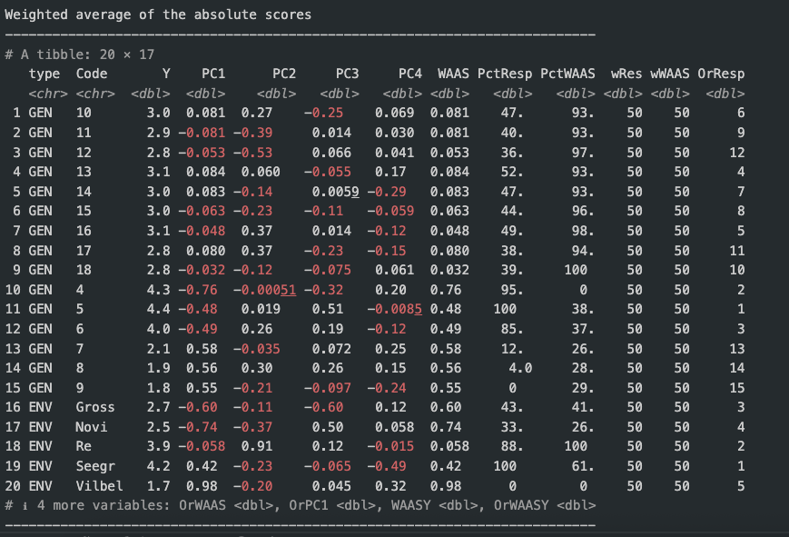dbl>, WAASY <dbl>, OrWAASY <dbl>
Interpretation of my AMMII biplot:
Element on the plot | What it means | How to read it
Axes (IPCA-1, IPCA-2) | The first two Interaction Principal Components extracted from the GE interaction matrix. Together they explain ≈ 91 % of the genotype × environment (GE) sum of squares (71 % + 20 % in your table). | The closer a point is to the origin (0, 0) the smaller its GE interaction; large absolute scores indicate a strong, environment-specific response.
Blue circles = treatments (GEN) | Each treatment’s coordinates are its IPCA scores (columns PC1, PC2 in the WAAS table). | • Treatments close to the origin (e.g. 18, 16) are broadly adapted and interact weakly.• Treatments far from the origin (e.g. 4, 8) exploit certain environments but may perform unpredictably elsewhere.
Red triangles = environments (ENV) | Environment scores (columns PC1, PC2 for ENV rows). They mark directions of maximum interaction. | • If a treatment and an environment fall in the same quadrant and near the same ray, that treatment tends to perform better than expected in that environment.• Opposite quadrants imply poorer-than-expected performance.
Quadrants / rays | Partition the biplot into sectors of similar interaction pattern. | • Example: Vilbel (PC1 ≈ +1.4) lies far right; treatments with large positive PC1 (e.g. 8, 7) are specifically adapted to Vilbel, whereas negative-PC1 genotypes (4, 5, 6) will be penalised there.• Gross and Novi (negative PC1) favour negative-PC1 treatments such as 4 and 6.
Step-by-step interpretation of your plot
- Stability vs. specificity
GEN 16 and GEN 18 cluster near (0, 0) → small GE interaction → stable across all sites.
GEN 4 (far left, −PC1) and GEN 8 (far right, +PC1) interact strongly → high environment-specific response.
- Environment association
Gross and Novi share negative PC1; varieties on the same side (e.g. 4, 6) tend to give higher-than-expected yields there.
Re has large positive PC2 but near-zero PC1 → genotypes with high PC2 (e.g. 17) capitalise on Re.
- Which treatment for which site?
Vilbel (+PC1) → choose treatments 7–9 or 8.
Seegr (moderate +PC1, −PC2) → favours 9 and 14.
Stable choice everywhere → 16 or 18 (low interaction, respectable mean yield).
- Cross-validation with WAAS × Y scatter
Treatments in the upper-left quadrant of the Yield × WAAS graph (high mean yield, low WAAS) and close to (0, 0) in the biplot are the most desirable (e.g. GEN 16 if its yield is competitive).
Citations for your Methods section
- Gauch HG (1992) Statistical Analysis of Regional Yield Trials. Cambridge U Press.
- Zobel RW, Wright MJ, Gauch HG (1988) Crop Sci 28: 1–6 – original AMMI filter.
- Olivoto T et al. (2019) Agron J 111: 2961–2970 – WAAS and WAASY metrics.

# A tibble: 36 × 5
l trt n median_diff mad_diff
<fct> <fct> <int> <dbl> <dbl>
1 Gross 10 12 30 7.5
2 Gross 11 12 32.5 7.5
3 Gross 12 12 25 7.5
4 Gross 13 12 30 7.5
5 Gross 14 12 30 5
6 Gross 15 12 30 5
7 Gross 16 12 22.5 10
8 Gross 17 11 15 10
9 Gross 18 12 15 12.5
10 Re 10 8 56 1.5
11 Re 11 8 58 4
12 Re 12 8 53 5.5
13 Re 13 8 44.5 4
14 Re 14 8 52.5 5
15 Re 15 8 44.5 5
16 Re 16 8 21.5 4.5
17 Re 17 8 24.5 6
18 Re 18 8 19.5 8.5
19 Seegr 10 4 51 4
20 Seegr 11 4 51 8
21 Seegr 12 4 53 1.5
22 Seegr 13 4 49.5 3.5
23 Seegr 14 4 52.5 5.5
24 Seegr 15 4 43.5 3
25 Seegr 16 4 18.5 6.5
26 Seegr 17 4 24 1.5
27 Seegr 18 4 21.5 3.5
28 Vilbel 10 12 35 8
29 Vilbel 11 12 33 7.5
30 Vilbel 12 12 30 5
31 Vilbel 13 12 24.2 4.25
32 Vilbel 14 12 35 9
33 Vilbel 15 12 27 7
34 Vilbel 16 12 5 3
35 Vilbel 17 12 10 1.25
36 Vilbel 18 12 10.2 4.75
>
Terminal

Height differences

Yield

# A tibble: 75 × 4
Location Treatment `Oat yield (t ha⁻¹)` `Lupin yield (t ha⁻¹)`
<fct> <chr> <dbl> <dbl>
1 Gross Bison 5.24 NA
2 Gross Bison × Jowisz 1.03 0.405
3 Gross Bison × Lunabor 1.02 0.335
4 Gross Bison × Probor 1.18 0.325
5 Gross Jowisz NA 0.915
6 Gross Lion 4.35 NA
7 Gross Lion × Jowisz 1.17 0.465
8 Gross Lion × Lunabor 1.19 0.38
9 Gross Lion × Probor 1.30 0.2
10 Gross Lunabor NA 0.99
11 Gross Probor NA 0.69
12 Gross Troll 4.50 NA
13 Gross Troll × Jowisz 0.795 0.425
14 Gross Troll × Lunabor 0.68 0.6
15 Gross Troll × Probor 0.92 0.285
16 Novi Bison 4.5 NA
17 Novi Bison × Jowisz 1.57 0.29
18 Novi Bison × Lunabor 1.71 0.36
19 Novi Bison × Probor 1.71 0.5
20 Novi Jowisz NA 0.57
21 Novi Lion 4.36 NA
22 Novi Lion × Jowisz 1.57 0.215
23 Novi Lion × Lunabor 1.43 0.36
24 Novi Lion × Probor 1.57 0.43
25 Novi Lunabor NA 0.93
26 Novi Probor NA 1
27 Novi Troll 4 NA
28 Novi Troll × Jowisz 1.36 0.29
29 Novi Troll × Lunabor 1.28 0.5
30 Novi Troll × Probor 1.21 0.43
31 Re Bison 4.93 NA
32 Re Bison × Jowisz 1.94 1.60
33 Re Bison × Lunabor 1.81 2.36
34 Re Bison × Probor 1.74 2.08
35 Re Jowisz NA 2.78
36 Re Lion 5.42 NA
37 Re Lion × Jowisz 2.43 1.53
38 Re Lion × Lunabor 2.01 2.22
39 Re Lion × Probor 2.22 1.67
40 Re Lunabor NA 3.13
41 Re Probor NA 3.61
42 Re Troll 5.21 NA
43 Re Troll × Jowisz 2.22 1.67
44 Re Troll × Lunabor 1.67 2.92
45 Re Troll × Probor 1.88 2.36
46 Seegr Bison 4.86 NA
47 Seegr Bison × Jowisz 1.32 2.85
48 Seegr Bison × Lunabor 1.11 3.06
49 Seegr Bison × Probor 1.18 2.85
50 Seegr Jowisz NA 3.26
51 Seegr Lion 5.35 NA
52 Seegr Lion × Jowisz 1.60 2.57
53 Seegr Lion × Lunabor 1.32 2.92
54 Seegr Lion × Probor 1.46 2.92
55 Seegr Lunabor NA 3.33
56 Seegr Probor NA 3.19
57 Seegr Troll 4.93 NA
58 Seegr Troll × Jowisz 0.833 3.19
59 Seegr Troll × Lunabor 0.694 3.61
60 Seegr Troll × Probor 0.972 3.13
61 Vilbel Bison 2.18 NA
62 Vilbel Bison × Jowisz 0.485 0.775
63 Vilbel Bison × Lunabor 0.492 1.15
64 Vilbel Bison × Probor 0.462 0.863
65 Vilbel Jowisz NA 0.772
66 Vilbel Lion 2.75 NA
67 Vilbel Lion × Jowisz 0.674 0.581
68 Vilbel Lion × Lunabor 0.555 1.14
69 Vilbel Lion × Probor 0.674 0.810
70 Vilbel Lunabor NA 1.44
71 Vilbel Probor NA 0.892
72 Vilbel Troll 2.19 NA
73 Vilbel Troll × Jowisz 0.500 0.850
74 Vilbel Troll × Lunabor 0.397 1.22
75 Vilbel Troll × Probor 0.444 0.764

