**電子電路設計模擬與實習**

實驗名稱：CMOS反向器電壓轉移特性VTC

班級：電子二乙

組員：U0922113 郭晏寧

U0922107 張志斌

**Lab 10-1.** CMOS 反向器 VTC 曲線模擬及靜態參數萃取

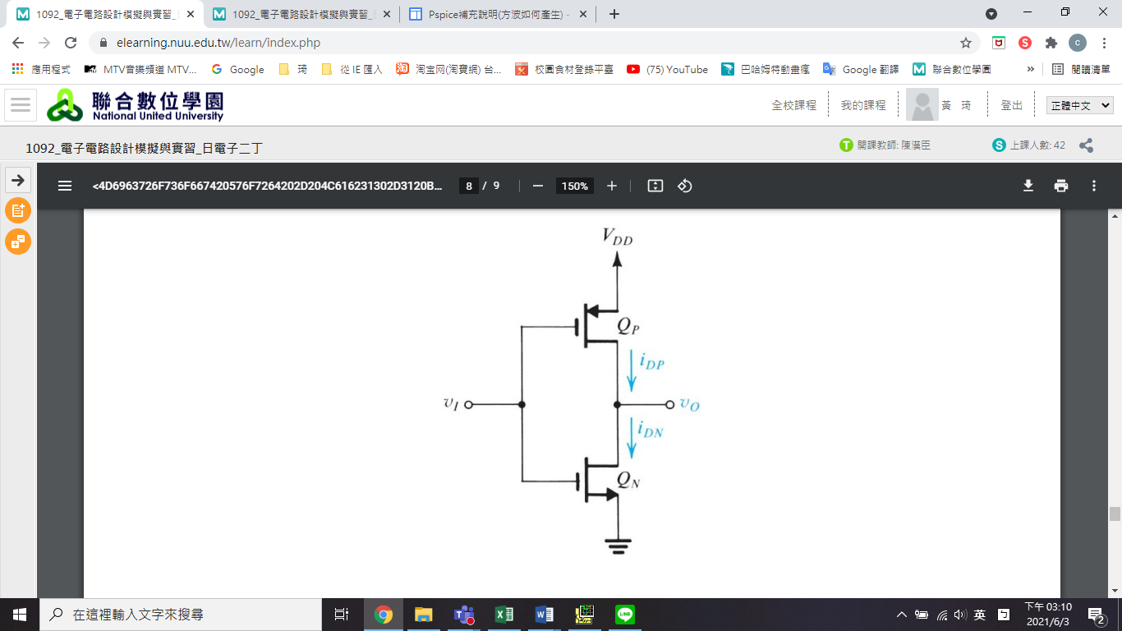

**1**

1. 模擬不同λ(0.2、0.02、0.002)下之 VTC 曲線。

|  |  |  |  |
| --- | --- | --- | --- |
|  |  | | |
| 0.2 | 0.02 | 0.002 |
|  | 732.4407m | 734.8051m | 734.8529m |
|  | -46.1856 | -11.1404 | -8.00048 |

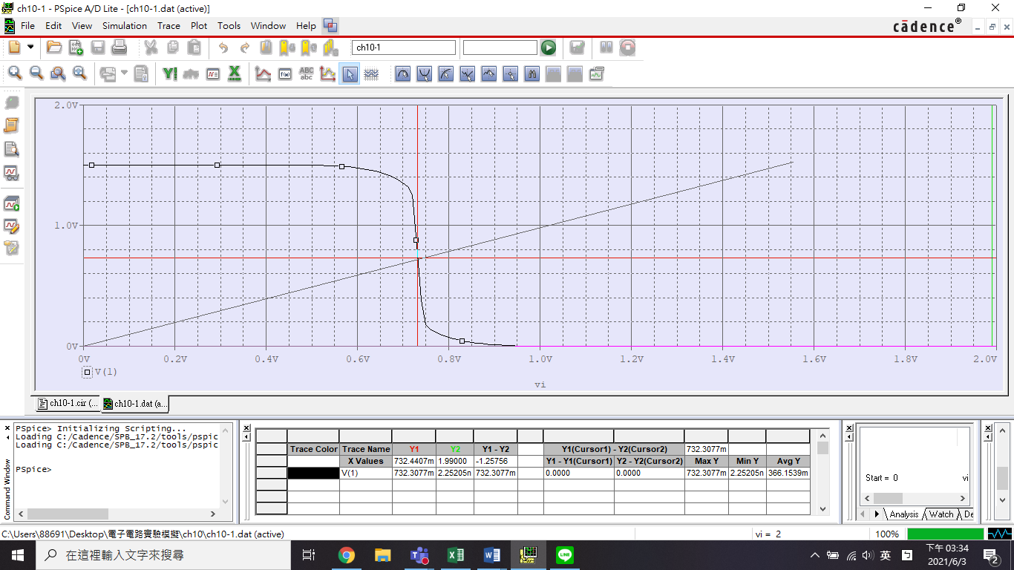

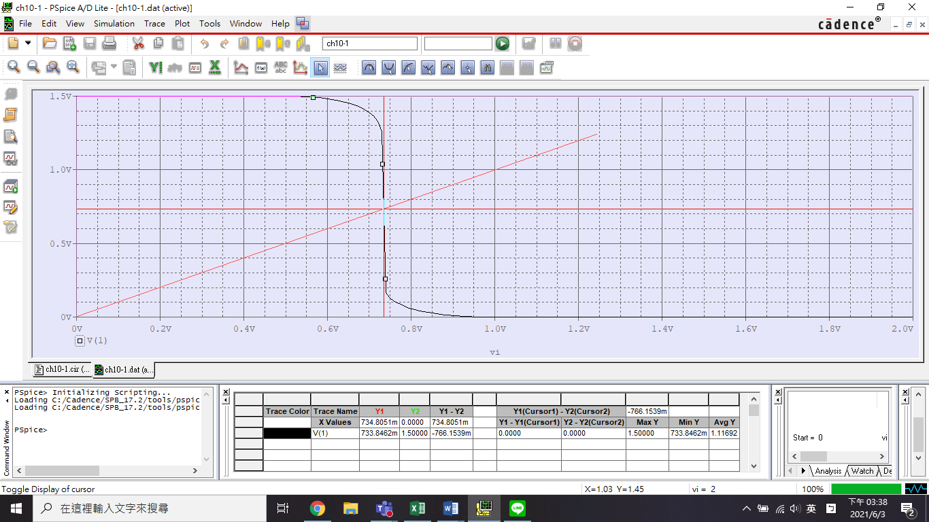

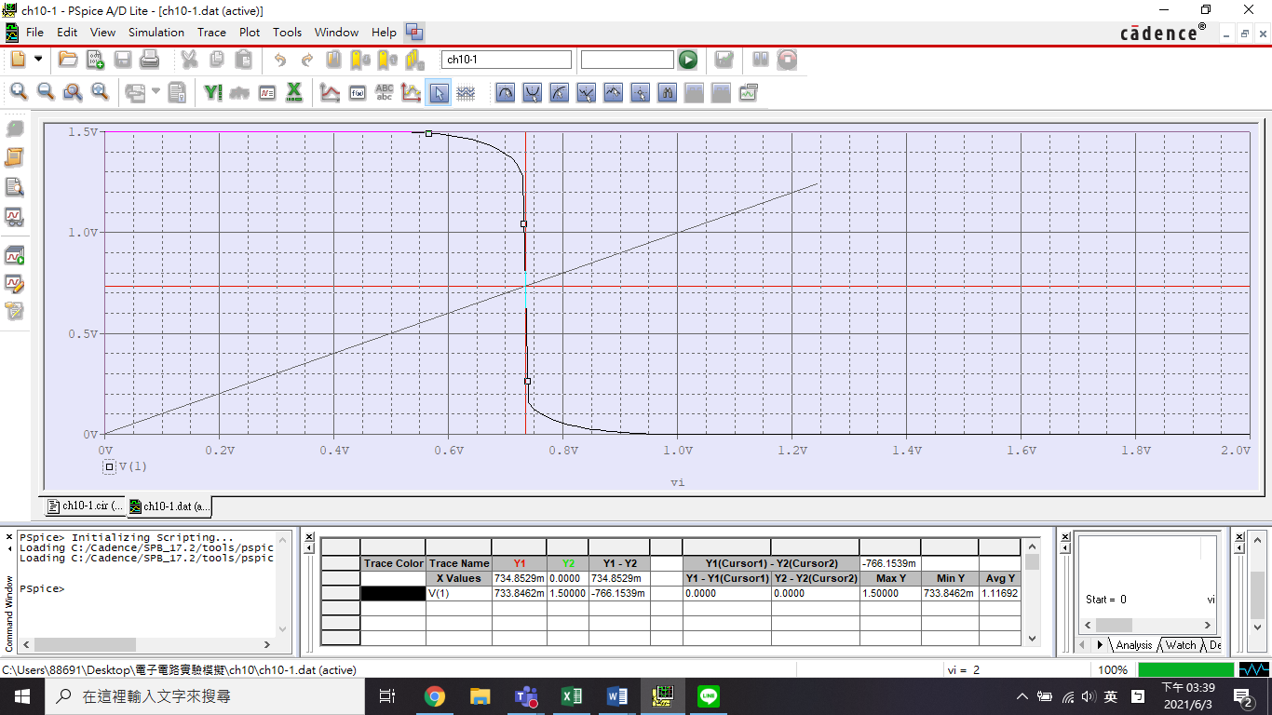

1. 模擬 PMOS、NMOS W/L的尺寸比變動對反向器 VTC 曲線的影響。

|  |  |  |  |
| --- | --- | --- | --- |
| **靜態變數** | **PMOS-to-NMOS ration** | | |
| 1 | 5 | 11 |
|  | 665.3303m | 764.9058m | 814.6295m |
|  | -33.3033 | -406.699 | -14.613 |
|  | 580.4878m | 697.561m | 773.9837m |
|  | 702.439m | 835.7724m | 881.3008m |
|  | 0 | 0 | 0 |
|  | 1.5 | 1.5 | 1.5 |
|  | 797.561m | 664.2276m | 618.6992m |
|  | 580.4878m | 697.561m | 773.9837m |

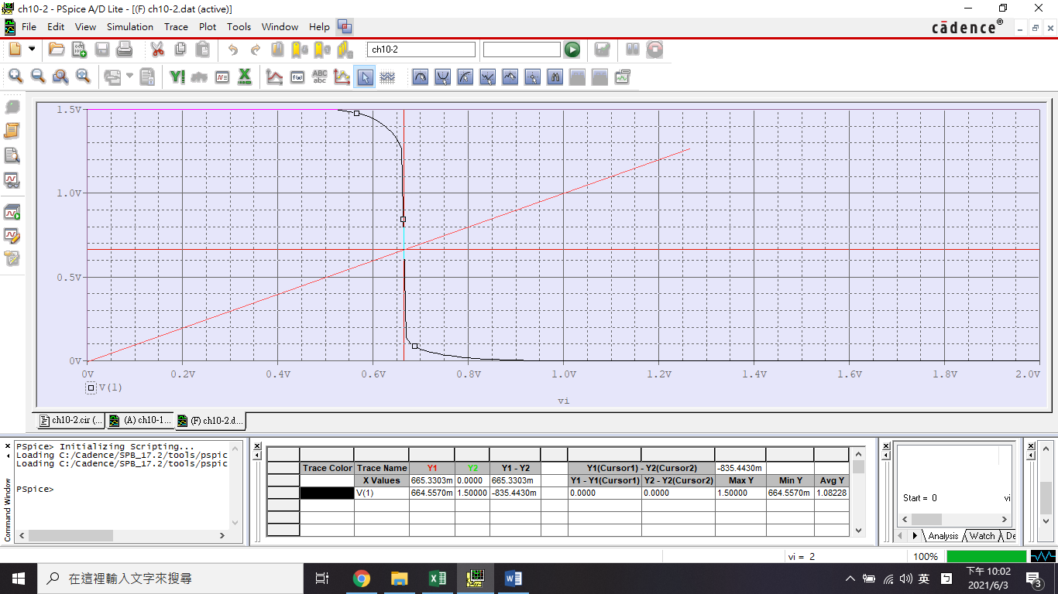

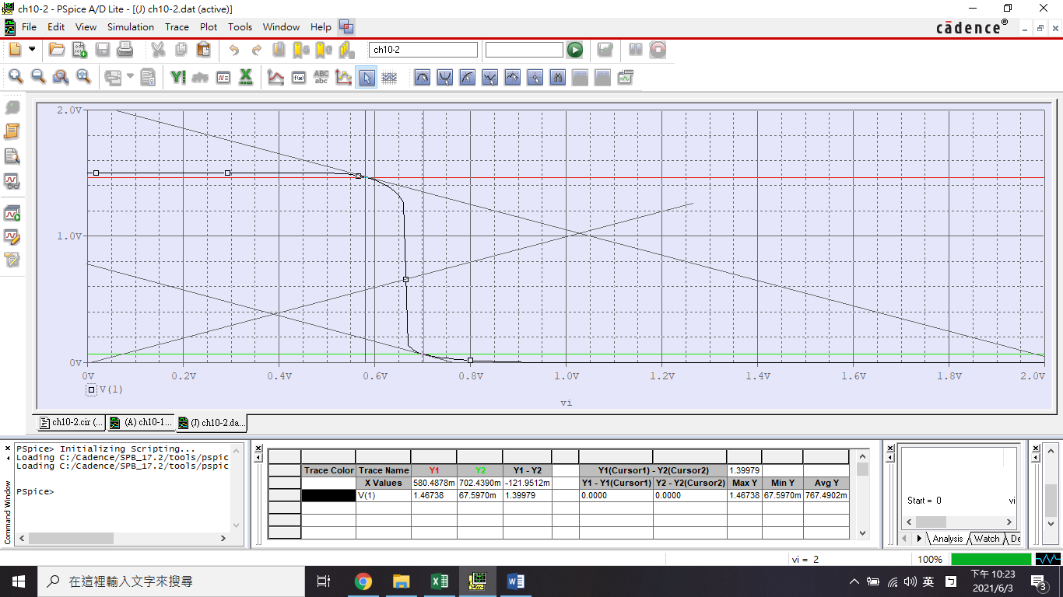

PMOS-to-NMOS ration = 1

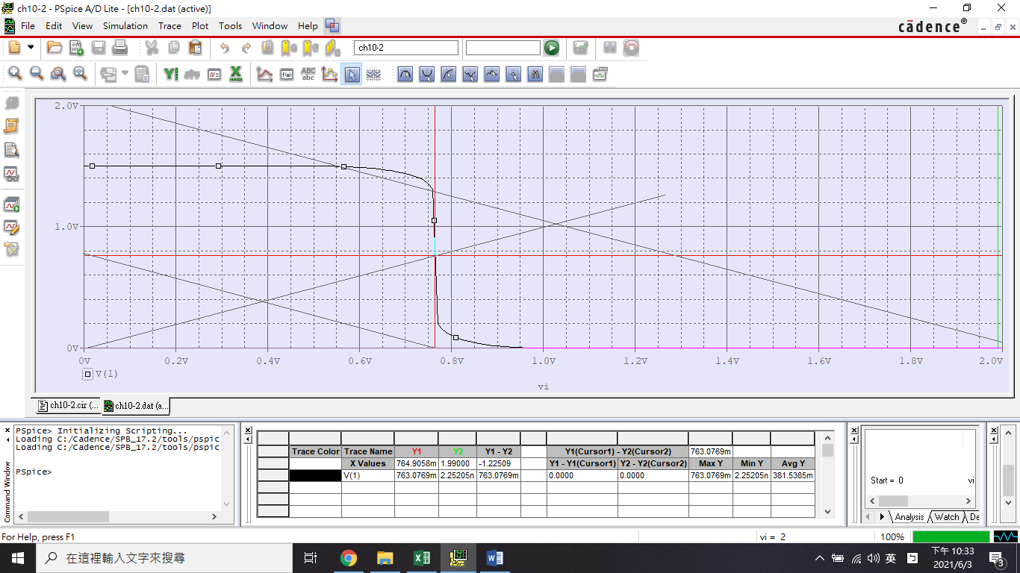

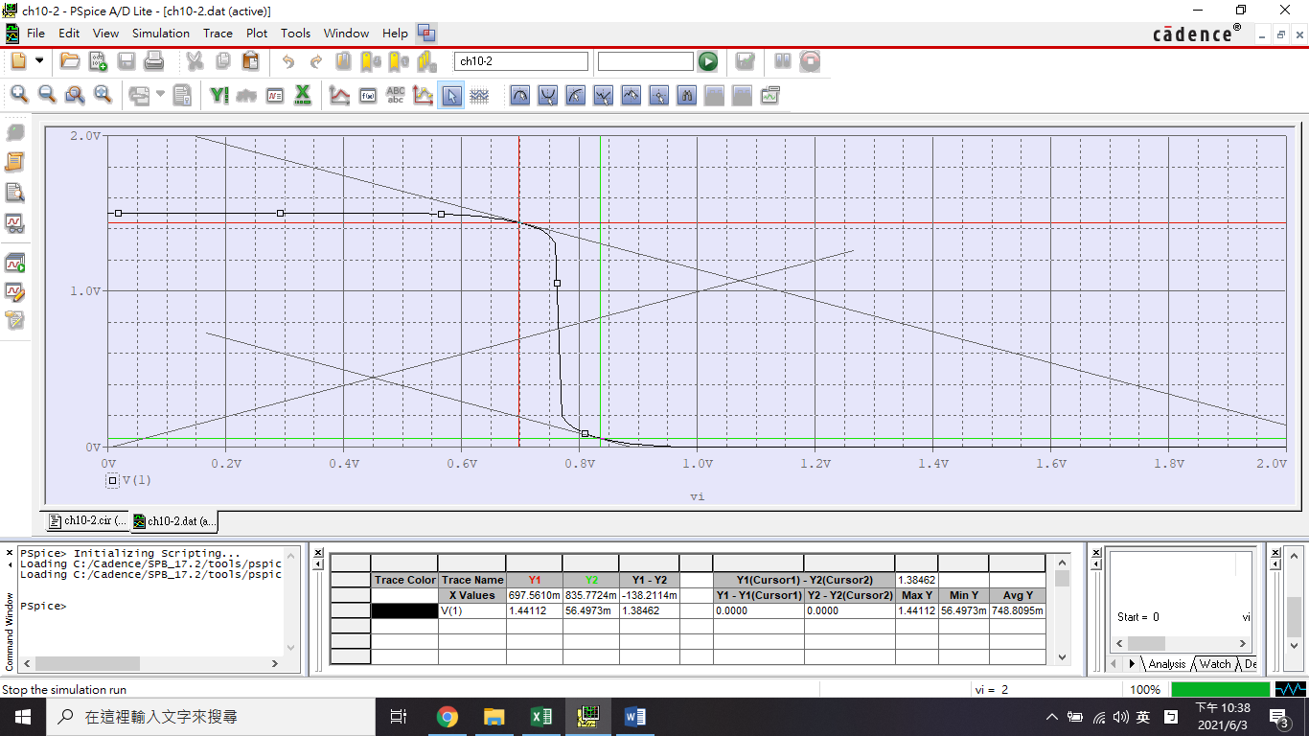

PMOS-to-NMOS ration = 5

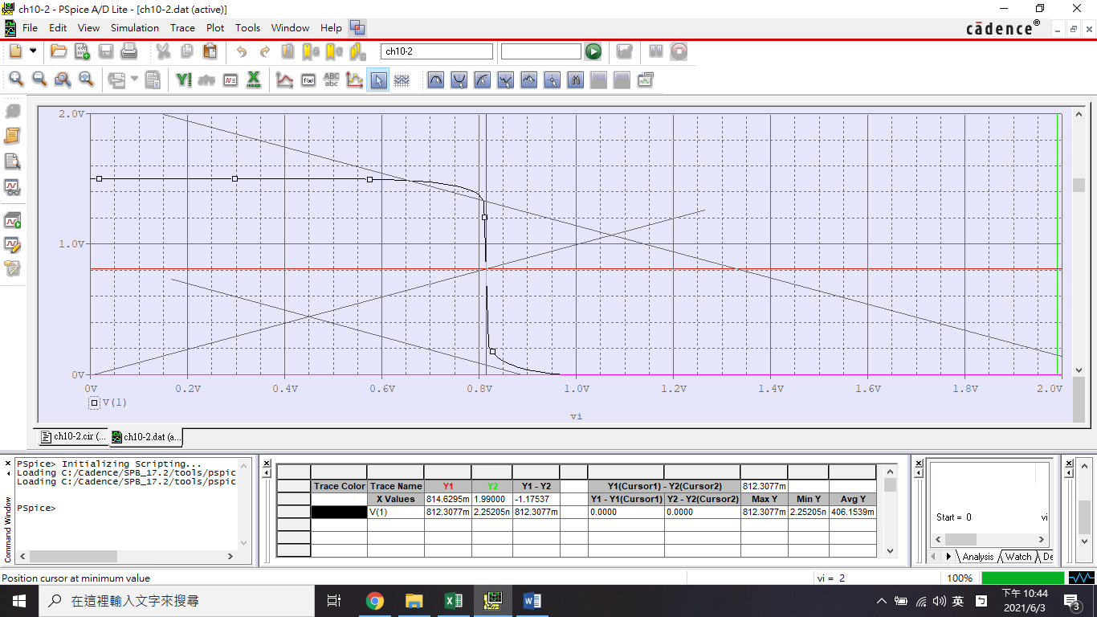

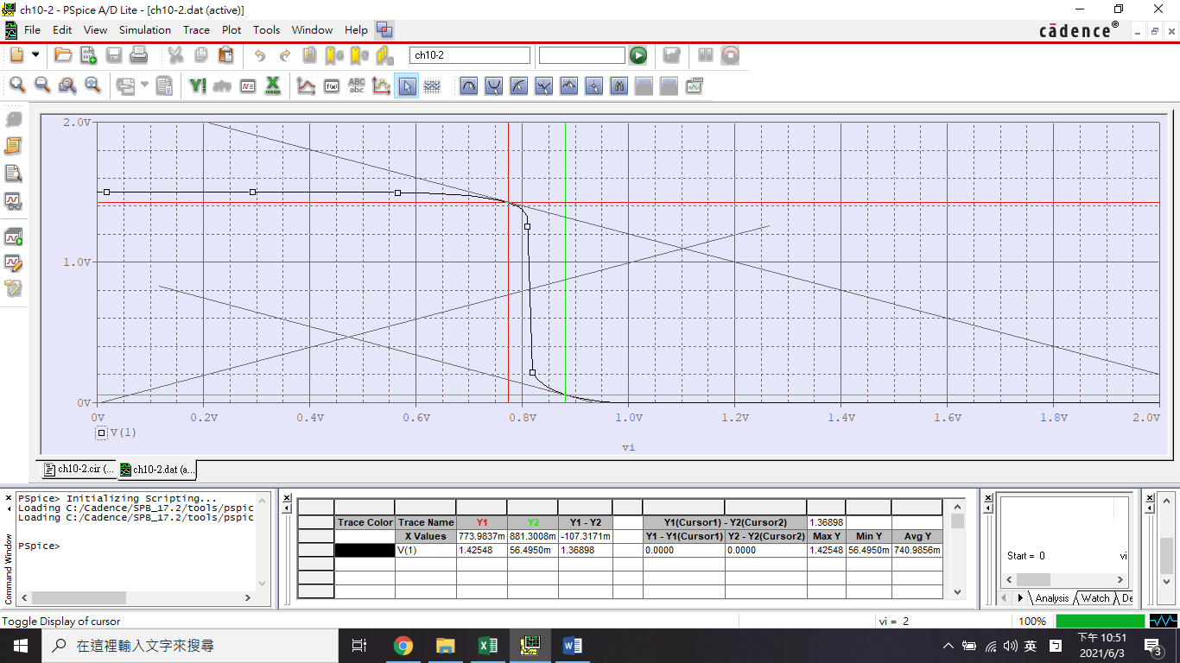

PMOS-to-NMOS ration = 11

1. 模擬電源電壓 VDD 變動對反向器 VTC 曲線的影響。

|  |  |  |  |
| --- | --- | --- | --- |
| **靜態變數** |  | | |
| 1 | 3 | 5 |
|  | 0.5 | 1.42848 | 2.35918 |
|  | 0 | -103.479 | -52.6367 |
|  | 487.8049m | 1.17480 | 1.83058 |
|  | 513.8211m | 1.67886 | 2.85950 |
|  | 0 | 0 | 0 |
|  | 1 | 3 | 5 |
|  | 486.1789m | 1.32114 | 2.14050 |
|  | 487.8049m | 1.17480 | 1.83058 |

