1. Project Overview
This project focuses on analyzing an e-commerce transaction dataset to uncover insights into sales performance, product trends, and customer behavior.
The dataset is sourced from Kaggle (Online Retail Dataset) and contains over 540,000 transaction records, including detailed information such as invoice data, product descriptions, quantities, prices, and customer IDs.
The objective of this project is to build an end-to-end data analytics pipeline using Python, SQL, and Power BI, transforming raw transactional data into actionable business insights.
The analysis covers three main areas:
- Sales Performance Analysis: evaluating total revenue, order volume, and monthly growth trends
- Product Performance Analysis: identifying top-selling and high-revenue products, as well as revenue concentration patterns
- Customer Behavior Analysis: understanding customer spending patterns, segmentation (RFM), and retention behavior (cohort analysis)
The project follows a structured workflow:
- Data cleaning and preprocessing using Python (Pandas)
- Data analysis using SQL (MySQL) with advanced techniques such as window functions and cohort logic
- Data visualization through an interactive Power BI dashboard
This project demonstrates the ability to perform end-to-end data analysis, from raw data preparation to business-focused insights and dashboard reporting.

2. Business Objectives
The primary objective of this project is to leverage transactional data to generate actionable business insights that support data-driven decision-making in an e-commerce context.
Specifically, the analysis aims to address the following key business questions:
- How is the business performing overall in terms of revenue, order volume, and growth trends?
- Which products contribute the most to sales, and how concentrated is revenue across the product portfolio?
- What are the purchasing patterns of customers, and how does spending vary across different customer segments?
- How effectively does the business retain customers over time, and what are the typical repurchase behaviors?
- How can these insights be translated into strategic recommendations to improve revenue, customer retention, and overall business performance?
By answering these questions, the project aims to bridge the gap between raw transactional data and meaningful business strategies.

3. Dataset Description
The dataset used in this project is sourced from Kaggle (Online Retail Dataset), containing transactional data from a UK-based online retailer.
It consists of 541,909 transaction records with information on products, orders, customers, and geographic locations. The data spans approximately one year, from December 2010 to December 2011, enabling time-based analysis such as seasonality and customer retention.
The dataset includes the following key fields:
Column Name | Description
InvoiceNo | Unique identifier for each transaction
StockCode | Product identifier
Description | Product name
Quantity | Number of items purchased (can be negative for returns)
InvoiceDate | Date and time of the transaction
UnitPrice | Price per unit of product
CustomerID | Unique customer identifier
Country | Customer location
Initial data exploration reveals several data quality issues:
- Missing values: Approximately 135,000 records have missing CustomerID values, which impacts customer-level analysis.
- Negative values: Some records contain negative Quantity (returns) and negative UnitPrice (invalid or erroneous entries).
- Minor missing descriptions: A small number of product descriptions are missing.
These issues were addressed during the data cleaning stage to ensure reliable and accurate analysis.
4. Data Cleaning & Preparation
Data cleaning and preprocessing were performed using Python (Pandas) to ensure data quality and reliability for subsequent analysis.
Several key steps were taken to address data quality issues identified during the initial exploration phase:
- Handling missing values: Records with missing CustomerID and Description were removed to ensure accurate customer-level and product-level analysis.
- Removing invalid transactions: Rows with negative Quantity were excluded, as they represent product returns rather than actual purchases. Additionally, records with non-positive or extreme UnitPrice values were filtered out to eliminate erroneous entries.
- Data type conversion: The InvoiceDate field was converted into a datetime format to enable time-based analysis. The CustomerID field was also converted into an integer type for consistency.
- Feature engineering: A new column, Revenue, was created by multiplying Quantity and UnitPrice, providing a key metric for sales analysis.
- Time-based features: Additional fields such as Date and YearMonth were derived from InvoiceDate to support daily and monthly trend analysis.
After cleaning, the dataset was reduced from 541,909 to 397,863 records, ensuring that only valid and meaningful transactions were retained for analysis.

5. Summary of Key Findings
The analysis reveals several important insights across sales, products, and customer behavior. The business generated over £8.8M in revenue, with strong seasonality and peak performance in the final quarter.
Revenue is highly concentrated in the UK market (82%), while product sales follow a long-tail distribution, where a small number of items drive the majority of revenue.
Customer analysis shows that high-value customers contribute disproportionately, with the top 10 customers generating 17.35% of total revenue and an average customer lifetime value of £2,026.99.
However, retention remains relatively weak, with only 5.26% of customers returning within 7 days and 18.52% within 30 days. Most repeat purchases occur within the first month, indicating a critical window for customer retention strategies.

5.1 Sales Performance Analysis
The overall sales performance was analyzed using SQL to evaluate key business metrics, including revenue, order volume, and purchasing behavior.
The dataset generated a total revenue of £8,860,738, across 18,518 orders from 4,337 unique customers, resulting in an average order value of approximately £478.49. These metrics indicate a relatively high average transaction value, suggesting that customers tend to purchase multiple items per order.
To further understand sales trends over time, monthly revenue was calculated using aggregation functions. The results show noticeable fluctuations in sales performance, with a clear upward trend toward the end of the year.
A month-over-month (MoM) growth rate was calculated using SQL window functions (LAG) to compare each month's revenue with the previous period. This allows for identifying growth patterns and periods of acceleration or decline in sales.
Additionally, seasonality analysis reveals that revenue peaks in the final quarter (October to December), indicating strong year-end demand, likely driven by seasonal shopping behavior such as holiday sales.
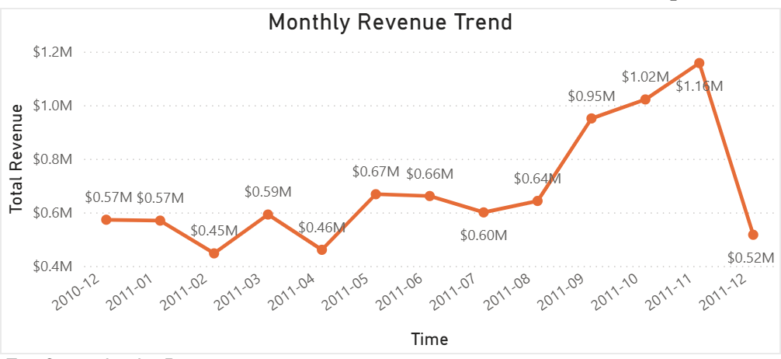
Monthly Revenue Trend
5.2 Country Revenue Analysis
Revenue contribution by country was analyzed to understand geographic distribution and identify key markets. SQL aggregation and window functions were used to calculate revenue share and rank countries by performance.
The results show that the United Kingdom dominates sales, contributing approximately 82.21% of total revenue, making it the primary market for the business.
The second and third largest markets are the Netherlands (3.22%) and EIRE (2.96%), followed by Germany and France. However, revenue contribution from these countries is significantly lower compared to the UK, indicating a highly concentrated revenue structure.
Beyond the top few countries, revenue is widely distributed across many smaller markets, each contributing less than 1% individually. This long-tail distribution suggests that while the business has a global customer base, most international markets remain underdeveloped.
From a business perspective, this indicates a strong dependence on the UK market, while also highlighting potential opportunities for international expansion and revenue diversification.
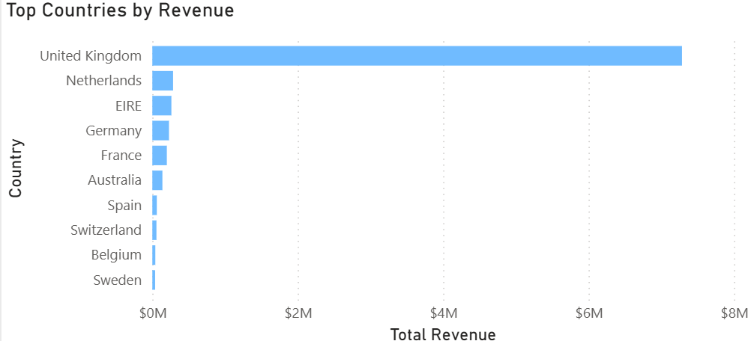
Top 10 Countries By Revenue

5.3 Product Performance Analysis
Product performance was analyzed to identify top-selling items, revenue-driving products, and overall revenue distribution across the product portfolio.
The analysis shows that a small number of products contribute a disproportionately large share of total revenue. For example, top-performing products such as “PAPER CRAFT, LITTLE BIRDIE” and “REGENCY CAKESTAND 3 TIER” generate significantly higher revenue compared to other items.
To further evaluate product concentration, a Pareto analysis (80/20 rule) was conducted using SQL window functions to calculate cumulative revenue contribution. The results indicate that approximately 785 products account for 80% of total revenue, confirming a strong revenue concentration among a relatively small subset of products.
This long-tail distribution suggests that while the product catalog is large, only a limited number of items drive the majority of sales. From a business perspective, this highlights the importance of focusing on high-performing products for inventory planning, promotions, and marketing strategies, while also identifying opportunities to optimize or discontinue low-performing items.
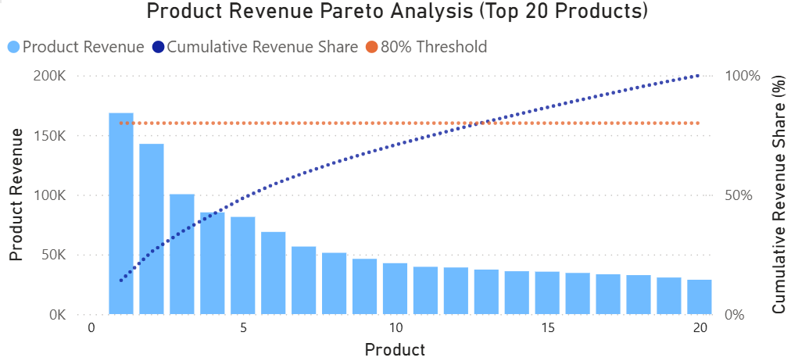
Product Revenue Pareto Analysis (Top 20 Products)

5.4 Customer Behavior Analysis
Customer behavior was analyzed to understand spending patterns, identify high-value customers, and evaluate revenue concentration across the customer base.
The results show significant variation in customer spending, with a small group of high-value customers contributing disproportionately to total revenue. For instance, the top customer generated over £279,000, while the top 10 customers account for 17.35% of total revenue, indicating a moderate level of concentration.
Customer purchasing behavior also differs across individuals. Some customers place frequent orders with lower average order values, while others make fewer but high-value purchases, suggesting distinct behavioral segments such as frequent buyers and high-value buyers.
To further evaluate customer value, Customer Lifetime Value (CLV) was analyzed. The average CLV is approximately £2,026.99, with 4.26 orders per customer and an average order value of £476.04.
CLV distribution shows a clear long-tail pattern, where most customers fall within the lower spending ranges (£100–£1,000), while a smaller group of high-value customers (above £5,000) contributes a disproportionately large share of revenue.
From a business perspective, this highlights the importance of retaining high-value customers while also increasing the value of lower-tier customers through targeted marketing and upselling strategies.
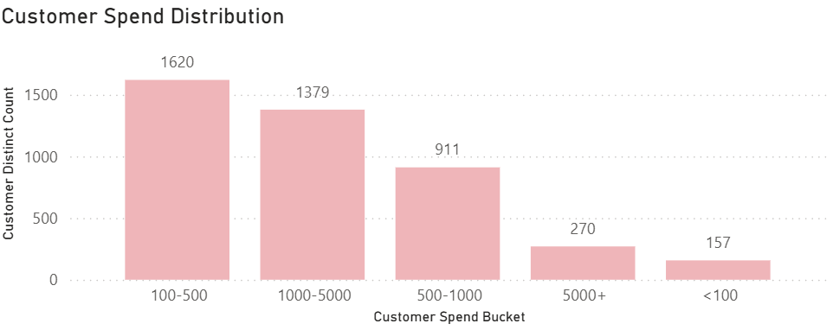
Customer Spend Distribution
5.5 Customer Segmentation (RFM)
Customer segmentation was performed using the RFM (Recency, Frequency, Monetary) model to better understand customer value and support targeted business strategies.
- Recency (R) measures how recently a customer made a purchase
- Frequency (F) measures how often a customer makes purchases
- Monetary (M) measures how much a customer spends
Customers were scored using SQL window functions (NTILE) and grouped into five segments: Champions, Loyal Customers, Big Spenders, At Risk, and Others.
The results show that Champions represent the most valuable segment, contributing approximately 65.87% of total revenue, despite accounting for a smaller portion of the customer base. This indicates that highly engaged and active customers drive the majority of business value.
Loyal Customers and Big Spenders also contribute significantly, accounting for 14.63% and 10.32% of revenue respectively, suggesting opportunities for upselling and retention strategies.
On the other hand, the At Risk segment represents a large number of customers but contributes relatively low revenue, indicating potential churn risk and the need for re-engagement strategies.
From a business perspective, this segmentation provides a clear framework for targeted marketing, personalized campaigns, and customer retention efforts.
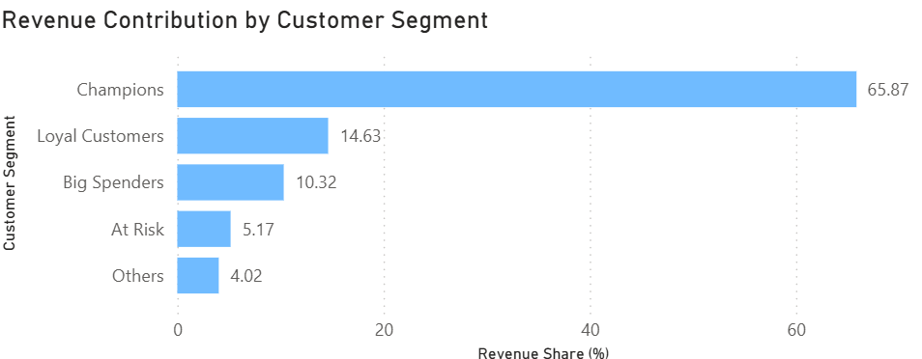
Customer Segmentation Distribution
5.6 Customer Retention & Cohort Analysis
Customer retention was analyzed using cohort analysis to evaluate repeat purchasing behavior and customer loyalty over time.
Customers were grouped into cohorts based on their first purchase month, and retention rates were tracked across subsequent months. The results show a sharp decline in retention after the first purchase, with most cohorts experiencing a significant drop after month 1, followed by relatively stable but lower retention levels in later periods.
To further quantify repeat behavior, short-term and mid-term repeat rates were calculated. Approximately 5.26% of customers made a repeat purchase within 7 days, while 18.52% returned within 30 days, indicating that immediate retention is relatively low but improves over a longer time window.
Purchase interval analysis shows that most repeat purchases occur within 30 days, with 8–30 days (4,470 orders) being the most common interval. The average time between purchases is approximately 40.14 days, suggesting that if customers do not return within the first one to two months, the likelihood of repeat purchase declines significantly.
Overall, these findings highlight a critical early-stage retention window, emphasizing the importance of timely engagement strategies such as follow-up campaigns and personalized offers.
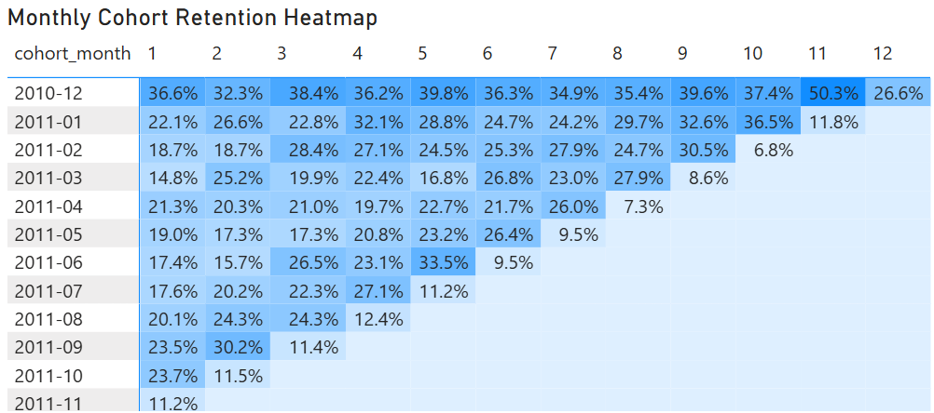
Monthly Cohort Retention Heatmap
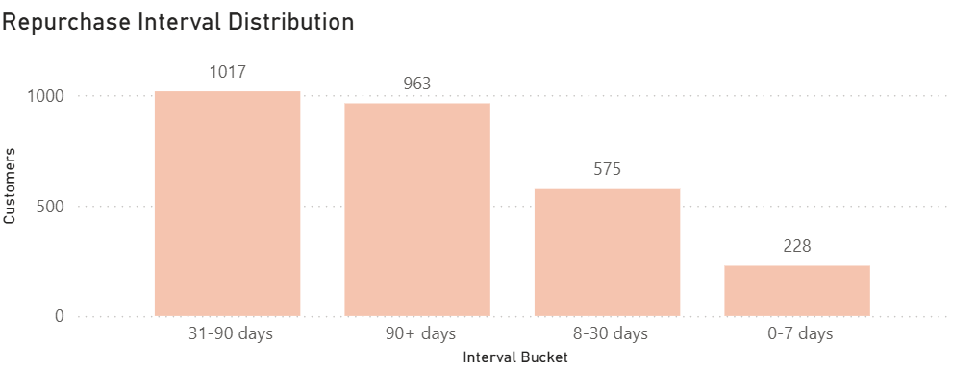Repurchase Interval Distribution
6. Power BI Dashboard
An interactive Power BI dashboard was developed to visualize key business insights and support data-driven decision-making. The dashboard is structured into four main pages, each focusing on a specific analytical area.
Dashboard Pages
1. Sales Overview
Provides a high-level view of business performance, including total revenue, total orders, total customers, and average order value. It also includes monthly revenue trends, MoM growth, and seasonality analysis to highlight sales patterns over time.
2. Product Performance
Highlights top-performing products by revenue and quantity, along with a Pareto analysis to demonstrate revenue concentration across the product portfolio.
3. Customer Analysis
Focuses on customer behavior, including spending distribution, top customers, customer lifetime value, and RFM segmentation. This page helps identify high-value customer segments and revenue drivers.
4. Customer Retention & Cohort Analysis
Visualizes customer retention patterns using cohort analysis, repeat rate KPIs, and repurchase interval distribution. This page provides insights into customer loyalty and repurchase behavior over time.
Dashboard Components
The dashboard incorporates multiple visualization techniques, including:
- KPI cards for key business metrics
- Line and bar charts for trend and distribution analysis
- Ranking charts for top products and customers
- Customer segmentation visuals (RFM)
- Cohort retention heatmap for lifecycle analysis
These interactive dashboards allow users to filter by time and country, enabling dynamic exploration of business performance and customer behavior.
7. Key Insights
This analysis uncovers several key business insights across sales performance, product trends, and customer behavior.
- Revenue is highly concentrated in a small number of products.
A Pareto analysis shows that a limited subset of products contributes the majority of total revenue, indicating a strong long-tail distribution and the importance of focusing on high-performing items.
- Customer value is unevenly distributed.
A small group of high-value customers generates a disproportionately large share of revenue, with the top 10 customers contributing approximately 17.35% of total sales.
- Customer purchasing behavior varies significantly.
Some customers purchase frequently with lower order values, while others make fewer but high-value transactions, highlighting distinct customer segments.
- Most repeat purchases occur within a short time window.
Purchase interval analysis shows that the majority of repeat orders happen within 30 days, with 8–30 days being the most common interval.
- Customer retention declines rapidly after the first purchase.
Cohort analysis reveals a sharp drop in retention after month 1, indicating weak short-term retention and a high proportion of one-time buyers.
- Early-stage engagement is critical for retention.
With only 5.26% of customers returning within 7 days and 18.52% within 30 days, the first month represents a key opportunity to drive repeat purchases.
- Sales exhibit strong seasonality patterns.
Revenue peaks in the final quarter of the year, suggesting increased demand during holiday periods and opportunities for seasonal promotions.
Overall, the findings highlight opportunities to improve business performance through targeted product strategies, customer segmentation, and early-stage retention initiatives.
8. Business Recommendations
Based on the analysis, several actionable strategies can be implemented to improve business performance and customer retention.
- Strengthen customer retention through early-stage engagement.
Since most repeat purchases occur within the first 30 days, businesses should implement follow-up strategies such as personalized emails, product recommendations, and limited-time discounts shortly after the first purchase to encourage repeat behavior.
- Develop loyalty programs for high-value customers.
Given that a small group of customers contributes a significant share of revenue, targeted loyalty programs, exclusive offers, and VIP benefits can help retain these high-value customers and maximize lifetime value.
- Leverage customer segmentation for targeted marketing.
Using RFM segmentation, businesses can design tailored campaigns for different customer groups, such as re-engagement strategies for at-risk customers and upselling strategies for loyal or high-spending customers.
- Focus on promoting high-performing products.
Since revenue is concentrated in a small number of products, marketing efforts should prioritize these items through promotions, bundling strategies, and featured placements to further drive sales.
- Optimize product portfolio management.
Low-performing products can be reviewed for potential improvement, repositioning, or discontinuation, allowing the business to allocate resources more efficiently.
- Expand international market opportunities.
With revenue heavily concentrated in the UK, there is potential to grow sales in underperforming regions through localized marketing strategies and improved logistics support.
- Capitalize on seasonal demand patterns.
Given the strong sales peak in the final quarter, businesses should plan inventory, marketing campaigns, and promotions in advance to maximize revenue during high-demand periods.
9. Tech Stack
- Python (NumPy) – data cleaning, preprocessing, and feature engineering
- MySQL & SQL – data querying and advanced analytics (window functions, CTEs, cohort analysis)
- Power BI – interactive dashboard development and business reporting
- Data Visualization – trend analysis, distribution analysis, and performance tracking

