This tool is meant to auto-generate (part of) datasets needed to build Innolight’s Adexa data model.

How to use it?

1. Open Generator.xlsm, click the Icon on top of the screen (see screenshot below), to launch the model generator.
2. Results will be in adx_out.xlsx (each tab corresponds to an Adexa table), and the same results in csv will be located in the folder csv (each csv file corresponds to an Adexa table). This process may take a few minutes with a few spreadsheets automatically opened and closed intermittently.
3. Each run will override (replace) the previous one.

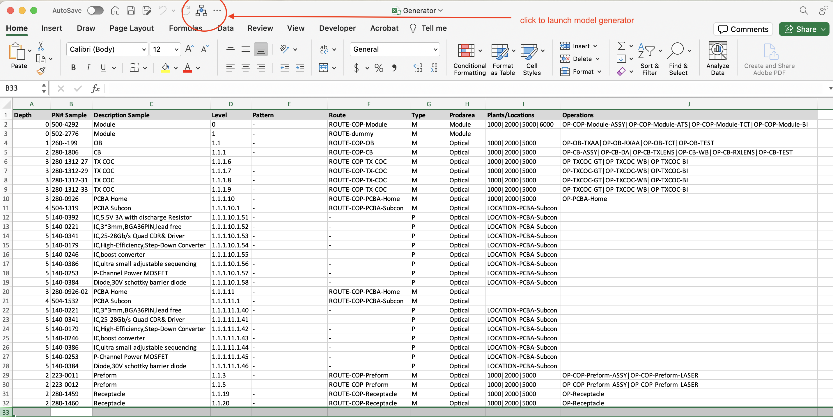

How it works?

1. Generator.xlsm contains configuration information used to drive the model generation.
2. Each DP model corresponds to 2 tabs. For example, for COP, COP tab contains configuration while COP BOM tab contains BOM file lists.
3. The configuration tab basically contains “filters” used to retain only those rows relevant to the model generation. The filtering process adheres to either of the following logic:
   1. Matching by “Level”. The “Level” column lists possible levels of which the rows are to retained. For example, level “1.1.1.10” which corresponds to PCBA Home process is to be retained.
   2. Matching by “matching pattern”. Two columns are used in this logic: “Pattern” column dictates what a Part Number should abide by, and “Depth” column dictates the number of dots “.” In “level”.
4. The configuration tab also tells Route, Type, Prodarea, Plants/Locations and Operations for retained rows.
5. One can basically change filtering patterns in the configuration tabs to drive the model generation process. For example, if we decide to retain all rows, majority of which are to be mapped to “dummy route”, we could add a “wildcard” in the last row of the configuration tab (see below):

