QGIS stylesheets and code to render OSM data as a scalable map

QGIS stylesheets and code to render OSM data as a scalable map
Copyright 2017 Industrial Data & Analytics Ltd. Distributed under the GPLv3 license. See the statement at the end of this document for more information. For support, please use GitHub tickets / bug tracker. For other contact or to work together, email info@dataandanalytics.co.uk.
The goal of this project is to produce beautiful, modern map styles or OpenStreetMap (OSM) data in QGIS.
This project will enable anyone to easily create professional quality maps without needing to look into tile servers and other technicalities. Simply load the OSM data into QGIS, apply the stylesheets and let it render.
If you improve these maps, please upload & commit your changes. Full attribution will be given to you under the GPLv3 license.
OpenStreetMap (openstreetmap.org) is a project to free the information about our world and ensure it belongs to all, and not a small group (eg Google, Microsoft etc who may ‘be evil’ at some point in the future).
The steps to your beautiful, scalable map in QGIS are below.

QUICK START GUIDE
To get started quickly these are the steps:
Note: recommended to untick “Render” to speed creation.
1) load your OSM data into QGIS as Postgres vector layers.
One layer should be created for each table of planet_osm_roads, planet_osm_point, planet_osm_line, planet_osm_polygon (in rendering order last→first ie, in the layers panel, roads should be on top of point, on top of line etc).
2) Apply stylesheets. There is one stylesheet per layer with the same name eg planet_osm_roads.qml should be applied to planet_osm_roads
3) Set the ocean back ground. Project→Project Properties→Background color (click the color bar). Set to colour #b2ddf2.
4) Apply national parks. Database→DB Manager→PostGIS→(select db name eg osm)→(select login role)→SQL Window
Enter:
with "dumped_polygonised" as
(
SELECT
"polygonised"."name" as "name",
"polygonised"."boundary" as "boundary",
(ST_Dump("polygonised"."polycoll"))."geom" As "polygon_geom"
FROM (
SELECT
string_agg(distinct "name",' ') as "name",
"boundary",
ST_Polygonize("way") as "polycoll"
FROM "planet_osm_line"
WHERE "boundary" = 'national_park' and "highway" IS NULL
group by "osm_id","boundary"
) as "polygonised"
)
SELECT row_number() over(order by "name") as "id",
"name",
"boundary",
ST_Multi(ST_Collect("polygon_geom")) as "polygon_geom_multi"
FROM "dumped_polygonised"
GROUP BY "name", "boundary"

Check “Load as new layer”. Check “Column(s) with unique id” and select id. For the Geometry column select polygon_geom_multi. For layer name add osm_polygons_from_lines. Click “Load Now!”.
Your map will now have national parks.
5) Country outlines.
WG84, faster render / smaller scales, download from here: http://data.openstreetmapdata.com/land-polygons-complete-4326.zip
WG84, Slower render / more detailed / larger scales, download from here:
http://data.openstreetmapdata.com/land-polygons-complete-4326.zip
Others, eg Mercator, can be downloaded from here. Just select the one you want:
http://openstreetmapdata.com/data/land-polygons
Import as shapefile into QGIS and apply land.qml stylesheet.

You’re done. Tick “Render” and you now have a beautiful, scalable map.

Step-by-step guide:

GET THE OSM DATA
For this to work, you need to have the OpenStreetMap.org data in a Postgres DB.
A quick search should tell you where to find it.
If you only want a section of the world, http://download.geofabrik.de is a good option. Download the pbf file desired.
In linux, I used this to get European data:
nohup wget -O europe-latest.osm.pbf "http://download.geofabrik.de/europe-latest.osm.pbf" &
Load data into Postgres
I used osm2pgsql which is hosted here https://github.com/openstreetmap/osm2pgsql
If you only need a subset of the data, then use a bounding box to save time. This will load data for the UK only (replace DATABASE with the name of the db you have created and USERNAME with the name of the login role. It will ask you for the password as -W is set):
osm2pgsql --bbox -14.106,48.720,2.505,62.063 --number-processes=4 --latlong --keep-coastlines --hstore --slim -C 30000 -d DATABASE -U USERNAME -W -S /usr/share/osm2pgsql/default.style europe-latest.osm.pbf
Otherwise, this will load whatever data from OSM you have in the osm.pbf file:
osm2pgsql --latlong --keep-coastlines --hstore --slim -C 30000 -d DATABASE -U USERNAME -W -S /usr/share/osm2pgsql/default.style osm.pbf
Please refer to the osm2pgsql documentation at GitHub for further information.

FIRST STEPS

Untick “render” on the bottom toolbar of the QGIS window.

Set the map background to an ocean color
Project→Project Properties→Background color (click the color bar).
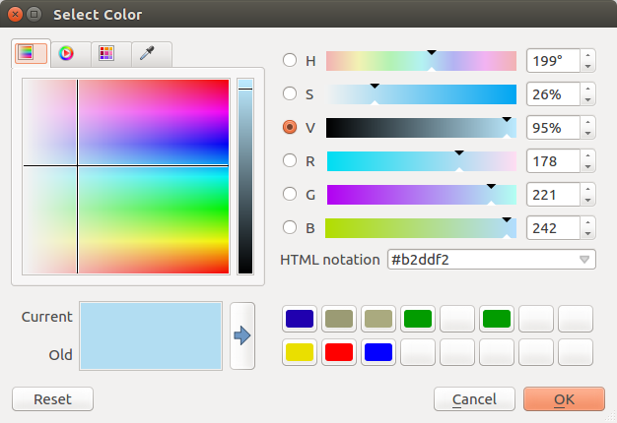
In the Select Color window, write in the HTML notation #b2ddf2 (or our ocean colour).
Click Ok.

ADD THE COUNTRY OUTLINES
So far your map only contains ocean. Beautiful but not so useful to a land dwelling race. Adding the countries from the osm data is surprisingly complicated requiring intersections of administrative boundaries and coastlines.
Of course, being the open source philanthropist project it is, the problem has been solved for you for free (I donate £2 per year to every project I use. I encourage you to do the same. It costs me about £50 per year but because I make sure it doesn’t all happen at once, I don’t notice it).
Download the shapefile you want from here http://openstreetmapdata.com/data/land-polygons
If you are not sure which one you want, use this one: http://data.openstreetmapdata.com/land-polygons-complete-4326.zip
And if it looks bad, you’re probably zooming in too much so use this: http://data.openstreetmapdata.com/land-polygons-complete-4326.zip
Unzip the .shp file into your project folder and delete the zip.
Import as shapefile into QGIS and apply land.qml stylesheet. Double click on the layer→Style→Load Style→”Load from file...” and select the land.qml from the folder you downloaded the stylesheets to.
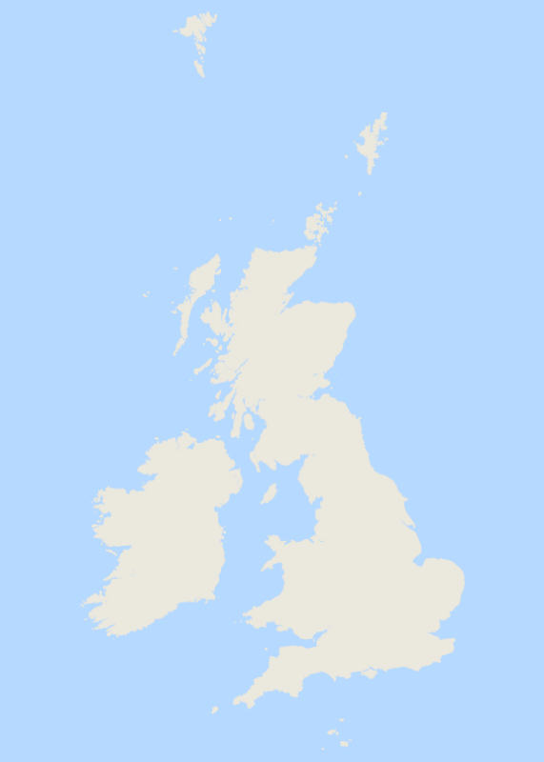
You now have countries.

LOAD THE OSM LAYERS

Create a new postgres vector layer by clicking the button on QGIS.
Add the connection to your db. Select each of the main tables:
planet_osm_roads
planet_osm_point
planet_osm_line
planet_osm_polygon
(Note in QGIS they should be listed in the order above).

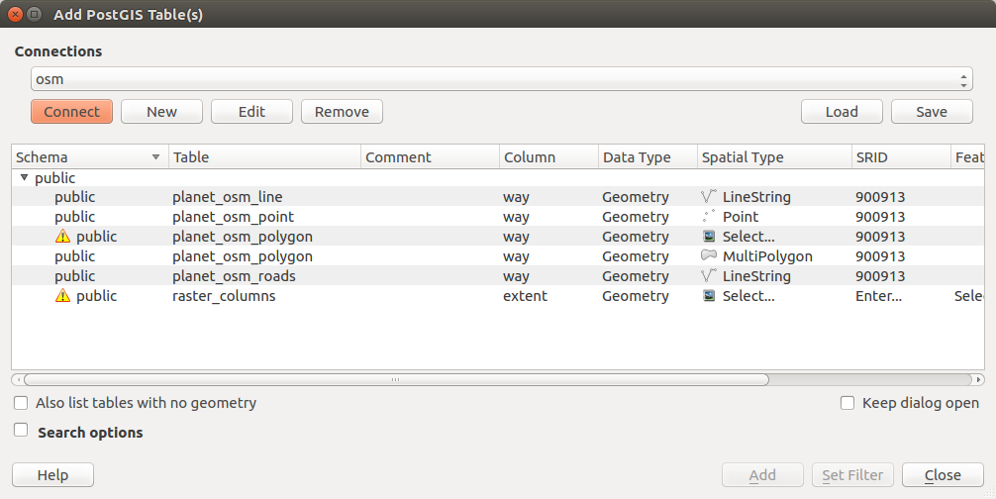

Click the “Add” button.

Load Style sheets
Right click->Layer Properties (or double click on the layer). Click the “Style” dropdown. Follow “Load file” and select “Load from file...”
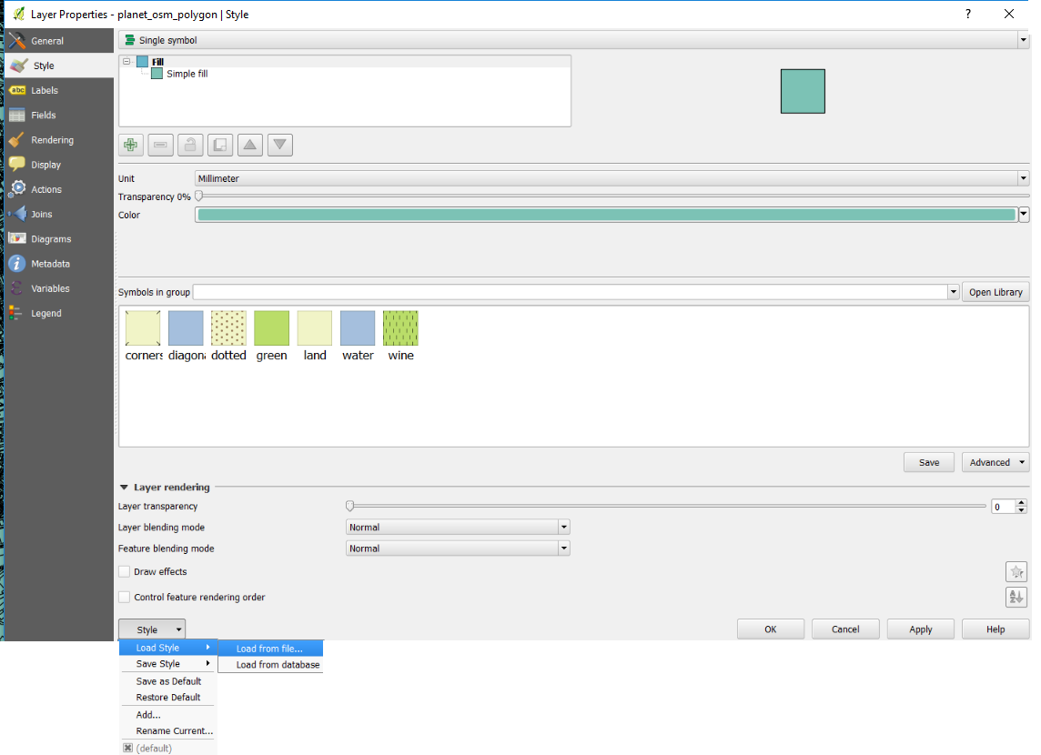
Go to your stylesheets folder and chose the style sheet that has the same name as the layer.
Select “Open”

NATIONAL PARKS
Natoinal parks will be missing from your maps. To apply them, select from the QGIS menu Database→DB Manager→PostGIS→(select db name eg osm)→(select login role)→SQL Window
And enter:
with "dumped_polygonised" as
(
SELECT
"polygonised"."name" as "name",
"polygonised"."boundary" as "boundary",
(ST_Dump("polygonised"."polycoll"))."geom" As "polygon_geom"
FROM (
SELECT
string_agg(distinct "name",' ') as "name",
"boundary",
ST_Polygonize("way") as "polycoll"
FROM "planet_osm_line"
WHERE "boundary" = 'national_park' and "highway" IS NULL
group by "osm_id","boundary"
) as "polygonised"
)
SELECT row_number() over(order by "name") as "id",
"name",
"boundary",
ST_Multi(ST_Collect("polygon_geom")) as "polygon_geom_multi"
FROM "dumped_polygonised"
GROUP BY "name", "boundary"

Check “Load as new layer”.
Check “Column(s) with unique id” tickbox and select “id”.
For the Geometry column select “polygon_geom_multi”.
For layer name add “osm_polygons_from_lines” or choose your layer name.
Click “Load Now!”
Your map will now have national parks.
And you’re done for a beautiful, scalable map in QGIS using OSM data.

KNOWN HACKS & ISSUES
The planet_osm_roads stylesheet contains a hack to limit the frequency of roadshields displayed. By default, so many roadshields are displayed at high scales that it can be hard to see the roads. The stylesheet only displays the roadshield if the feature’s osm_id is divisible by 40 with no remainder (using modulo ie if osm_id % 40 = 0). This is completely arbitrary and a hack. Feel free to improve it if you know how.

DESIGN NOTES

PLANET_OSM_point.qml:
This style sheet is designed for OSM planet_osm_point data, it shows/labels the place name, bus stop and symbol of amenities.

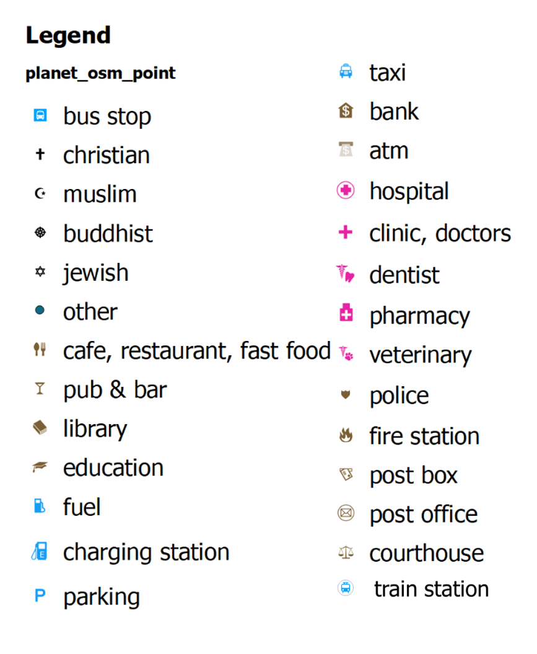
Figure: Legend of amenity

PLACE
It is shows some important places name:
- locality. A named place that has no population.
- hamlet. A smaller rural community, typically with fewer than 100-200 inhabitants, and few infrastructure.
- village. A smaller distinct settlement, smaller than a town with few facilities available with people traveling to nearby towns to access these.
- farm. An individually named farm.
- isolated dwelling. The smallest kind of settlement (1-2 households).
- suburb. A part of a town or city with a well-known name and often a distinct identity.
- town. An important urban centre, between a village and a city in size.
- neighbourhood. A neighbourhood is a smaller named, geographically localised place within a suburb of a larger city or within a town or village.
- island. Any piece of land that is completely surrounded by water and isolated from other significant landmasses.
- city. The largest urban settlement or settlements within the territory.
- country.
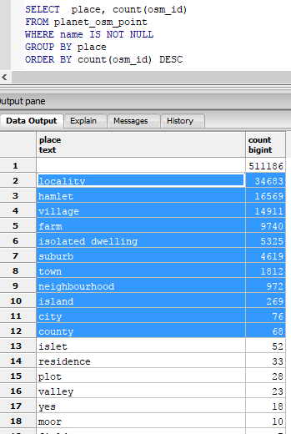
Figure: SQL Query: Get the number of objects (place) from planet_osm_point

PLANET_OSM_LINE.QML:
This style sheet is designed for OSM planet_osm_line data and present the osm lines in different styles (width, color) based on their functional class, e.g. highway, trunk, secondary street, footway, river, etc. ** This style sheet can be used by planet_osm_roads which only included major roads.

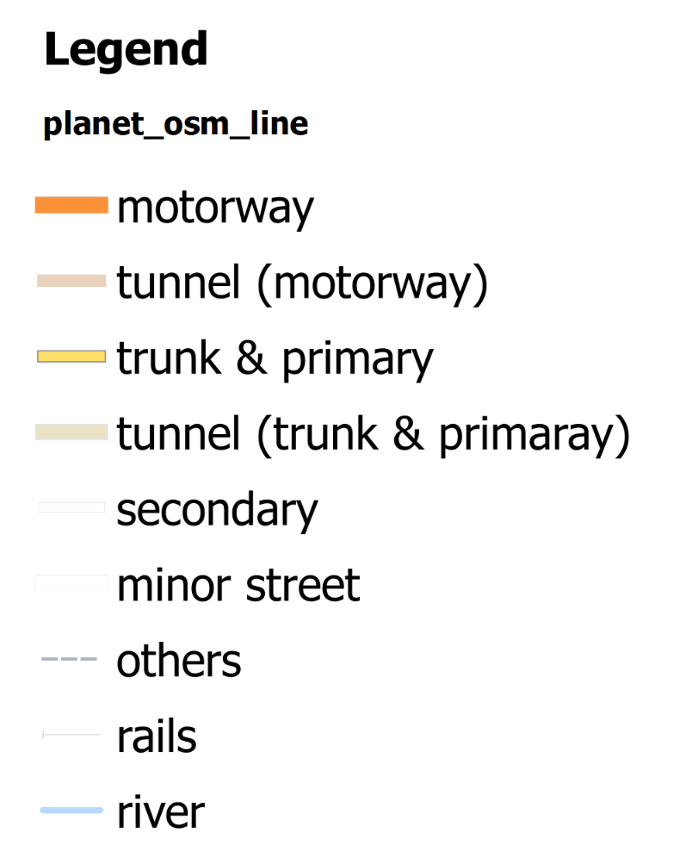
Figure: Legend of roads, river and others.

PLANET_OSM_POLYGON.QML: USED FOR PLANET_OSM_POLYGON
This style sheet is designed for OSM planet_osm_polygon. It classifies the osm polygon in several styles based on land use (park, industrial, water, commercial, retail, etc.) and building types (school, hospital, residential, etc.)

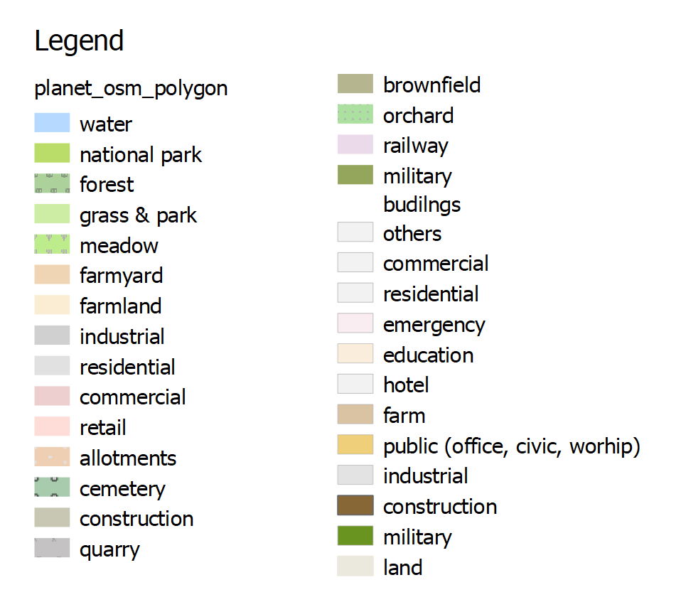
Figure: Legend of land use

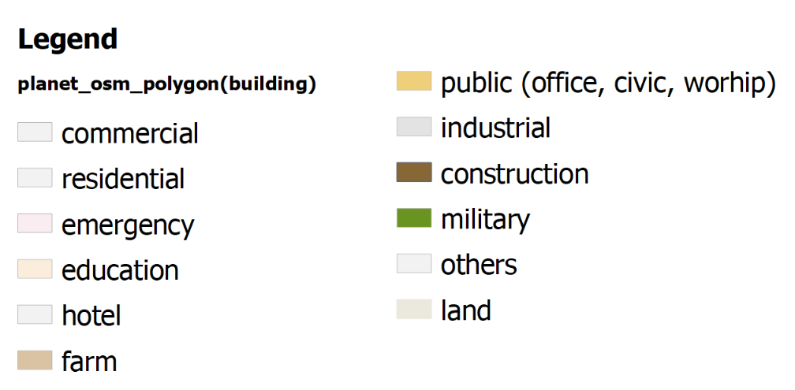
Figure: Legend of buildings

COPYRIGHT AND LICENSE
Copyright 2017 Industrial Data & Analytics Ltd. Released under the GPLv3 license.
This file is part of "QGIS stylesheets and code to render OSM data as a scalable map".
"QGIS stylesheets and code to render OSM data as a scalable map" is free software: you can redistribute it and/or modify it under the terms of the GNU General Public License as published by the Free Software Foundation, either version 3 of the License, or (at your option) any later version.
"QGIS stylesheets and code to render OSM data as a scalable map" is distributed in the hope that it will be useful, but WITHOUT ANY WARRANTY; without even the implied warranty of MERCHANTABILITY or FITNESS FOR A PARTICULAR PURPOSE. See the GNU General Public License for more details.
You should have received a copy of the GNU General Public License along with "QGIS stylesheets and code to render OSM data as a scalable map" in a file called COPYING.txt and/or COPYING.license-gpl-3.0.odt. If not, see <http://www.gnu.org/licenses/>.
For support, please use GitHub tickets / bug tracker. For other contact, email info@dataandanalytics.co.uk.

