TIES 4911 (2024): Guidelines for the Task 2

Your surname: Qu
Your first name: Yanren

Study lecture materials… Refer to the examples in the materials to complete following sub-tasks:

Task 2-1: Compare performance (loss, accuracy, and examples of predictions of trained model) of several implementations for MNIST dataset classification mentioned in the lecture materials: single-layer neural network and Multi-Layer Perceptron (MLP) (at least in TF2, but if you what, you may also try TF1 version as well). But this time, use Fashion-MNIST dataset instead. Play with training hyper-parameters (e.g. network architecture, learning rates, optimizers, etc.) and compare performance… Present comparison results in a table (including corresponding hyper-parameters settings).

Result in 100 epochs

Model | Train CE | Val Acc
Single layer NN with dropout | 0.77841 | 74.7%
MLP (shallow) | 0.39018 | 86.9%
MLP (deep) | 0.16393 | 89.5%

Task 2-2: Taking Iris dataset classification as an example, implement classification for some other similar dataset (find existing dataset). Play with data preprocessing, training hyper-parameters and network architecture to gain better performance (place corresponding settings and performance results into a table).

Dataset: CIFAR10

Model | Train CE | Val Acc
Single layer NN | 1.685 | 40.7%
Single layer NN with preprocessing | 1.7912 | 39.0%
MLP (shallow) | 0.32 | 50.9%
MLP (shallow) with preprocessing | 0.64 | 60.5%

Task 2-3: Take Fashion-MNIST Classification example from the lecture materials and make a predictions of 5 input samples (on your chose) from the test set using simple “Single layer with 1 unit” and improved “Multiple layers” (with and without dropout) models. Use TensorBoard to detect possible overfitting. Visualize input images and show corresponding predicted categories (e.g. T-shirt, Trouser, Pullover, etc.)

Model | Train CE | Val Acc
Single layer NN without dropout | 0.4793 | 82.6%
MLP without dropout | 0.00478 | 90.04%
MLP with dropout | 0.0874 | 90.26%

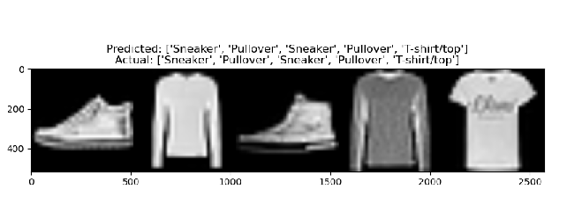

Extra task for those who are aiming higher (optional):
Task 2-4 (extra): Implement classifier for XOR Gate.
Code in xor.py

Files to include in the demo results (archive file ties4911-task02-(your_surname).zip):
- Task2-instructions.doc (this file)
- PPT presentation with (comparisons, corresponding screenshots, dataset examples, etc.)
- source codes (.py files, Jyputer Notebooks, etc.)

Send the demo results as an archive to lecturer (oleksiy . khriyenko @ jyu . fi) before the deadline (end of 01.02.2024).
Be ready to present and comment your results during the Demo-2 Session. Be sure that you have all the necessary adapters to connect your computer in the classroom (if applicable).

