YAN NISHIYAMA

System engineer

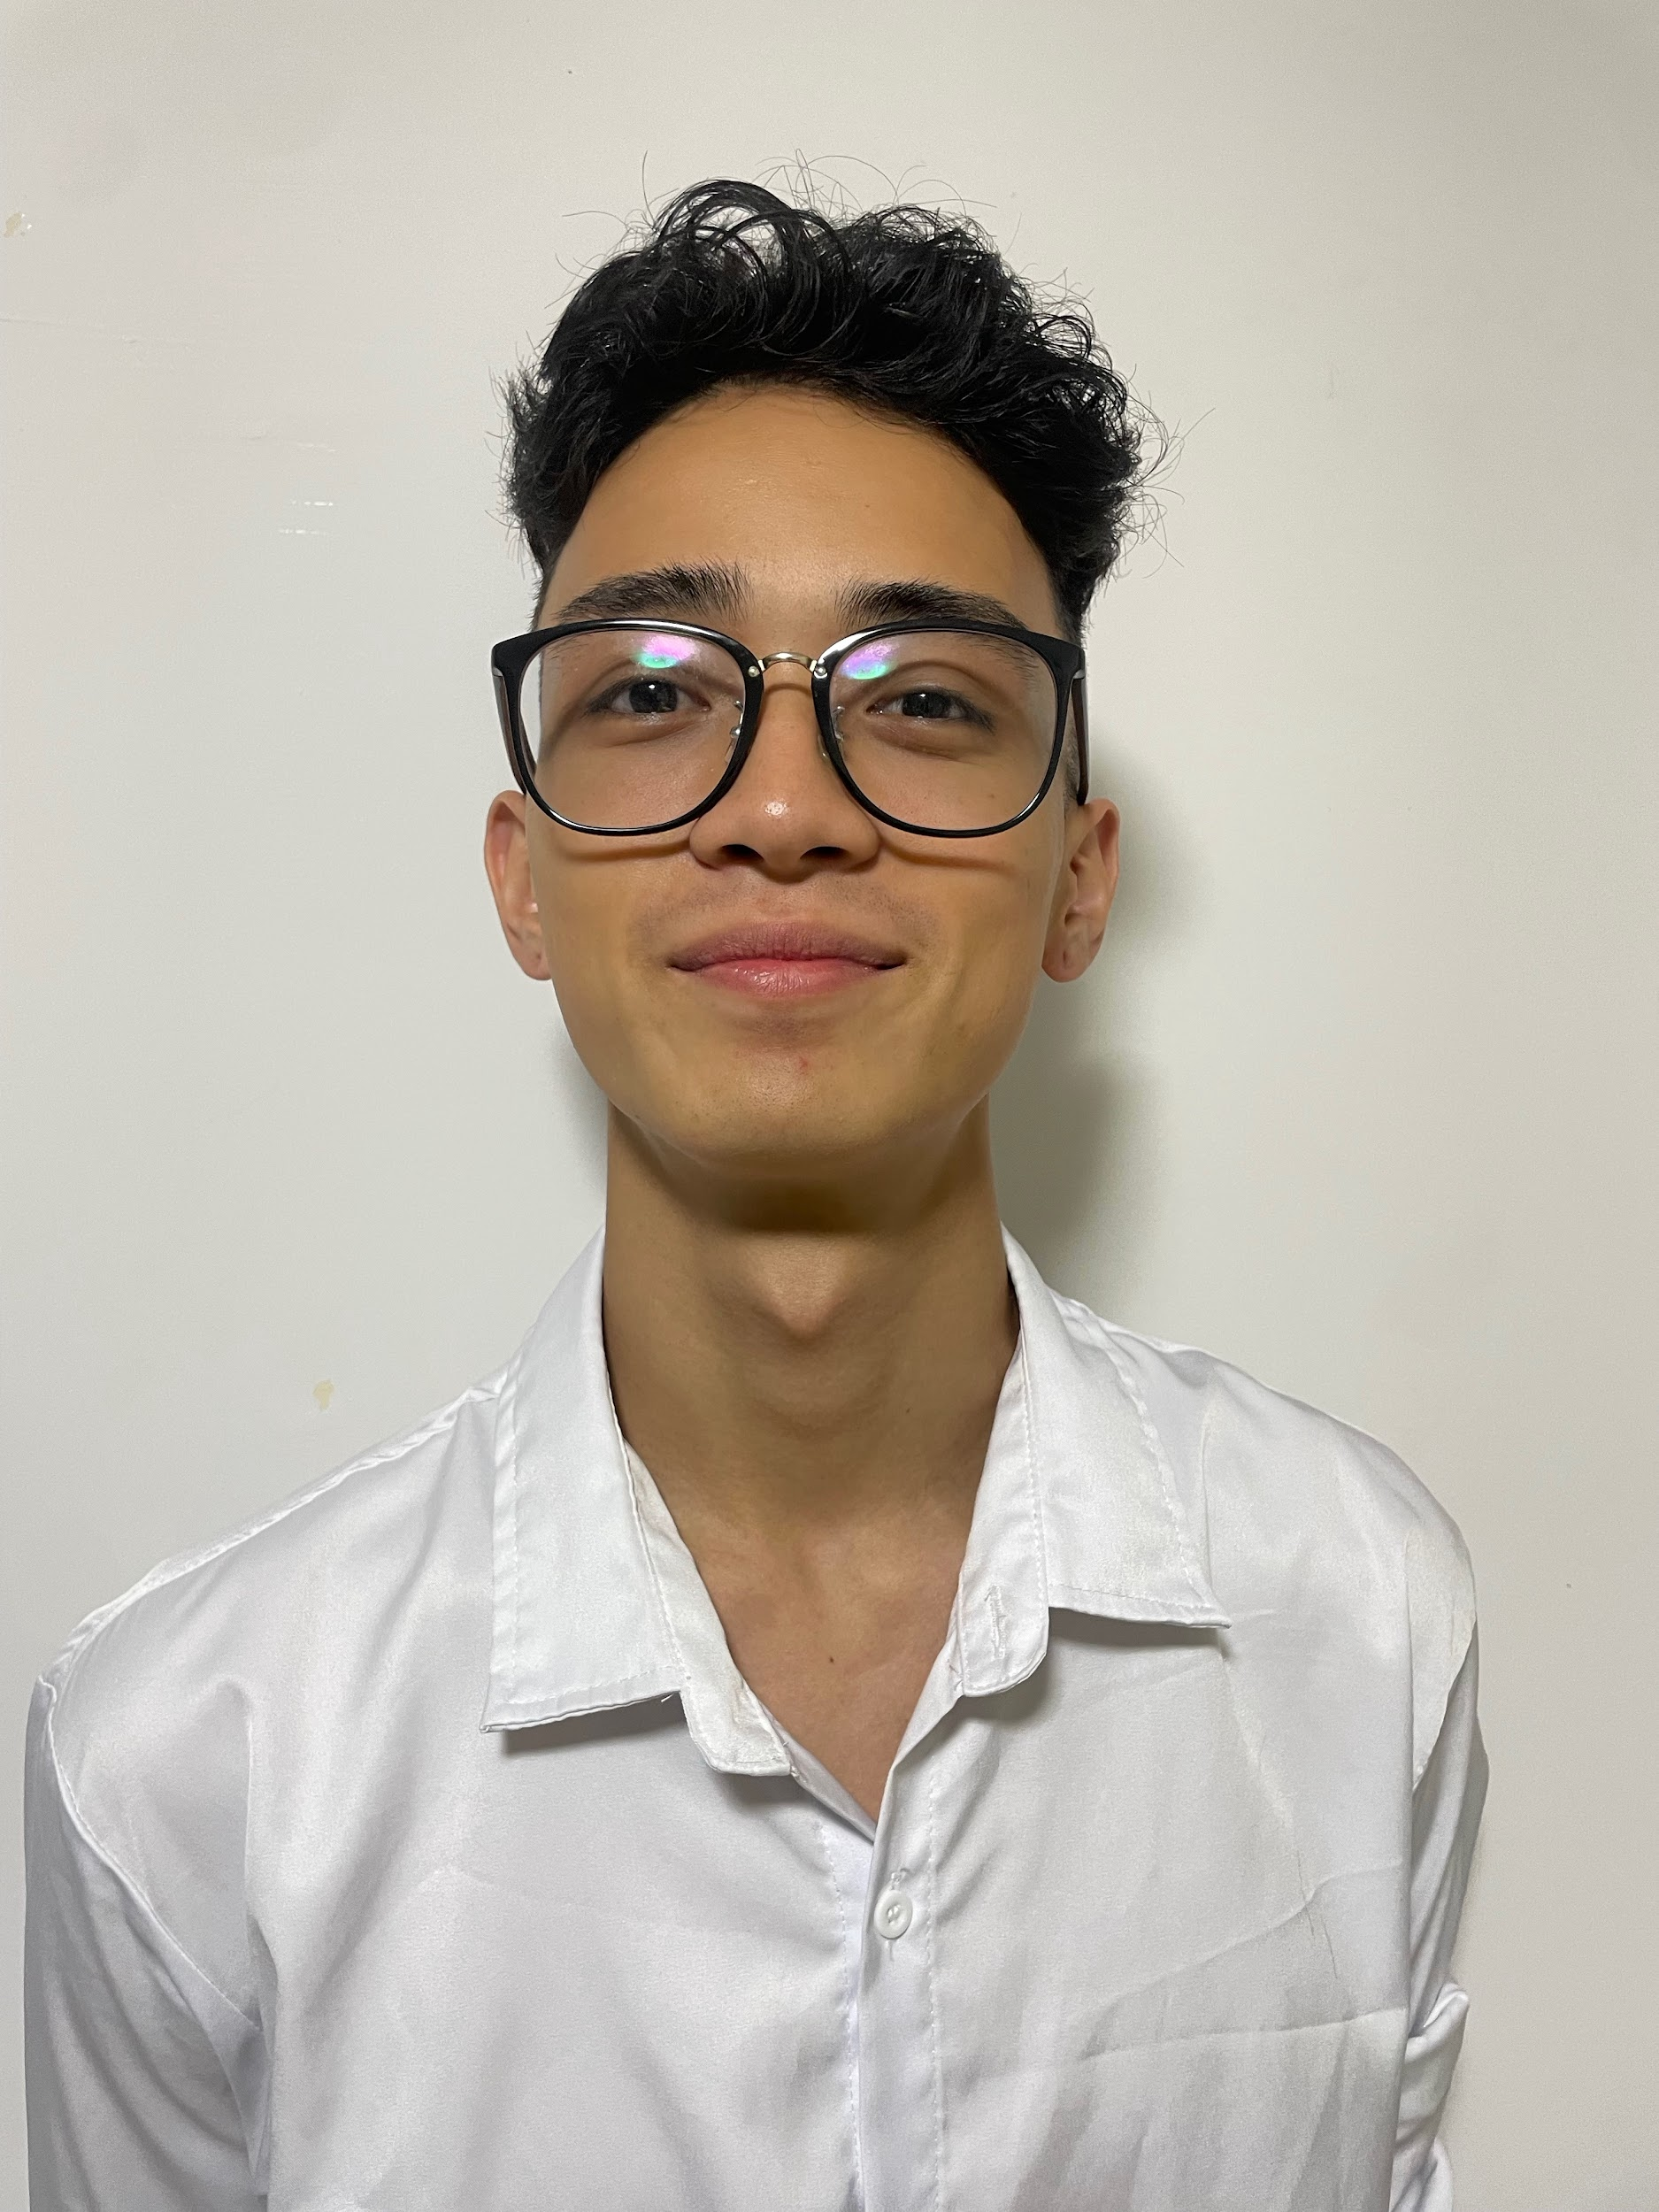

22 years old

Hanamigawa, kashiwa

Chiba-shi, Chiba-ken, 262-0048

08069821513

[yanyanseiji@gmail.com](mailto:yanyanseiji@gmail.com)

LinkedIn: Yan Nishiyama

# 

Career objective:

I am Yan, i have 22 years old technology and data science enthusiast. I dont have so much time of work experience but i am eager to embark on a journey of continuous learning and contribute to something big. I am currently pursuing a degree in Data Science Technology and i am determined to make the most of every opportunity life gives to me.

About me:

Beyond my commitment to professional development, i am a travel enthusiast who loves exploring new cultures and costumes. Through my travels, i seek to make new friendships and learn new languages to enrich my perspective and life experiences. I believe that every encounter and experience can teach us something valuable even the bad ones, and i am always open to absorbing knowledge from those around me.

My goal is to continue growing professionally and personally, contributing to meaningful projects, embracing the cultural diversity that world has to offer, and be recognize as a professional and helping others wherever i can.

# Job Experience

## Pacific co. Ogaki-shi, Gifu-ken *- car factory operator*

04/2019 - 08/2023

* Factory machine operator

## Sanlize, Chiba-ken, Yachiyo-shi *- System engineer*

09/2023 - ~

* Desing Medical Systems
* Develope Medical Systems
* Maintenance Medical Systems

# **EDUCATION**

## Hiro Gakuen *- primary school ~ high school*

01/2007 - 12/2018

Universidade international (uninter)- *Associate Degree in Data Science*

01/2021 - expected to graduate 09/2024

Simplilearn & Perdue University- professional certificate in Data Science

01/2022- expected to graduate 01/2024

# Skills and Certificates

Languages -

* Portuguese - native level
* English - business level
* Japanese - conversational level

Operating Systems -

* Windows - 3 years studies experience
* Linux - 3 years studies experience

Programming Language -

* Python - 3 years studies experience
* C# - 3 months Work experience
* Sql - 3 Years studies experience and 3 months work experience

Certificates -

* IBM Python advanced for data science Certificate
* IBM Relational Database administrator Certificate
* IBM Linux/Unix commands and shell scripiting Certificate
* IBM Database and Sql for data science with python Certificate
* IBM Python project for data engineer Certificate
* IBM Python for data science, AI & Development
* IBM The Data Scientist’s toolbox