# MINI PROJECT

# EVENT COUNTDOWN TIMER **Name – Ansh Yadav**

1. Abstract

This assignment involves the development of a web application that allows users to manage countdowns to upcoming events. Users can add, edit, and delete events, and view the remaining time until each event in a visually appealing interface. The application updates countdowns in real-time, providing a dynamic user experience.

1. Introduction

Time management is crucial in both personal and professional settings. The "Event Countdown" application serves as a helpful tool for users to track important dates and deadlines. By providing a clear countdown to events, users can better prepare and manage their schedules. This assignment combines HTML, CSS, and JavaScript to deliver a user-friendly and responsive web application.

1. Background

The concept of countdown timers is widely used in various applications, from event planning to product launches. A countdown timer visually displays the time remaining until a specific event, helping users anticipate and prepare accordingly.

1. Technologies Used

HTML: For structuring the web page, CSS: For styling the web page, including layout, colours, and fonts, JavaScript: For implementing the countdown functionality and event management features, Bootstrap: For responsive design and pre-built UI components.

1. System Description

The system comprises the following modules:

Event Form: Allows users to input event details including name and date.

Countdown Display: Dynamically shows the countdown for each event.

Edit and Delete Functions: Provide options to modify or remove events.

1. Block Diagram
2. Output

**Welcome Screen**  
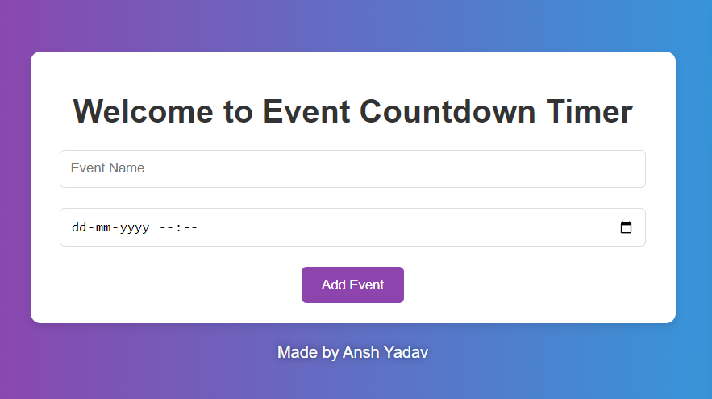

**Adding an event and countdown display**

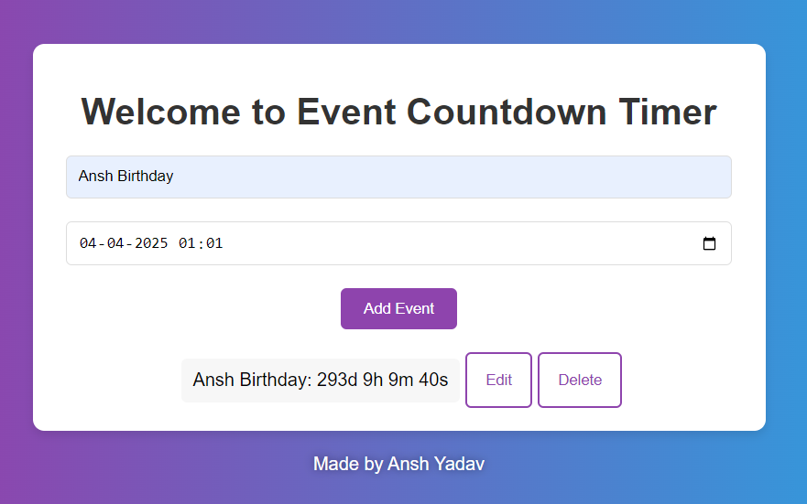

**Editing an event**

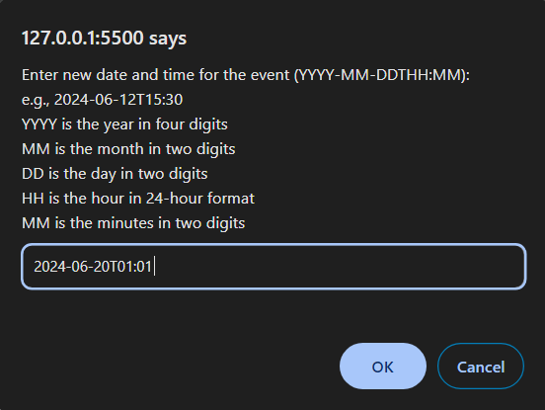

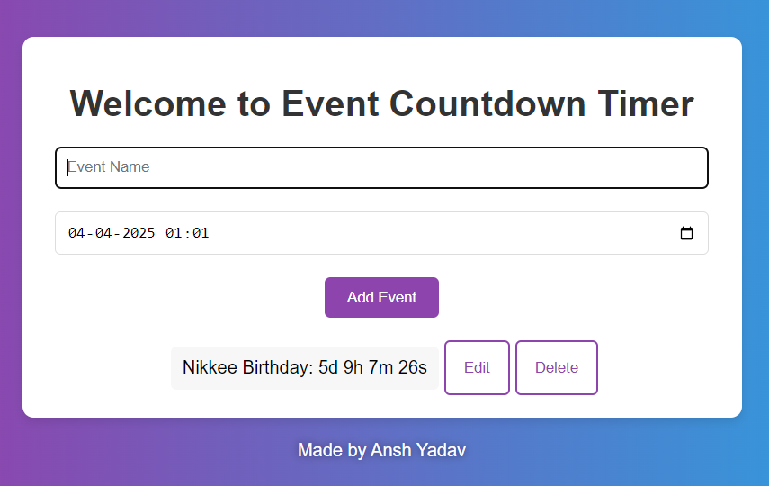

**Deleting an event**

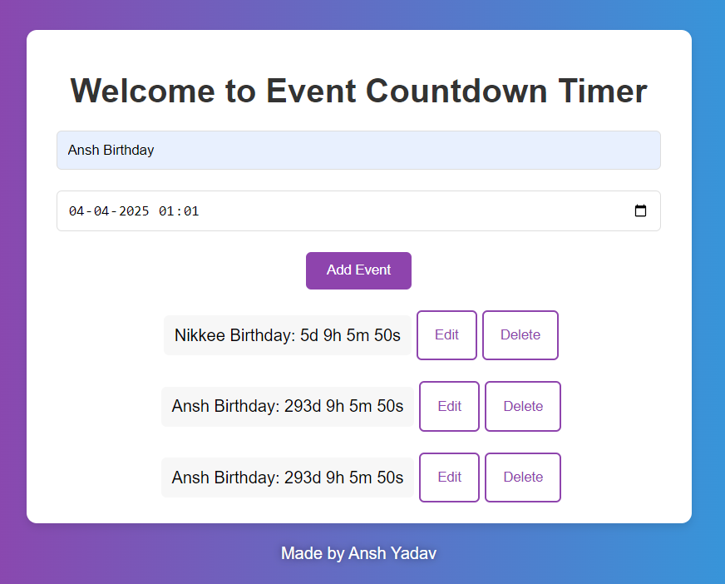

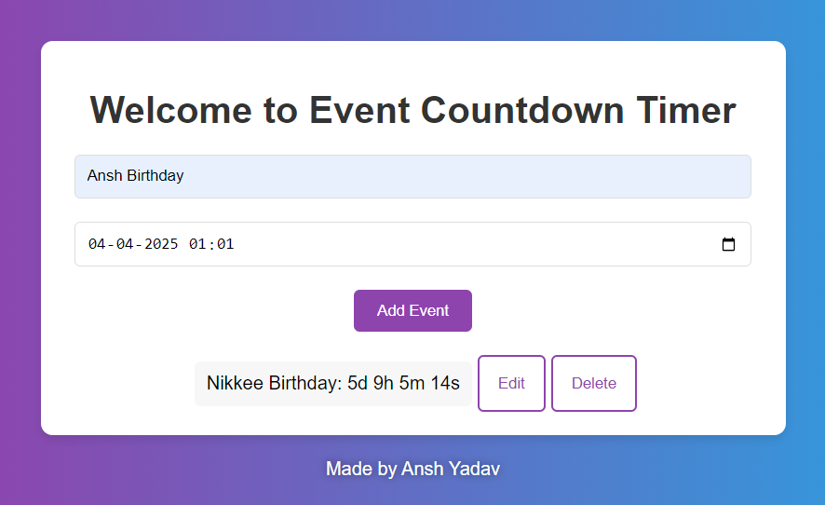

1. Conclusion

The "Event Countdown" assignment provides a practical and user-friendly tool for managing upcoming events. The application is robust, responsive, and visually appealing, making it a useful addition for users needing to track important dates.

1. Main code with functions

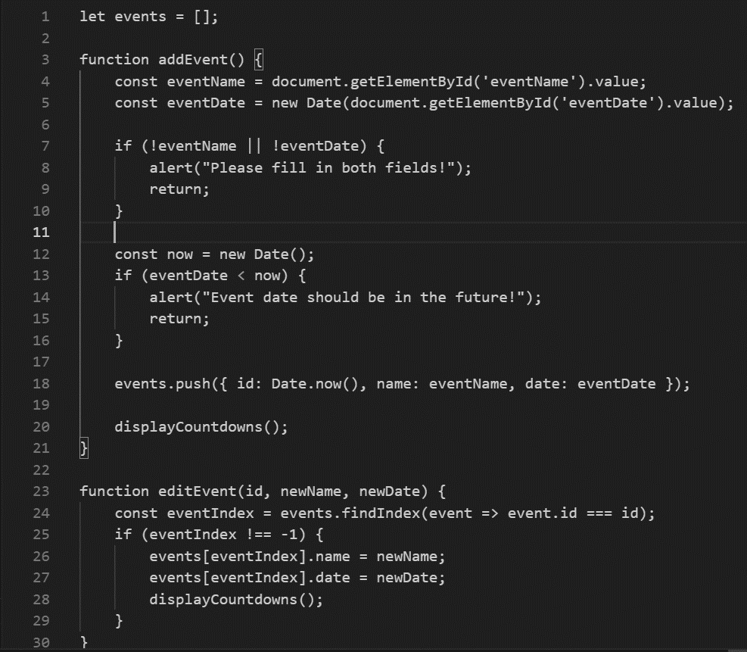

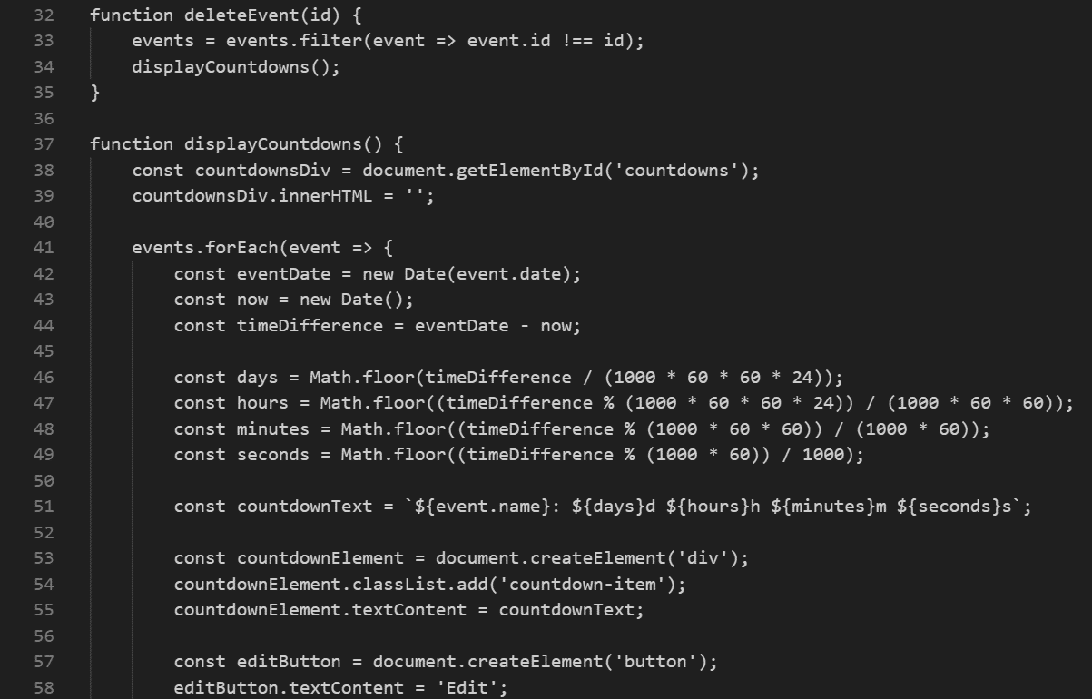

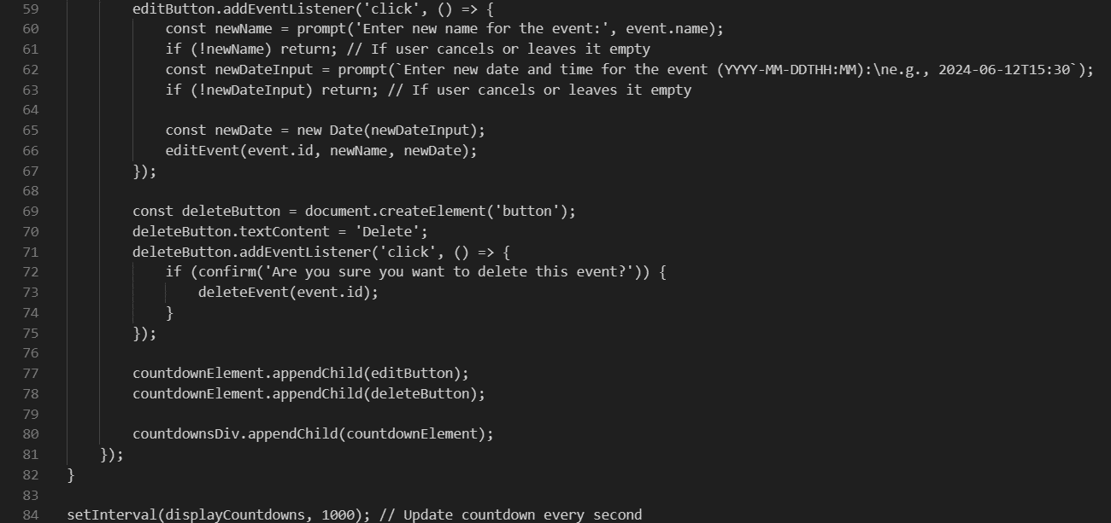

**Thank You**