**Power BI Dashboard Report**

Introduction

This report aims to provide a detailed analysis of financial performance through various visualizations. The dataset consists of segment, country, product, discount band, units sold, manufacturing price, sale price, gross sales, discount, sales, COGS, profit, date, month number, month name, and year. By creating a dashboard with three distinct pages—Sales Overview, Profitability Insights, and Time-Based Trends—we allow stakeholders to gain actionable insights into key metrics such as sales performance, profitability, and temporal trends. Each page leverages different visualization types to capture a comprehensive view of the dataset.

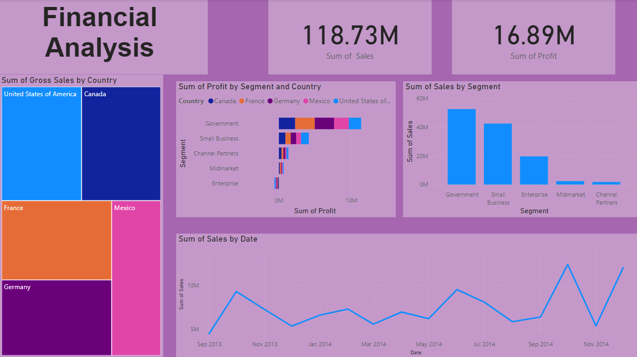

Page 1: Sales Overview

Introduction

The Sales Overview page is designed to present an overview of sales distribution and key performance drivers. This page helps identify top products, geographical segments, and discount impact on sales. By using visualizations such as a bar chart, scatter plot, and clustered column chart, users can understand how different factors interact to influence sales and profitability.

Visualizations:

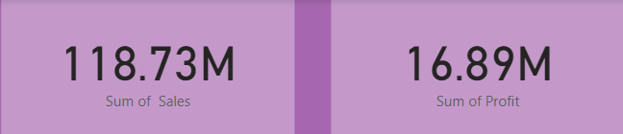

1. Sum of Sales and Profit:

This visualization shows the total sales and total profit for the selected period. By calculating the aggregate sales and profit, this KPI provides a high-level overview of how well the company is performing financially. It helps stakeholders understand the overall revenue generated and the profitability of that revenue, serving as a benchmark for comparing other metrics.

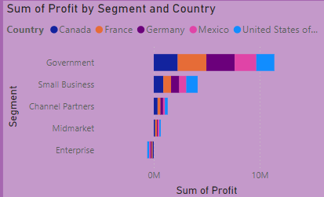

1. Sum of Profit by Country and Segment:

This KPI chart breaks down total profit by country and segment, offering valuable insights into which regions and business segments are the most profitable. It enables decision-makers to identify high-performing regions and segments, as well as any underperforming areas that might require attention. Understanding these profit drivers helps in targeted resource allocation and strategic planning.

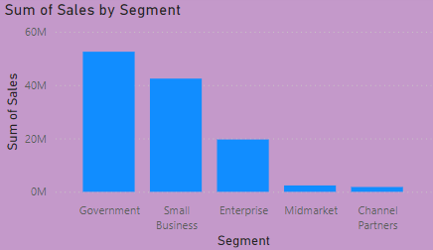

1. Sum of Sales by Segment:

This metric shows the total sales amount broken down by business segment. It allows stakeholders to quickly evaluate which segments contribute the most to overall sales, helping identify trends in demand for specific product categories or services. This visualization aids in the strategic decision-making process, such as prioritizing resources for top-selling segments or addressing issues in low-performing segments.

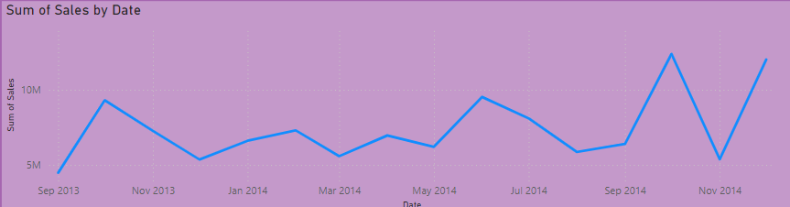

1. Sum of Sales by Date:

The sum of sales by date visualization tracks the performance of sales on a day-by-day basis. This metric

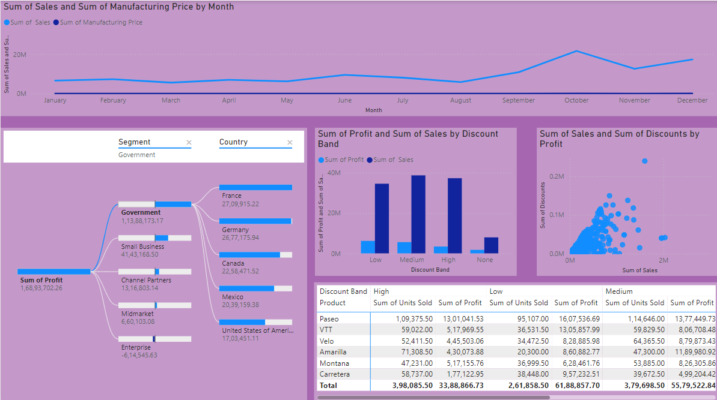

Page 2: Discount and Pricing Analysis

Introduction

The Profitability Insights page is dedicated to understanding the drivers of profit and identifying areas where additional cost control or revenue generation might be necessary. By focusing on profit share, contribution, and margin patterns, stakeholders can pinpoint opportunities for improvement and optimize business performance.

Visualizations:

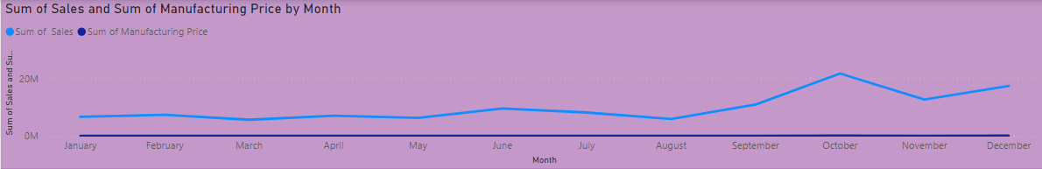

1. Sum of Sales and Manufacturing Price by Month:

This visualization displays the total sales and manufacturing prices by month, providing insight into how sales performance correlates with production costs. By comparing the two metrics, stakeholders can track changes in the cost of manufacturing relative to revenue generation. If manufacturing prices rise without a corresponding increase in sales, it could signal inefficiencies or rising production costs. This graph helps identify seasonal patterns in sales and manufacturing pricing, allowing for better forecasting and cost management.

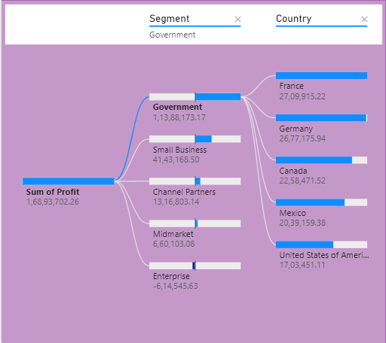

1. Decomposition Tree of Profit Based on Segment and Country:

The decomposition tree breaks down the profit by different dimensions, focusing on segments and countries. This interactive chart allows users to drill down into profit by various business segments (e.g., product categories) and by geographic regions. By exploring profit drivers across different layers, stakeholders can identify which specific segments or countries contribute the most to profits and uncover opportunities for optimization. This tool is useful for understanding complex relationships and uncovering areas where the business could improve profitability.

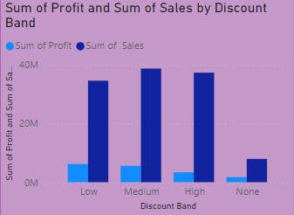

1. Sum of Profit and Sales by Discount Band:

This visualization compares the sum of sales and profit across different discount bands. It provides insights into how discounts affect sales and profit margins. For example, large discounts may increase sales volume, but they could also erode profit margins. Analyzing the sales and profit by discount band allows the business to assess the effectiveness of various discount strategies and their impact on overall profitability. This information can guide decisions on pricing strategies, promotions, and discount policies.

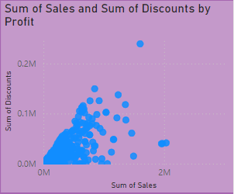

1. Sum of Sales and Discounts by Profit:

This metric shows the relationship between sales, discounts, and profit. By analyzing the effect of discounts on sales and profit, this visualization helps determine whether discounting is a profitable strategy. It allows users to assess whether sales volume increases due to discounts offset the potential reduction in profit margins. This information is crucial for evaluating the financial impact of promotional offers and determining the optimal discounting strategy for maximizing profit.

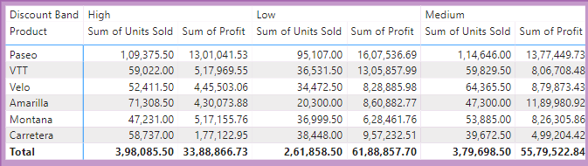

1. Product with Units Sold and Profit Based on Discount Band:

The Matrix Table of Product provides a detailed view of how each product performs in terms of units sold and profit, segmented by discount band. This table is designed to give users a clear understanding of how discounts impact both the volume of sales and the profitability of individual products. By breaking down the data by discount band, it helps identify which discount levels lead to the most profitable sales for each product.

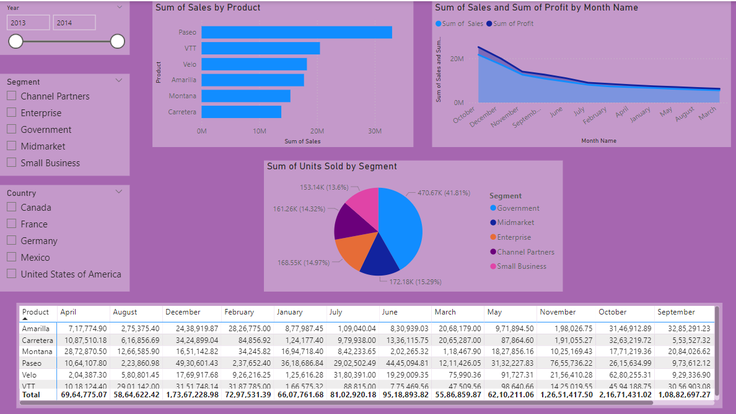

Page 3: Monthly Performance and Insights

Introduction

The Time-Based Trends page provides a clear view of performance over time, helping users understand patterns, seasonality, and growth or decline trends. By tracking monthly sales trends, stakeholders can make informed decisions related to inventory management, seasonal promotions, and revenue projections.

Visualizations:

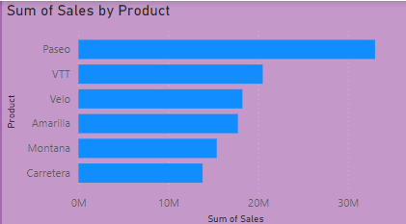

1. Sum of Sales by Product

This bar chart provides a visualization of total sales for each product. The products are listed on the X-axis, while the Y-axis represents the sum of sales values. By looking at this chart, users can quickly identify which products generate the highest sales, offering insights into which items are driving revenue. It helps the team focus on high-performing products, and businesses can strategize around promoting or restocking these top sellers. The visualization highlights product performance, guiding decisions on inventory, marketing campaigns, and future product development.

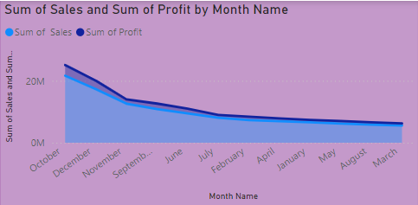

1. Sum of Sales and Profit by Month

The line chart (or area chart) in this visualization displays the trend of both sales and profit over each month. The X-axis represents months, while the Y-axis shows the values for both sales and profit. This chart enables a comparison between the sales figures and profit margins over time. It is particularly useful for understanding how changes in sales volumes impact profitability. For instance, if sales are high but profit is low, it may suggest that costs are increasing or that the sales volume is driven by low-margin products. By examining these trends, decision-makers can identify periods of growth or downturn and adjust strategies accordingly to improve both sales and profitability.

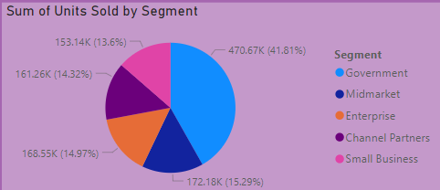

1. Sum of Units Sold by Segment

This column chart shows how many units were sold in each market segment, with each bar representing a segment. The height of the bars corresponds to the total units sold within each segment. This visualization helps to identify which segments are performing the best in terms of sales volume. For businesses, this information is critical for segmenting marketing efforts and focusing resources on high-performing segments. It also reveals which segments may require further attention, adjustments in strategy, or product offerings to boost sales performance.

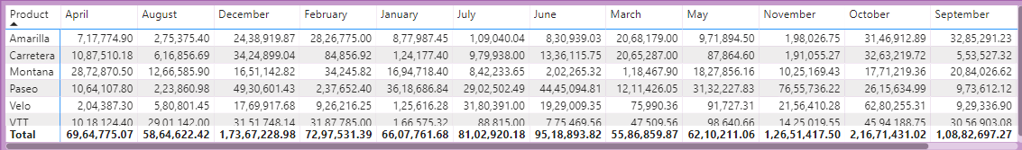

1. Matrix of Product Sales Based on Month Name

This matrix table offers a detailed breakdown of product sales by month. The rows represent the individual products, while the columns represent the months of the year. Each cell in the matrix shows the sales value for a particular product in a specific month. This format allows users to track how each product performs over time and assess seasonal patterns. If a product has fluctuating sales, this table can help pinpoint months with high or low sales, aiding in stock planning, promotions, or forecasting. It gives a granular look at product performance and trends, helping teams optimize sales strategies on a month-to-month basis.

Conclusion

This Power BI dashboard effectively visualizes sales performance, profit contribution, and temporal trends through interactive and insightful visualizations. Each page is designed to provide different perspectives on financial performance, empowering stakeholders to make data-driven decisions. The comprehensive analysis through graphs, charts, and slicers enables detailed exploration and better understanding of key business metrics, supporting strategic planning and optimized performance management.