**INFOSYS MILESTONE 1**

**GLOBAL SALES DATA DASHBOARD**

**Introduction:** A Power BI sales dashboard is a powerful tool that visually summarizes global sales data, enabling quick and easy analysis of key metrics like revenue, discounts, profits, and returns across different segments, regions, and product categories. By consolidating data into interactive visuals, the dashboard allows stakeholders to identify trends, high-performing areas, and cost-saving opportunities. This streamlined view helps teams make informed decisions to improve sales strategies, optimize operations, and enhance overall profitability.

1. **Sum of Sales Contribution by Segment**: This shows how different customer segments contribute to overall sales, identifying which segments drive the most revenue and allowing for targeted marketing strategies.
2. **Sum of Sales After Discount by Quantity**: This metric indicates the effectiveness of discounting strategies by comparing sales volume before and after discounts, helping to assess whether discounts boost sales volume enough to justify their impact on revenue.
3. **Sum of Shipping Cost by Category**: Visualizing shipping costs by category highlights which product categories incur the most shipping expenses, helping to optimize cost structures and potentially identify opportunities for more cost-effective logistics.
4. **Sum of Return Rate by Sub-Category**: Tracking return rates by sub-category provides insights into customer satisfaction with specific products, aiding in identifying problematic products and improving quality control.
5. **Sum of Unique Products**: Knowing the count of unique products sold allows businesses to gauge product diversity, assess inventory needs, and identify which product lines are performing well.
6. **Sum of Average Sales**: This measure shows the average sales across the dataset, giving a general view of sales performance and helping to benchmark individual products or categories against overall performance.
7. **Count of Returns by Region**: Visualizing returns by region provides insight into potential regional issues with products or logistics, helping to tailor customer service or adjust product offerings in specific regions.
8. **Sum of Shipping Cost by Shipping Mode**: This highlights which shipping methods are the most or least costly, allowing for optimization in shipping choices based on cost efficiency.
9. **Sum of Quantity by Market**: This metric shows product quantity sold across various markets, helping identify high-demand regions and aiding in inventory planning.
10. **Sum of Sales by Sub-Category**: Breaking down sales by sub-category reveals which product types drive the most revenue, aiding in focusing resources on top-performing sub-categories.
11. **Sum of Total Orders**: Total order count provides an overview of transaction volume, helping assess customer demand and sales trends.
12. **Profit**: Profit calculation is crucial as it shows overall financial health, allowing stakeholders to evaluate whether revenue strategies are effectively translating into profitability.
13. **Average Sales**: This measure shows average sales per transaction or product, giving insight into customer spending patterns and helping set sales targets.
14. **Average Discount**: Tracking average discount helps to understand the impact of discount strategies on revenue, enabling adjustments to discount policies.
15. **Maximum and Minimum Discount by Quantity**: These metrics help identify the highest and lowest discount levels applied per quantity sold, providing insight into discount range and effectiveness at driving volume.

**POWER BI DASHBOARD:**

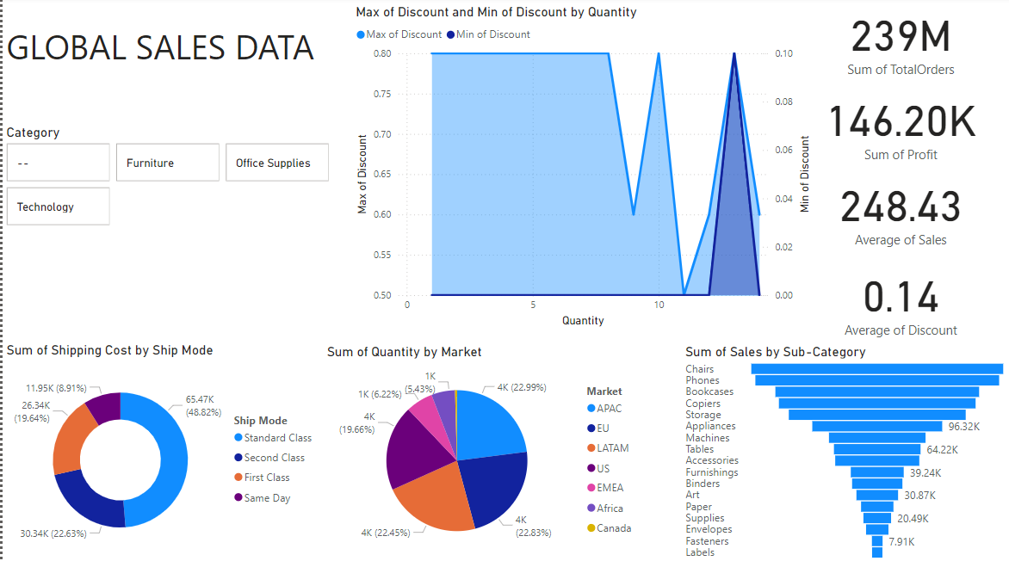

PAGE 1

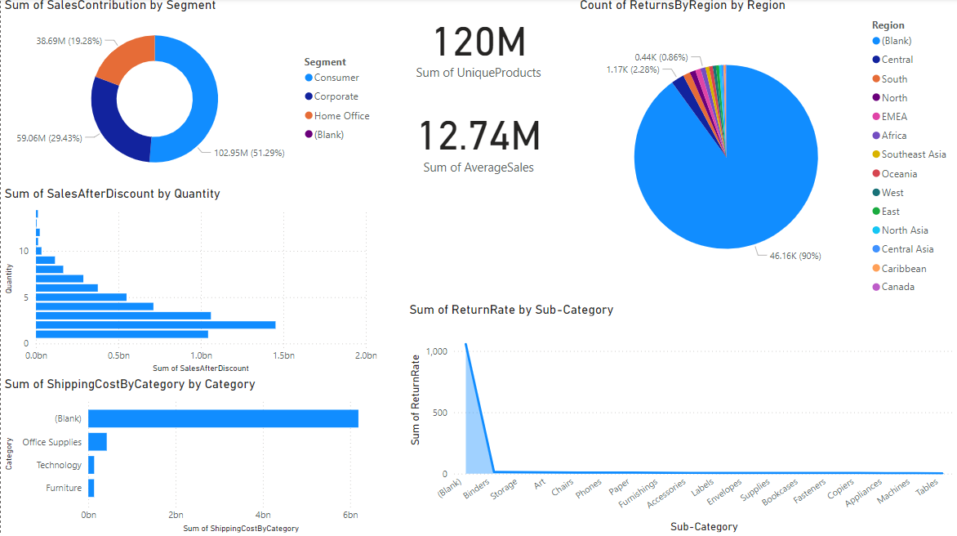

PAGE 2